
GYE NTOBOA
MANUAL 2 - SUPERVISOR TRAINING
PROCESS GUIDE 05 / 05

Find your assigned boundary and territory
Find your assigned divisions and blocks, inspect the map and filter property, business and attendance views without changing official boundaries.
WHO THIS IS FOR  Assembly supervisors | ALLOW ABOUT  5-10 minutes | DOCUMENT VERSION  1.0 | 19 October 2026

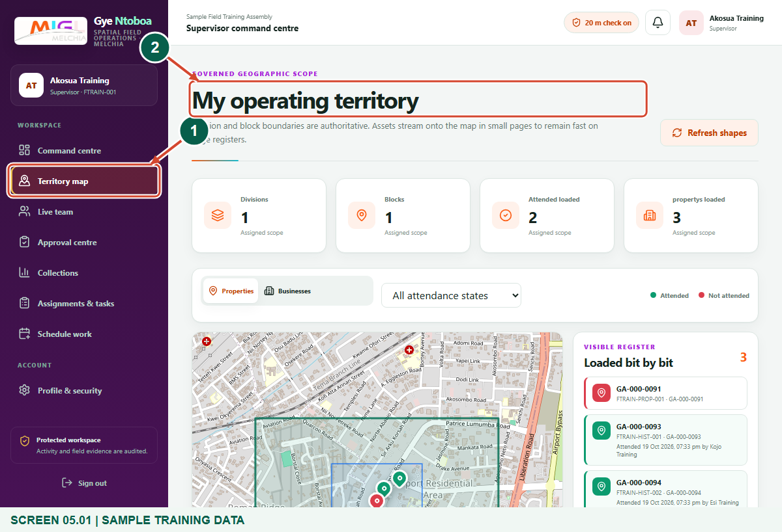
Illustrated steps with numbered arrows and clear expected results.
About the examples
Screens show the actual application in a training environment with sample data. Use your own verified account, assigned records and contact details when following the guide.

Website: operations.gyentoboa.com

Process flow
Follow the arrows from start to finish. Optional routes are explained in the numbered steps.

Before you start
- Sign in at https://operations.gyentoboa.com/ with your supervisor account and confirm the assembly.
- The assembly administrator must assign your supervisor divisions. Agents have their own division or block assignments within your permitted area.
- Allow time for map tiles and register pages to load. The sample records shown are training examples.
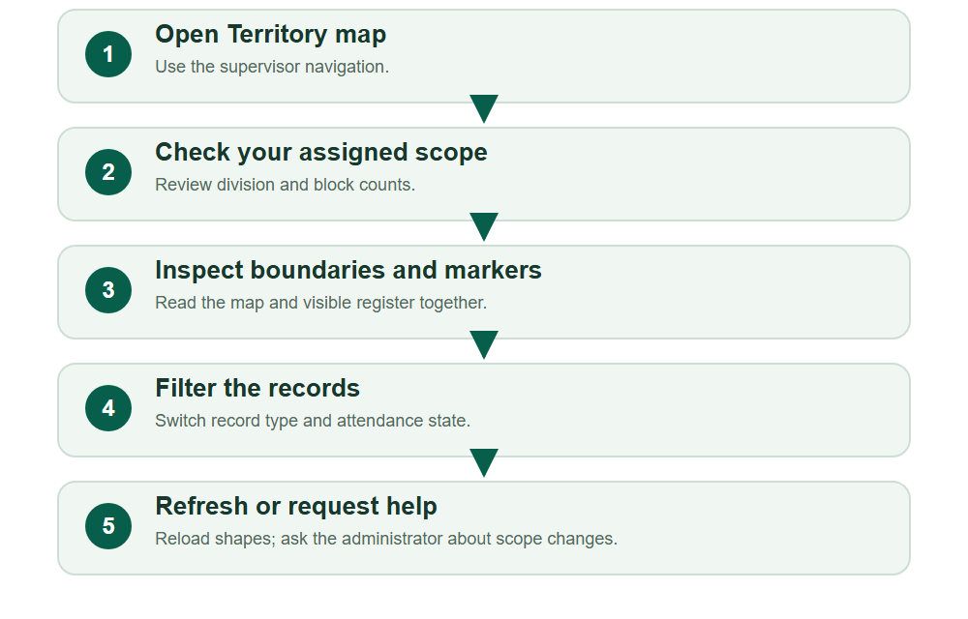
Numbered markers on screenshots identify the controls described beneath each image.

STEP 01

Open Territory map from your supervisor workspace
1. Choose Territory map in the left navigation. On a narrow screen, open the navigation menu first.
2. Wait for My operating territory and its map. Confirm your assembly and supervisor role.
Synthetic training example: Find your assigned territory.
1 Territory map navigation
2 My operating territory
What should happen
The page displays your assigned geographic scope, summary cards, record filters, a map and the visible register.

STEP 02

Check the division and block summary
1. Read Divisions and Blocks to understand the territory returned for your account. Blocks shown on this page belong to the permitted assigned area.
2. Read Attended loaded and the record-type loaded count separately. These describe the markers currently loaded, rather than an assembly-wide total.
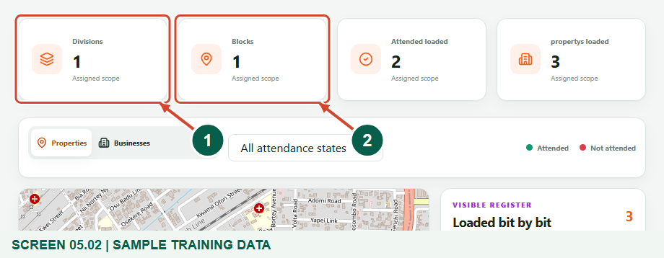
Synthetic training example: Check assigned divisions and blocks.
1 Assigned divisions
2 Assigned blocks
What should happen
You can distinguish assigned-area counts from the number of records currently displayed.

Helpful note: Changing the record type or attendance filter changes the loaded-record counts. It does not change your assigned boundaries.

STEP 03

Inspect the official boundary shapes
1. Zoom with the plus and minus controls and drag to inspect the outline. Hover over a boundary for its name and Division or Block label.
2. Read green division outlines and blue block outlines alongside the visible register. Select a marker to see the available record reference and attendance information.
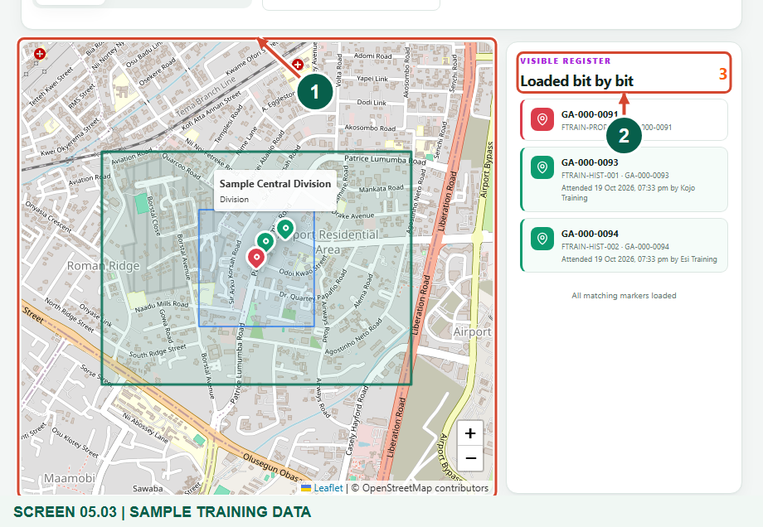
Synthetic training example: Inspect the assigned map and register.
1 Assigned division and block boundaries
2 Records loaded for this scope
What should happen
You can identify the assigned area and relate its mapped records to the list.

Helpful note: This map is for viewing. Dragging or zooming changes your view only; it does not redraw an official boundary or grant access to another area.

STEP 04

Filter properties by attendance
1. Select Properties, then open the attendance filter. Choose All attendance states, Attended - green or Not attended - red as needed.
2. Compare markers with the register. Attended entries can show check-in time and agent name. Choose All attendance states to remove the filter.
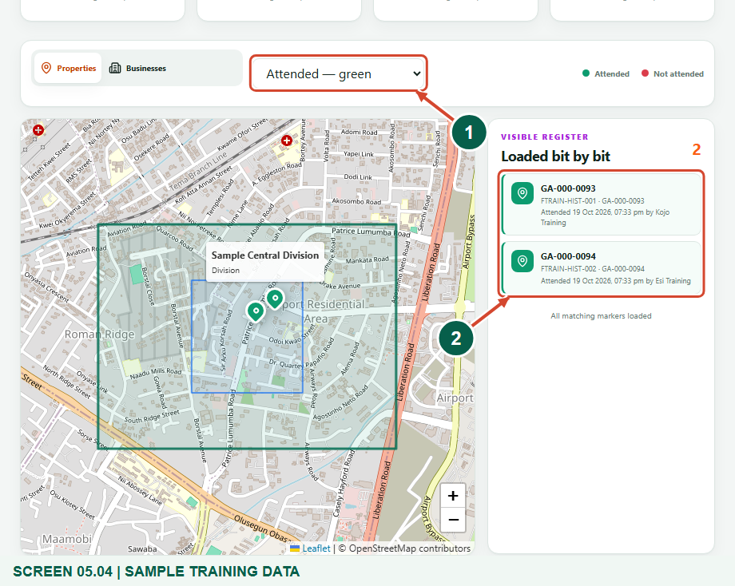
Synthetic training example: Filter attended properties.
1 Attendance filter
2 Green attended-property records
What should happen
Only properties matching your assigned scope and the selected attendance state remain in the loaded register.

Helpful note: An attended marker represents a recorded field check-in. It does not by itself confirm task completion or bill payment.

STEP 05

Switch to businesses and continue through the register
1. Choose Businesses to view business markers. The attendance filter remains selected; choose All attendance states for all matching businesses.
2. Scroll the register to continue loading small pages. Where available, use Load next 100. Continue until All matching markers loaded appears.
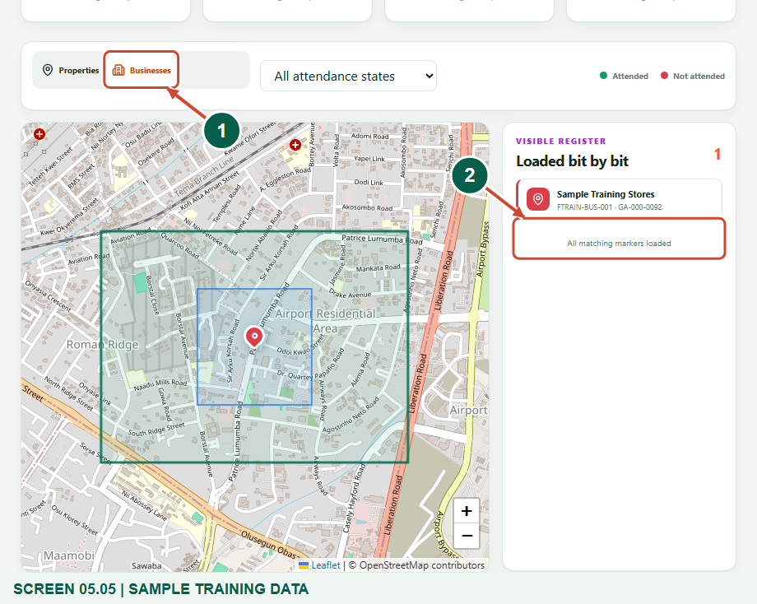
Synthetic training example: View businesses in the assigned territory.
1 Businesses tab
2 End of the matching business register
What should happen
Business records replace the property view. The end message confirms that all records matching the current scope and filter have been loaded.

Helpful note: This one-business example already shows All matching markers loaded. A missing marker may indicate a record without mapped coordinates.

STEP 06

Refresh the assigned boundary shapes
1. If the administrator has corrected your territory, choose Refresh shapes and wait for the assigned areas to reload.
2. Check the division and block summary again. If a record list also appears outdated, reload the page or reselect its type and filter before drawing conclusions.
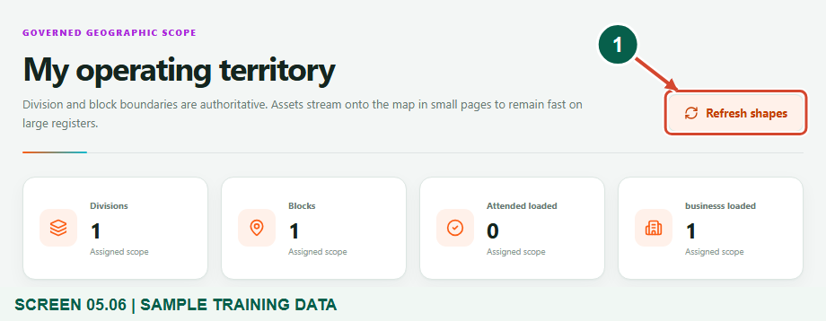
Synthetic training example: Reload authoritative boundary shapes.
1 Refresh shapes
What should happen
The portal requests the current assigned-area shapes again; your account permissions remain authoritative.

Helpful note: Refresh shapes reloads boundary information. It is not a boundary editor and does not assign an agent to a new area.

STEP 07

Resolve an empty or unexpected territory
1. If No operating area assigned appears, contact the assembly administrator and ask them to review your supervisor division assignment.
2. For an empty property or business list, check the selected type and attendance filter first. Give support the relevant record reference and area name through an approved support channel.
What should happen
Scope problems are referred to the administrator rather than bypassed by searching or working outside your permitted area.

Check your result
- You have identified the assigned division and block shapes and read their names on the map.
- You can switch between properties and businesses, filter attendance and recognise when the current register has finished loading.
- You know who to contact when your assigned scope or a mapped record needs correction.

If you need help
The boundary map does not load.
Check the internet connection and use the page retry control or reload. Report a repeated loading error to assembly support.
A record is missing or its loaded count seems low.
Check Properties versus Businesses, restore All attendance states and finish loading the register. Ask support to verify its coordinates and assigned scope if it remains absent.
My team needs a different operating area.
Ask the assembly administrator to review your supervisor divisions. Manage agent coverage only within your permitted supervisor area; a map view does not authorise extra territory.

Useful things to know
- Official area assignments and server permissions control which records are visible. Map movement cannot expand your authorised scope.
- Attendance colours describe relevant recorded field check-ins; they are not a payment, completion or full-team performance report.
- The map has no supervisor boundary-drawing tool. Boundary corrections require the authorised assembly process.

Continue learning
- Guide 01: Access your supervisor account on the web
- Guide 02: See agents assigned to you
- Guide 03: Allocate jobs to your agents
- Guide 04: View individual agent performance
Download all 5 guides in this collection
For account or bill-record corrections, contact the relevant assembly using its verified contact details. Keep your account or bill reference available when requesting assistance.

