
GYE NTOBOA
MANUAL 2 - SUPERVISOR TRAINING
PROCESS GUIDE 04 / 05

View individual agent performance
Review an individual agent’s allocated and completed work, inspect relevant visit evidence, and assess collection outcomes for a consistent reporting period without treating team totals as individual performance.
WHO THIS IS FOR  Assembly supervisors reviewing operational progress and collection outcomes | ALLOW ABOUT  10–15 minutes | DOCUMENT VERSION  1.0 | 19 October 2026

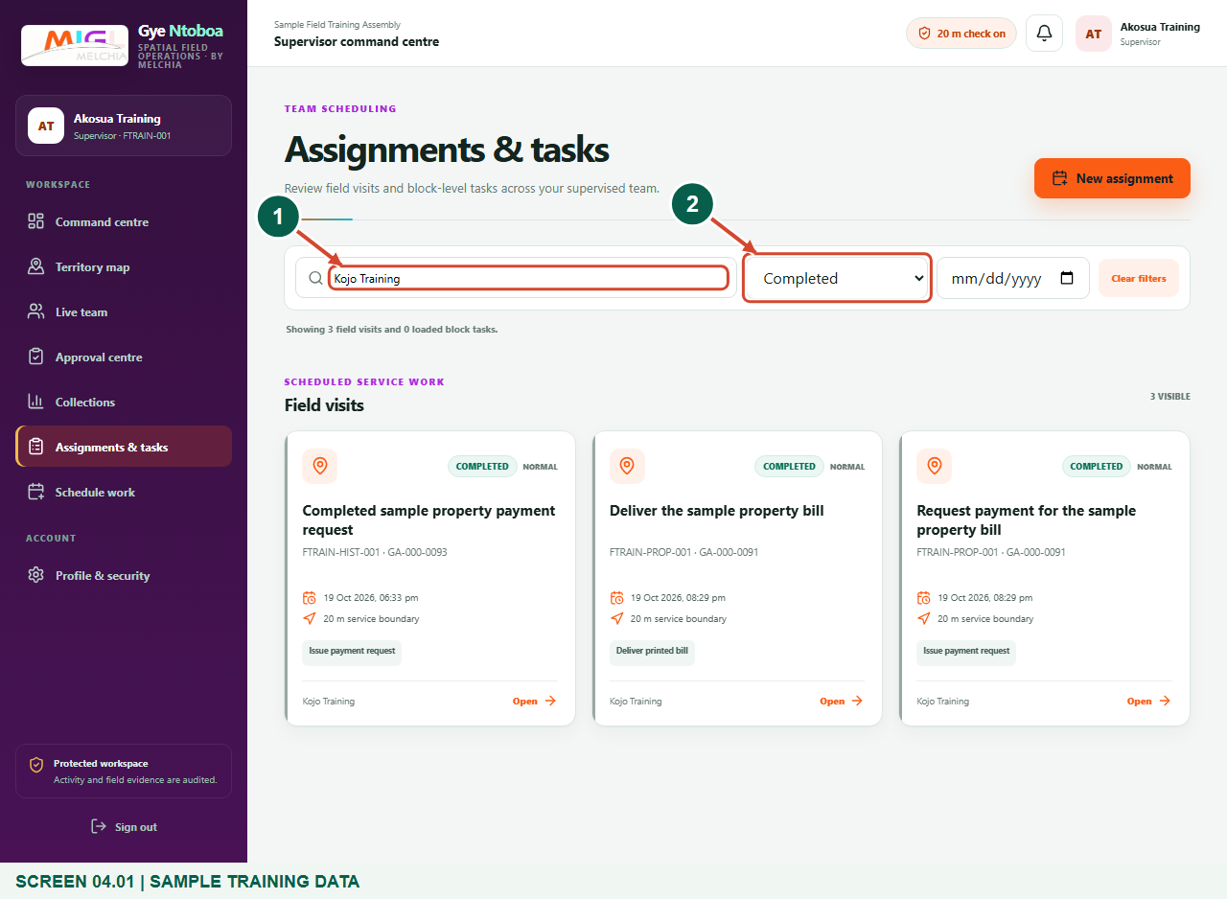
Illustrated steps with numbered arrows and clear expected results.
About the examples
Screens show the actual application in a training environment with sample data. Use your own verified account, assigned records and contact details when following the guide.

Website: operations.gyentoboa.com

Process flow
Follow the arrows from start to finish. Optional routes are explained in the numbered steps.

Before you start
- Sign in as a supervisor and confirm the correct assembly and supervised agent.
- Choose the reporting period and comparison purpose before interpreting the figures.
- Remember that sample figures in this guide are synthetic; use the current live report for operational decisions.
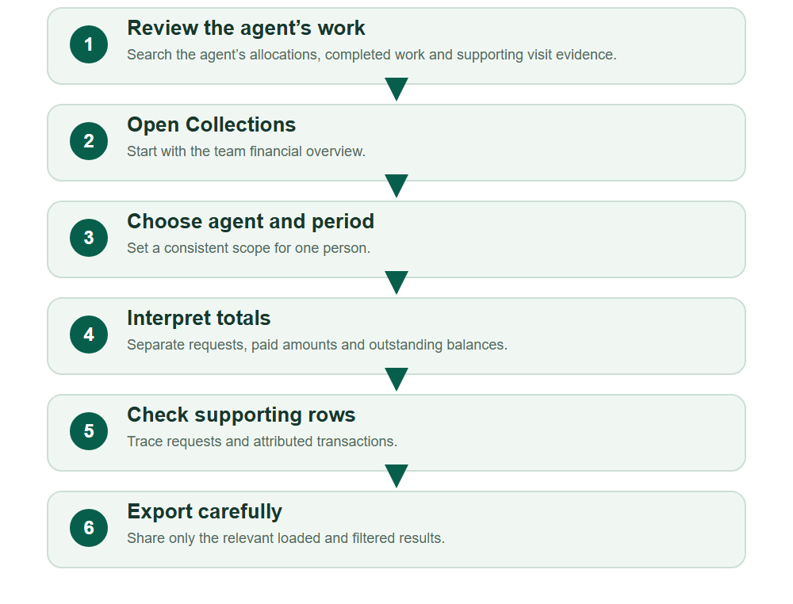
Numbered markers on screenshots identify the controls described beneath each image.

STEP 01

Review the agent’s allocated and completed work
1. Open Assignments & tasks, search for the agent’s name, and start with All statuses to review their allocated work.
2. Choose Completed to inspect completed work. Set Filter by date only for the work date you need, or clear it for all dates. Read the separate loaded block-task and field-visit results; load more block tasks when offered.
3. Open a relevant field visit when you need to inspect its assigned agent, verified arrival, service actions and completion evidence. A status alone is not a complete assessment of work quality.
4. The Command centre Completed figure is a team aggregate, not an individual agent’s completed-work total.
Synthetic training data. Review the selected agent’s completed field visits using the search and work-status filters.
1 Find the individual agent
2 Select the work status
What should happen
The loaded results identify the intended agent’s work in the chosen status/date scope, with relevant visit evidence available for review.

STEP 02

Open Collections for team results
1. Choose Collections in the supervisor navigation.
2. The page reports payment requests issued by your field team and payments attributed to those requests. Read the reporting period before comparing figures.
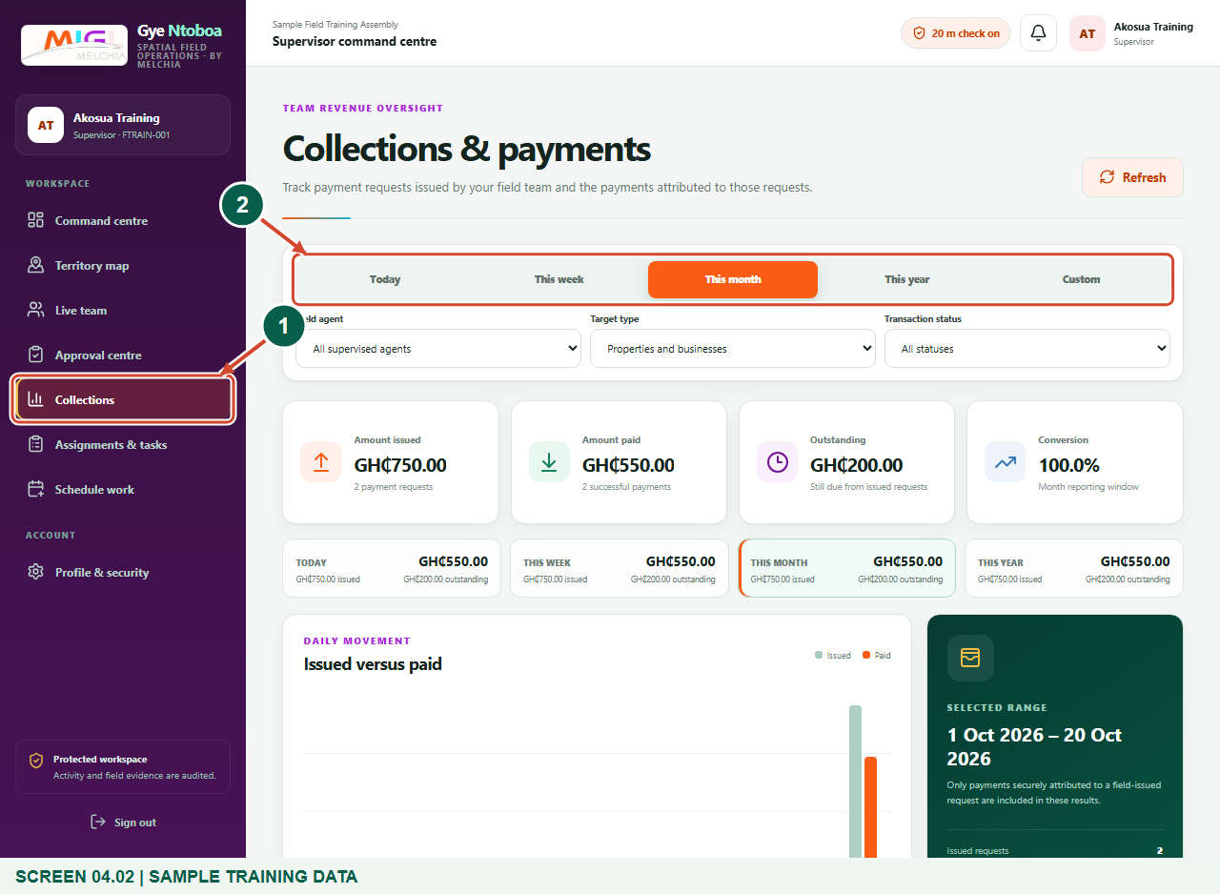
Synthetic training data. Open Collections for team results.
1 Collections
2 Reporting period
What should happen
Collections & payments opens with reporting controls and selected-period totals.

STEP 03

Select one agent and a reporting period
1. Choose the required agent in Field agent rather than leaving All supervised agents.
2. Choose Today, This week, This month or This year. Use Custom only when you need explicit From and To dates.
3. Use the same period and filters when comparing two agents.
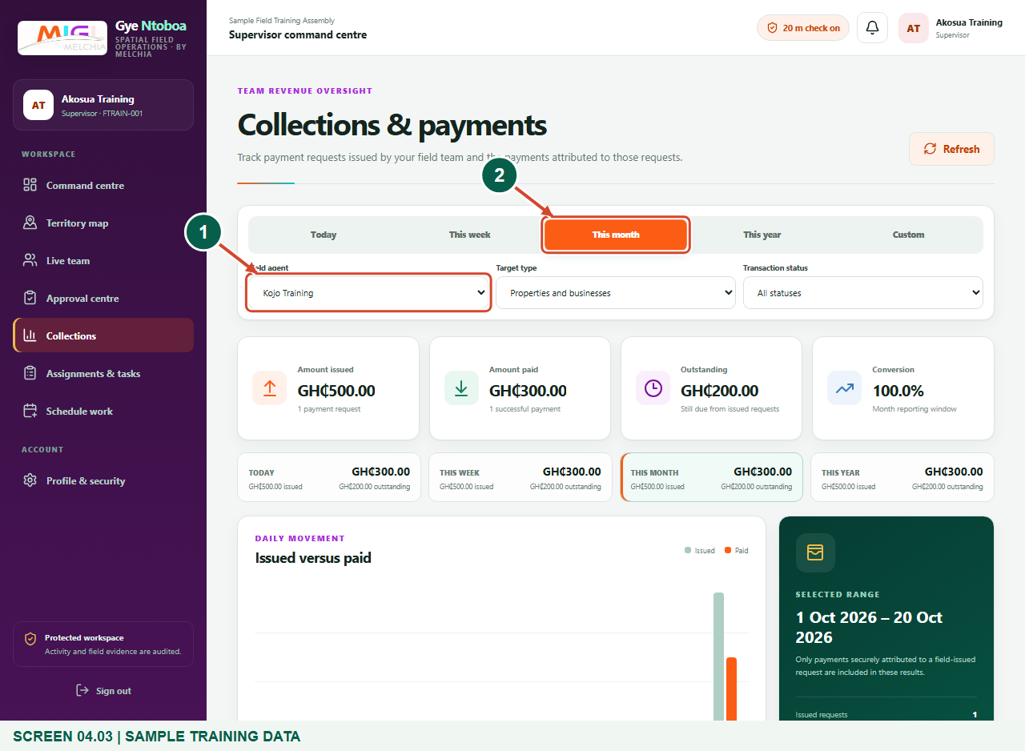
Synthetic training data. Select one agent and a reporting period.
1 Individual agent
2 Selected period
What should happen
The report is requested for the selected agent and period.

STEP 04

Interpret issued, paid and outstanding amounts
1. Read Amount issued as the value of field payment requests in the chosen scope.
2. Read Amount paid as successful payments attributed to those requests. A request or pending prompt alone is not a confirmed payment.
3. Outstanding is the remaining issued amount. Conversion compares the number of successful payments with the number of issued requests; it is not the percentage of money collected. Check dates and filters before acting on a difference.
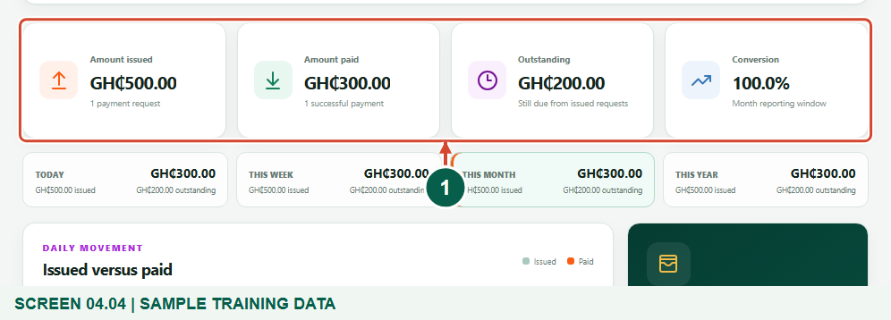
Synthetic training data. Interpret issued, paid and outstanding amounts.
1 Selected-period totals
What should happen
You can distinguish requests, successful payment outcomes and outstanding amounts for the selected agent.

STEP 05

Review the agent-level breakdown
1. Scroll to Collections by agent and read the selected agent’s issued, paid and outstanding amounts.
2. Use the trend chart and period totals as context. A financial collection figure is not a complete assessment of all field work or task quality.
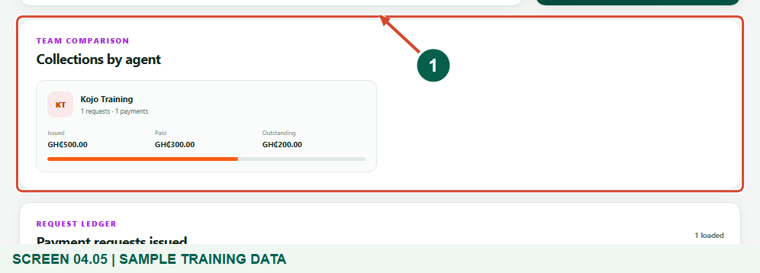
Synthetic training data. Review the agent-level breakdown.
1 Agent collection breakdown
What should happen
The agent breakdown explains the selected financial totals.

STEP 06

Check the supporting request and payment ledgers
1. Read Payment requests issued to trace a request back to its bill and assignment.
2. Review Attributed transactions below it for the resulting payment status and dates. Use Target type or Transaction status to narrow the report when necessary.
3. Table search, sorting and filters apply to the loaded table rows; they do not broaden your assembly access.
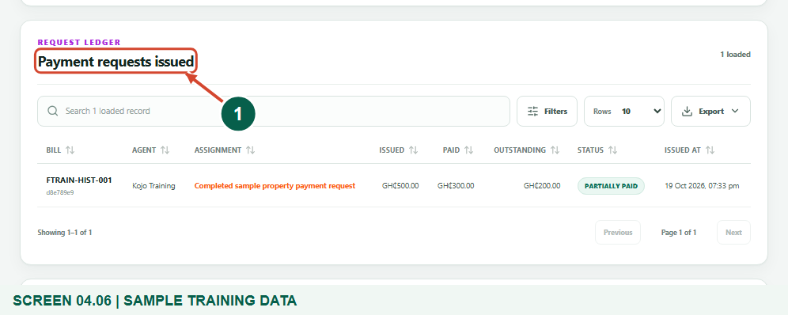
Synthetic training data. Check the supporting request and payment ledgers.
1 Request ledger
What should happen
The supporting rows provide the references needed to explain a selected agent’s collection result.

STEP 07

Export the relevant loaded results
1. Choose Export on the relevant ledger after setting the required filters.
2. Use CSV spreadsheet for a spreadsheet, JSON data for structured data, or Print / PDF for the current results.
3. Check the file’s scope before sharing it. The export reflects the loaded, filtered table results, not an automatic complete account statement.
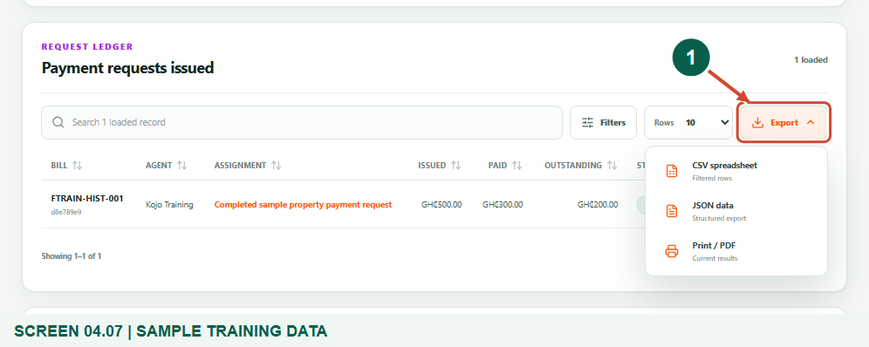
Synthetic training data. Export the relevant loaded results.
1 Export formats
What should happen
The export menu identifies the available formats and the results it will include.

Check your result
- The intended agent’s allocated/completed work and relevant visit evidence have been reviewed without using team aggregate counts as individual totals.
- The Field agent selector identifies the intended person.
- You understand the chosen period, issued amount, successful paid amount and outstanding balance.
- Supporting bill/payment references and export scope are clear.

If you need help
The report is empty.
Check the selected agent, reporting period, target type and transaction-status filters. A lack of attributed payment activity does not prove that the agent did no field work.
A payment is not included.
Confirm that it is successful and securely attributed to a field-issued request in this assembly and reporting period. Pending or unrelated payments are not counted as successful attributed collections.
The export has fewer records than expected.
Review table search/filter settings and loaded pages. Exports use current loaded table results; use the approved wider reporting process if a complete dataset is required.

Useful things to know
- Collections measures attributed collection outcomes. Combine it with work and evidence review; there is no standalone individual productivity score or dashboard here.
- A payment request, QR code or pending transaction does not prove settlement.
- Keep staff and rate-payer financial reports within authorised assembly channels.

Continue learning
- Guide 02: See agents assigned to you
- Guide 03: Allocate jobs to your agents
Download all 5 guides in this collection
For account or bill-record corrections, contact the relevant assembly using its verified contact details. Keep your account or bill reference available when requesting assistance.

