
GYE NTOBOA
MANUAL 2 - SUPERVISOR TRAINING
PROCESS GUIDE 03 / 05

Allocate jobs to your agents
Create a governed field visit for a supervised agent using the correct target, visit window and service permissions, then verify the resulting assignment.
WHO THIS IS FOR  Assembly supervisors scheduling field visits | ALLOW ABOUT  10–15 minutes | DOCUMENT VERSION  1.0 | 19 October 2026

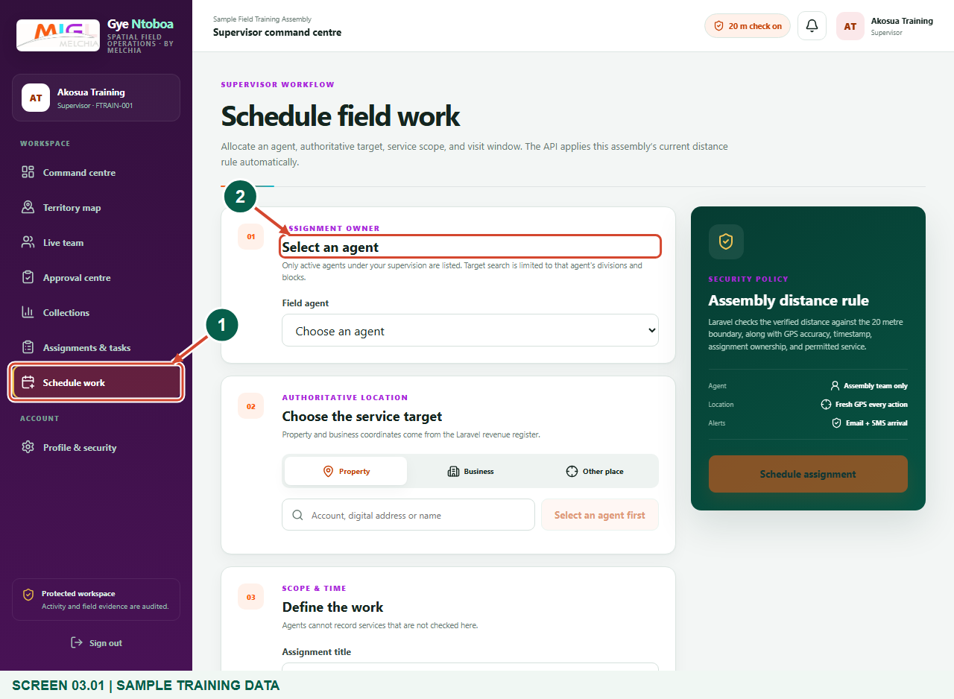
Illustrated steps with numbered arrows and clear expected results.
About the examples
Screens show the actual application in a training environment with sample data. Use your own verified account, assigned records and contact details when following the guide.

Website: operations.gyentoboa.com

Process flow
Follow the arrows from start to finish. Optional routes are explained in the numbered steps.

Before you start
- The assembly administrator must assign your supervisor divisions, and the agent must be active, allocated to your team and assigned appropriate divisions/blocks.
- The property or business must have accurate authoritative coordinates inside the selected agent’s coverage.
- Know the purpose, authorised services, target reference and intended visit window before scheduling.
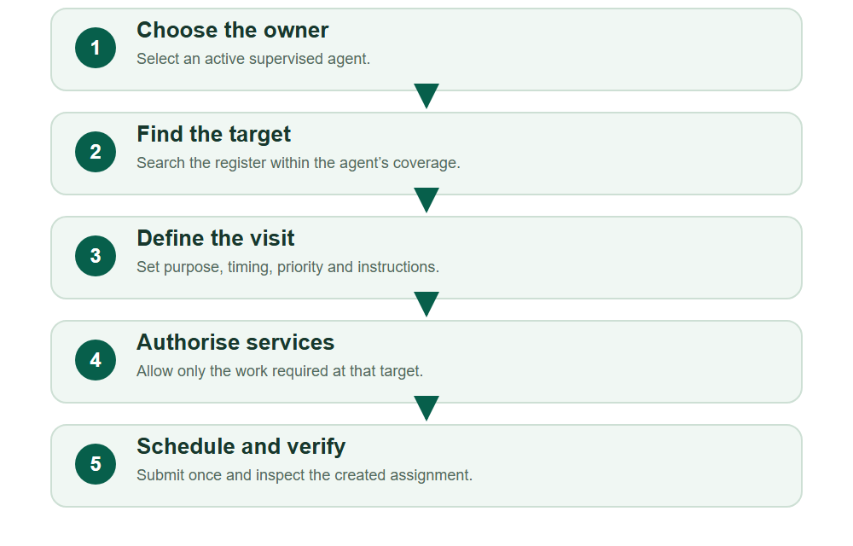
Numbered markers on screenshots identify the controls described beneath each image.

STEP 01

Open Schedule work
1. Choose Schedule work from the supervisor navigation, or New assignment from Assignments & tasks.
2. Confirm that the visit is needed and that its intended agent and target fall within approved coverage.
Synthetic training data. Open Schedule work.
1 Schedule work
2 Assignment owner
What should happen
The Schedule field work form opens.

STEP 02

Choose the responsible field agent
1. Select the active agent who will own this visit in Field agent.
2. Only your current supervised team is available. Changing the agent clears a previously selected target, so choose the owner first.
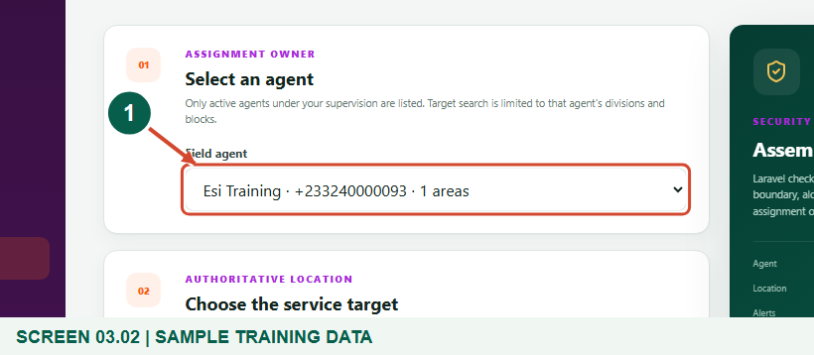
Synthetic training data. Choose the responsible field agent.
1 Responsible field agent
What should happen
The selected agent becomes the owner of the new field visit.

STEP 03

Search the assigned property or business register
1. Choose Property or Business as appropriate, enter an account, digital address or name, and choose Search assigned register.
2. Select the intended result only after checking its reference and location. Results are limited to the chosen agent’s authorised areas.
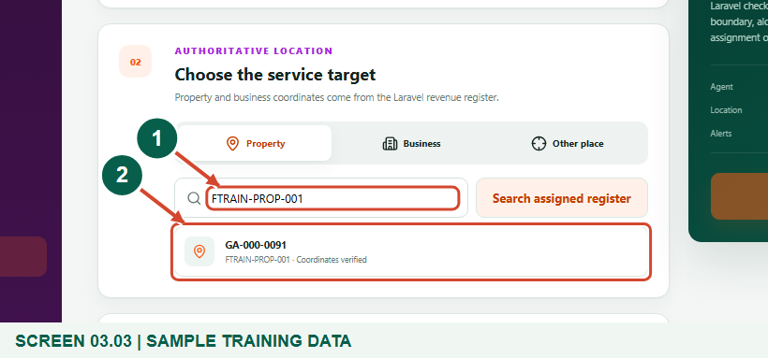
Synthetic training data. Search the assigned property or business register.
1 Target search
2 Verified register result
What should happen
Matching assigned register records appear with their coordinate status.

STEP 04

Confirm the authoritative service target
1. Choose the correct result and confirm that Coordinates verified is shown.
2. For property and business visits, the saved register supplies the authoritative location. If coordinates are missing or wrong, arrange an authorised register correction before scheduling.
3. Other place is a separate option requiring valid latitude/longitude and a compatible service; it does not replace a property or business record.
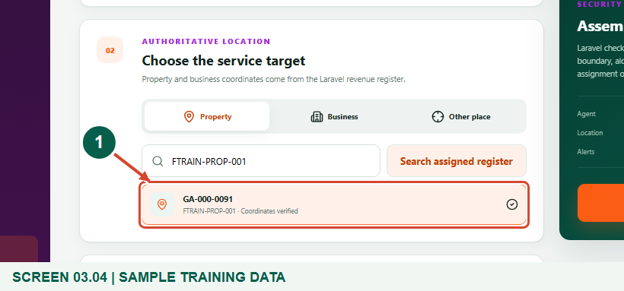
Synthetic training data. Confirm the authoritative service target.
1 Selected target
What should happen
The chosen register record is visibly selected for this visit.

STEP 05

Set the title, visit window and instructions
1. Use a clear assignment title and set Starts and Ends in the intended local time. The end must be later than the start.
2. Choose the appropriate priority and enter practical instructions for the agent. Include only necessary handling/contact details.
3. Confirm that the agent can reasonably reach the target during the visit window.
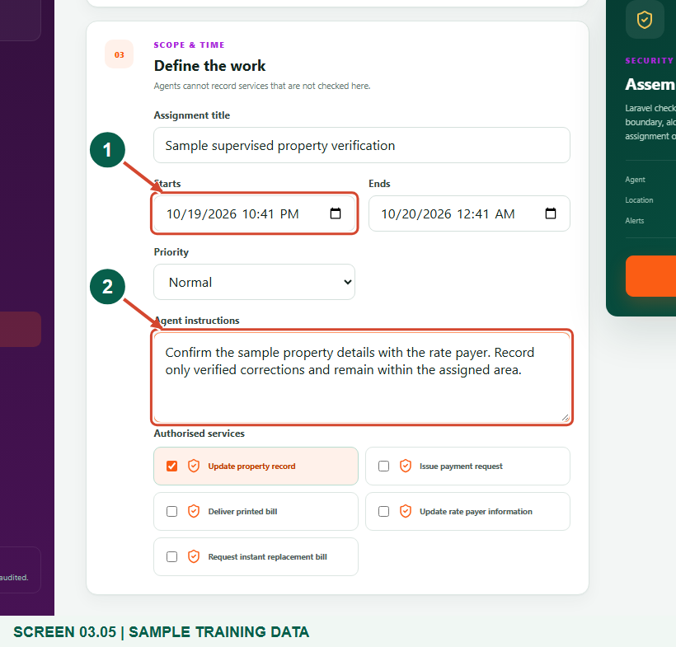
Synthetic training data. Set the title, visit window and instructions.
1 Visit window
2 Agent instructions
What should happen
The visit has a clear purpose, valid time window, priority and instructions.

STEP 06

Authorise the required services and schedule
1. Check only the Authorised services required for this visit. Agents cannot record a service that is not authorised here.
2. Review the selected agent, target, timing and instructions once more, then choose Schedule assignment.
3. The assembly controls the current distance rule. Agents still need fresh, accurate GPS and verified arrival for protected actions.
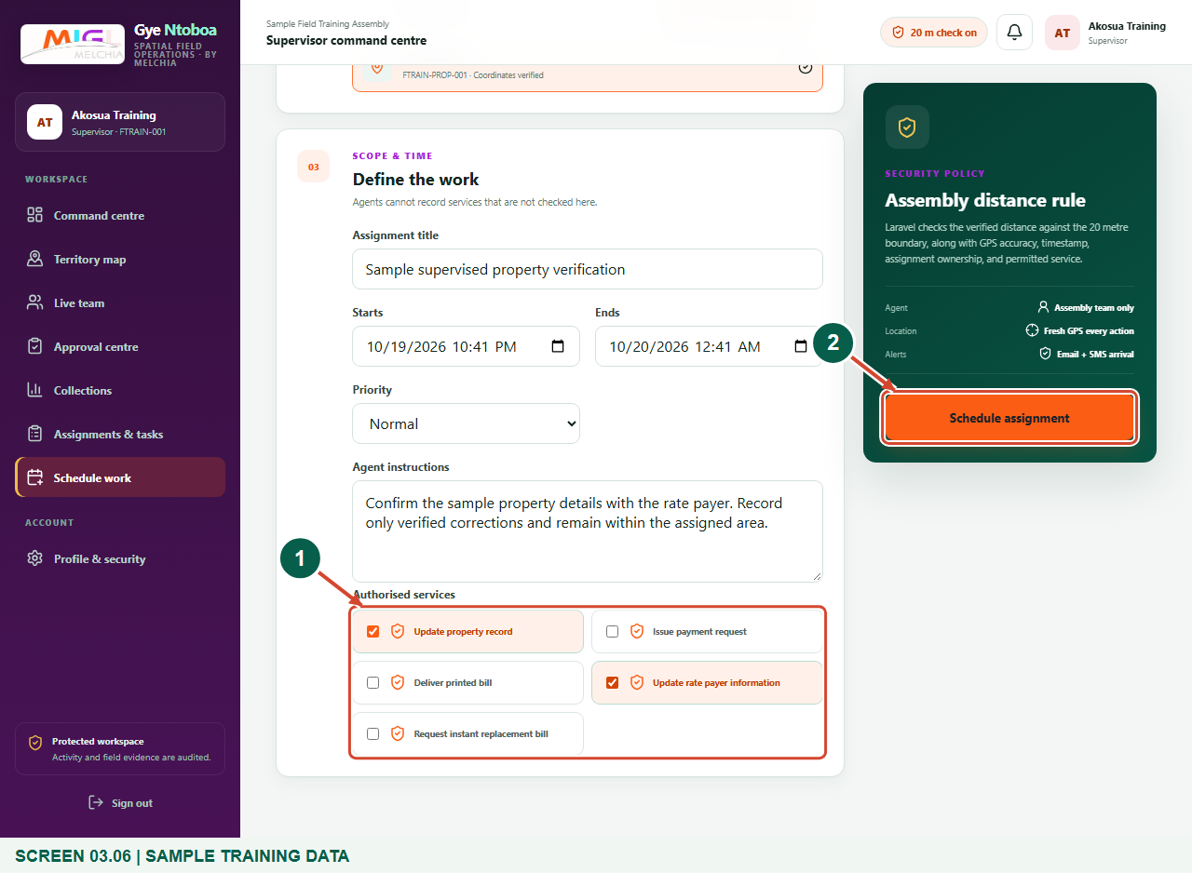
Synthetic training data. Authorise the required services and schedule.
1 Authorised services
2 Schedule assignment
What should happen
A valid submission creates a scheduled field visit with its permitted service scope.

STEP 07

Verify the created assignment
1. Read the new assignment’s title, assigned agent, target, schedule and service permissions.
2. Confirm that its status is Scheduled. The visit is now available to its assigned agent; creating the job is not proof of arrival or completion.
3. Use Assignments & tasks to find and monitor it later.
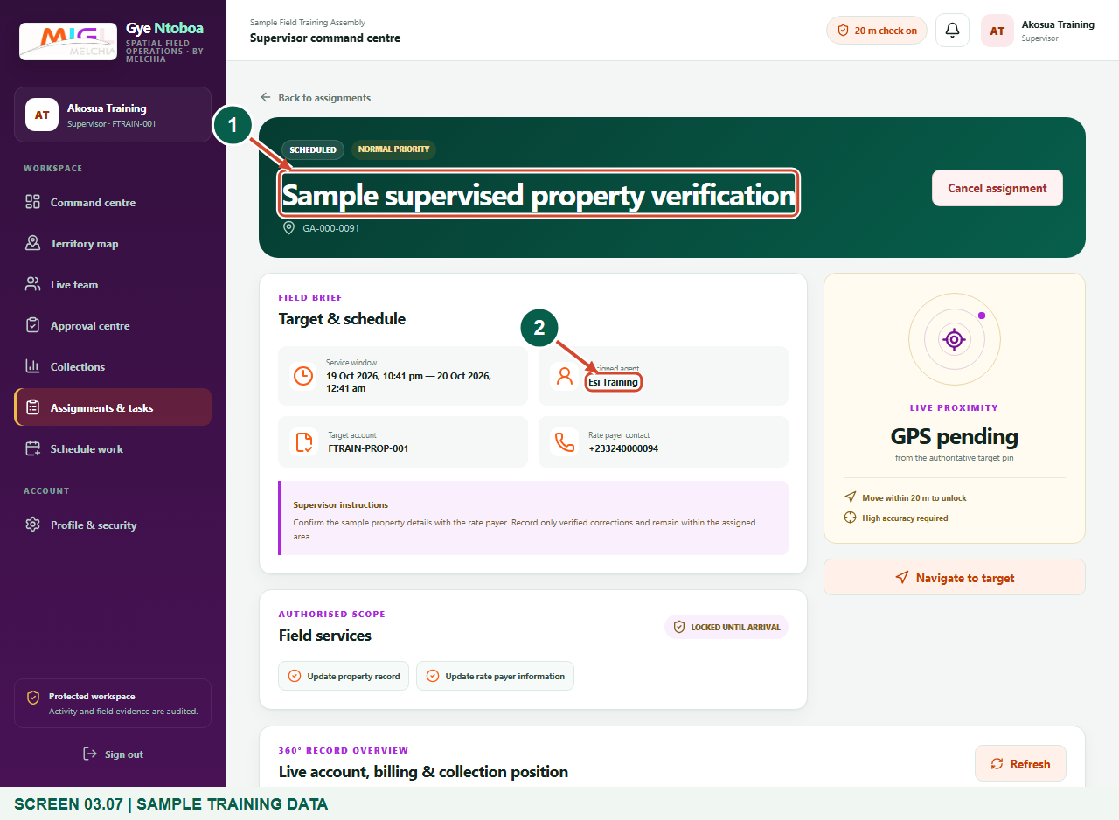
Synthetic training data. Verify the created assignment.
1 Created assignment
2 Assigned agent
What should happen
The created scheduled visit matches the work you intended to allocate.

Check your result
- The created visit belongs to the intended supervised agent and correct target.
- The start/end window and permitted services match the approved work plan.
- The assignment is visible as Scheduled and can be found in Assignments & tasks.

If you need help
The required agent is not listed.
Check that the account is active and currently allocated to your supervised team in the same assembly.
No target matches, or coordinates are required.
Check the target type, spelling and selected agent’s coverage. Arrange authorised register/geographic corrections instead of entering an unrelated target.
The end time or service selection is rejected.
Use a valid end later than the start and select at least one service compatible with the target type.
You are unsure whether submission succeeded.
Check Assignments & tasks for the title and agent before creating another copy. Read the returned error and correct it rather than repeatedly clicking Schedule assignment.

Useful things to know
- Schedule work creates field visits. Existing block-level tasks are displayed separately and are not created by this form.
- A scheduled visit does not prove arrival, completion or payment. Those outcomes require their own verified steps.
- The current assembly distance setting is applied automatically; the supervisor does not set an arbitrary arrival radius here.

Continue learning
- Guide 02: See agents assigned to you
- Guide 05: Find your assigned boundary and territory
Download all 5 guides in this collection
For account or bill-record corrections, contact the relevant assembly using its verified contact details. Keep your account or bill reference available when requesting assistance.

