
GYE NTOBOA
MANUAL 2 - SUPERVISOR TRAINING
PROCESS GUIDE 02 / 05

See agents assigned to you
Find the agents allocated to your supervised team, understand their coverage and presence indicators, and locate their current work without confusing offline status with allocation.
WHO THIS IS FOR  Assembly supervisors | ALLOW ABOUT  5–10 minutes | DOCUMENT VERSION  1.0 | 19 October 2026

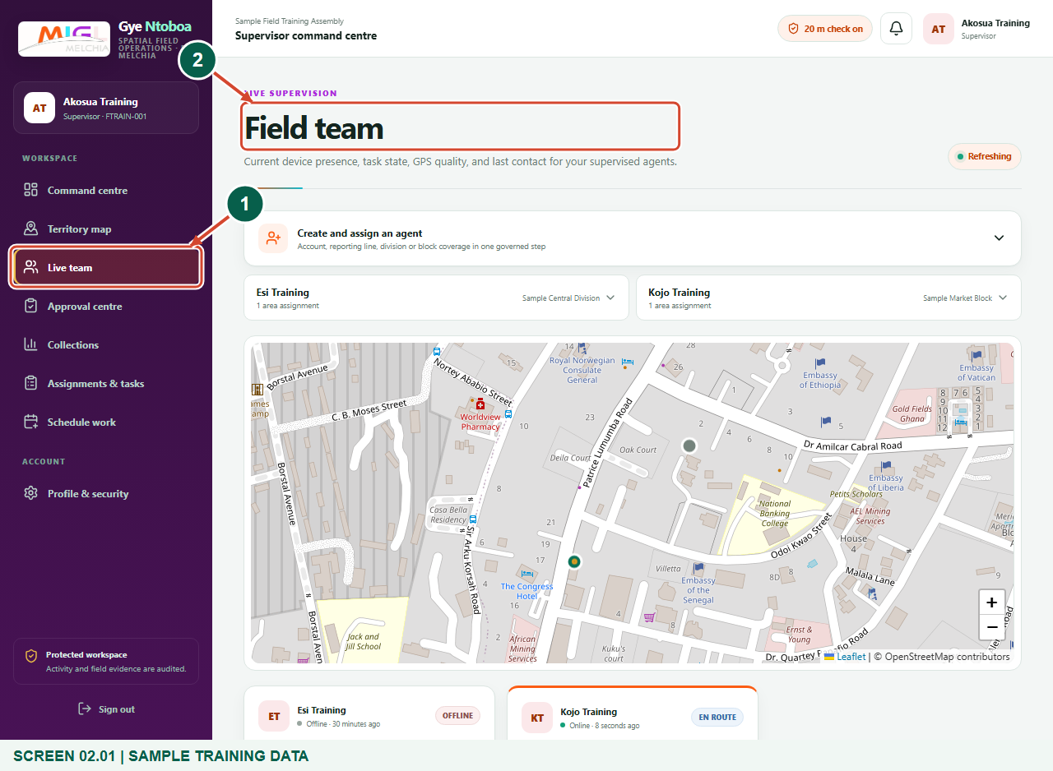
Illustrated steps with numbered arrows and clear expected results.
About the examples
Screens show the actual application in a training environment with sample data. Use your own verified account, assigned records and contact details when following the guide.

Website: operations.gyentoboa.com

Process flow
Follow the arrows from start to finish. Optional routes are explained in the numbered steps.

Before you start
- Use an active supervisor account assigned to the correct assembly.
- The assembly must allocate the reporting line and operating divisions. The figures show synthetic agents, not live staff.
- Allow the page to load its current team information before interpreting presence or assignments.
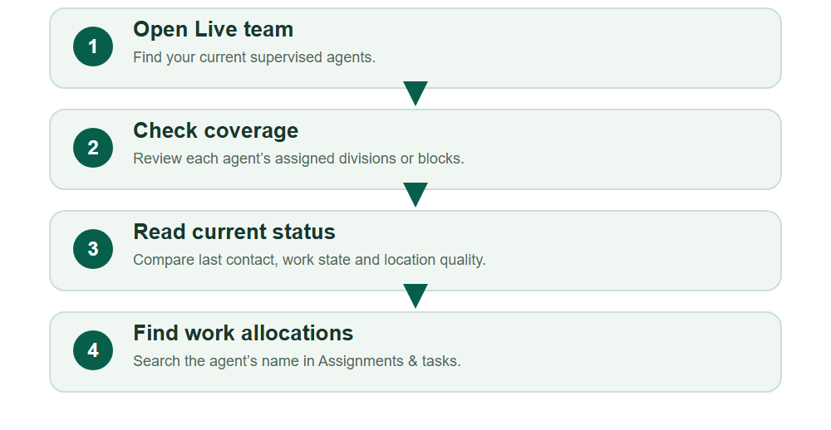
Numbered markers on screenshots identify the controls described beneath each image.

STEP 01

Open Live team
1. Sign in to the supervisor workspace and choose Live team in the navigation.
2. Use the Field team page to review the active agents currently allocated to your supervised team.
Synthetic training data. Open Live team.
1 Live team
2 Field team
What should happen
The page shows your team coverage entries and live supervision panels.

STEP 02

Check an agent’s assigned coverage
1. Expand the required agent’s coverage entry. Read the current division or block assignment.
2. An entire division covers its current and future blocks; a selected block is narrower. Compare the assignment with your approved work plan before scheduling a visit.
3. This review does not require changing coverage or choosing Save agent coverage.
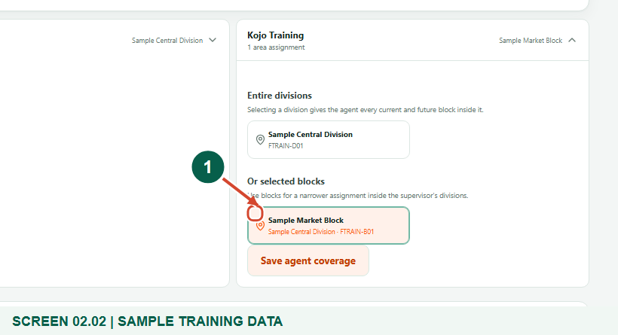
Synthetic training data. Check an agent’s assigned coverage.
1 Selected block
What should happen
The agent’s existing checked areas identify where work can be allocated.

STEP 03

Read the team’s last reported positions
1. Scroll to the team map. Use its zoom controls to inspect the reported team area.
2. Treat positions and last-contact times as reported device information, not a guarantee that an offline agent is still at that point.
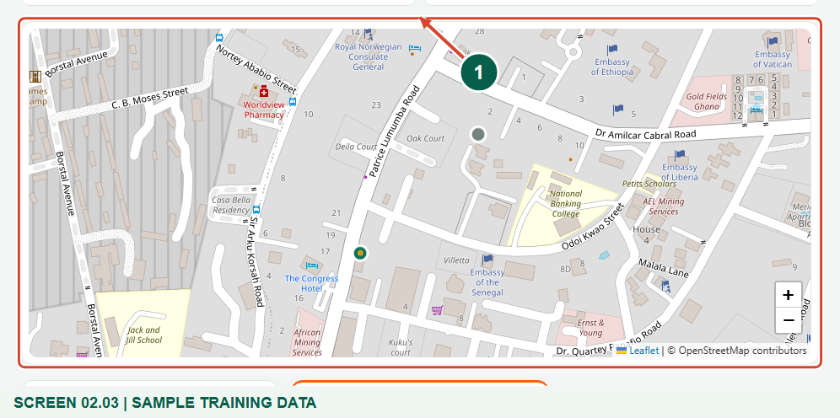
Synthetic training data. Read the team’s last reported positions.
1 Team map
What should happen
The map plots available reported locations for agents in your team.

STEP 04

Read presence and the current work state
1. Find the agent’s card and check Online or Offline, the last-contact time and the work-status badge.
2. Review Current assignment, GPS accuracy and battery information when available. Available for work means no current assignment is shown; Offline does not remove the agent from your team.
3. Use Call agent only when you intend to place a call on your device.
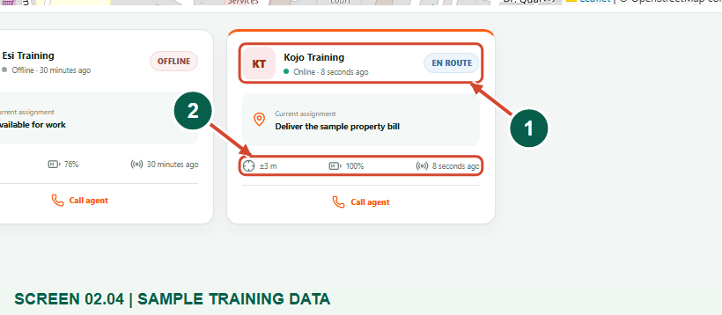
Synthetic training data. Read presence and the current work state.
1 Presence and work state
2 GPS and last contact
What should happen
The card provides a scoped contact and operational snapshot for the selected agent.

STEP 05

Find that agent’s work allocations
1. Open Assignments & tasks and search for the agent’s name.
2. Use the status and date filters when you need a narrower view. Block tasks and scheduled field visits are shown in separate sections.
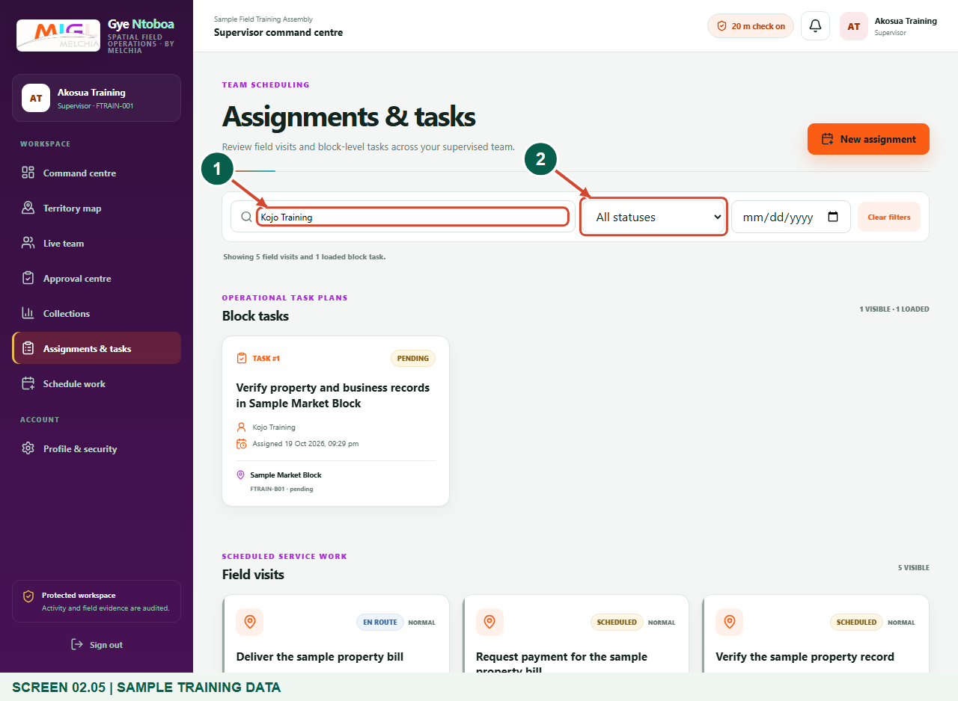
Synthetic training data. Find that agent’s work allocations.
1 Search by agent
2 Work status filter
What should happen
The loaded results are narrowed to work matching the chosen agent and filters.

Check your result
- You can identify the agent’s reporting relationship and authorised coverage.
- You distinguish Online/Offline presence from assignment status.
- You can locate the agent’s loaded tasks and field visits.

If you need help
An expected agent is missing.
Check the assembly and reporting allocation with the administrator. Only active, currently supervised agents are listed.
The agent is offline or has no GPS.
Check last contact before relying on the map. Ask the agent to open the portal, enable location and reconnect when safe.
No operating areas are listed.
Ask the assembly administrator to assign the supervisor’s divisions before attempting to allocate field work.

Useful things to know
- Presence is device-reported and can become stale; it is not a guarantee of physical location.
- Coverage changes require the appropriate authority. This guide reviews existing assignments and does not instruct you to broaden access.

Continue learning
- Guide 03: Allocate jobs to your agents
- Guide 04: View individual agent performance
- Guide 05: Find your assigned boundary and territory
Download all 5 guides in this collection
For account or bill-record corrections, contact the relevant assembly using its verified contact details. Keep your account or bill reference available when requesting assistance.

