
GYE NTOBOA
MANUAL 2 - SUPERVISOR TRAINING
PROCESS GUIDE 01 / 05

Access your supervisor account on the web
Sign in with an authorised supervisor account, complete the configured verification step, confirm the correct assembly workspace and sign out safely.
WHO THIS IS FOR  Assembly supervisors | ALLOW ABOUT  5–10 minutes | DOCUMENT VERSION  1.0 | 19 October 2026

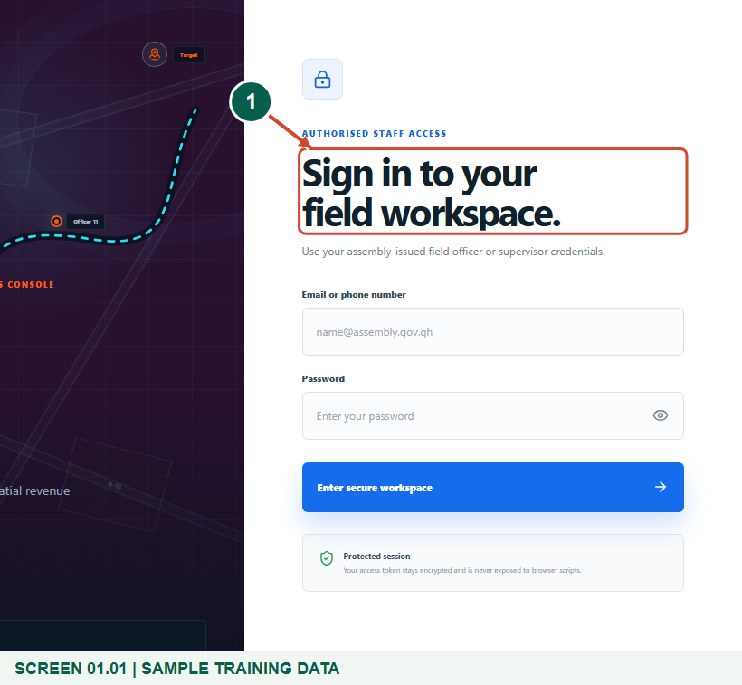
Illustrated steps with numbered arrows and clear expected results.
About the examples
Screens show the actual application in a training environment with sample data. Use your own verified account, assigned records and contact details when following the guide.

Website: operations.gyentoboa.com

Process flow
Follow the arrows from start to finish. Optional routes are explained in the numbered steps.

Before you start
- Obtain an active supervisor account from the assembly administrator; this is a staff portal and has no public self-registration.
- Have access to the registered phone when staff SMS verification is enabled.
- Use a modern browser with an internet connection and keep passwords and security codes private.
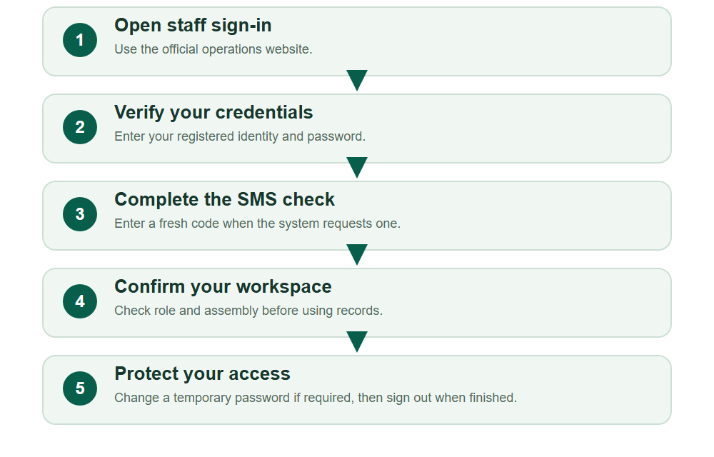
Numbered markers on screenshots identify the controls described beneath each image.

STEP 01

Open the official staff sign-in page
1. Open https://operations.gyentoboa.com/ in a modern browser and choose the staff sign-in link, or open its /login page directly.
2. Check the address before typing credentials. Your assembly must first create an active supervisor account and assign it to the correct assembly.
Synthetic training data. Open the official staff sign-in page.
1 Staff sign-in
What should happen
The field workspace sign-in form displays Email or phone number and Password.

STEP 02

Enter your assembly-issued credentials
1. Enter your registered email or phone number and your own password.
2. Choose Enter secure workspace. Keep the password masked when working near other people; never use the sample training identity.
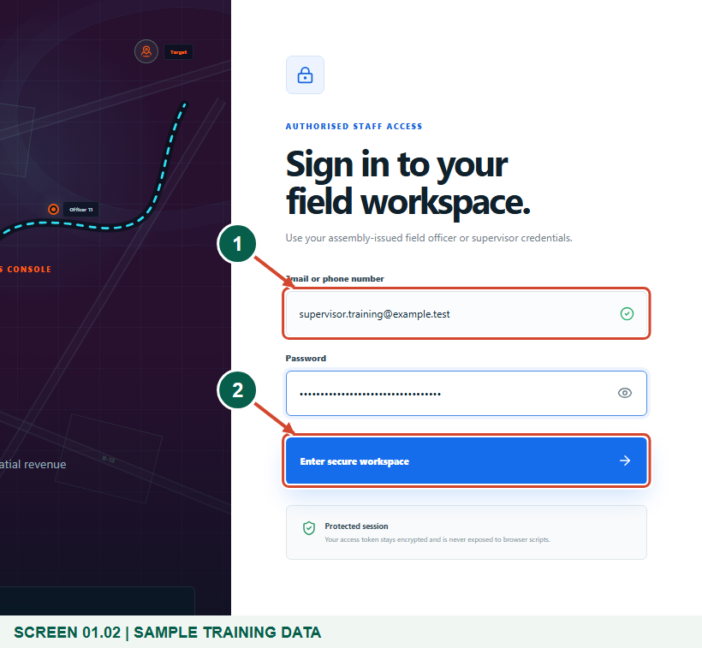
Synthetic training data. Enter your assembly-issued credentials.
1 Registered email or phone
2 Enter secure workspace
What should happen
The system checks that the account is active, has the supervisor role and belongs to an assembly.

STEP 03

Complete the verification step when requested
1. When staff verification is enabled, read the masked registered phone and enter the current six-digit SMS code sent to you.
2. Choose Verify and sign in. Use Resend code after the countdown if needed; the latest code replaces the earlier code.
3. If the registered phone is wrong, use Use different credentials or contact the assembly administrator. Never share the code with another person.
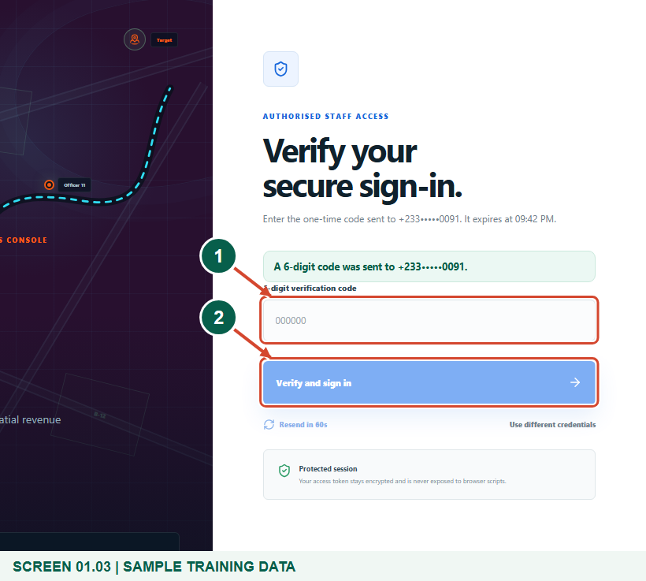
Synthetic training data. Complete the verification step when requested.
1 Your six-digit SMS code
2 Verify and sign in
What should happen
A valid, unexpired code completes the secure sign-in. Some authorised configurations may sign in directly after password verification.

Helpful note: Enter only the current code sent to your registered phone; the figure leaves it blank.

STEP 04

Confirm your supervisor workspace
1. Check that your name, assembly and supervisor role are correct before opening team records.
2. The Command centre summarises your team, current arrivals and work status. Live team, Territory map and Schedule work provide the supervisor controls used in the next guides.
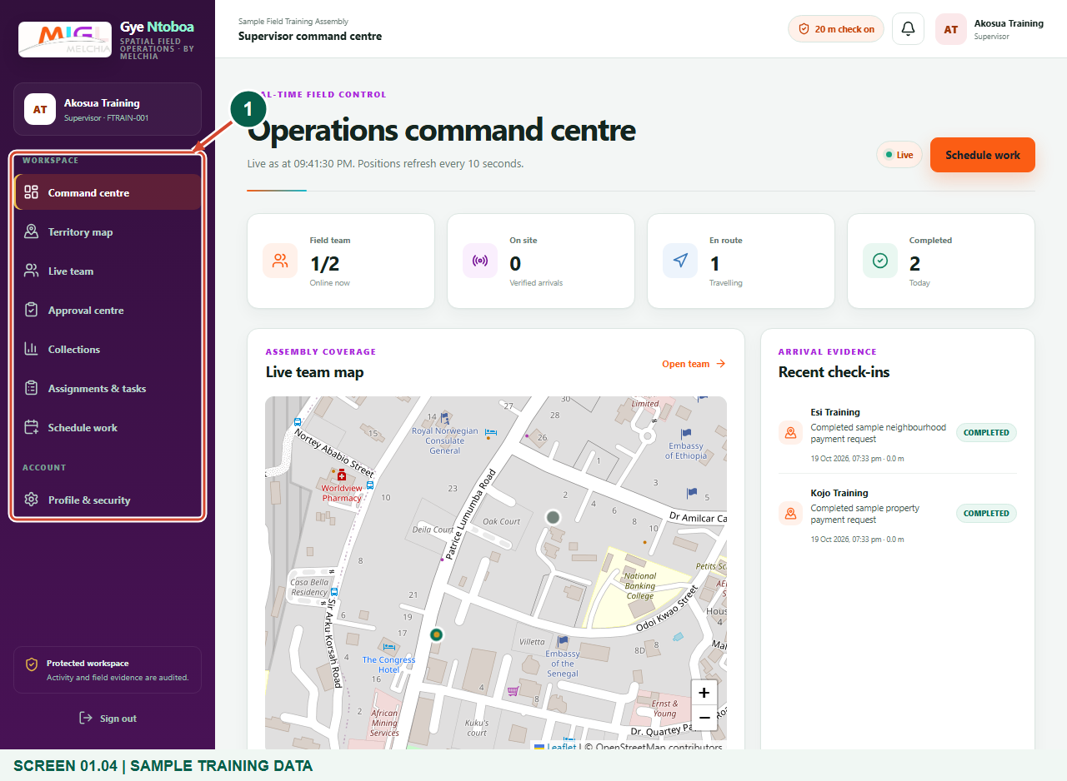
Synthetic training data. Confirm your supervisor workspace.
1 Supervisor navigation
What should happen
Your authorised supervisor navigation and the Operations command centre are visible.

STEP 05

Review your identity and password controls
1. Open Profile & security from the workspace account controls and check your assembly identity.
2. If the system requires a temporary-password change, enter the current password, a new unique password and its confirmation, then choose Update password before continuing.
3. Use at least 12 characters with upper and lower case letters, a number and a symbol. Never use a mobile-money PIN or share a staff password.
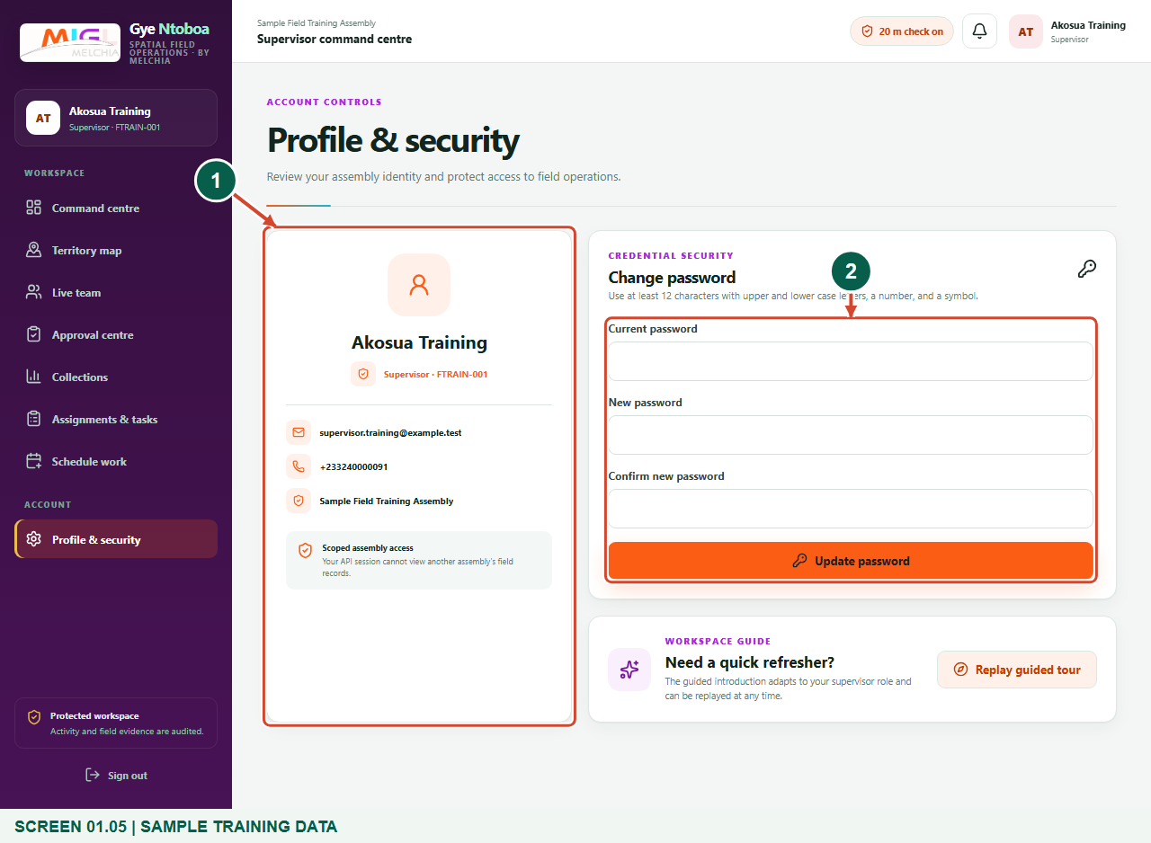
Synthetic training data. Review your identity and password controls.
1 Your scoped identity
2 Password controls
What should happen
The profile identifies the correct assembly; the password form supports a required or voluntary password change.

STEP 06

Sign out safely when you finish
1. Use Sign out when leaving a shared device or finishing your shift.
2. Wait until the sign-in page returns. Closing a tab alone is not the same as signing out.
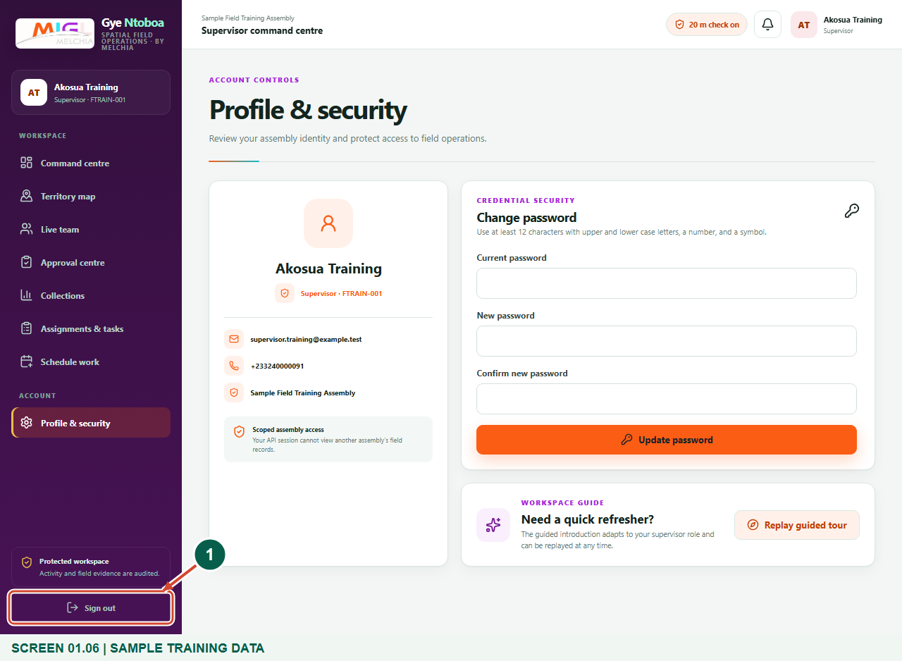
Synthetic training data. Sign out safely when you finish.
1 Sign out
What should happen
The secure session is ended and the sign-in form is displayed.

Check your result
- The profile shows your own supervisor identity and correct assembly.
- The supervisor navigation opens only your authorised workspace.
- Sign out returns you to the sign-in page.

If you need help
The credentials could not be verified.
Check the registered email/phone and password. An inactive or incorrectly assigned account must be corrected by the assembly administrator.
The SMS code is missing, invalid or expired.
Check the registered phone, wait for Resend code, then use the latest code. Never repeatedly guess codes; contact support if delivery remains unavailable.
The profile requests a password change.
Complete Current password, New password and Confirm new password, then Update password before using field records.

Useful things to know
- Staff SMS verification follows the current system policy; it is not a personal option on this page.
- Screens use synthetic training records; no usable password or code is shown.

Continue learning
- Guide 02: See agents assigned to you
- Guide 05: Find your assigned boundary and territory
Download all 5 guides in this collection
For account or bill-record corrections, contact the relevant assembly using its verified contact details. Keep your account or bill reference available when requesting assistance.

