
GYE NTOBOA
MANUAL 1 - RATE PAYER TRAINING
PROCESS GUIDE 08 / 08

Personalize your theme and skin colour
Choose a colour mode, adjust the desktop sidebar, show or hide dashboard cards, reorder visible cards and restore the default appearance without changing financial records.
WHO THIS IS FOR  Signed-in rate payers who want a more comfortable workspace | ALLOW ABOUT  8–12 minutes | DOCUMENT VERSION  1.0 | 19 October 2026

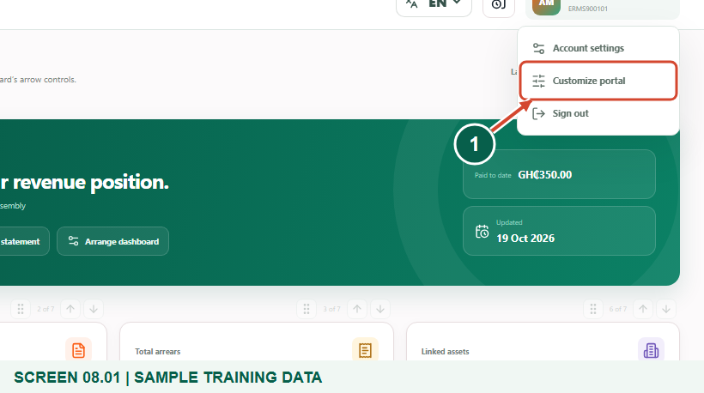
Illustrated steps with numbered arrows and clear expected results.
About the examples
Screens show the actual application in a training environment with sample data. Use your own verified account, bill and contact details when following the guide.

Website: gyentoboa.com

Process flow
Follow the arrows from start to finish. Optional routes are explained in the numbered steps.

Before you start
- Sign into your own account and use a desktop or tablet-sized screen for the clearest view of sidebar and card controls.
- Decide whether you want the portal to follow the device theme or use a fixed light or dark workspace.
- The available controls are colour modes and layout preferences. There is no separate catalogue of named skins; assembly branding colours are managed by the assembly.
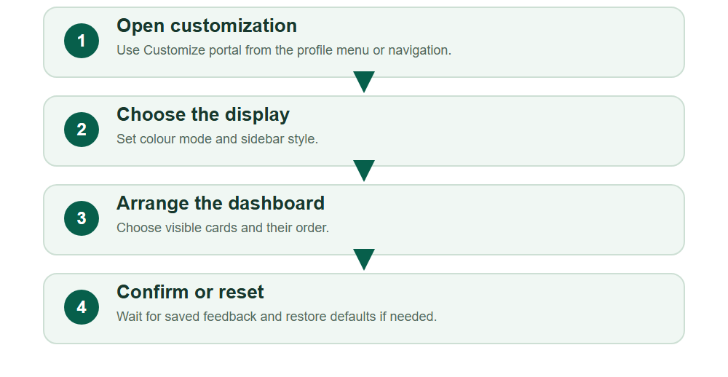
Numbered markers on screenshots identify the controls described beneath each image.

STEP 01

Open Customize portal
1. Open the profile menu in the top-right area and select Customize portal. The navigation also has a Customize portal entry.
2. Check that the page title is Portal customization. These settings apply to the signed-in account rather than to another person’s records.
Sample training data. Open Customize portal from your profile.
1 Customize portal
What should happen
The appearance and layout controls are available.

STEP 02

Choose System, Light or Dark
1. Under Colour mode, choose System to follow the device setting, Light for a bright workspace, or Dark for a lower-light workspace.
2. Select the option you find comfortable and wait for the saved confirmation. A selected appearance choice is visibly marked.
3. Changing a mode does not change bill amounts, payment status or which assets you are authorised to see.
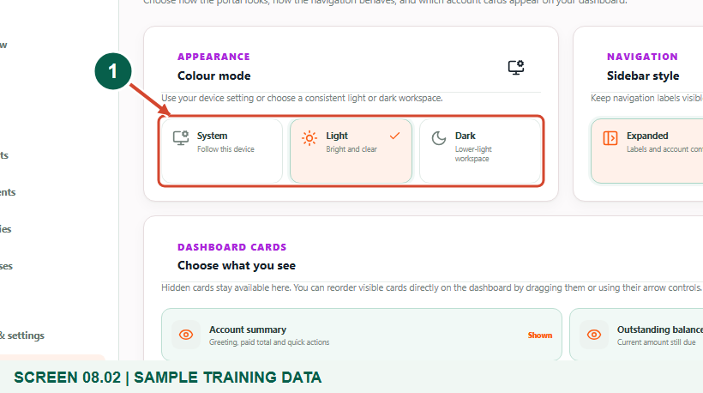
Sample training data. Choose System, Light or Dark colour mode.
1 Colour mode choices
What should happen
The chosen colour mode is selected and the workspace appearance changes.

STEP 03

Confirm the selection is saved
1. The training example chooses Dark and confirms that it remains selected after reloading the page. You may choose Light or System instead.
2. If a save fails, read the message and try again when the connection is stable. Do not assume a brief visual change means the server saved it.
3. System can look different on different devices because it follows each device’s colour setting.
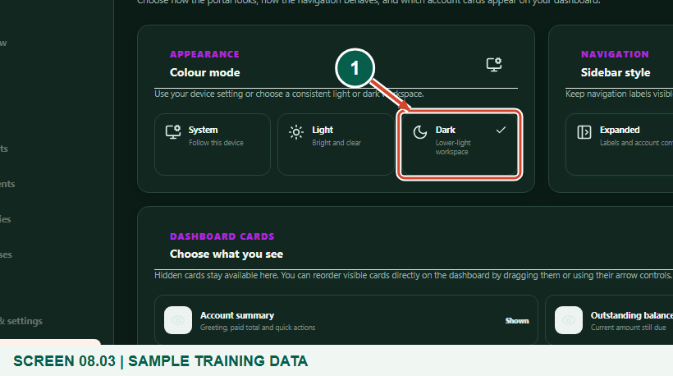
Sample training data. Confirm Dark mode is selected and saved.
1 Dark selected
What should happen
Your colour preference survives an ordinary page reload.

STEP 04

Adjust the sidebar style
1. Under Sidebar style, choose Expanded to keep navigation labels and account context visible. Choose Compact for an icon rail with more room for account content on a larger screen.
2. Wait for the selection confirmation and use the navigation to make sure the new layout is comfortable. Icons can expose labels through their normal tooltips.
3. On smaller screens, the responsive navigation menu is still used; Compact is mainly useful for the desktop workspace.
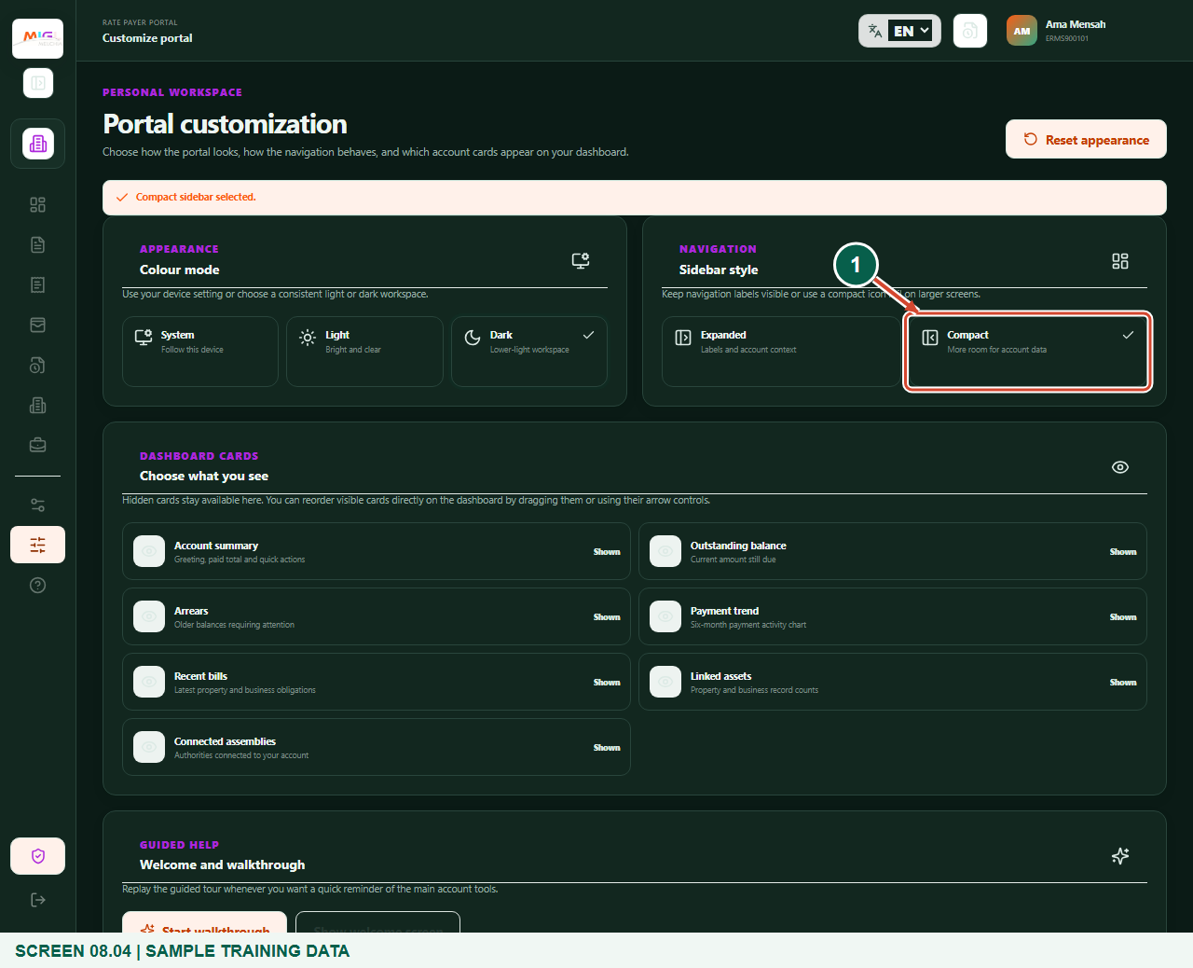
Sample training data. Use a compact sidebar on a larger screen.
1 Compact sidebar
What should happen
The selected sidebar style is saved.

STEP 05

Choose which dashboard cards appear
1. Find Choose what you see under Dashboard cards. Each card shows whether it is Shown or Hidden.
2. Select a card to change its visibility, then wait for Dashboard visibility updated. Hidden cards remain available in this customization page.
3. Hiding a card only changes the dashboard display. It does not hide a bill from the assembly, remove a debt or delete payment history.
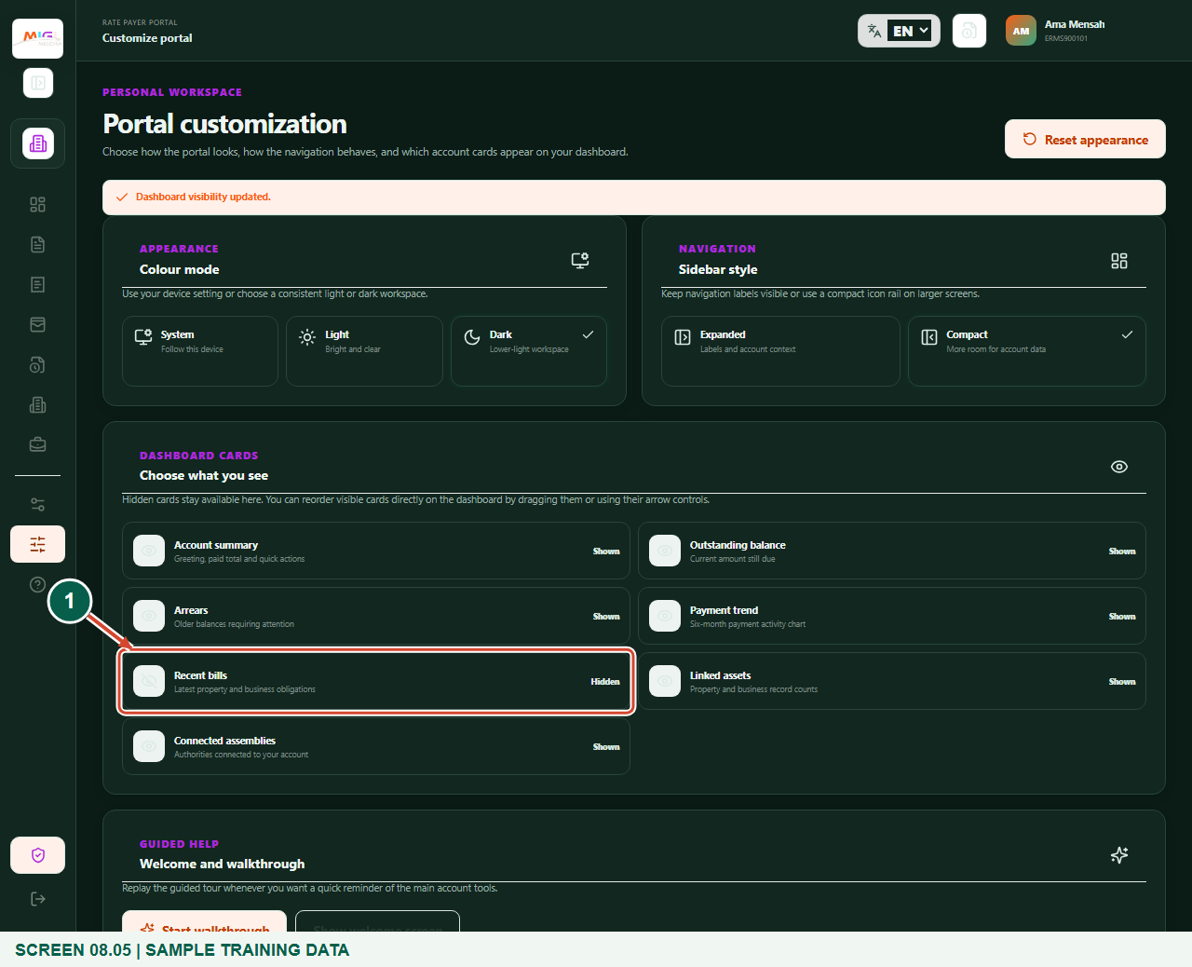
Sample training data. Show or hide a dashboard card.
1 Recent bills visibility
What should happen
The selected card is shown or hidden according to your preference.

STEP 06

Reorder visible dashboard cards
1. Return to Overview to arrange visible cards. Use a card’s earlier or later arrow control, or its drag handle where convenient.
2. Move one card at a time and wait for the layout to settle. The arrow controls provide an alternative to dragging.
3. If an arrow is unavailable at the start or end of the list, the card cannot move farther in that direction. Keep an order that helps you find balances and records reliably.
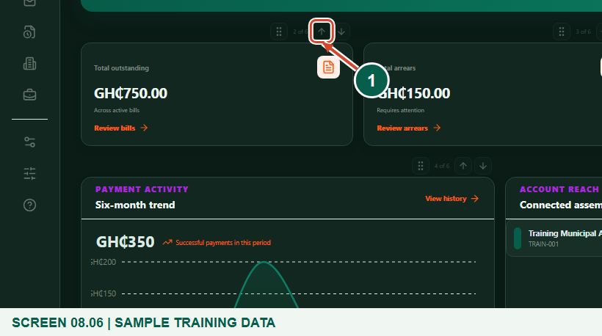
Sample training data. Reorder visible cards with the dashboard arrow controls.
1 Move card earlier
What should happen
The dashboard uses your chosen card order.

STEP 07

Restore the default appearance
1. Return to Portal customization and select Reset appearance if you want the default colour mode, sidebar and card layout back.
2. Wait for Portal appearance reset to its defaults. Check the restored mode and visible cards before leaving the page.
3. This action resets appearance preferences; it does not delete the account, issued bills, successful payments or statement requests.
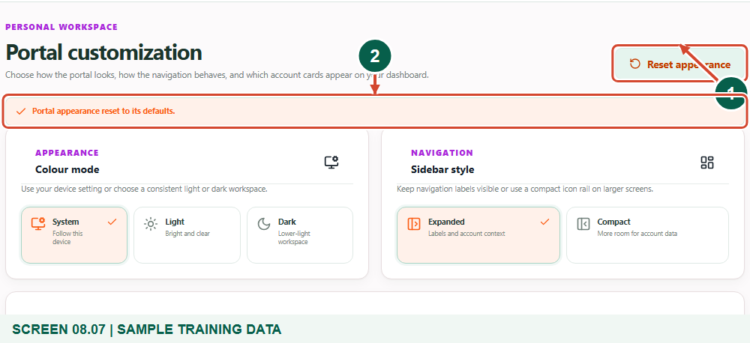
Sample training data. Restore the default appearance without changing account records.
1 Reset appearance
2 Reset confirmation
What should happen
Default appearance and card layout are restored.

Helpful note: Reset is useful if you hide a card and cannot remember the previous layout.

STEP 08

Replay help when useful
1. The Welcome and walkthrough section provides Start walkthrough and Show welcome screen. Use them when you need a reminder of the main account tools.
2. The walkthrough can move between Overview, Statements and Customize portal. End it when you are ready to continue normal work.
What should happen
You know how to get guided help again without altering account data.

Check your result
- You selected a comfortable colour mode and sidebar.
- You can show, hide and reorder cards.
- You understand how to reset the appearance safely.

If you need help
The colour mode did not remain selected.
Check the connection and saved feedback, then select it again and verify after reload.
A dashboard card disappeared.
Open Customize portal and mark the card Shown, or use Reset appearance.
Compact navigation is uncomfortable.
Select Expanded; the account data remains unchanged.

Useful things to know
- Colour modes are System, Light and Dark; there is no separate skins catalogue.
- Assembly branding colours are not payer-editable appearance choices.

Continue learning
- Guide 03: Access your rate payer account on the web
- Guide 04: View bills and arrears
Download all eight training guides
Open Help and support
For account or bill-record corrections, contact the relevant assembly using its verified contact details. Keep your account or bill reference available when requesting assistance.

