
GYE NTOBOA
MANUAL 1 - RATE PAYER TRAINING
PROCESS GUIDE 07 / 08

Check your locality weather
Find a locality, read its current conditions and seven-day outlook, use browser location only if desired, and handle denied permission without losing access to weather search.
WHO THIS IS FOR  Any website visitor; no account is required | ALLOW ABOUT  5–10 minutes | DOCUMENT VERSION  1.0 | 19 October 2026

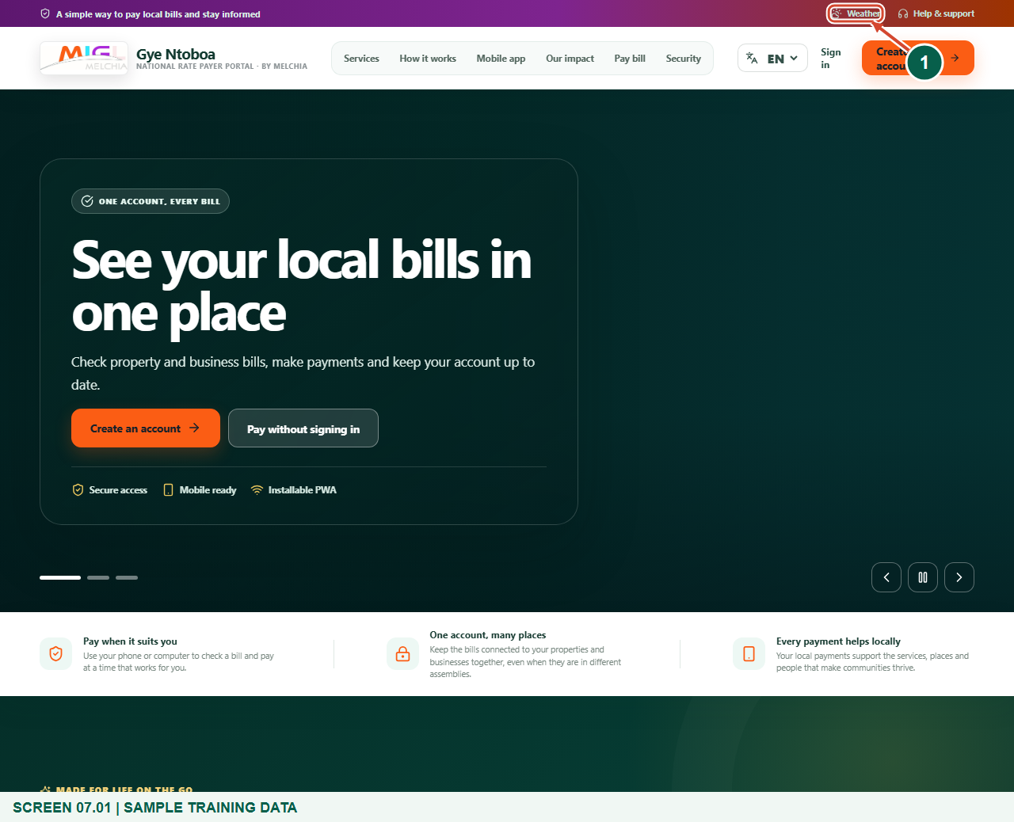
Illustrated steps with numbered arrows and clear expected results.
About the examples
Screens show the actual application in a training environment with sample data. Forecast values are examples, not a current weather report.

Website: gyentoboa.com

Process flow
Follow the arrows from start to finish. Optional routes are explained in the numbered steps.

Before you start
- Open the official Gye Ntoboa website in a modern browser. Weather is a public service and does not require sign-in.
- Know the city, town or district you want to check. Search is available even if you do not want to share your current location.
- The figures show deterministic sample weather from a local training fixture. They are not current forecasts or warnings for the named locality.
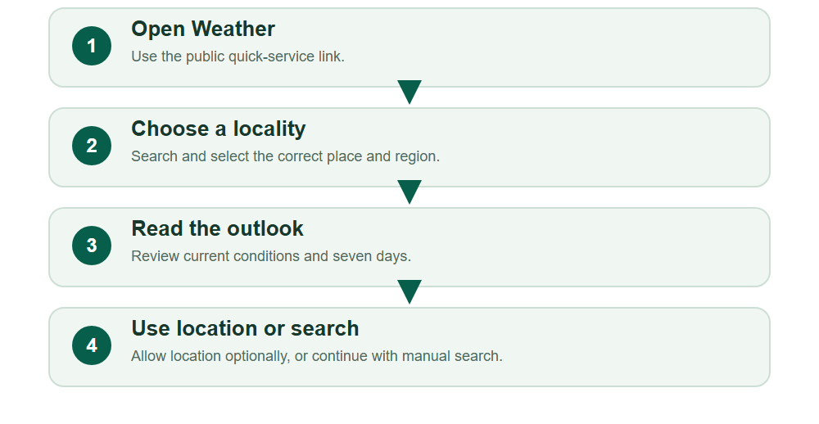
Numbered markers on screenshots identify the controls described beneath each image.

STEP 01

Open the public Weather service
1. From the website, select Weather in the quick-service links near the top. You can also use the Weather entry in the mobile menu or footer.
2. No account registration or payment is required. A visitor can open the weather page directly.
Sample training data. Open the public Weather service.
1 Weather quick link
What should happen
The page opens with Plan ahead with a local seven-day outlook.

STEP 02

Search for a city, town or district
1. Enter the locality name in Search city, town or district. Use at least two characters so the search can run.
2. Select Search and wait for the matching places. The training figure uses Accra only as a sample; use the locality relevant to your own plans.
3. A broader nearby town or district can help when a small place name has no match.
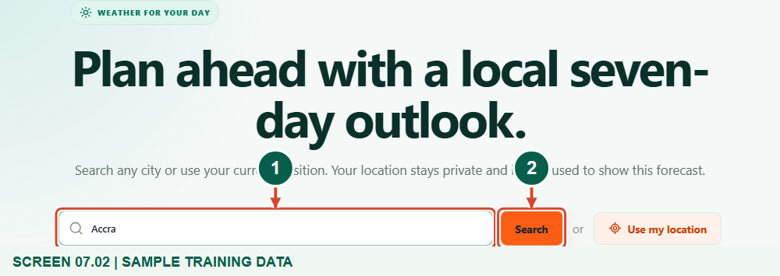
Sample training data. Search for your city, town or district.
1 Enter a locality
2 Search
What should happen
Matching place results appear below the search controls.

STEP 03

Choose the correct matching place
1. Read the place name together with its region and country. The same locality name can occur in more than one area.
2. Select the matching result instead of assuming the first place is always correct. The selection loads its coordinates and forecast.
3. If the results do not describe your locality, change the search phrase and search again.
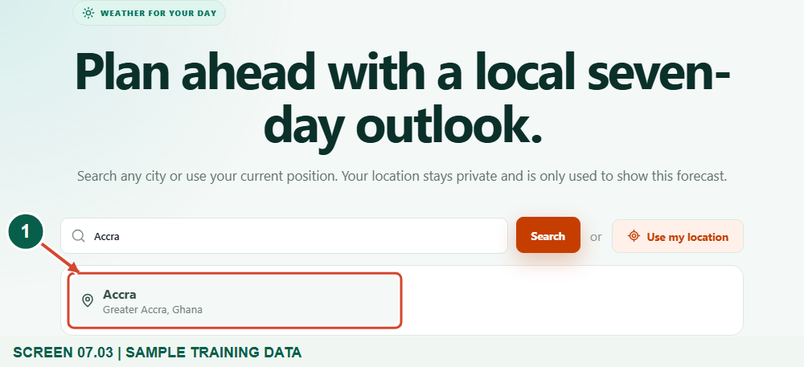
Sample training data. Choose the matching locality.
1 Select the correct place and region
What should happen
The forecast is labelled with the place you selected.

STEP 04

Read conditions and the seven-day outlook
1. Start with the selected place and timezone. Read the current temperature, condition, humidity, wind and feels-like value.
2. Review the seven daily cards for expected conditions, maximum and minimum temperatures, and rain probability. Forecast values are guidance, not a promise that the same weather will occur.
3. Use the forecast to plan ordinary activities while continuing to follow official warnings and local advice for hazardous conditions.
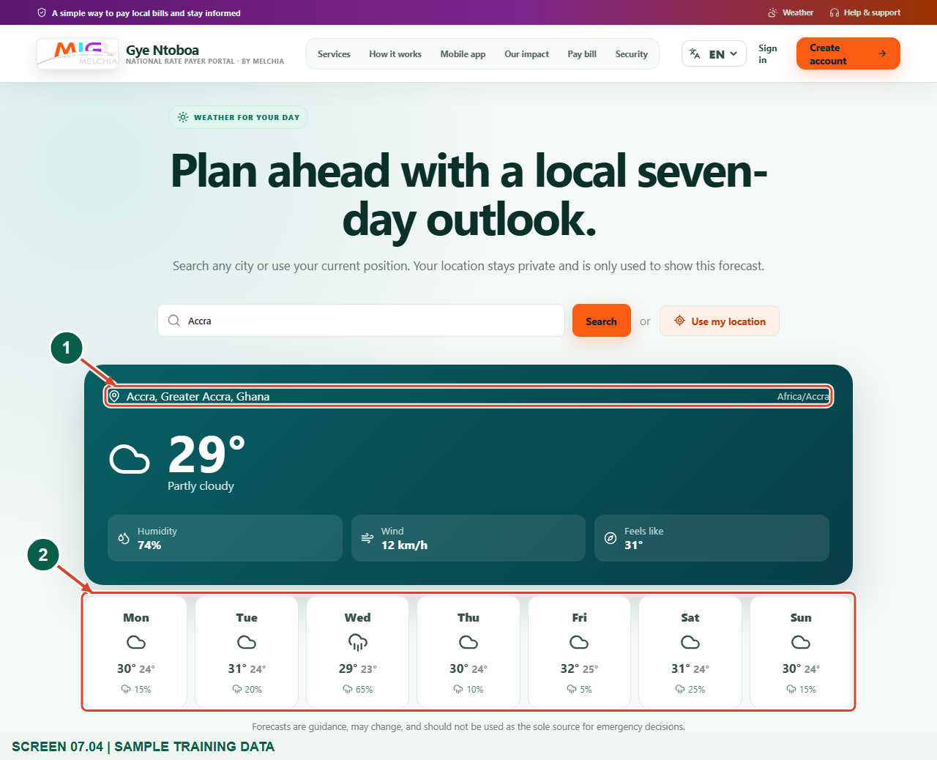
Sample training forecast; not a live weather report.
1 Selected locality
2 Seven-day outlook
What should happen
You can identify the locality and read the current and seven-day information.

STEP 05

Optional: use your current browser location
1. Choose Use my location if you want a forecast for the device’s current position. Respond to the browser permission request according to your preference.
2. If permission is granted, the app requests a forecast and labels it Current location. The application does not require high-precision field-service GPS for this public weather feature.
3. This selection is page state, not a saved account-locality preference. A new search or a new page visit can require you to choose a place again.
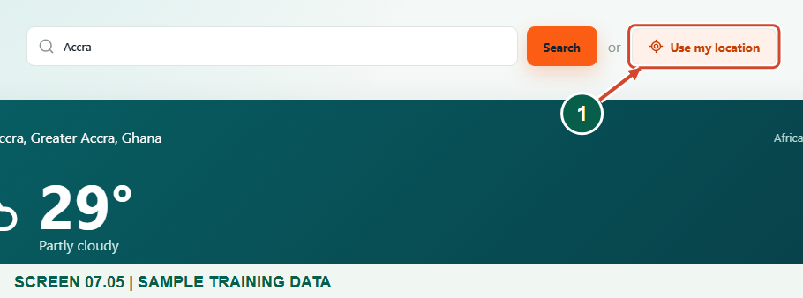
Sample training data. Optional: use your browser location.
1 Use my location
What should happen
With permission, the forecast updates for the browser-provided position.

STEP 06

Continue when permission is denied
1. If the browser cannot provide location or permission is denied, the page explains that you can search instead.
2. Enter a city, town or district manually and choose a matching result. You do not need to grant location permission to use weather search.
3. If you later want to allow location, use your browser’s site-permission settings. Do not grant broad permissions to an unfamiliar website.
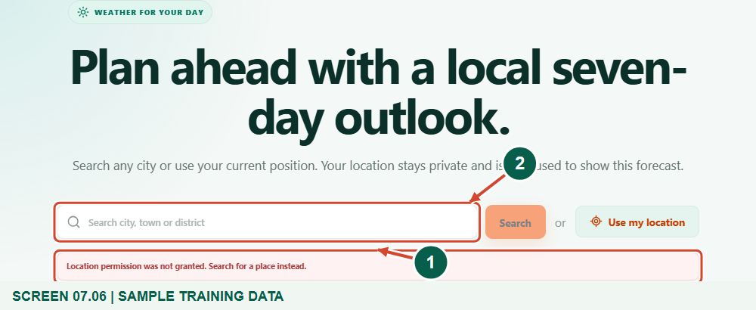
Alternative denied-permission branch; the page’s real fallback guidance is shown.
1 Permission guidance
2 Search for a place instead
What should happen
You can still obtain a forecast through manual place search.

STEP 07

Read the community safety guidance
1. Below the forecast, read the community safety reminders about warnings, waste, gutters and helping vulnerable neighbours.
2. Follow official alerts, seek safe shelter when advised and never walk or drive through floodwater. Do not enter damaged or dangerous drains.
3. Report dangerous drainage conditions through the appropriate local channel instead of trying to solve them by taking personal risks.
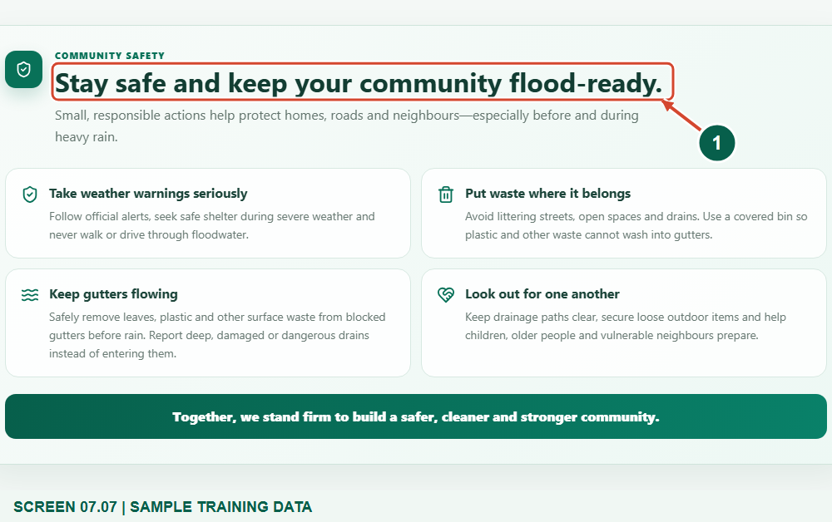
Sample training data. Read local weather and flood-safety guidance.
1 Community safety guidance
What should happen
You understand that forecast information supports, but does not replace, official safety advice.

STEP 08

Check again when plans or locality change
1. Search again when you need a different locality, and confirm the place label after each change.
2. Weather information can change. If the service is unavailable, wait and retry rather than treating the previous screenshot as a current report.
3. For emergencies, follow official warnings and local authorities. Never rely on this public outlook as your only source for a safety decision.
What should happen
You can repeat the process without confusing sample, old or different-locality weather with a current forecast.

Check your result
- You selected the correct locality.
- You can read the current and seven-day outlook.
- You can continue without location permission.

If you need help
No matching place is found.
Check spelling or search for a nearby city or district.
Location permission is denied.
Use manual search; granting location is optional.
Weather is temporarily unavailable.
Retry later and use official information for time-sensitive safety decisions.

Useful things to know
- The figures show sample forecast data, not live conditions.
- The chosen locality is not stored as an account preference.

Continue learning
- Guide 03: Access your rate payer account on the web
Download all eight training guides
Open Help and support
For account or bill-record corrections, contact the relevant assembly using its verified contact details. Keep your account or bill reference available when requesting assistance.

