
GYE NTOBOA
MANUAL 1 - RATE PAYER TRAINING
PROCESS GUIDE 06 / 08

Request account statements
Choose an appropriate statement scope and period, request a PDF to the registered email address, and track queued, processing, sent or failed status without expecting an immediate browser download.
WHO THIS IS FOR  Signed-in rate payers needing bills and payment records | ALLOW ABOUT  10–15 minutes plus processing time | DOCUMENT VERSION  1.0 | 19 October 2026

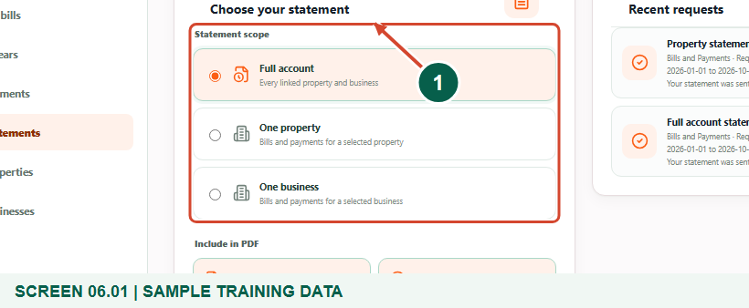
Illustrated steps with numbered arrows and clear expected results.
About the examples
Screens show the actual application in a training environment with sample data. Use your own verified account, bill and contact details when following the guide.

Website: gyentoboa.com

Process flow
Follow the arrows from start to finish. Optional routes are explained in the numbered steps.

Before you start
- Sign into the correct account and make sure the relevant property or business is linked.
- Check the email address in your profile before requesting a statement. The service sends only to the registered address, not an arbitrary address entered in the statement form.
- Decide whether you need bills, payments or both, and whether the request should cover the full account or a single linked asset.
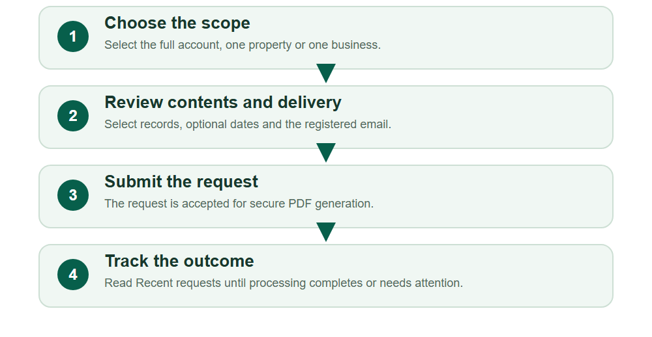
Numbered markers on screenshots identify the controls described beneath each image.

STEP 01

Open Statements and choose a scope
1. Select Statements in the navigation or Request statement on the dashboard. Wait for the form and recent-request history to load.
2. Choose Full account to include linked properties and businesses, One property for a particular property, or One business for a particular business.
3. The scope controls which records the service can include; it does not grant access to an asset that is not linked to your account.
Sample training data. Choose a full-account, property or business statement.
1 Statement scope choices
What should happen
The chosen scope is visibly selected.

STEP 02

Choose a linked asset when needed
1. For One property or One business, use the search and selection controls to find the intended linked record.
2. Check its account number and location before selecting it. Similar names can refer to different assets.
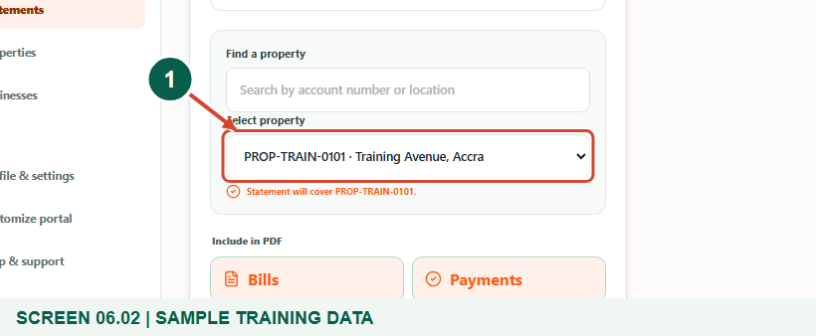
Optional one-property branch; a full-account request skips this picker.
1 Select property
What should happen
The form confirms the selected property or business.

STEP 03

Set contents and the requested period
1. Under Include in PDF, keep Bills, Payments or both selected. At least one type must remain selected. Payments includes successful payments; pending or failed attempts remain in the portal payment history.
2. Enter optional From and To dates if a particular period is required. The start must not be later than the end, and future dates are not appropriate.
3. Leaving both dates blank uses the service’s recent configured period; the current interface describes the most recent 24 months. Shorten the range if a configured safety limit rejects it.
What should happen
The scope, record types and dates match the document you need.

STEP 04

Check where the PDF will be delivered
1. Read Secure email delivery and confirm that the registered profile email belongs to you and is accessible.
2. If it is wrong, correct the profile first and return to the statement form. The statement form is not a way to send another person’s financial records elsewhere.
3. Review the selected asset, contents and period one last time, then choose Request PDF statement once.
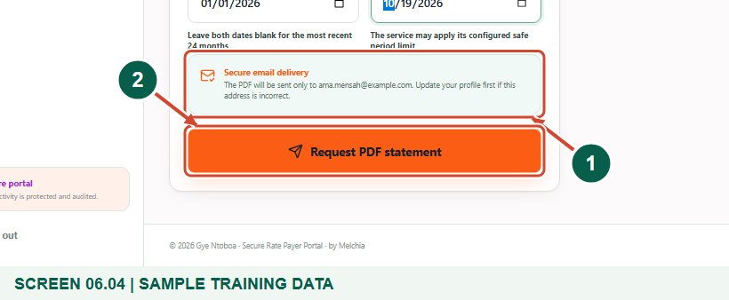
Sample training data. Review registered email delivery before requesting the statement.
1 Registered email delivery
2 Request PDF statement
What should happen
The service accepts a valid request for the registered address.

STEP 05

Understand a queued confirmation
1. A successful request displays a confirmation and appears in Recent requests. Queued means it has been accepted for secure generation.
2. Do not expect the browser to download a PDF immediately. Generation and email delivery happen separately from the form submission.
3. Keep the request in Recent requests rather than repeatedly clicking the request button because processing has not finished yet.
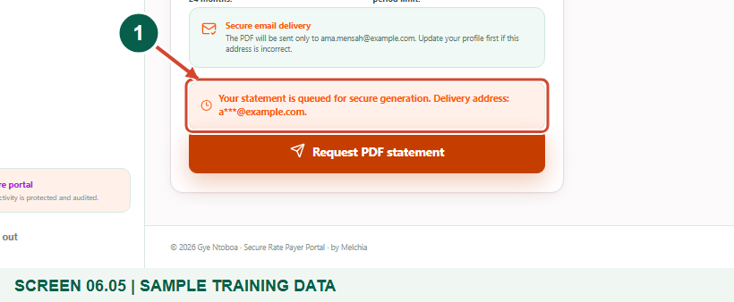
Sample training data. A queued request has been accepted for processing.
1 Queued confirmation
What should happen
The request is visible with its current processing state.

STEP 06

Track Recent requests
1. Read the scope, period, requested time and status in Recent requests. The page refreshes active queued or processing requests periodically.
2. Use Refresh statement status if you need an updated view. Queued and Processing are intermediate states, not successful delivery.
3. If a request fails, the page explains that it could not be delivered. Request it again when appropriate or contact support with the account and request context.
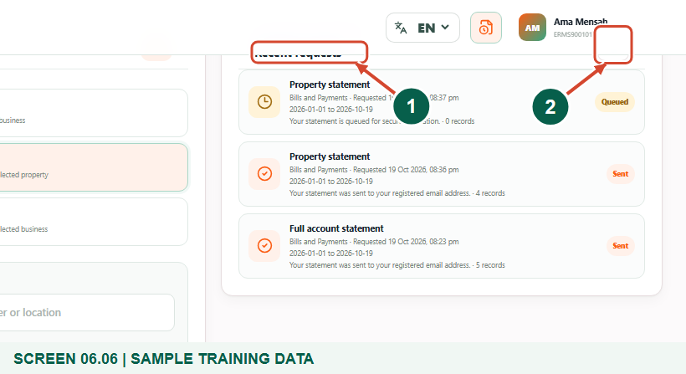
Sample training data. Follow the request in Recent requests.
1 Recent requests
2 Refresh statement status
What should happen
You can tell whether work is waiting, running, completed or failed.

STEP 07

Check the final status and your email
1. When the request is marked Sent, check the registered email address and its spam or junk folder. Keep the document private when saving or forwarding it.
2. There is no portal Download PDF button on this page. Bills Export current view is a separate CSV action, not a substitute for the emailed statement.
3. The example shows a sample Sent status. For your own request, confirm that the PDF arrives at your registered email address before relying on delivery.
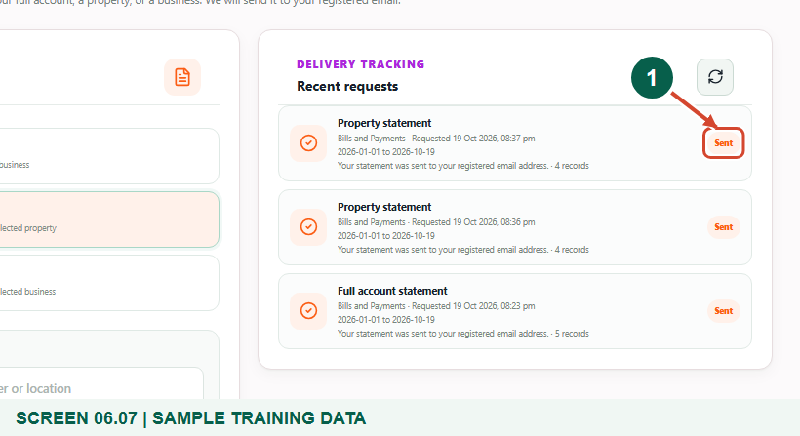
Sample training data. Sent means the statement processing completed.
1 Sent status
What should happen
You know where to look for the PDF and how the portal reports completion.

Helpful note: A Sent status describes the service’s completed sending step; inbox arrival can still depend on the email service.

Check your result
- You selected the correct scope and contents.
- You checked the registered email before submitting.
- You can distinguish queued, processing, sent and failed status.

If you need help
No selectable asset appears.
Check the scope and search term, then ask the assembly to verify the record link.
The date range is rejected.
Correct reversed or future dates and use a shorter period within the configured limits.
The request is Sent but no email appears.
Check the registered address and spam folder, then contact support rather than sending repeated requests.

Useful things to know
- PDF statements are delivered by email; there is no immediate browser PDF-download control on this page.
- The figures contain synthetic account information and sample processing states.

Continue learning
- Guide 03: Access your rate payer account on the web
- Guide 04: View bills and arrears
- Guide 05: Pay bills or arrears on the web
Download all eight training guides
Open Help and support
For account or bill-record corrections, contact the relevant assembly using its verified contact details. Keep your account or bill reference available when requesting assistance.

