
GYE NTOBOA
MANUAL 1 - RATE PAYER TRAINING
PROCESS GUIDE 05 / 08

Pay bills or arrears on the web
Review the correct recipient and amount, recognise phone approval, provider-code and checkout branches, and distinguish a pending request from verified payment confirmation.
WHO THIS IS FOR  Rate payers using public bill payment or their signed-in account | ALLOW ABOUT  12–18 minutes | DOCUMENT VERSION  1.0 | 19 October 2026

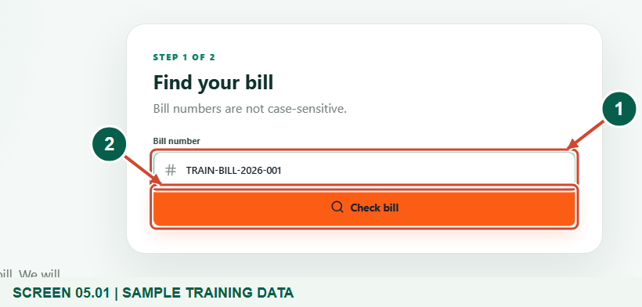
Illustrated steps with numbered arrows and clear expected results.
About the examples
Screens show the actual application in a training environment with sample data. Payment prompts and outcomes are simulated examples, not evidence of a real payment.

Website: gyentoboa.com

Process flow
Follow the arrows from start to finish. Optional routes are explained in the numbered steps.

Before you start
- Have an issued payable bill number and access to the phone or provider account you intend to use.
- Use the official website. A signed-in payer can begin with Pay now in My bills; public Pay bill starts with a bill-number lookup.
- Every payment figure uses a synthetic local provider response. No real checkout was opened, no money moved and no external message was sent.
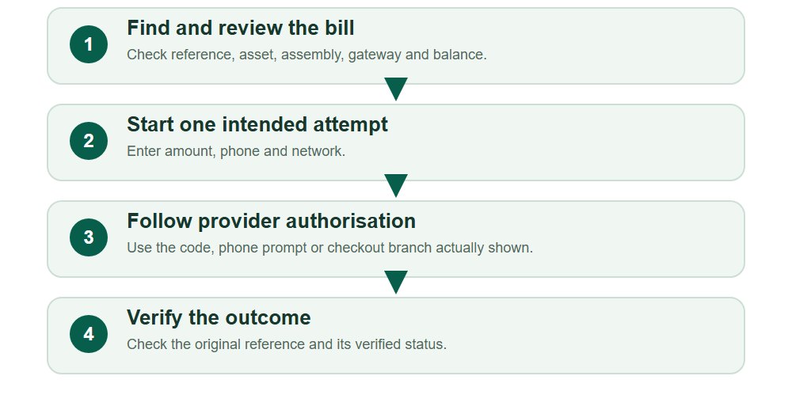
Numbered markers on screenshots identify the controls described beneath each image.

STEP 01

Find the bill through the appropriate entry point
1. On the public website, choose Pay bill, enter the bill number and select Check bill. Bill numbers are not case-sensitive.
2. Signed-in users can instead open My bills and select Pay now; this opens the account payment panel.
Sample training data. Enter the bill number and choose Check bill on the public Pay bill page.
1 Bill number
2 Check bill
What should happen
The service displays the bill or a clear reason it cannot be paid.

STEP 02

Verify who receives the payment
1. Read the issuing assembly, bill reference, asset, bill type and year before entering payment details.
2. Check the payment gateway and the difference between amount billed, arrears and outstanding balance. The bill’s assembly selects its own merchant account.
3. Stop if the assembly or reference is wrong. A payer’s home assembly or personal preference does not change the recipient on this bill.
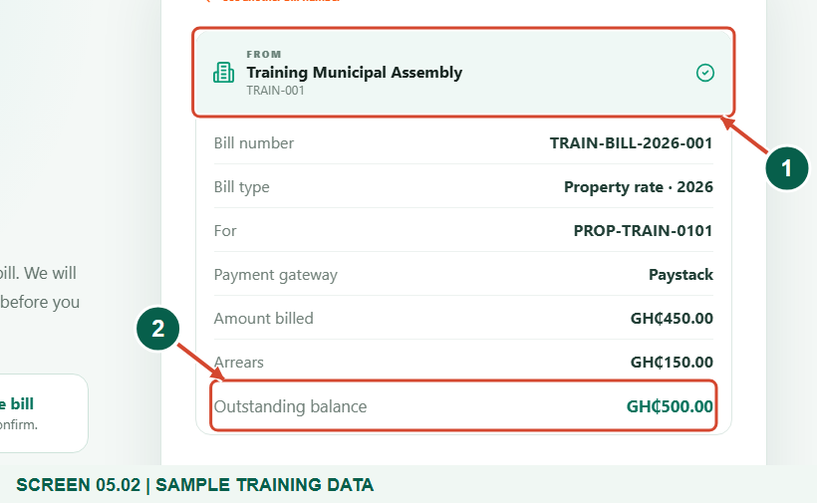
Sample training data. Confirm the issuing assembly and outstanding bill.
1 Receiving assembly
2 Outstanding balance
What should happen
You can identify the exact bill and receiving assembly.

STEP 03

Enter one intended payment
1. Enter an amount within the available balance. Use the phone number and network associated with the intended payment route.
2. Review the amount and contact details again, then select the Pay button once and wait for the service response.
3. Keep the payment tab open while completing the process. A public payment uses a short-lived follow-up token held by the page, so refreshing or closing it can lose that page’s status context.
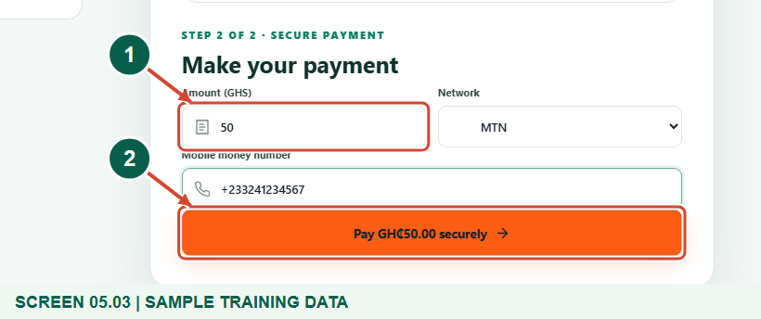
Sample training data. Set the amount, phone number and network.
1 Amount to pay
2 Pay after checking the details
What should happen
The page shows the next authorisation step or an error that needs attention.

STEP 04

Provider-code branch, only when shown
1. If a Payment code or Confirmation code field appears, enter the confirmation code requested for this payment and select the confirmation button.
2. This is a provider authorisation code, not your portal sign-in code and never your mobile-money PIN. Do not share it with an agent or trainer.
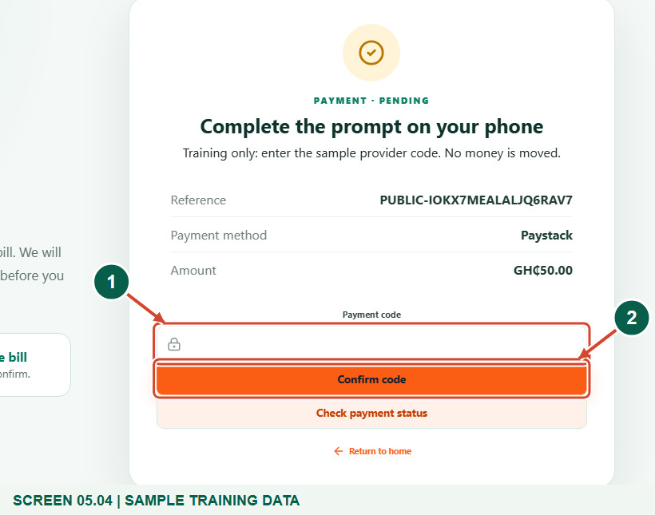
Optional provider-code branch. Training upstream only; no real provider was contacted.
1 Provider payment code
2 Confirm code
What should happen
The original payment request proceeds to its next state.

Helpful note: The figure intentionally leaves the code blank.

STEP 05

Treat Pending as unfinished
1. Read the displayed status and keep the payment reference. A prompt or a pending request is not proof of successful settlement.
2. Use Check payment status on the original attempt. The signed-in payment panel can also check automatically for a bounded period.
3. If the page reports an uncertain or failed outcome, do not assume no debit happened. Check the original attempt, your provider records and the assembly before paying again.
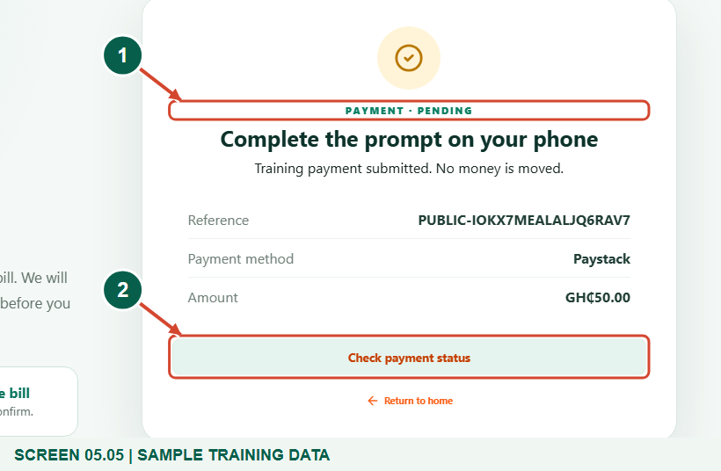
Sample training data. Pending is not yet a confirmed payment.
1 Current payment state
2 Check payment status
What should happen
You can distinguish a request awaiting confirmation from a successful payment.

STEP 06

Checkout hand-off alternative
1. Some requests show Continue to payment or Continue to secure checkout. This opens the provider’s authorisation flow rather than a portal code field.
2. Check the destination and complete only the provider steps you intended. Return to the original portal attempt and check its status afterwards.
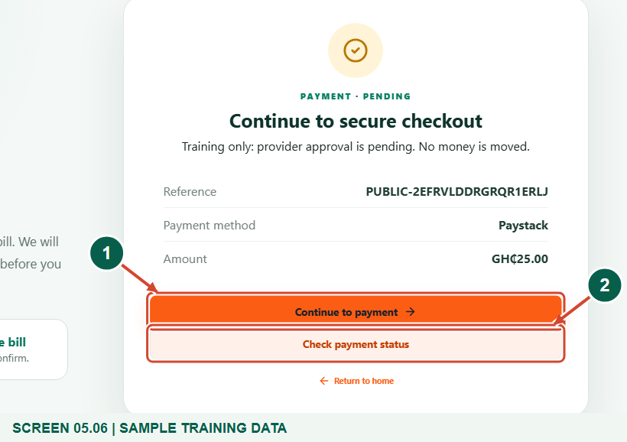
Alternative checkout branch. No gateway or bank interface is fabricated or opened in this guide.
1 Provider hand-off link
2 Check the original attempt status
What should happen
You understand the hand-off branch without confusing it with confirmation.

STEP 07

Read verified confirmation
1. Wait for Payment confirmed or a successful verified status. Match the displayed reference and amount to the intended attempt.
2. Keep the reference for support and reconciliation. The service verifies the original payment account, reference, amount and GHS currency before recording success.
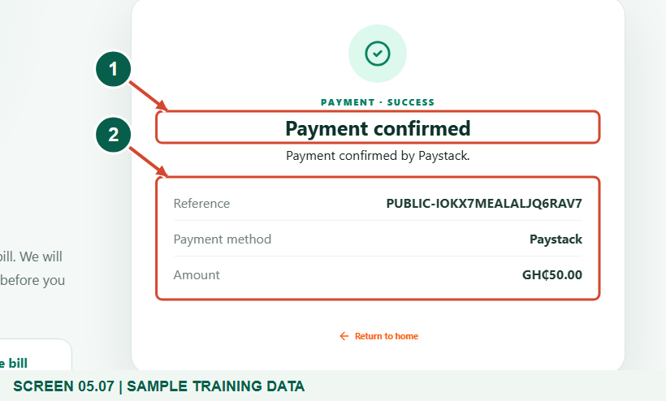
Synthetic local verification and settlement path; no real money moved.
1 Payment confirmed
2 Keep the reference
What should happen
The original attempt is shown as successfully verified.

STEP 08

Review account payment history
1. In a signed-in account, open Payments to read references, dates, amounts and statuses for authorised linked bills.
2. Use Check status on a pending row when available. Use the statement icon to open Statements if you need an emailed PDF record.
3. There is no direct Download receipt button in the current payment history. Do not assume that the document icon downloads an individual receipt.
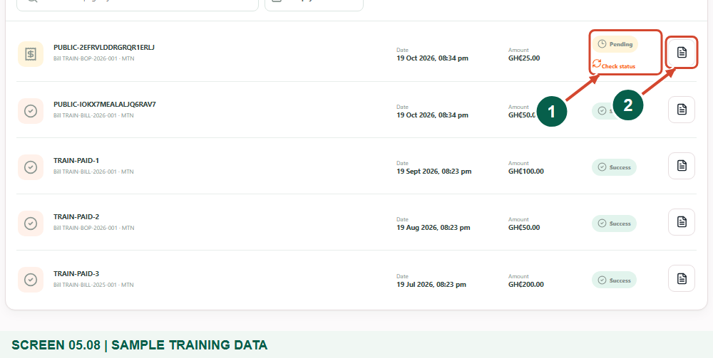
Sample training data. Review payment references and statuses in your account.
1 Live payment status
2 Request a payment statement
What should happen
You can find the attempt and choose the correct document or follow-up action.

Check your result
- You checked the bill and recipient before starting.
- You followed only the authorisation branch actually shown.
- You can distinguish pending, hand-off and verified confirmation.

If you need help
Online payments are unavailable.
Contact the issuing assembly. A disabled or incomplete assembly account cannot use a global fallback merchant.
The provider outcome is uncertain.
Check the existing reference and provider account before retrying; an unconfirmed attempt may still settle.
A public status session has expired.
Keep the reference and ask the assembly or use your authorised account history for follow-up.

Useful things to know
- No real provider, bank or inbox screenshot is included.
- A request, prompt or redirect is not a settled payment.

Continue learning
- Guide 04: View bills and arrears
- Guide 06: Request account statements
Download all eight training guides
Open Help and support
For account or bill-record corrections, contact the relevant assembly using its verified contact details. Keep your account or bill reference available when requesting assistance.

