
GYE NTOBOA
MANUAL 1 - RATE PAYER TRAINING
PROCESS GUIDE 04 / 08

View bills and arrears
Find your linked bills, understand bill value versus paid and outstanding amounts, use filters correctly, export the loaded view, and distinguish arrears from the full balance before considering payment.
WHO THIS IS FOR  Signed-in rate payers with verified linked records | ALLOW ABOUT  10–15 minutes | DOCUMENT VERSION  1.0 | 19 October 2026

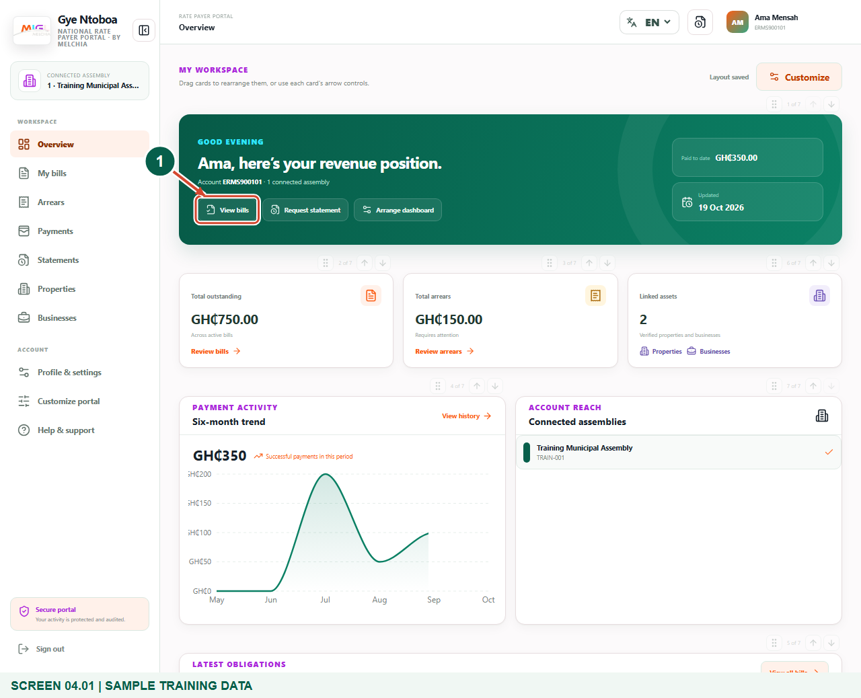
Illustrated steps with numbered arrows and clear expected results.
About the examples
Screens show the actual application in a training environment with sample data. Use your own verified account, bill and contact details when following the guide.

Website: gyentoboa.com

Process flow
Follow the arrows from start to finish. Optional routes are explained in the numbered steps.

Before you start
- Sign into your own account and check its name and account number.
- The relevant assembly must have issued and linked your property or business records. An empty new account may need assembly verification.
- These figures use synthetic bills belonging to the Training Municipal Assembly. The amounts are examples, not demands for payment.
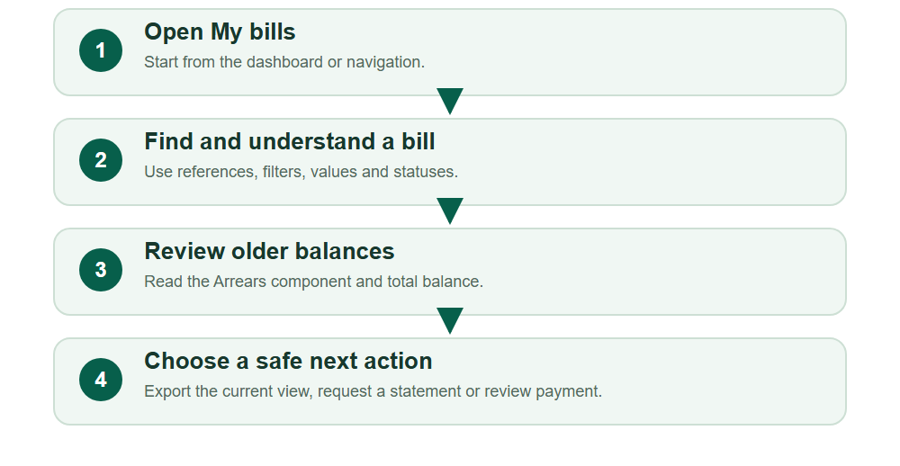
Numbered markers on screenshots identify the controls described beneath each image.

STEP 01

Open your bill workspace
1. From Overview, select View bills. You can also choose My bills in the sidebar; smaller screens use the navigation menu.
2. Wait for the Bills page and its records to load. Avoid interpreting a loading indicator as an empty account.
3. Use the account identity in the header to confirm that you are reviewing your own records.
Sample training data. Open Bills from the dashboard.
1 View bills
What should happen
The Bills workspace shows linked property and business bills.

STEP 02

Read the figures before acting
1. Identify the bill reference, asset and billing year. Use these together when comparing an electronic record with a printed bill.
2. Bill value includes the bill amount and arrears component, less applicable discount. Paid shows recorded successful payments; Balance is the amount still outstanding.
3. Read the status as well as the amount. A historical Replaced bill is not a current payable bill, and a settled bill does not require another payment.
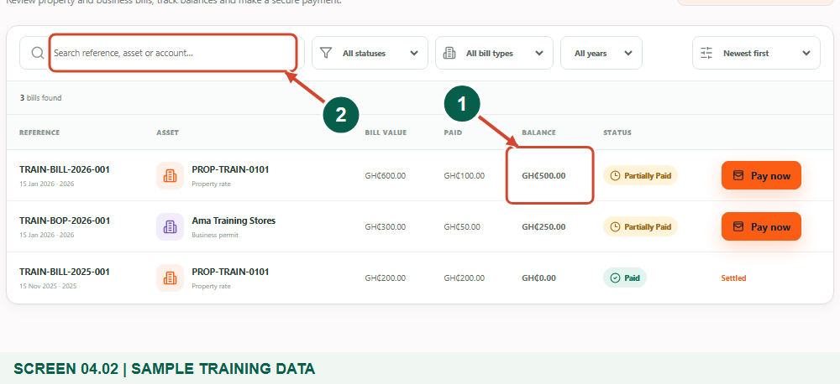
Sample training data. Read the bill references, values and balances.
1 Outstanding balance
2 Search bills
What should happen
You can explain the difference between bill value, paid and balance.

STEP 03

Use search and filters
1. Enter a reference, asset or account term in the search box. Let the result update before selecting a row.
2. Use the status, bill-type and year selectors to narrow the view. Sort order can help find newer, older or larger bills.
3. The bill count describes the filtered results. Use Clear filters when a bill seems to be missing, and check any additional pages.
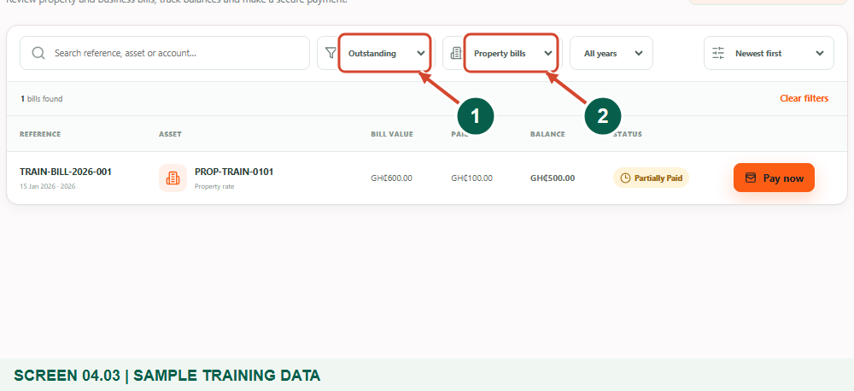
Sample training data. Narrow the list with status and bill-type filters.
1 Status filter
2 Bill type filter
What should happen
The list reflects your chosen search and filters.

Helpful note: A filter can hide a record without changing or deleting it.

STEP 04

Export only the current view
1. Choose Export current view when you need a CSV copy of the currently loaded bill rows. The browser downloads a spreadsheet-compatible file.
2. The export is not a complete account PDF and does not automatically include every page of results. Review filters and pagination before relying on it.
3. For a PDF covering a defined account, property or business period, use Statements instead. Keep exported financial records on a trusted device.
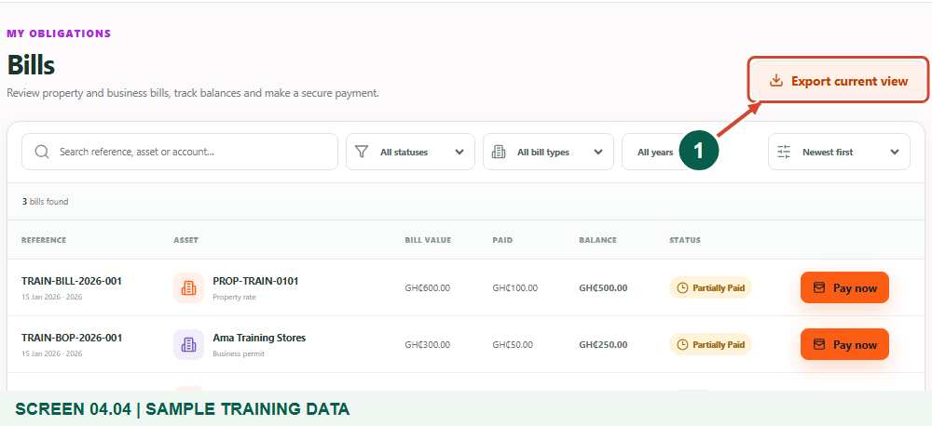
Sample training data. Export the currently loaded bill view as CSV.
1 Export current view
What should happen
A CSV file of the loaded view is downloaded.

STEP 05

Open Arrears and separate the amounts
1. Select Arrears in the navigation. Read Arrears in current view separately from Total balance to clear.
2. The arrears component represents older obligations included in the displayed bills. A bill’s full balance can also include current charges and prior payments.
3. The summary is for the current loaded view. Search and check other pages where applicable; do not assume a page subtotal is a whole-account total.
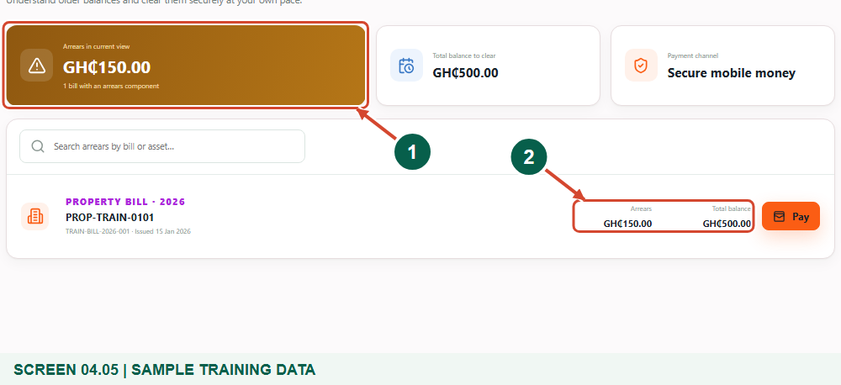
Sample training data. Distinguish arrears from the full balance to clear.
1 Arrears in current view
2 Total balance
What should happen
You understand the arrears component and the displayed full balances.

STEP 06

Review a payment without rushing it
1. Pay now on a bill, or Pay in Arrears, opens the secure payment review. Opening this panel does not itself send money.
2. Check the bill reference, asset, receiving assembly, payment gateway and outstanding balance. The bill’s issuing assembly determines the recipient.
3. If a figure or recipient looks wrong, close the panel and contact the assembly with the reference. Follow Manual 05 only after the details are correct.
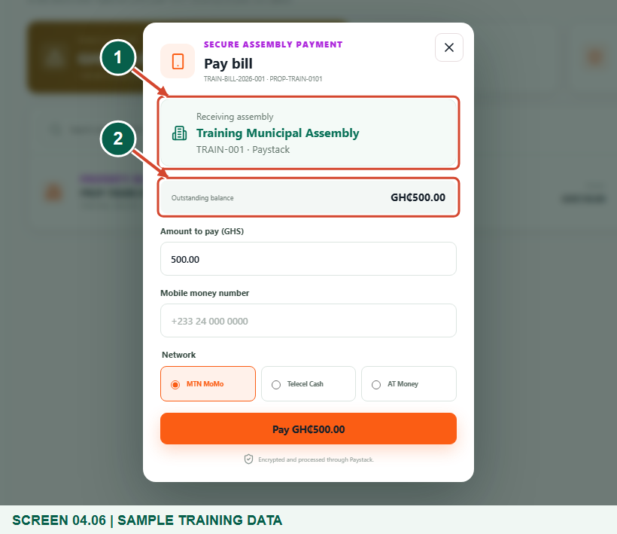
Sample training data. Review the bill and receiving assembly before any payment.
1 Receiving assembly
2 Outstanding balance
What should happen
You can confirm the intended bill and recipient before starting payment.

STEP 07

Resolve missing or inconsistent records
1. Clear filters and search by the exact reference before reporting a missing bill. Check whether it is replaced or linked to a different authorised account.
2. If a payment is pending, use Payments to check the original attempt instead of paying the same amount again. A provider-backed failed or unconfirmed attempt may still settle.
3. Contact the assembly with the bill reference and relevant payment reference. Do not send passwords, one-time codes or mobile-money PINs as evidence.
What should happen
You know what information to provide when a record needs review.

Check your result
- You located the intended bill and its issuing assembly.
- You can distinguish arrears, bill value, paid and balance.
- You know the difference between a current-view CSV and an emailed PDF statement.

If you need help
No bills appear.
Clear filters, check account identity and ask the assembly to verify/link the correct records.
A paid amount has not appeared.
Check the original payment status and reference before starting another attempt.
The bill is marked Replaced.
Use the current replacement bill; keep the older record for history only.

Useful things to know
- CSV and Arrears summary figures describe the current loaded view.
- The training review panel did not initiate a payment.

Continue learning
- Guide 03: Access your rate payer account on the web
- Guide 05: Pay bills or arrears on the web
- Guide 06: Request account statements
Download all eight training guides
Open Help and support
For account or bill-record corrections, contact the relevant assembly using its verified contact details. Keep your account or bill reference available when requesting assistance.

