
GYE NTOBOA
MANUAL 1 - RATE PAYER TRAINING
PROCESS GUIDE 03 / 08

Access your rate payer account on the web
Sign in through the official website, handle a conditional one-time security-code step, confirm that you reached the correct account, and sign out safely.
WHO THIS IS FOR  Rate payers with an existing account | ALLOW ABOUT  8–12 minutes | DOCUMENT VERSION  1.0 | 19 October 2026

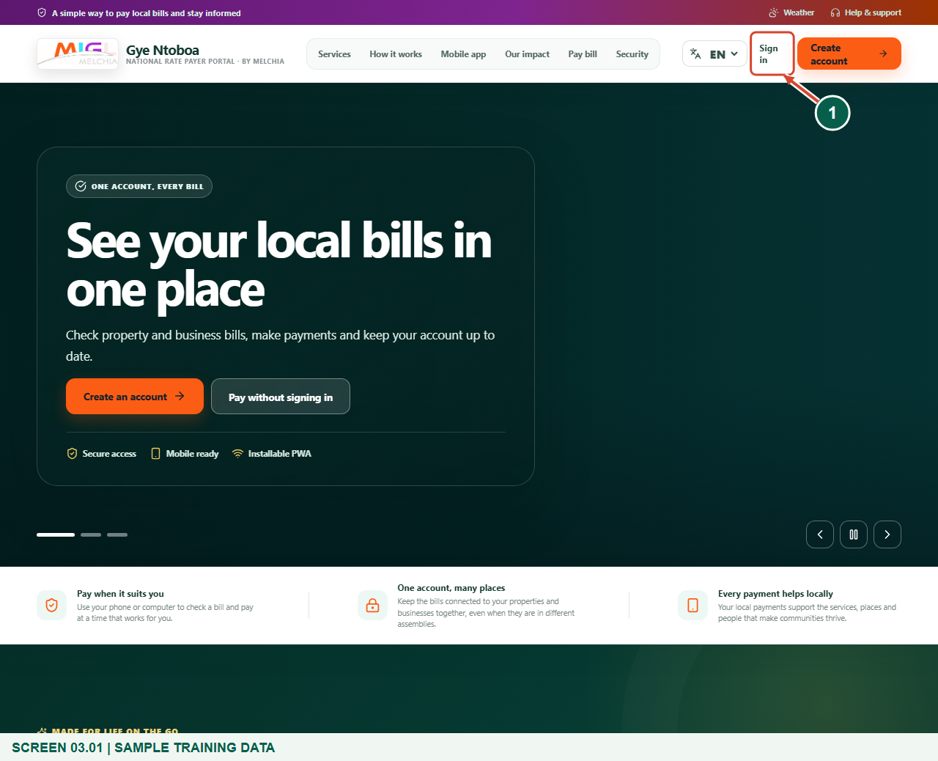
Illustrated steps with numbered arrows and clear expected results.
About the examples
Screens show the actual application in a training environment with sample data. Use your own verified account, bill and contact details when following the guide.

Website: gyentoboa.com

Process flow
Follow the arrows from start to finish. Optional routes are explained in the numbered steps.

Before you start
- You need an existing account and your current password. Assembly-created accounts may require an initial setup or password-change step first.
- Have access to the registered phone associated with the account if SMS sign-in verification is enabled.
- Use a trusted browser. Avoid saving a sign-in on a shared or public device. The figures use sample contacts and never display usable passwords or security codes.
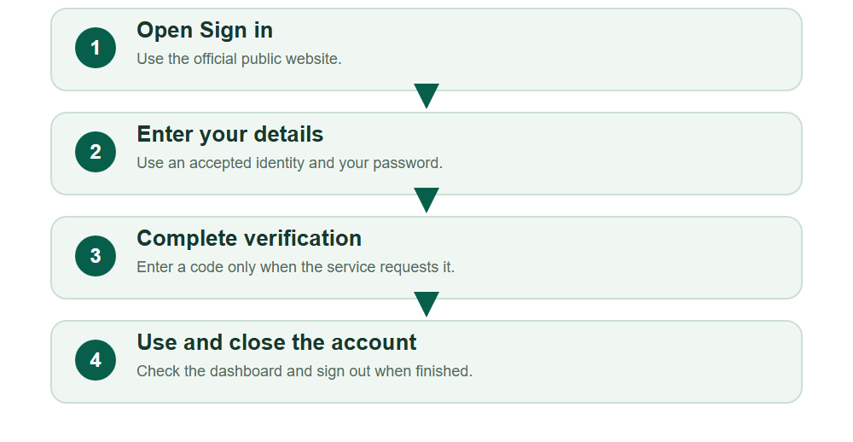
Numbered markers on screenshots identify the controls described beneath each image.

STEP 01

Reach the official sign-in page
1. Open https://gyentoboa.com/ and check the address. Select Sign in in the website header.
2. On a smaller screen, use the navigation menu to reveal the sign-in link. You do not need to create another account.
Sample training data. Choose Sign in on the website.
1 Sign in
What should happen
The page displays Sign in to your account.

STEP 02

Enter your account identity and password
1. Enter the email, phone number or account number associated with your existing account. Use one identity, not all three at once.
2. Enter your password. Keep it hidden while other people can see your screen; the visibility icon is optional.
3. Choose Continue securely and wait for the response. If sign-in fails, check the details rather than repeatedly submitting the same mistake.
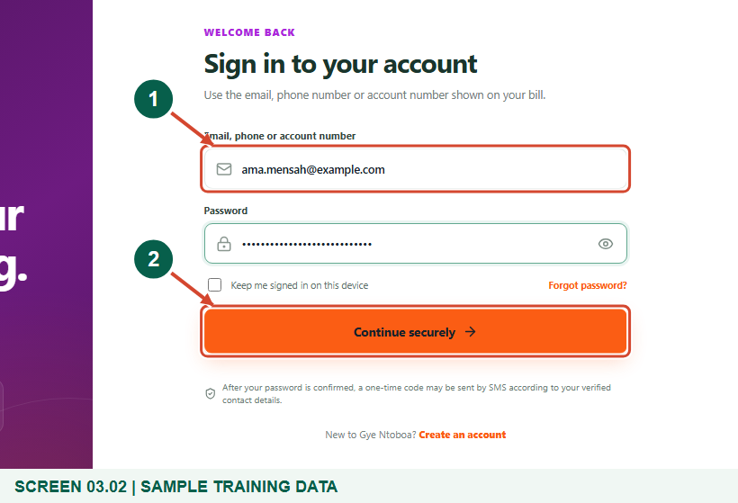
Sample training data. Enter your sign-in details securely.
1 Account identity
2 Continue securely
What should happen
The service either opens your account or asks for additional verification.

STEP 03

Decide whether to keep the sign-in
1. The Keep me signed in on this device checkbox is optional. Leave it clear on a shared or public computer.
2. A saved sign-in does not replace normal security checks. The server still decides whether verification or a password change is needed.
What should happen
Your choice matches whether the device is private or shared.

STEP 04

Read a requested security-code challenge
1. When verification is enabled, the page changes to Enter your security code. Read the masked SMS number to confirm where the code was sent.
2. The challenge shows an expiry timer and the number of attempts remaining. Obtain the current six-digit code from the messages on your registered phone.
3. If this screen is not shown and the dashboard opens directly, follow the service response; this additional step depends on the current policy.
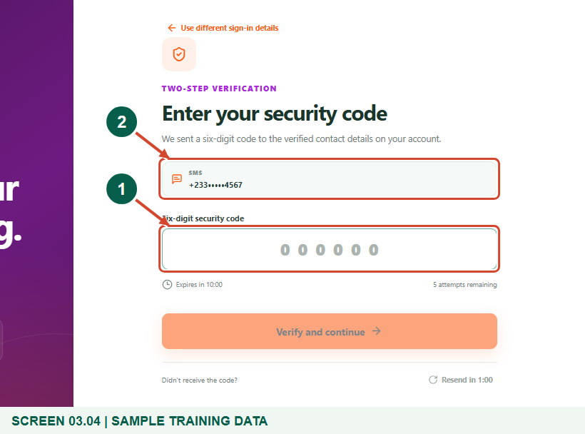
Sample training data. Complete the optional sign-in security check.
1 Six-digit security code
2 Masked SMS number
What should happen
You understand whether a code is required and where it was sent.

Helpful note: The illustrated input is deliberately blank; do not copy a code from any training material.

STEP 05

Verify and continue
1. Enter the requested six-digit SMS sign-in code and select Verify and continue before the timer expires.
2. Use Send a new code only when the resend countdown allows it. A newly issued code can replace the previous one.
3. If the masked phone number is wrong, choose Use different sign-in details or contact the assembly. Never keep guessing codes for an account you cannot identify.
What should happen
A valid code completes sign-in and opens the workspace.

STEP 06

Check that this is your account
1. Read the name and account number in the profile area and dashboard. Stop if the account identity is not yours.
2. Use Overview, My bills, Arrears, Payments or Statements to move around the workspace. The account only shows records within your authorised scope.
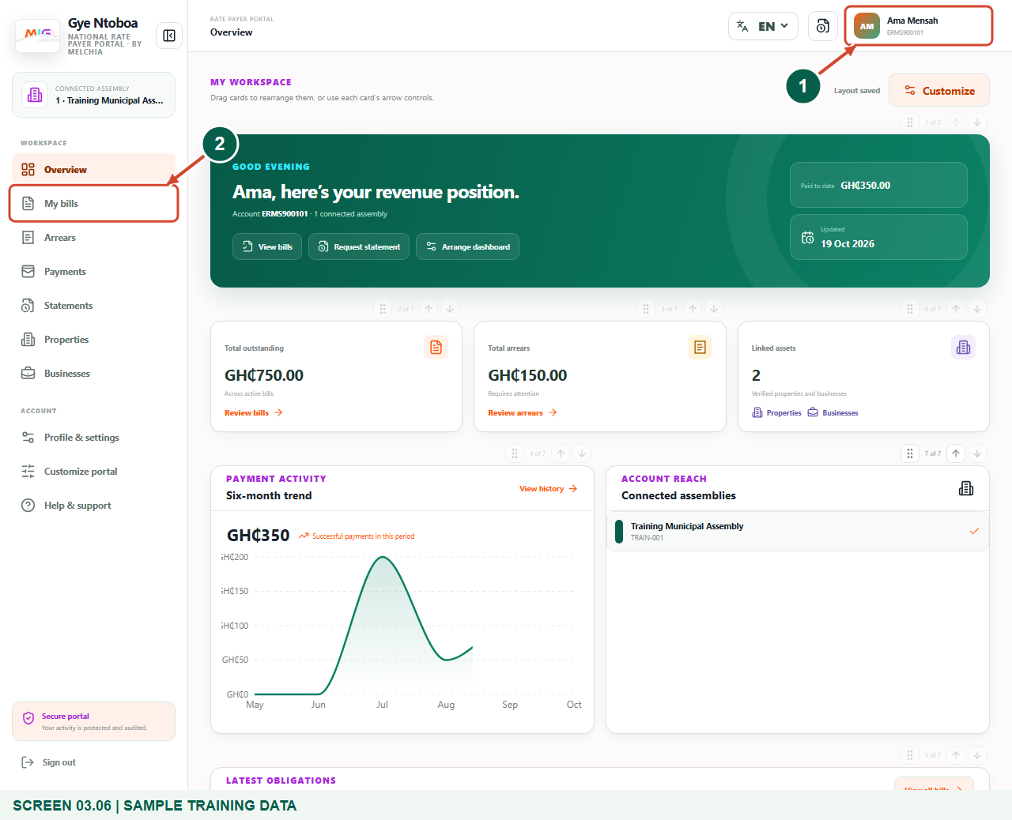
Sample training data. Confirm you are in your own account.
1 Your account identity
2 My bills navigation
What should happen
You can recognise your own account and the main navigation.

STEP 07

Sign out when you finish
1. Open the profile menu in the upper-right corner and select Sign out.
2. Wait for the sign-in page or public site to reappear. On a shared computer, close the browser tab after signing out.
3. Signing out does not delete your account, bills, payments or saved appearance preferences. You can return through Sign in later.
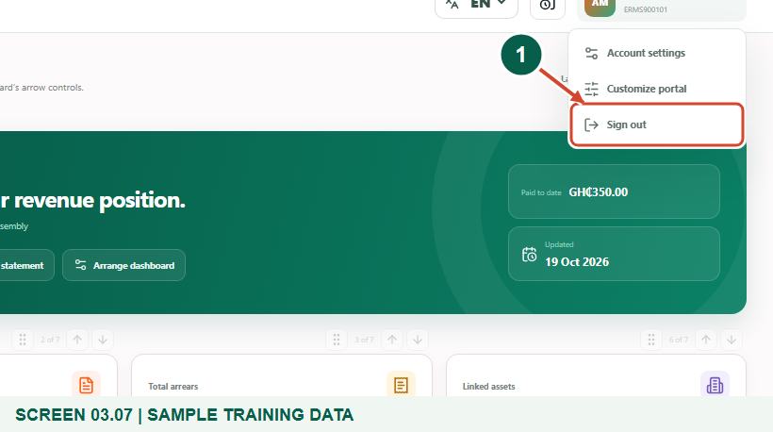
Sample training data. Sign out when you finish, especially on shared devices.
1 Sign out
What should happen
Your active portal session ends.

STEP 08

Use recovery when the password is forgotten
1. From the sign-in page, choose Forgot password? and follow the recovery form for your registered identity.
2. Use only a fresh recovery code or setup link that you requested. An assembly-created account may use a separate initial setup message.
3. If you no longer control the registered contact method, contact the assembly or support for verification. Do not create a second account as a recovery shortcut.
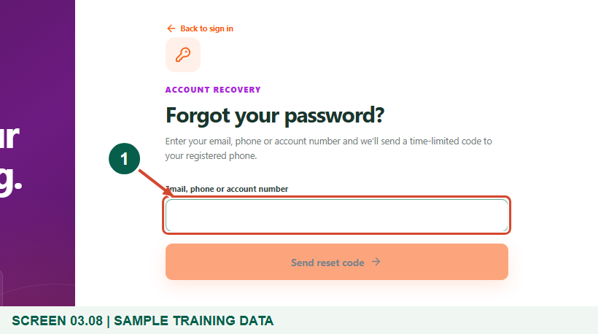
Recovery entry only; no external reset message was sent for this figure.
1 Password recovery form
What should happen
You know the correct recovery entry point without exposing a password.

Check your result
- You reached the correct account.
- You completed any required verification without sharing secrets.
- You can sign out and locate password recovery.

If you need help
A code has not arrived.
Check the masked SMS number and phone signal, wait for the resend countdown, and request a new code only when allowed.
The code expired.
Request a new code or restart sign-in; do not keep using an expired value.
A temporary-password change is requested.
Complete the required password change before using protected account pages.

Useful things to know
- Sign-in verification depends on the live server policy. When requested, the login code is delivered by SMS.
- The figures use synthetic training contacts and blank code fields.

Continue learning
- Guide 01: Register a rate payer account
- Guide 02: Create a rate payer account as assembly staff
- Guide 04: View bills and arrears
- Guide 08: Personalize your theme and skin colour
Download all eight training guides
Open Help and support
For account or bill-record corrections, contact the relevant assembly using its verified contact details. Keep your account or bill reference available when requesting assistance.

