
GYE NTOBOA
MANUAL 1 - RATE PAYER TRAINING
PROCESS GUIDE 02 / 08

Create a rate payer account as assembly staff
Create the correct payer record in your assembly and hand access to the payer through private password setup or recovery.
WHO THIS IS FOR  Authorised assembly staff with permission to view and create rate payers. Secure password setup requires the relevant administrator and reset permissions. | ALLOW ABOUT  8-12 minutes | DOCUMENT VERSION  1.0 | 19 October 2026

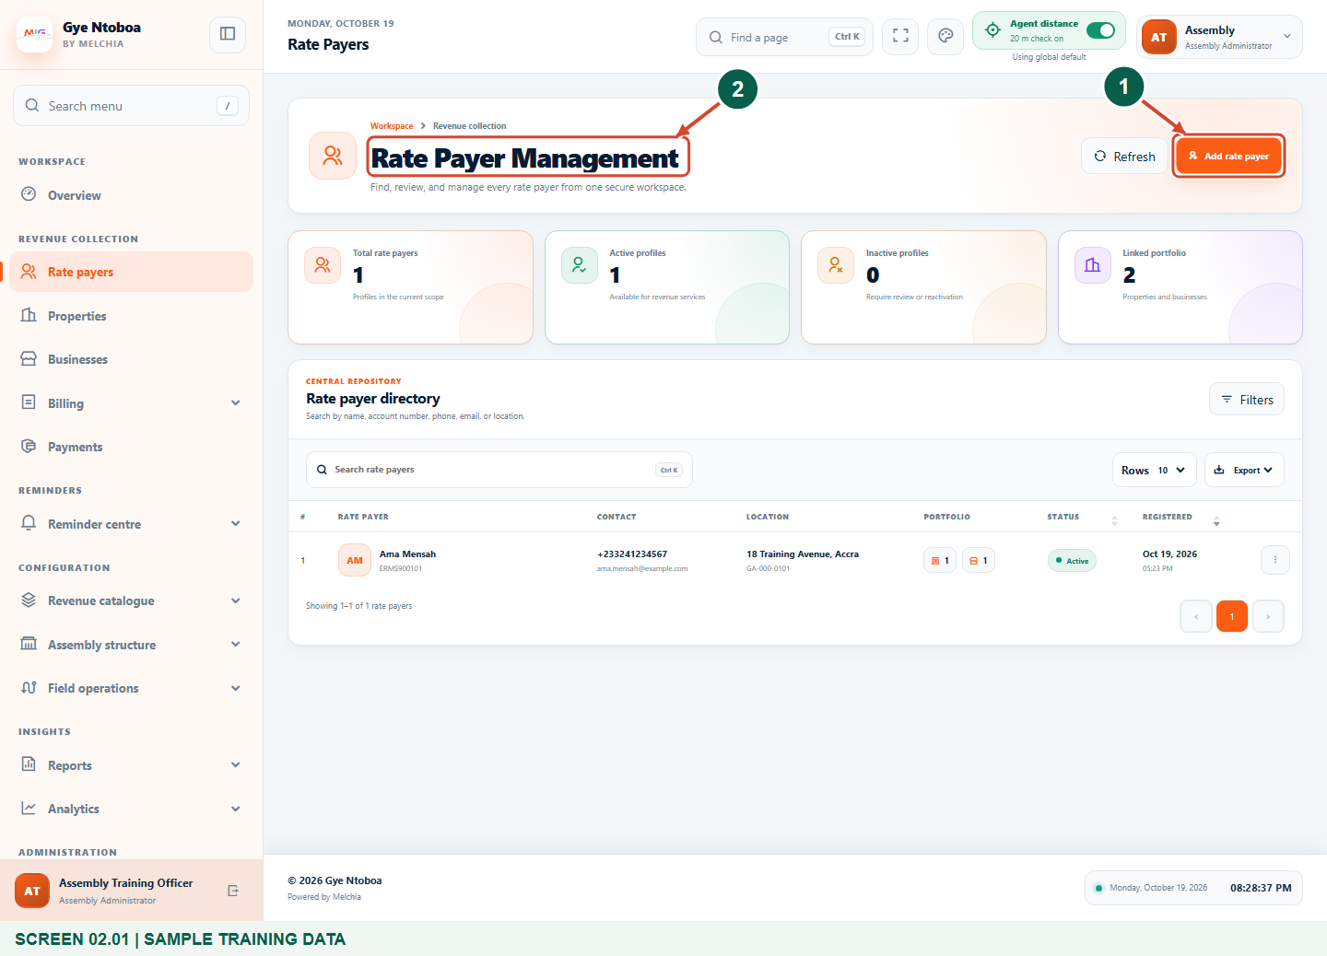
Illustrated steps with numbered arrows and clear expected results.
About the examples
Screens show the actual application in a training environment with sample data. Use your own verified account, bill and contact details when following the guide.

Website: gyentoboa.com

Process flow
Follow the arrows from start to finish. Optional routes are explained in the numbered steps.

Before you start
- Use your own authorised assembly staff account. Do not share staff logins.
- Search for an existing payer first. Have verified identity and phone details; email setup requires a real payer-controlled email.
- The staff workspace is https://assembly.gyentoboa.com. The payer website is https://gyentoboa.com.
- Screenshots use Training Municipal Assembly and synthetic people, records and contacts.
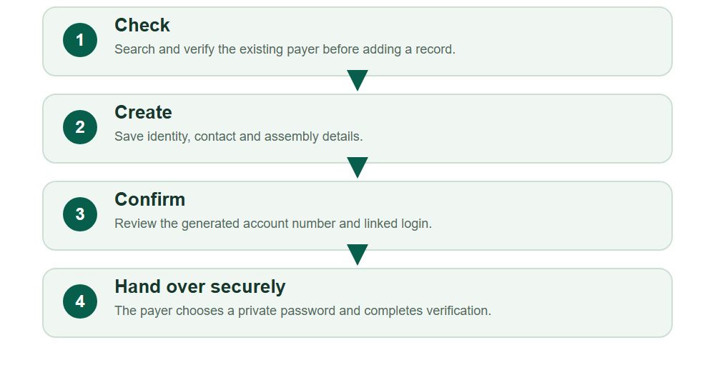
Numbered markers on screenshots identify the controls described beneath each image.

STEP 01

Find the rate payer directory
1. Sign in to https://assembly.gyentoboa.com with your own authorised assembly staff account. Open Rate payers in the sidebar.
2. Search by name, account number or phone before creating another record. If the person already exists, review the existing profile instead.
3. For a new payer, select Add rate payer.
Local training capture with synthetic data.
1 Add rate payer
2 Rate Payers directory
What should happen
The Add a rate payer form opens.

Helpful note: Verify contacts and assembly. A matching name alone does not prove identity.

STEP 02

Enter the identity details
1. Enter the First name and Last name, then select Gender.
2. Enter the Tax identification number only when a valid reference is available.
3. Use the person's own details. Esi Boateng in this guide is a synthetic training example.
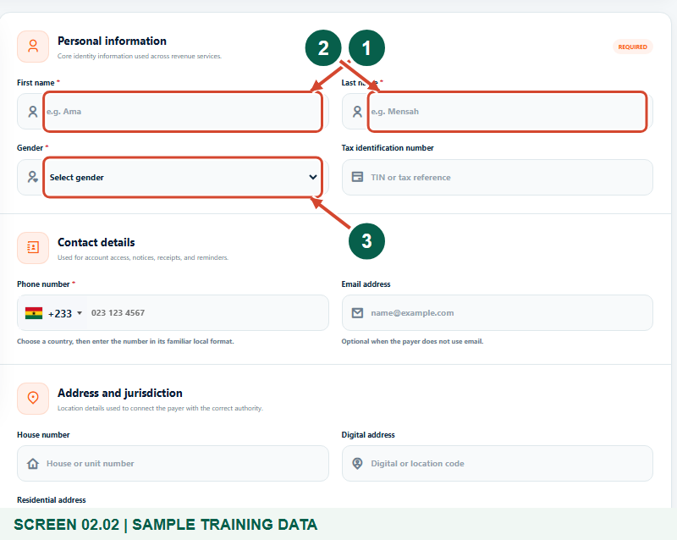
Local training capture with synthetic data.
1 First name
2 Last name
3 Gender
What should happen
Required identity details are complete.

Helpful note: Do not replace the person's name with a property or business name.

STEP 03

Check the contact details
1. Choose the correct country and enter a valid Phone number.
2. Enter the payer's own Email address when available. A genuine email is required for the optional email setup link.
3. Confirm these contacts with the payer. The phone and email must not already belong to a different login.
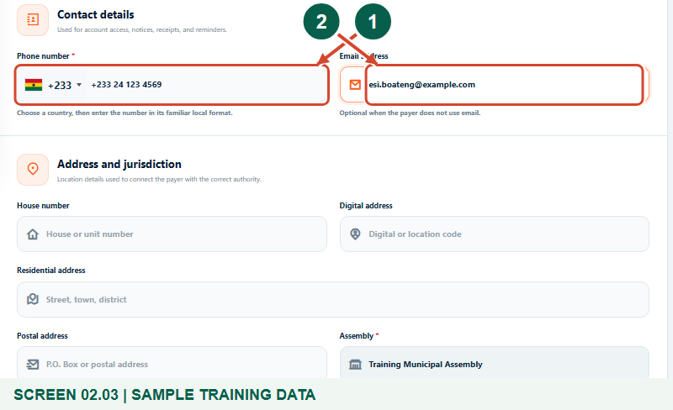
Local training capture with synthetic data.
1 Phone number
2 Email address
What should happen
The payer's contacts are ready for validation and future recovery.

Helpful note: Email is optional for creating the record. Never invent an email for a payer who does not use one.

STEP 04

Review the assembly and save
1. Complete the available House number, Digital address, Residential address and Postal address.
2. Check the read-only Assembly field. A record created by assembly staff is automatically assigned to their own assembly.
3. Select Create rate payer once and wait. Correct any highlighted validation errors before trying again.
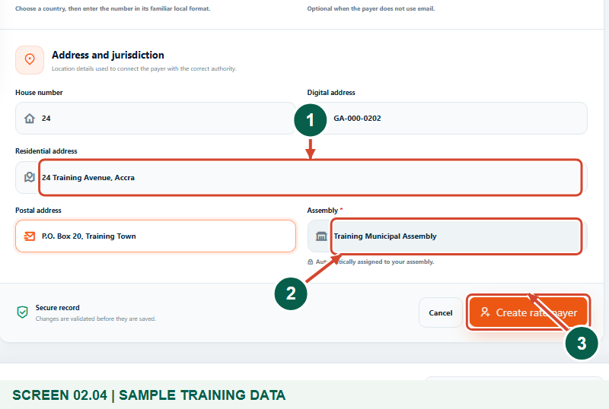
Local training capture with synthetic data.
1 Residential address
2 Your assembly is automatic
3 Create rate payer
What should happen
The saved profile opens with a generated ERMS account number.

Helpful note: The system generates the account number. Staff do not choose or share a temporary password.

STEP 05

Confirm the profile and linked login
1. Review the name, phone, email, Active status, assembly and generated account number.
2. A linked customer login is created automatically. The registration reminder tells an administrator-created payer to use Forgot password to choose a private password.
3. A new profile starts without linked property or business records. Authorised staff must associate the correct revenue records with the correct payer.
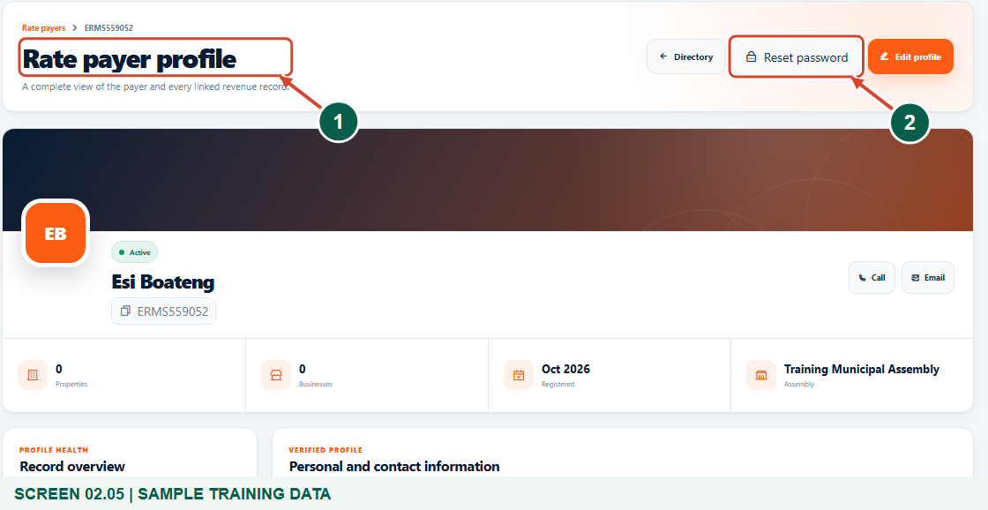
Local training capture with synthetic data.
1 Rate payer profile
2 Reset password
What should happen
A saved payer profile and linked portal identity exist.

Helpful note: A new online registration alone does not authorise access to old bills or another person's records.

STEP 06

Offer a secure email setup link
1. If you have the separate Reset password permission and the payer has a usable email address, select Reset password on the profile.
2. Review Email a one-time setup link and the warning that existing portal sessions will be revoked.
3. If this setup or recovery action is intended, select Revoke access and send link. If the control is absent, contact an authorised administrator.
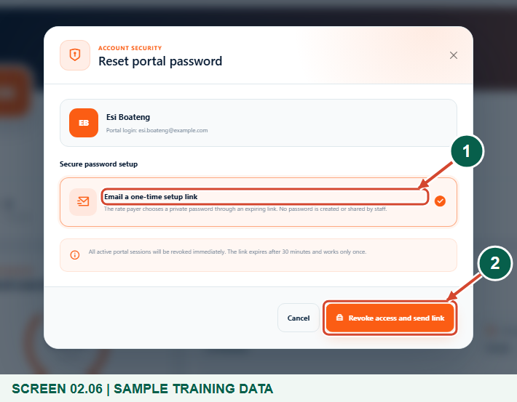
Local training capture with synthetic data.
1 Email a one-time setup link
2 Revoke access and send link
What should happen
An expiring, single-use setup link is queued for email delivery.

Helpful note: The payer can also use Forgot password with their registered phone. Never send setup links to placeholder or third-party addresses.

STEP 07

Check the queued confirmation
1. Confirm the message that sessions were revoked and a one-time setup link was queued.
2. Ask the payer to check their own inbox and spam folder. Queued does not mean delivered.
3. If no message arrives, verify the address and ask support to check delivery. Do not create a duplicate payer to solve a delivery problem.
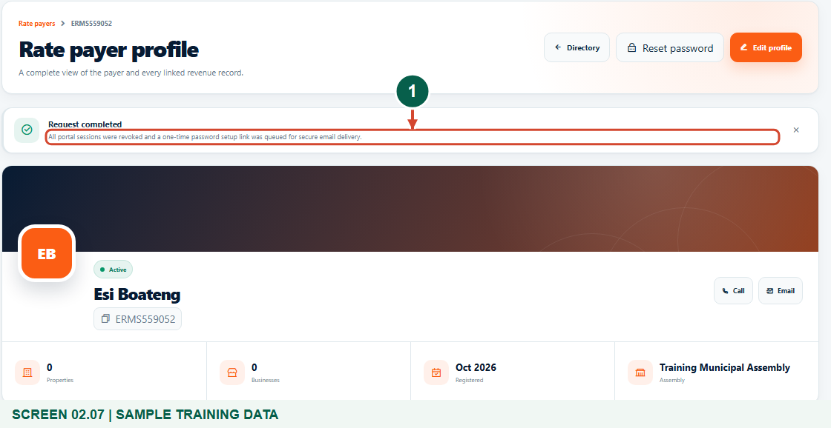
Local training capture with synthetic data.
1 Setup link queued
What should happen
The intended setup or reset request is recorded.

Helpful note: Training messages are captured locally. No real SMS or email is sent.

STEP 08

Let the payer set a private password
1. The payer opens their own email link before it expires. The default validity is 30 minutes, and the link works only once.
2. The payer enters New password and Confirm new password, then selects Save password and continue. Use at least 8 characters with uppercase, lowercase and a number.
3. The payer signs in at https://gyentoboa.com using their registered phone or email and completes SMS verification when prompted. Staff must never request the password or one-time code.
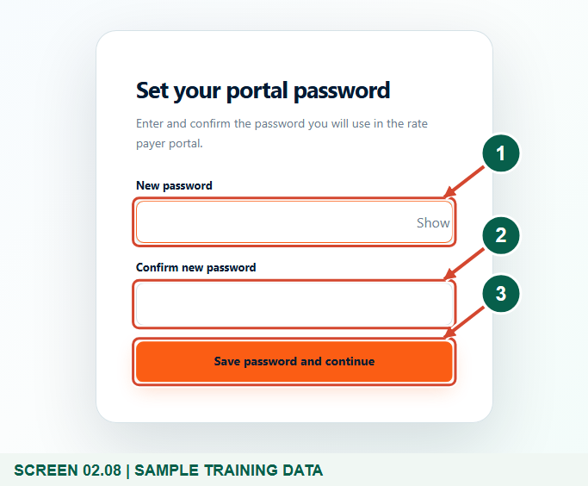
Local training capture with synthetic data.
1 New password
2 Confirm new password
3 Save password and continue
What should happen
The payer can complete private password setup and use the normal sign-in verification flow.

Helpful note: An expired or used link cannot be reused. Request a fresh link or use Forgot password.

Check your result
- One correct payer profile is saved in the intended assembly with its generated account number.
- The phone and any supplied email have been checked.
- The payer knows how to set a private password and complete sign-in verification. No password or OTP was shared with staff.
- Any required asset or portal linking is assigned to an authorised officer rather than assumed from registration.

If you need help
The payer, phone or email already exists.
Review the existing profile and verify ownership. Do not alter contacts simply to bypass duplicate validation.
Add rate payer or Reset password is missing.
Ask an authorised administrator to review your role permissions and jurisdiction.
The payer has no usable email.
Leave optional email blank. Guide the payer to Forgot password using their registered phone; do not send an email link to a placeholder.
The setup link expired or was already used.
Request a new authorised one-time link or use Forgot password. The old link cannot be reused.
Older assets or bills are not visible after sign-in.
Ask the revenue office to check the exact owner, asset and verified portal links. Registration alone does not authorise historical records.
No SMS or email arrives.
Recheck contacts and ask support to inspect delivery. A queued notification is not a delivery guarantee.

Useful things to know
- A reusable temporary password is not provided. Use private password setup or the payer website's Forgot password process.
- The optional email setup action revokes current portal sessions. It requires an authorised administrator and a valid payer-controlled email.
- Creating a login does not by itself authorise historical property or business records. The assembly must verify the correct record links.

Continue learning
- Guide 01: Register a rate payer account
- Guide 03: Access your rate payer account on the web
- Guide 04: View bills and arrears
Download all eight training guides
Open Help and support
For account or bill-record corrections, contact the relevant assembly using its verified contact details. Keep your account or bill reference available when requesting assistance.

