
GYE NTOBOA
MANUAL 4 - ASSEMBLY USER
PROCESS GUIDE 13 / 13

Print bills
Find the correct individual bill, review its identity and charges, and print or download its PDF without confusing billing output with payment receipts or register exports.
WHO THIS IS FOR  Assembly staff authorised to view and print bills | ALLOW ABOUT  10-15 minutes | DOCUMENT VERSION  1.0 | 19 October 2026

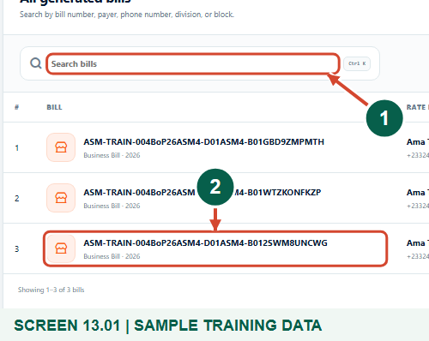
Illustrated steps with numbered arrows and clear expected results.
About the examples
Screens show the actual application in a training environment with sample data. Use your own verified account, assigned records and contact details when following the guide.

Website: assembly.gyentoboa.com

Process flow
Follow the arrows from start to finish. Optional routes are explained in the numbered steps.

Before you start
- Use your own authorised assembly account with bill-view permission.
- Have the bill/account reference and know the intended payer and billing year.
- Use an approved printer or secure file location and follow the assembly privacy/distribution process.
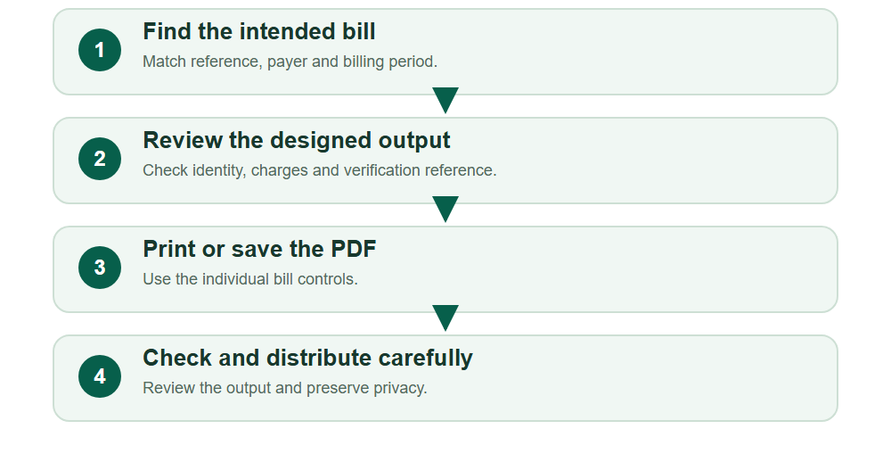
Numbered markers on screenshots identify the controls described beneath each image.

STEP 01

Find the exact bill in the register
1. Open Billing, then All bills. Use bill-type/date/arrears filters and Search bills to find the intended record.
2. Match the reference, year, rate payer and assembly before opening or printing. Do not assume that a similar name identifies the right account.
Synthetic training records in the actual assembly workspace. Find the exact bill in the register.
1 Search the bill reference
2 Verify the bill reference
What should happen
The intended generated bill can be identified in the authorised register.

STEP 02

Choose the individual bill output
1. Open Bill actions for the verified row. Choose Open bill to review the designed bill.
2. View PDF opens a PDF version; Download PDF saves a file directly. These actions apply to this individual bill. Make payment is a separate financial action and is not required for printing.
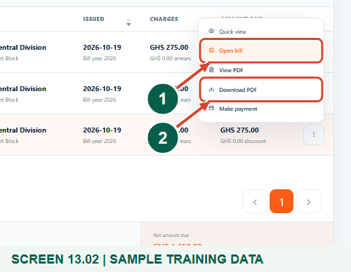
Synthetic training records in the actual assembly workspace. Choose the individual bill output.
1 Review the designed bill
2 Save the PDF directly
What should happen
The individual bill and PDF actions are visible.

STEP 03

Review the bill identity before printing
1. Check the assembly heading, bill type, billing year and unique bill reference.
2. Compare the rate payer and property/business account details with the requested bill. Stop and correct the selection if anything is inconsistent.
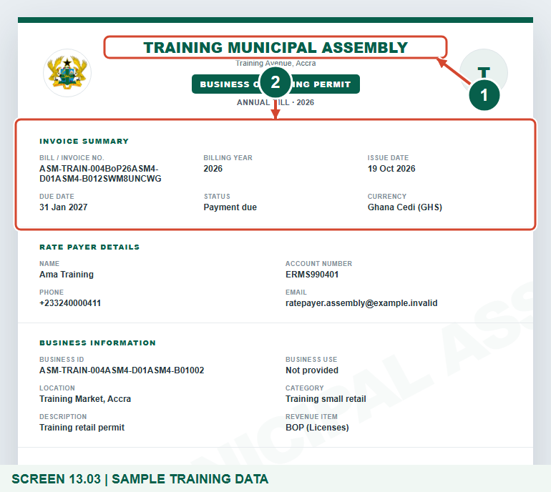
Synthetic training bill. The QR target uses a reserved, nonpayable training host; use the bill issued by your own assembly for real work.
1 Confirm the issuing assembly
2 Check the bill reference
What should happen
The designed bill belongs to the intended account and billing period.

STEP 04

Check the charges and verification reference
1. Read the current charge, arrears, discounts where shown and total amount due. Use the assembly review process for a disputed amount; printing is not a way to edit a bill.
2. Check the verification reference. The QR shown in this guide is a nonpayable synthetic example; do not use it for a real payment.
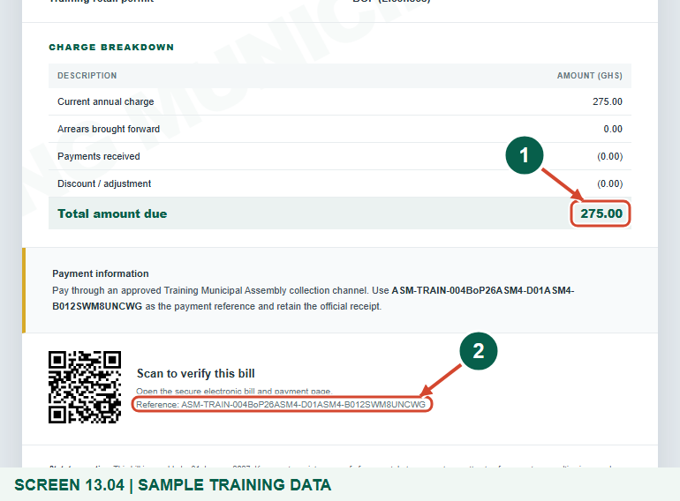
Synthetic training bill. The QR target uses a reserved, nonpayable training host; use the bill issued by your own assembly for real work.
1 Review the total amount due
2 Check the verification reference
What should happen
The financial details and bill reference have been reviewed before distribution.

STEP 05

Open the browser print controls
1. Choose Print or download bill. In the browser or device print controls, select the correct printer or Save as PDF where available.
2. Review the paper, scale, page count and preview before confirming. The print dialog depends on the browser and device; the screenshot shows the actual bill control, not a simulated operating-system dialog.
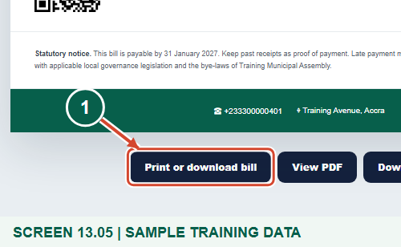
Synthetic training bill. The QR target uses a reserved, nonpayable training host; use the bill issued by your own assembly for real work.
1 Open the browser print controls
What should happen
The browser is asked to print the reviewed individual bill.

STEP 06

Download the generated PDF when a file is needed
1. Choose Download PDF when you need a saved bill file. View PDF is the alternative inline viewing action.
2. Save the file through the browser, then open it and check the reference, payer, amount and page layout. Do not rename a file as a receipt or mark it paid because it downloaded successfully.
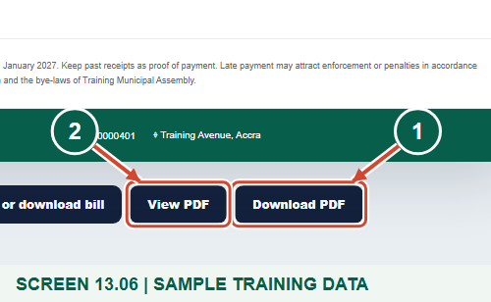
Synthetic training bill. The QR target uses a reserved, nonpayable training host; use the bill issued by your own assembly for real work.
1 Download the bill PDF
2 Alternative PDF viewing action
What should happen
A generated PDF for the same bill is downloaded for review.

STEP 07

Keep individual bills separate from register printouts
1. Before distribution, review the saved PDF or physical output and release it only through authorised assembly channels. Keep the financial reference intact.
2. The register Export menu also has Print, but that prints a register table of loaded rows. It is not a bulk set of individually designed bills and is not proof of delivery or payment. Open and review each required individual bill instead.
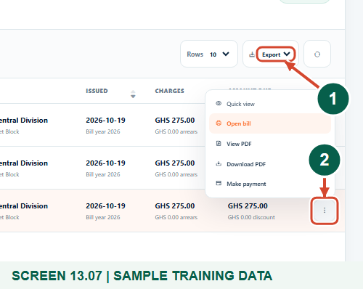
Synthetic training records in the actual assembly workspace. Keep individual bills separate from register printouts.
1 Register export is a different output
2 Open the intended individual bill
What should happen
The intended individual bill is ready for authorised distribution without confusing a table export with bill printing.

Check your result
- The printed/downloaded bill reference, payer and amounts were checked.
- The saved file opens as a PDF and the layout is readable.
- Individual bill output is distinguished from register-table Print and from payment receipts.

If you need help
The bill is not found.
Clear or correct date/type/search filters and verify the account, billing period and assembly scope. Check whether generation completed.
A new tab, PDF or print dialog is blocked.
Allow the required browser action for the trusted assembly site or use Download PDF. Follow device/printer support procedures rather than clicking repeatedly.
The preview is clipped or unreadable.
Review the paper size, scaling and page preview or open the downloaded PDF in a suitable viewer. Do not distribute an unreadable or incorrect bill.

Useful things to know
- Printing/downloading does not create a payment, receipt, delivery acknowledgement or confirmed settlement.
- The register Print export is a loaded table, not bulk individual designed bills.
- All shown data is synthetic; the sample QR uses a reserved nonpayable host. Use the genuine bill issued by your assembly.

Continue learning
- Guide 09: Create properties and assign a rate payer
- Guide 10: Create businesses
- Guide 11: Generate a BOP bill
- Guide 12: Generate business bills in bulk
Download all 13 guides in this collection
For account or bill-record corrections, contact the relevant assembly using its verified contact details. Keep your account or bill reference available when requesting assistance.

