
GYE NTOBOA
MANUAL 4 - ASSEMBLY USER
PROCESS GUIDE 12 / 13

Generate business bills in bulk
Generate a deliberate bulk set of business/BOP bills, monitor actual processing and verify results while preserving the duplicate-year safeguard.
WHO THIS IS FOR  Assembly billing staff authorised to generate business bills for a coverage area | ALLOW ABOUT  15-25 minutes | DOCUMENT VERSION  1.0 | 19 October 2026

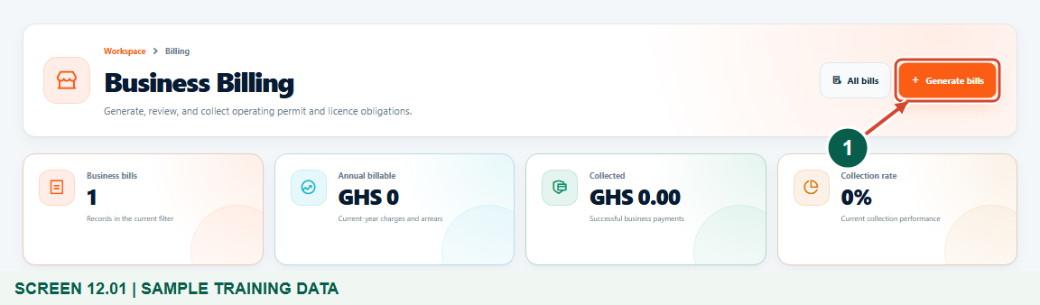
Illustrated steps with numbered arrows and clear expected results.
About the examples
Screens show the actual application in a training environment with sample data. Use your own verified account, assigned records and contact details when following the guide.

Website: assembly.gyentoboa.com

Process flow
Follow the arrows from start to finish. Optional routes are explained in the numbered steps.

Before you start
- Use your authorised assembly account and confirm the billing period and approved coverage.
- Ensure the relevant mapped businesses have configured approved revenue rates and linked rate payers.
- Check existing bills and recent runs before submitting another request.
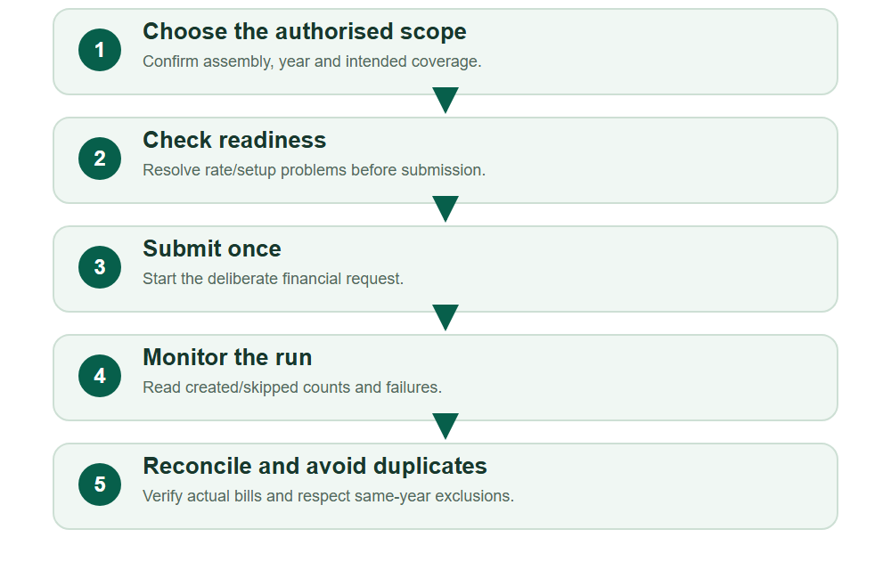
Numbered markers on screenshots identify the controls described beneath each image.

STEP 01

Open Business Billing for the bulk run
1. Open Billing, then Generate business bills. This is the same BOP/business billing engine used for a single selected business.
2. Review previous processing activity and the chosen year before creating a new run. The earlier same-year bill must not be generated again.
Synthetic training records in the actual assembly workspace. Open Business Billing for the bulk run.
1 Open the guided generator
What should happen
The business register and generation entry point are available.

STEP 02

Confirm the year and choose the intended coverage
1. Confirm the assembly and Billing year. Choose Whole assembly, One division, One block or Selected records according to the authorised batch.
2. This example uses One block. Whole assembly includes every eligible record in the assembly; Selected records supports up to 500 intentional choices. Review coverage carefully before submitting.
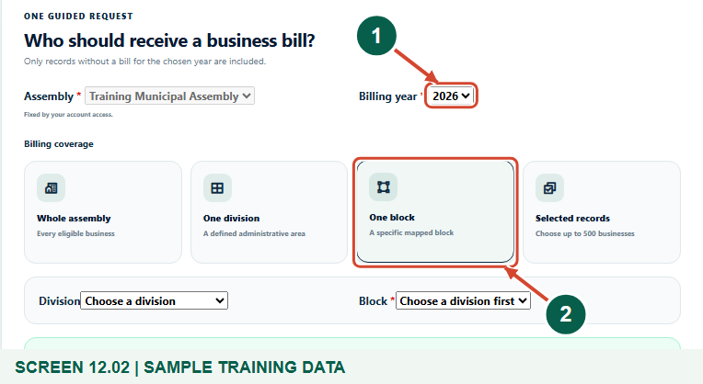
Synthetic training records in the actual assembly workspace. Confirm the year and choose the intended coverage.
1 Confirm the billing year
2 Choose the intended coverage
What should happen
The year and deliberate bulk coverage are selected.

STEP 03

Select the correct division and block
1. For One block, choose the division first and then a block within it. For One division, choose the intended division instead.
2. Read the selected names and the readiness count. The server limits the run to the authorised assembly and scope.
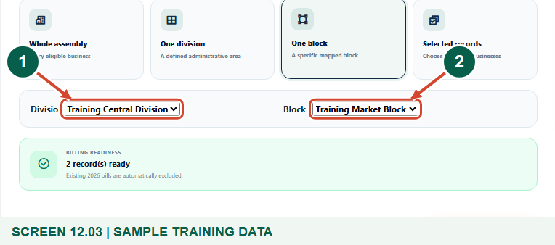
Synthetic training records in the actual assembly workspace. Select the correct division and block.
1 Select the correct division
2 Select the correct block
What should happen
The block and its two remaining eligible businesses are identified.

STEP 04

Review readiness and the financial scope
1. Read Billing readiness. Resolve missing rates before billing; an ineligible or skipped record is not evidence of a newly issued bill.
2. Recheck year and coverage, then choose Start generation once. Charges, arrears and authorised adjustments come from configured rules; you are not entering a payment here.
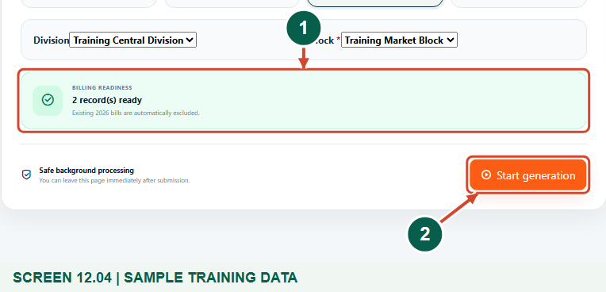
Synthetic training records in the actual assembly workspace. Review readiness and the financial scope.
1 Review the eligible-record count
2 Submit this scope once
What should happen
The deliberate bulk request is ready and existing same-year bills remain excluded.

STEP 05

Monitor created, skipped and failed results
1. Use Bill processing activity and Refresh to follow the actual background result. The system may continue processing after you leave the request form.
2. Read created/skipped counts and any failure or queue warning. Escalate unresolved failures with the run reference; do not create repeated overlapping requests.
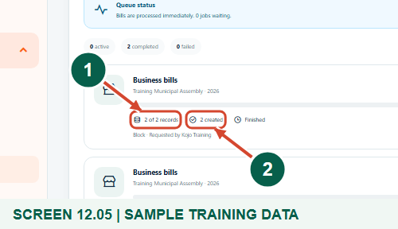
Synthetic training records. Close view of the actual completed run: processed records, bills created and Finished result. The full activity panel retains the run status and scope.
1 Read the processed-record count
2 Read actual bills created
What should happen
The example block run is Completed with two new bills created.

STEP 06

Verify the new bills and representative records
1. Review the Business bill register and use Bill actions > Quick view or Open bill for representative records. Check payer, year, current charge, arrears and amount due.
2. Check the earlier single-business bill remains the same record. Reconcile the batch to its scope and actual created/skipped counts; the figure shows one representative new bill, not the entire batch.
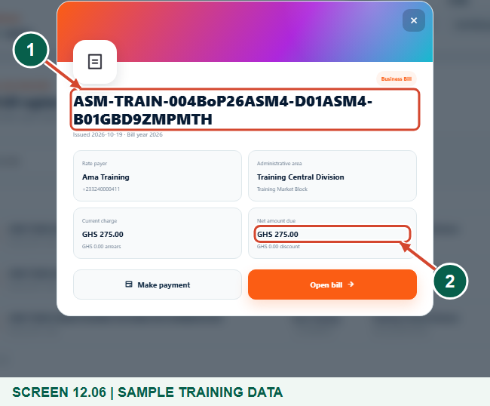
Synthetic training records. Actual Quick view of one representative bill from the two-business block run; the register and preserved run evidence confirm the complete batch.
1 Verify the bill reference
2 Check the net amount due
What should happen
The register includes the two new bills and the unchanged earlier single bill.

STEP 07

Recognise already-billed records and avoid duplicate runs
1. After all eligible businesses in this example have a bill for the year, the readiness check shows No records are eligible and Start generation is disabled.
2. Review existing bills instead of changing the year or registering a duplicate business to force another charge. A genuine correction or replacement follows the separate authorised assembly process.
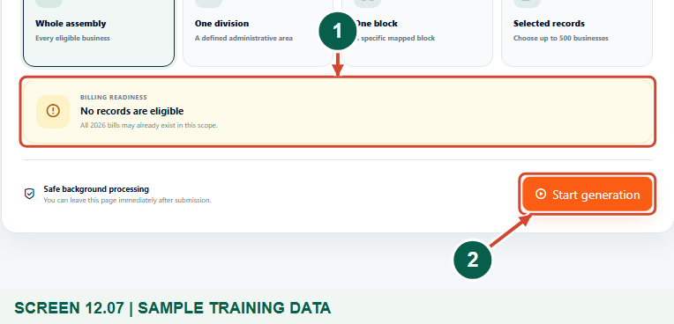
Synthetic training records in the actual assembly workspace. Recognise already-billed records and avoid duplicate runs.
1 Recognise the already-billed state
2 Do not bypass the disabled action
What should happen
The same-year readiness check prevents another ordinary generation request for these already-billed records.

Check your result
- The intended year and coverage were submitted once.
- Actual processing counts and representative bills were reviewed.
- The existing single bill remained unchanged and already-billed records are excluded.

If you need help
Some records need a rate.
Review their approved revenue assignments and configured positive rates. A readiness warning is not permission to use an unrelated rate.
No records are eligible.
Check the assembly, year, coverage and existing bills. Already-billed records are excluded; do not bypass this by changing identity or period.
The count is lower than expected.
Reconcile the scope, eligibility, configured rates and created/skipped counts. Ask authorised support to investigate unresolved failures.

Useful things to know
- Bulk business billing uses the same BOP/business generator as a single selected record.
- Register table exports contain loaded rows; they are not proof that every assembly business was billed.
- Generation creates obligations and notices through configured channels; it does not confirm payment.

Continue learning
- Guide 07: Create revenue streams
- Guide 08: Set rates
- Guide 10: Create businesses
- Guide 11: Generate a BOP bill
- Guide 13: Print bills
Download all 13 guides in this collection
For account or bill-record corrections, contact the relevant assembly using its verified contact details. Keep your account or bill reference available when requesting assistance.

