
GYE NTOBOA
MANUAL 4 - ASSEMBLY USER
PROCESS GUIDE 11 / 13

Generate a BOP bill
Assign the approved BOP licence rule, generate one bill for one selected business and verify the completed financial record without confusing billing with payment.
WHO THIS IS FOR  Assembly billing staff authorised to assign business revenue rules and generate bills | ALLOW ABOUT  15-20 minutes | DOCUMENT VERSION  1.0 | 19 October 2026

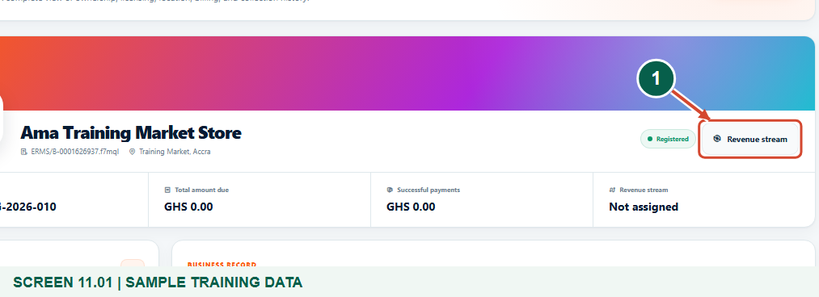
Illustrated steps with numbered arrows and clear expected results.
About the examples
Screens show the actual application in a training environment with sample data. Use your own verified account, assigned records and contact details when following the guide.

Website: assembly.gyentoboa.com

Process flow
Follow the arrows from start to finish. Optional routes are explained in the numbered steps.

Before you start
- Use the correct assembly account with business-update and bill-generation permissions.
- Have an existing mapped business linked to the correct active rate payer.
- Ensure the authorised BOP (Licenses) rule has a configured positive flat rate or minimum amount, and confirm that no bill already exists for the chosen year.
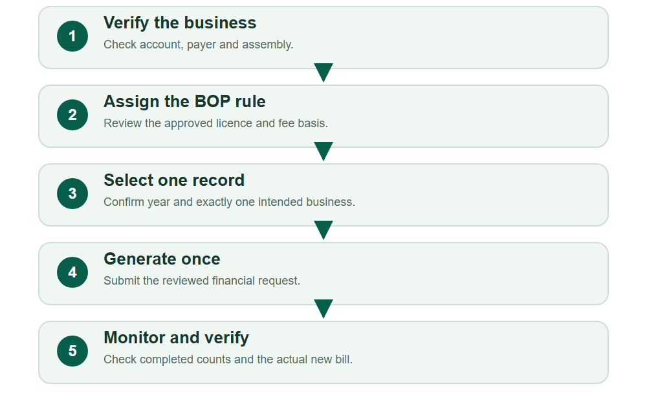
Numbered markers on screenshots identify the controls described beneath each image.

STEP 01

Open the intended business and its revenue setup
1. Open the saved business profile and verify the business account, owner and assembly.
2. Choose Revenue stream. A BOP bill uses the operating-permit or licence rule assigned to this business; it is not an agent payment request.
Synthetic training records in the actual assembly workspace. Open the intended business and its revenue setup.
1 Open the business revenue rule
What should happen
The correct business is identified before a billing rule is assigned.

STEP 02

Search and review the approved BOP rule
1. On Assign revenue stream, choose BOP (Licenses) and use Item description or Category to narrow the approved fee-fixing catalogue when needed. Choose Search streams.
2. Read the matching licence description, duration, flat rate and minimum amount. Use the authorised rule for this business, not merely the first result.
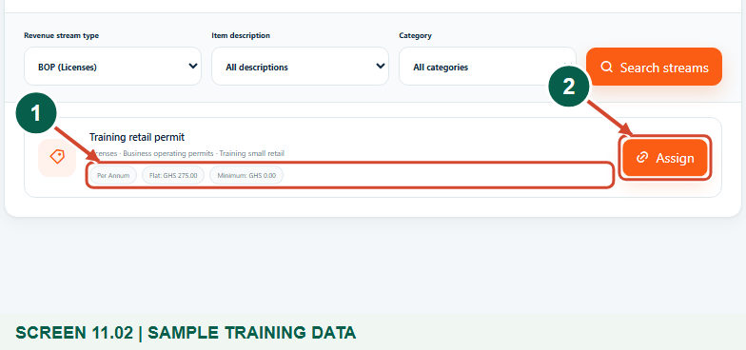
Synthetic training records in the actual assembly workspace. Search and review the approved BOP rule.
1 Review the BOP charge rule
2 Assign only the correct rule
What should happen
The intended BOP rule and its configured charge basis are visible.

STEP 03

Confirm the saved revenue assignment
1. Choose Assign for the approved rule and wait for the success confirmation.
2. Read Current revenue stream again. Assigning the rule prepares the business for billing; it does not yet create a bill or collect money.
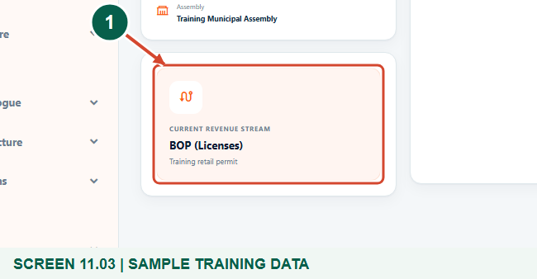
Synthetic training records in the actual assembly workspace. Confirm the saved revenue assignment.
1 Verify the current BOP stream
What should happen
The business profile has the intended BOP revenue assignment.

STEP 04

Choose the billing year and Selected records
1. From Billing, open Generate business bills and choose Generate bills. Confirm the assembly and billing year.
2. Choose Selected records for this single-business example. Existing bills for that same year are automatically excluded; do not change the year just to bypass an existing bill.
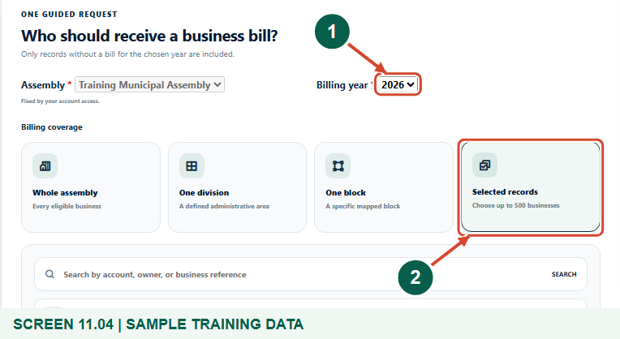
Synthetic training records in the actual assembly workspace. Choose the billing year and Selected records.
1 Confirm the billing year
2 Choose Selected records
What should happen
The generator is scoped to the correct year and allows an intentional single selection.

STEP 05

Select exactly the intended business
1. Search by business name, account, owner or reference, then select the correct Rate ready result.
2. Check the selected-record chip and confirm that only the intended business is selected. Remove an incorrect selection before proceeding. The readiness card can describe the available lookup scope; the selected chips determine this selected-record request.
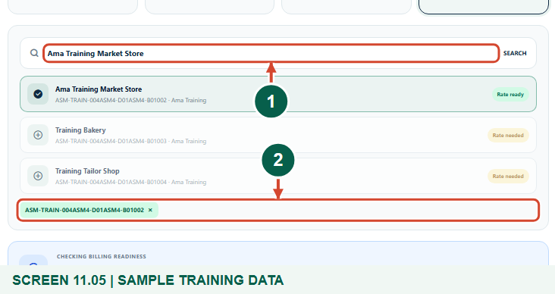
Synthetic training records in the actual assembly workspace. Select exactly the intended business.
1 Find the intended business
2 Review the selected record
What should happen
Exactly one intended business is selected for the run.

STEP 06

Review readiness and start generation once
1. Recheck the selected business, year, approved rate and any existing arrears or authorised adjustments.
2. Choose Start generation once. This creates a financial bill and may queue notices through configured channels; it does not collect payment. A request-accepted message is not a completed run.
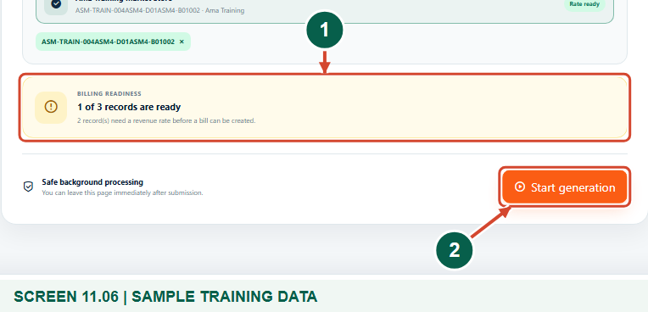
Synthetic training records in the actual assembly workspace. Review readiness and start generation once.
1 Review billing readiness
2 Start the reviewed run once
What should happen
The reviewed request is ready to be submitted without a duplicate click.

STEP 07

Monitor the actual processing result
1. After acceptance, use Bill processing activity and Refresh to follow queued, processing, completed or failed status.
2. Check created and skipped counts. If a queue warning or failure remains, ask the authorised support team to investigate; do not repeatedly generate the same bill.
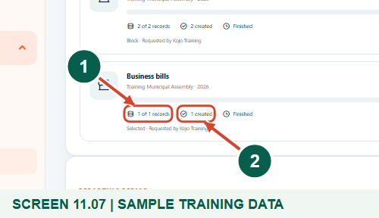
Synthetic training records. Close view of the actual completed run: processed records, bills created and Finished result. The full activity panel retains the run status and scope.
1 Read the processed-record count
2 Read actual bills created
What should happen
The example run is Completed with one bill created.

STEP 08

Verify the generated BOP bill
1. Find the new bill in the Business bill register. In Bill actions, choose Quick view to compare the reference, year, rate payer, current charge, arrears and amount due.
2. Use Open bill or its PDF for detailed review. A generated BOP bill is an obligation, not a payment receipt or confirmation that an operating permit has been paid.
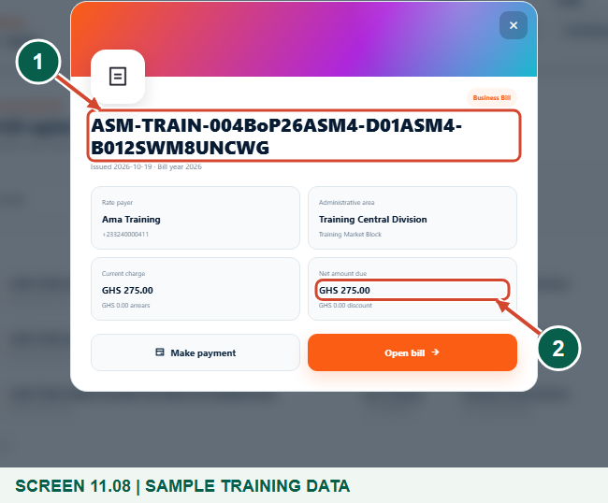
Synthetic training records. Actual Quick view of the generated single-business BOP bill; reference, payer and net amount are reviewed before opening the full bill.
1 Verify the bill reference
2 Check the net amount due
What should happen
One distinct BOP business bill exists for the selected business and year.

Check your result
- The intended BOP rule is assigned to the correct business.
- One selected business was submitted once for the correct year.
- The completed run and generated bill have been checked.

If you need help
No suitable BOP stream appears.
Check category/description filters and the assembly fee-fixing setup. Only eligible same-assembly BOP licence rules can be assigned here.
The business says Rate needed or is missing.
Check its assigned configured revenue rule and whether a bill already exists for that year. Do not create a duplicate business to bypass eligibility.
The run stays queued or fails.
Use Refresh and review the queue/status warning. Give support the request and assembly references rather than submitting repeatedly.

Useful things to know
- BOP billing uses the Business Billing engine. It is not a separate second bill for the same business and year.
- Generating a bill does not itself collect money or confirm permit payment.
- Delivery of configured SMS/email notices must not be assumed from the generation-accepted screen.

Continue learning
- Guide 07: Create revenue streams
- Guide 08: Set rates
- Guide 10: Create businesses
- Guide 12: Generate business bills in bulk
- Guide 13: Print bills
Download all 13 guides in this collection
For account or bill-record corrections, contact the relevant assembly using its verified contact details. Keep your account or bill reference available when requesting assistance.

