
GYE NTOBOA
MANUAL 4 - ASSEMBLY USER
PROCESS GUIDE 10 / 13

Create businesses
Create a complete, mapped business profile linked to its responsible rate payer, then verify the saved account before revenue assignment or billing.
WHO THIS IS FOR  Assembly staff authorised to create business records | ALLOW ABOUT  15–20 minutes | DOCUMENT VERSION  1.0 | 19 October 2026

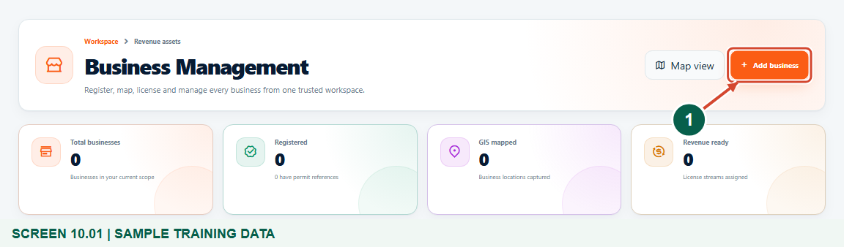
Illustrated steps with numbered arrows and clear expected results.
About the examples
Screens show the actual application in a training environment with sample data. Use your own verified account, assigned records and contact details when following the guide.

Website: assembly.gyentoboa.com

Process flow
Follow the arrows from start to finish. Optional routes are explained in the numbered steps.

Before you start
- Use your own assembly account with permission to view and add businesses.
- Have verified business/contact information and an active rate payer already registered in the same assembly.
- Ensure the correct division and block are configured; have the actual business location available.
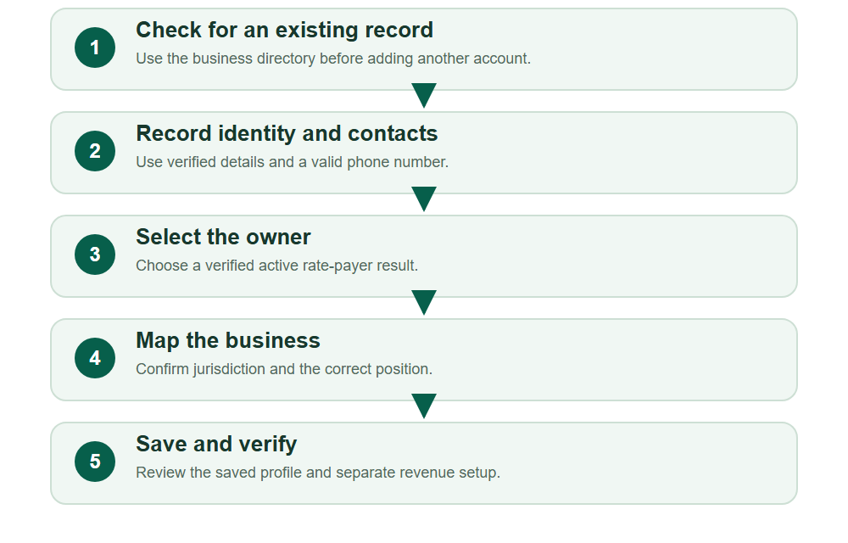
Numbered markers on screenshots identify the controls described beneath each image.

STEP 01

Open the business directory
1. Open Businesses in your assembly workspace and check for an existing record for the same business.
2. Choose Add business when a new registration is appropriate. Use your own authorised account.
Synthetic training records in the actual assembly workspace. Open the business directory.
1 Add a business
What should happen
The directory provides the authorised Add business action.

STEP 02

Record verified business details
1. Enter the Business Name and verified address/location details. Add a Registration No. or Permit No. only when it already exists and is supported by the assembly record.
2. Location and business name are required. Saving this profile does not itself issue a registration certificate or operating permit.
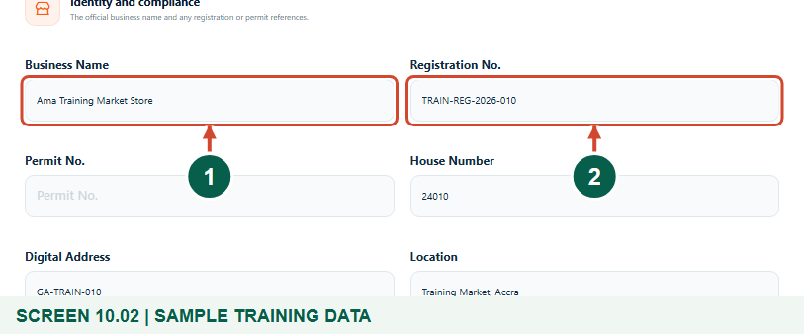
Synthetic training records in the actual assembly workspace. Record verified business details.
1 Enter the business name
2 Record verified references only
What should happen
The business is clearly identified without claiming an unissued permit.

STEP 03

Enter the business contact information
1. Choose the phone country and enter a valid telephone number in the format shown. Recheck the selected country and number.
2. Enter the verified contact address and email where available. Use approved business contacts; do not publish private contacts unnecessarily.
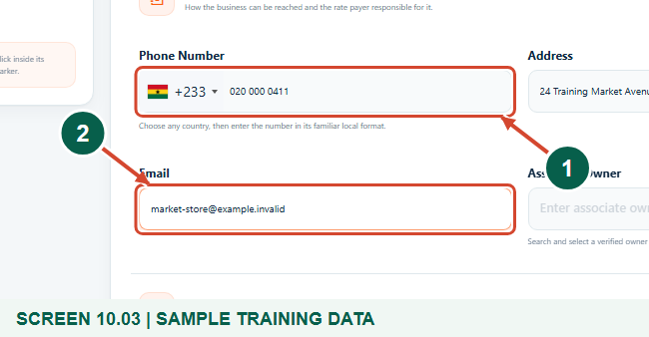
Synthetic training records in the actual assembly workspace. Enter the business contact information.
1 Choose the country and valid number
2 Check the contact email
What should happen
The required phone number is valid and optional contact details are accurate.

STEP 04

Select the active rate payer responsible for the business
1. Search Associate Owner using part of the active owner’s name, phone, email or ERMS ID.
2. Compare the returned identity and select the correct result. The confirmation reflects the current form selection; the business-owner association is persisted only after Save business succeeds. Typing a name alone does not complete the selection.
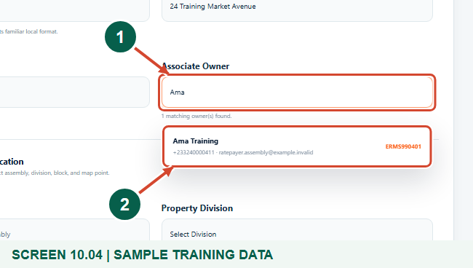
Synthetic training records in the actual assembly workspace. Select the active rate payer responsible for the business.
1 Search the active owner register
2 Select the responsible owner
What should happen
The correct active rate payer is selected in the form. The association becomes part of the saved business only when Save business succeeds.

STEP 05

Choose the assembly, division and block
1. Confirm the assembly fixed by your account. Choose the correct division and then a block belonging to that division.
2. If a required division or block is missing, ask the authorised assembly officer to check geographic setup; do not use an unrelated area.
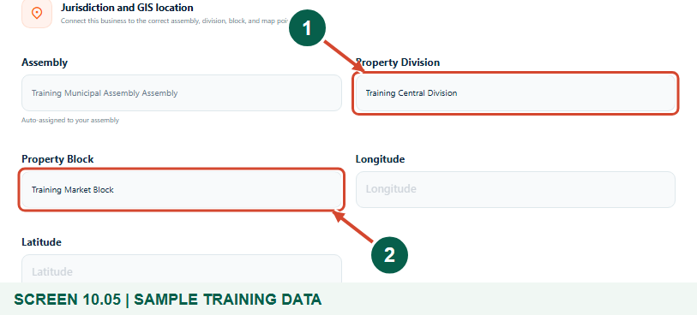
Synthetic training records in the actual assembly workspace. Choose the assembly, division and block.
1 Choose the division
2 Choose its block
What should happen
The selected block boundary is ready for the business location.

STEP 06

Place the business point inside its block
1. Click the actual business position inside the selected block. Check the marker and the automatically filled Longitude and Latitude.
2. Use the real location. The map helps place a business record; it is not a tool for changing the assembly’s administrative boundary.
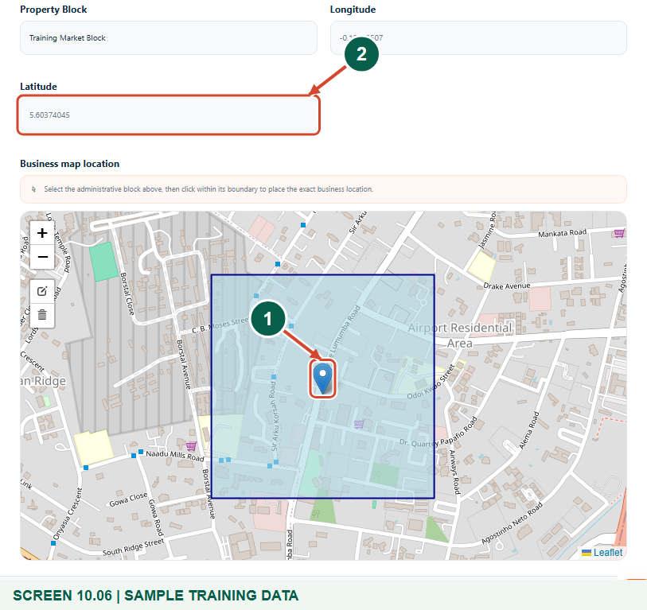
Synthetic training records in the actual assembly workspace. Place the business point inside its block.
1 Check the business marker
2 Review the latitude
What should happen
The business marker and coordinates match the intended location.

STEP 07

Review and save the business
1. Review the name, registration/permit references, contacts, selected owner and map position.
2. Choose Save business once. If validation fails, correct the highlighted fields and verify the owner selection before trying again.
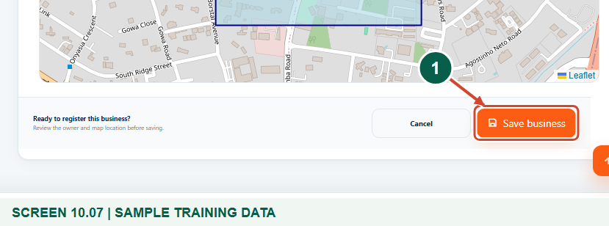
Synthetic training records in the actual assembly workspace. Review and save the business.
1 Save the reviewed business
What should happen
A successful save returns to the business directory with confirmation.

STEP 08

Verify the saved business account and owner
1. Open the saved Business profile. Confirm its name, generated account/reference and responsible owner.
2. In your live Business profile, inspect the full Revenue stream status before billing; the figure concentrates on business identity and the owner. A new business needs the approved BOP stream before billing. Profile creation is separate from bill generation, permit issuance and payment.
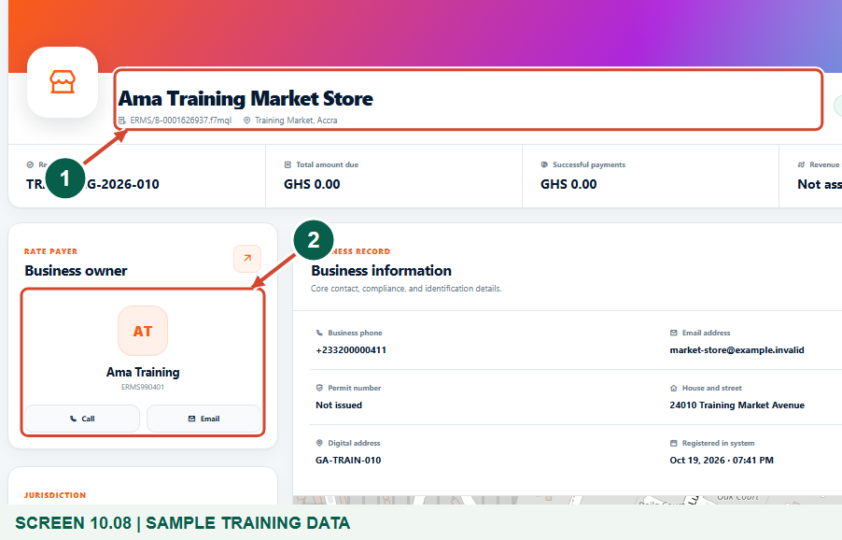
Synthetic training records in the actual assembly workspace. Verify the saved business account and owner.
1 Verify the business account
2 Verify its rate payer
What should happen
The saved business belongs to the intended rate payer and is ready for approved revenue setup.

Check your result
- The saved business name/account identify the intended establishment.
- Contact details and the active responsible owner are correct.
- The business is mapped to the right division and block.

If you need help
The phone number is rejected.
Check the selected country, national/international format and digits. Use a valid contact rather than a made-up placeholder.
The owner does not appear.
Check the assembly and search part of the name, phone, email or ERMS ID. Only an active owner in scope can be selected.
No block or map point is available.
Select the division first, then its block. Ask the authorised geographic officer to correct a missing or incorrect boundary.

Useful things to know
- Saving the business profile does not issue a legal registration, operating permit, bill or payment receipt.
- Revenue-stream assignment and BOP billing are separate authorised tasks.
- The sample business and contacts are synthetic training records.

Continue learning
- Guide 01: Access your assembly administrator account
- Guide 05: Create divisions in your assembly
- Guide 06: Create blocks within a division
- Guide 07: Create revenue streams
- Guide 08: Set rates
- Guide 11: Generate a BOP bill
- Guide 12: Generate business bills in bulk
Download all 13 guides in this collection
For account or bill-record corrections, contact the relevant assembly using its verified contact details. Keep your account or bill reference available when requesting assistance.

