
GYE NTOBOA
MANUAL 4 - ASSEMBLY USER
PROCESS GUIDE 09 / 13

Create properties and assign a rate payer
Register a mapped property, link the correct existing active rate payer, and verify the saved account without confusing registration with valuation, billing or payment.
WHO THIS IS FOR  Assembly staff authorised to create property records | ALLOW ABOUT  15–20 minutes | DOCUMENT VERSION  1.0 | 19 October 2026

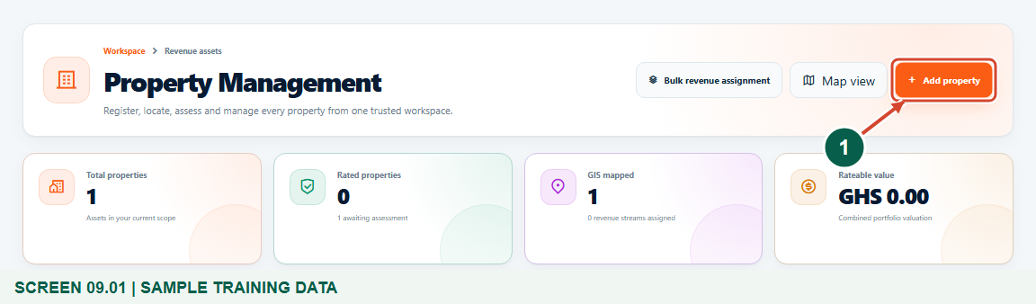
Illustrated steps with numbered arrows and clear expected results.
About the examples
Screens show the actual application in a training environment with sample data. Use your own verified account, assigned records and contact details when following the guide.

Website: assembly.gyentoboa.com

Process flow
Follow the arrows from start to finish. Optional routes are explained in the numbered steps.

Before you start
- Use your own authorised assembly account with Properties access and permission to add records.
- Have verified address/location details and an existing active rate payer in the same assembly.
- Ensure the correct division and block are configured. Use approved valuation information for a rated property.
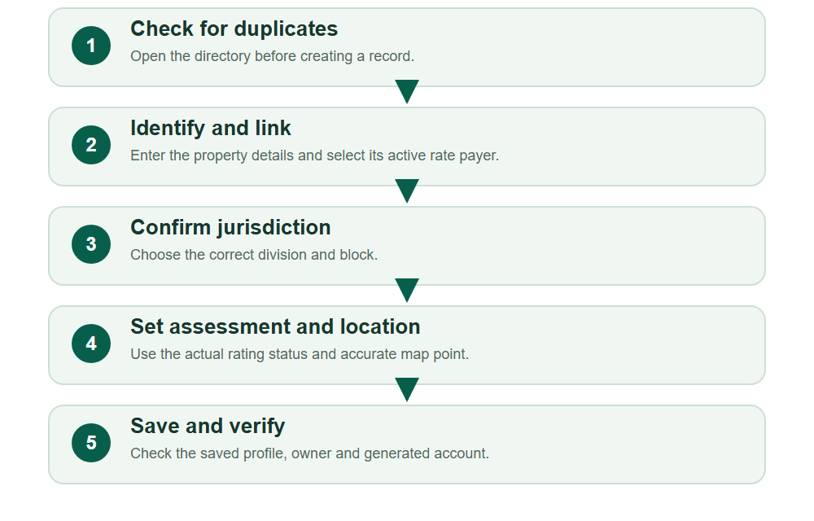
Numbered markers on screenshots identify the controls described beneath each image.

STEP 01

Open the property directory
1. Open Properties from the assembly navigation. Confirm that you are working in the correct assembly.
2. Choose Add property to register a new record. Search for an existing property first so you do not create a duplicate.
Synthetic training records in the actual assembly workspace. Open the property directory.
1 Add a property
What should happen
The property directory and Add property action are available to your authorised account.

STEP 02

Enter the property identity and address
1. Enter the verified house number, digital address, location and street where available. Location is required.
2. Use the actual property details from the assembly record or field evidence; do not invent a valuation or duplicate an existing account.
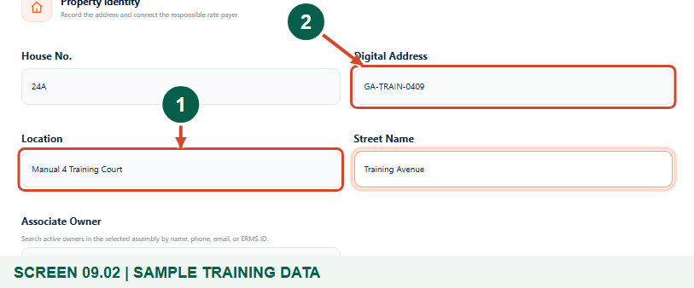
Synthetic training records in the actual assembly workspace. Enter the property identity and address.
1 Record the location
2 Check the digital address
What should happen
The address identifies the intended property before ownership is linked.

STEP 03

Search and select the responsible rate payer
1. In Associate Owner, type at least two characters of the active owner’s name, phone, email or ERMS ID.
2. Check the returned identity and choose the correct result. Typing a name without selecting a result does not complete the link. If the owner is missing, complete the approved rate-payer registration process first.
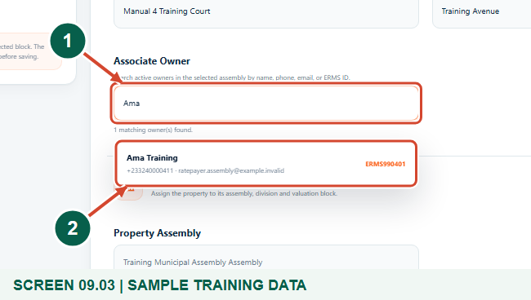
Synthetic training records in the actual assembly workspace. Search and select the responsible rate payer.
1 Search the active owner register
2 Select the verified owner
What should happen
The verified result identifies the rate payer responsible for this property.

STEP 04

Confirm the owner link
1. Read the confirmation below Associate Owner and verify the selected name and ERMS ID.
2. Correct an incorrect choice before saving. This confirmation reflects the current form selection; the property-owner association is persisted only after Save property succeeds. It does not create a separate web-login account.
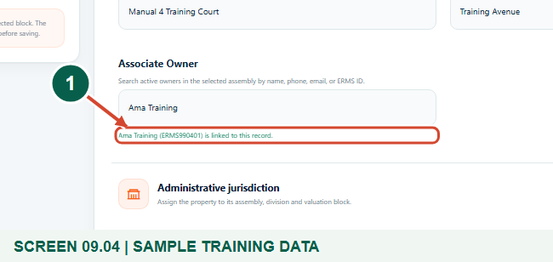
Synthetic training records in the actual assembly workspace. Confirm the owner link.
1 Verify the linked owner
What should happen
The correct existing owner is selected in the form. The association is saved only after Save property succeeds.

STEP 05

Choose the administrative jurisdiction
1. Confirm the Property Assembly fixed by your account. Select the correct Property Division, then its Property Block.
2. The block must belong to the selected division. Changing the assembly or division clears dependent choices; select them again before continuing.
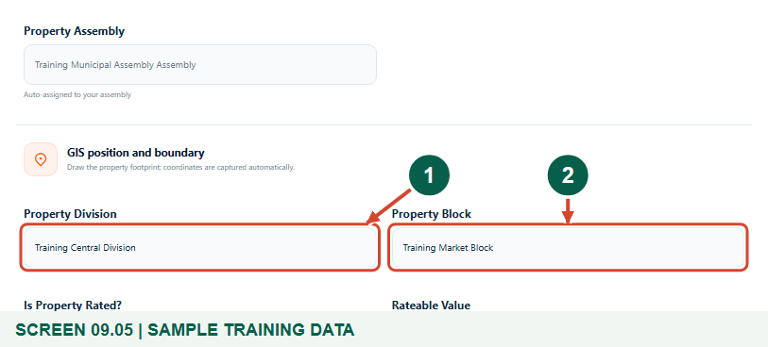
Synthetic training records in the actual assembly workspace. Choose the administrative jurisdiction.
1 Choose the division
2 Choose its block
What should happen
The selected block boundary is loaded for the intended assembly and division.

STEP 06

Set the assessment status honestly
1. For an unrated property, choose No for Is Property Rated? as shown in this example. Do not enter an invented rateable value.
2. For a rated property, choose Yes and use the valuation-number lookup for the approved imported record in this assembly. Enter the verified nonnegative rateable value and the accurate location inside the selected division and block. Check the actual approved valuation and location rather than assuming the lookup confirms every detail.
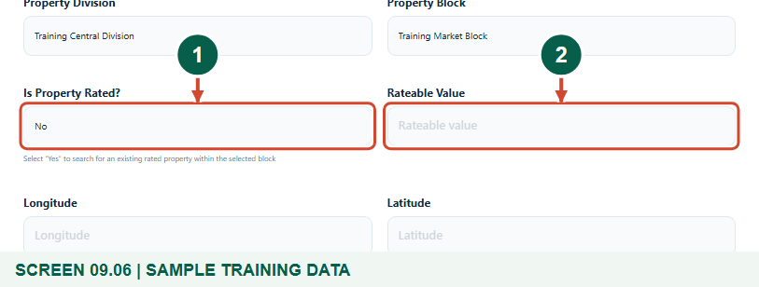
Synthetic training records in the actual assembly workspace. Set the assessment status honestly.
1 Choose the actual assessment status
2 Use approved valuation values only
What should happen
The assessment status reflects the property’s actual approved record.

STEP 07

Place the property at its correct map position
1. With the block selected, click the property’s exact position inside the displayed boundary. The form fills Longitude and Latitude.
2. Review the marker and coordinates. The current workflow loads the block boundary; do not redraw an administrative boundary or place the property outside its division or block.
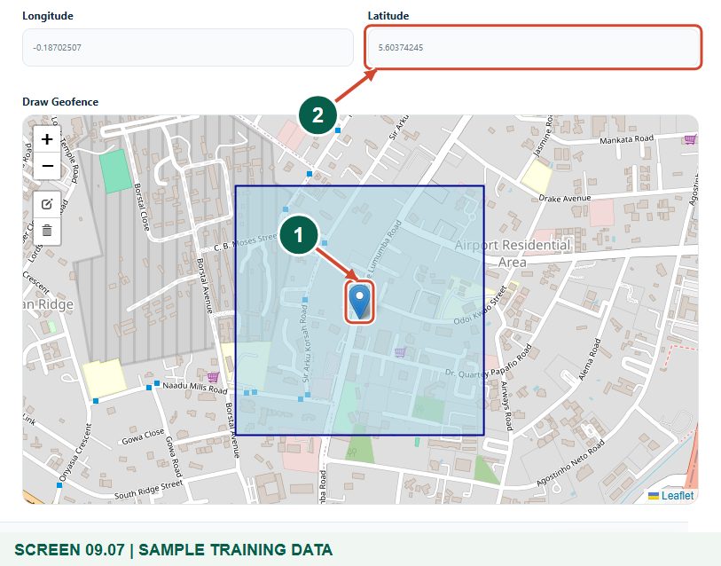
Synthetic training records in the actual assembly workspace. Place the property at its correct map position.
1 Check the selected map position
2 Check the coordinates
What should happen
The marker is inside the selected block and valid coordinates are present.

STEP 08

Review and save the property
1. Recheck the address, selected rate payer, jurisdiction, assessment status and map position.
2. Choose Save property once. Resolve any highlighted validation message before leaving; a missing owner result or out-of-bound point will prevent a valid registration.
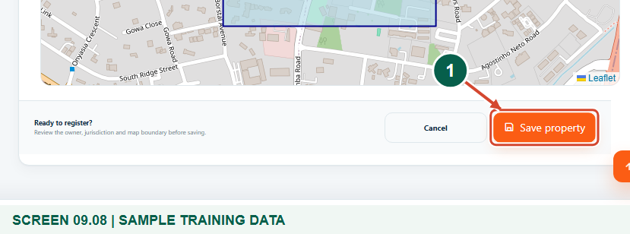
Synthetic training records in the actual assembly workspace. Review and save the property.
1 Save the reviewed property
What should happen
A successful save returns to the property directory with a confirmation.

STEP 09

Verify the saved property and rate payer
1. Open the saved property profile and confirm its generated account/reference, address and linked owner.
2. Property creation does not itself create a bill or payment. In your live Property profile, inspect the full Revenue stream status before billing; the figure concentrates on the property identity and owner. Assign the authorised revenue stream separately and use Edit property only when permitted.
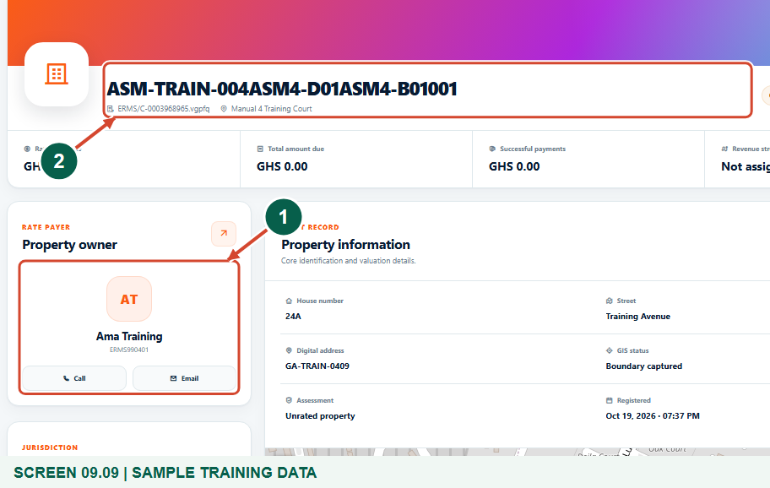
Synthetic training records in the actual assembly workspace. Verify the saved property and rate payer.
1 Verify the linked rate payer
2 Check the generated property account
What should happen
The saved property profile shows the intended existing rate payer and a distinct property account.

Check your result
- The saved address and account identify the intended property.
- The selected active rate payer is linked and confirmed on the profile.
- The jurisdiction and map point are correct; rating information is based on approved records.

If you need help
The owner is not found.
Check the selected assembly and search name, phone, email or ERMS ID. Only active owners in scope are offered; do not type an unverified substitute.
The map point or block is rejected.
Confirm that the block belongs to the selected division and place the point inside both boundaries. Ask an authorised officer to correct geographic setup when needed.
Rated-property validation fails.
Check the imported valuation number and assembly, entered value and administrative boundaries. Verify the actual approved valuation and physical location; do not switch to unrated simply to bypass an error.

Useful things to know
- The example demonstrates an unrated property. A rated property needs an imported valuation number in the correct assembly, a nonnegative rateable value and a location inside the selected administrative boundaries. Verify the real valuation and location separately.
- Linking an owner is separate from creating a rate-payer web account or collecting payment.
- A new property starts without an assigned billing revenue stream; approved revenue setup is a separate task.

Continue learning
- Guide 01: Access your assembly administrator account
- Guide 05: Create divisions in your assembly
- Guide 06: Create blocks within a division
- Guide 07: Create revenue streams
- Guide 08: Set rates
- Guide 13: Print bills
Download all 13 guides in this collection
For account or bill-record corrections, contact the relevant assembly using its verified contact details. Keep your account or bill reference available when requesting assistance.

