
GYE NTOBOA
MANUAL 4 - ASSEMBLY USER
PROCESS GUIDE 08 / 13

Set rates
Review and update approved charges on existing property and business revenue streams, confirm validation and understand when the revised configuration takes effect.
WHO THIS IS FOR  Assembly administrators | ALLOW ABOUT  15-20 minutes | DOCUMENT VERSION  1.0 | 19 October 2026

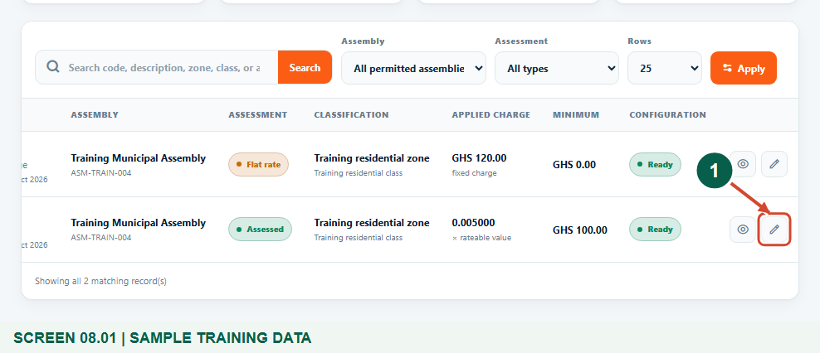
Illustrated steps with numbered arrows and clear expected results.
About the examples
Screens show the actual application in a training environment with sample data. Use your own verified account, assigned records and contact details when following the guide.

Website: assembly.gyentoboa.com

Process flow
Follow the arrows from start to finish. Optional routes are explained in the numbered steps.

Before you start
- Obtain the authorized fee-fixing change and its effective billing period from the finance team. Training amounts are fictional, not legal or financial guidance.
- Confirm your assembly, the exact stream classification and permission to update revenue streams. Create the stream first if it does not exist.
- Identify whether the charge is an assessed-property multiplier, a flat property amount or a business amount. These use different fields.
- Plan any separate bill generation or controlled rebilling with the responsible officer. Updating a stream does not automatically recalculate previously issued bills.
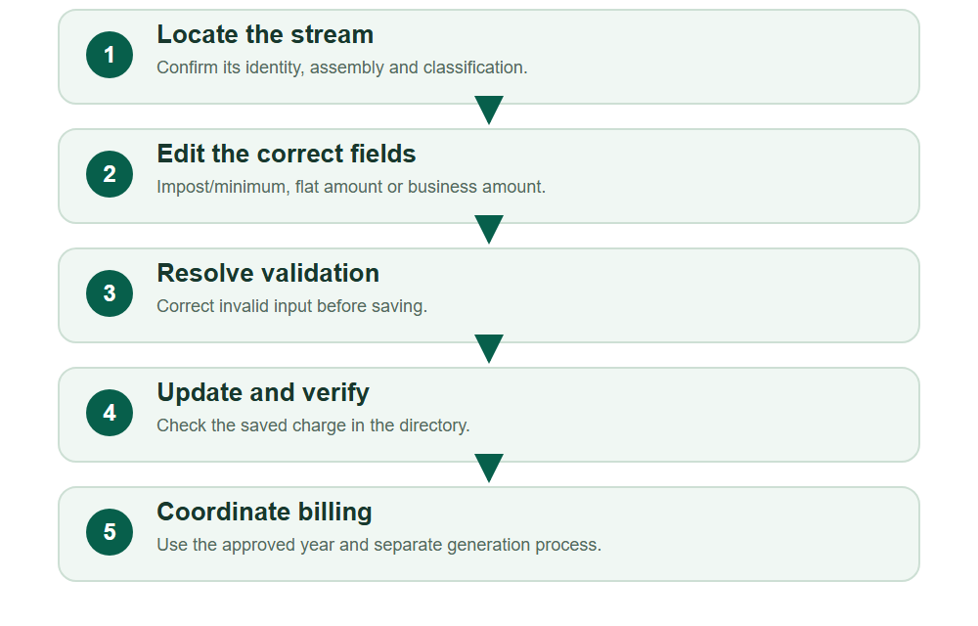
Numbered markers on screenshots identify the controls described beneath each image.

STEP 01

Locate the correct property stream
1. Open Revenue catalogue > Property revenue streams. Search or filter to find the configuration covered by the approved change.
2. Check its assessment type, zone, class and current charge. Select that row's Edit revenue stream pencil action. Do not edit another classification simply because its amount looks similar.
Synthetic property catalogue with a row-specific edit control.
1 Edit this property stream
What should happen
The existing property stream opens for editing.

STEP 02

Update an assessed-property impost and minimum
1. For an assessed stream, confirm Assessed Property? remains Yes and the zone and property class are correct.
2. Enter the approved Rate Impost and Min Amount. The training revision uses 0.006 and a GHS 150 minimum. Rate Impost is a multiplier of the property's rateable value, not an amount in GHS and not a percent-text field.
3. For illustration, a rateable value of GHS 10,000 multiplied by 0.006 is GHS 60; the GHS 150 minimum sets the gross charge before approved discounts. Review the entries before Update.
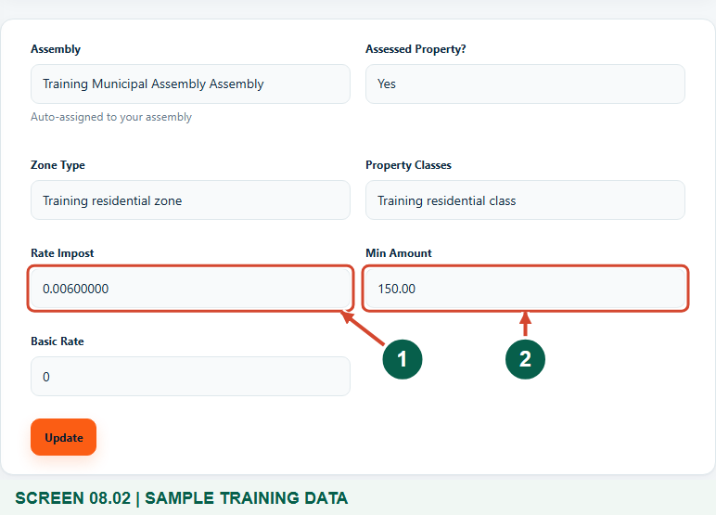
Fictional revised multiplier and minimum; no bill is generated on this screen.
1 Rate impost multiplier
2 Minimum charge in GHS
What should happen
The form shows the intended assessed-property configuration ready to save.

STEP 03

If validation appears, correct the value
1. Read the field-level message after an unsuccessful Update. This optional training example submitted a negative impost, which the form rejected.
2. In normal work, do not deliberately enter an invalid value. Replace an incorrect value with the approved non-negative number and check the remaining fields.
3. Select Update again only after correcting the error. A failed validation does not mean the new rate was saved.
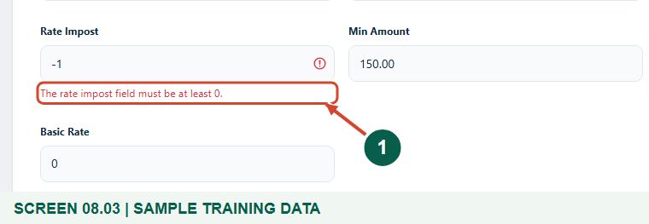
Deliberate negative-value validation demonstration in the isolated training database.
1 Validation message
What should happen
The invalid rate is rejected; the approved corrected configuration can then be submitted.

STEP 04

Verify the saved assessed charge
1. Wait for Revenue stream updated successfully. Return to the property directory and locate the same stream.
2. Confirm the Applied charge shows the intended multiplier and the Minimum shows the intended GHS floor. Scroll horizontally if needed.
3. Keep the approved change reference with your normal finance records. A successful update confirms the catalogue configuration, not a recalculated bill or a collection.
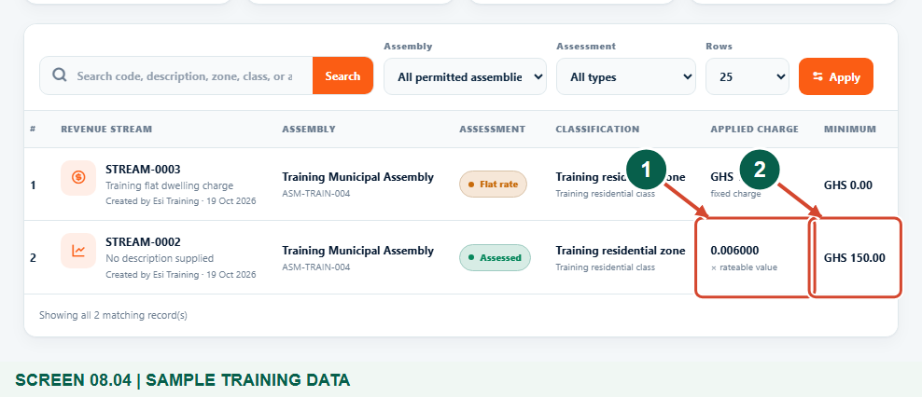
Saved synthetic impost 0.006000 and GHS 150.00 minimum.
1 Saved impost
2 Saved minimum
What should happen
The directory shows the revised assessed-property impost and minimum.

STEP 05

Alternative: update a flat property charge
1. Open Edit revenue stream for the intended unassessed property configuration. Confirm Assessed Property? is No and the Property Type is correct.
2. Enter the approved Flat Rate. The training example revises GHS 120 to GHS 135; retain the approved classification and review Min Amount. The gross charge is the larger of Flat Rate and Min Amount before approved discounts, so a higher minimum still applies to an unassessed property.
3. Select Update, wait for the success message and verify the GHS fixed charge in the directory. Do not replace a multiplier with a flat amount on an assessed stream.
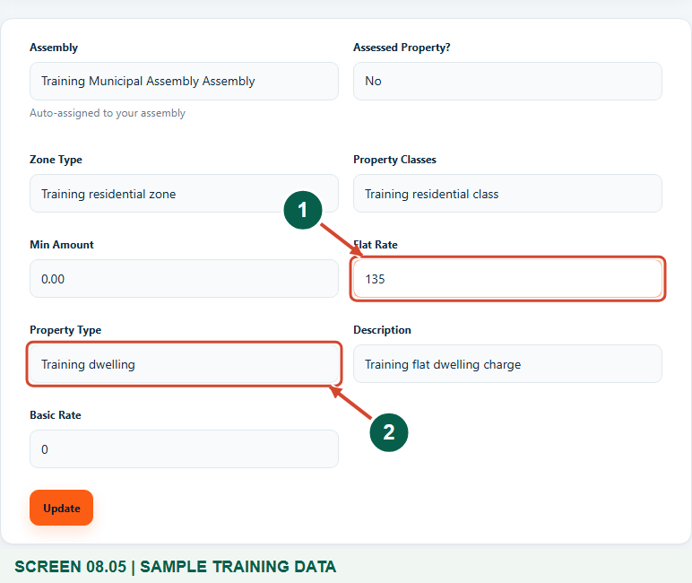
Alternative flat property charge revision with synthetic data.
1 Fixed property charge in GHS
2 Correct property type
What should happen
The intended flat-charge stream is updated after successful validation.

STEP 06

Business alternative: update amount and duration
1. Open Revenue catalogue > Business revenue streams, find the correct BOP code, category and fee item, then choose its Edit action.
2. Check the existing classification and enter the approved Amount. The training example changes the annual amount from GHS 250 to GHS 275 and keeps Per Annum.
3. Review Duration and Basic Rate with the approved schedule, then select Update. Do not assume a Per Square Meter label causes automatic floor-area multiplication in the current business billing flow.
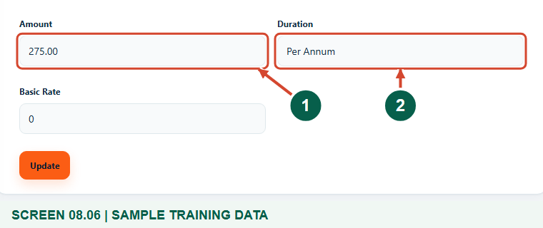
Fictional business amount revision to GHS 275; existing billing records are separate.
1 Business amount to save
2 Approved duration
What should happen
The intended business charge is updated without creating a duplicate stream.

STEP 07

Confirm the business rate and coordinate billing
1. Wait for the update success message, find the stream and check Amount and Duration in the BOP directory. The training final state is GHS 275.00, Per Annum.
2. Coordinate the applicable billing year and any generation or rebilling with the responsible officer. There is no billing-year selector on this rate form.
3. Do not tell a rate payer that a previously issued bill has changed solely because you updated the stream. Review the actual bill and follow the authorized billing process.
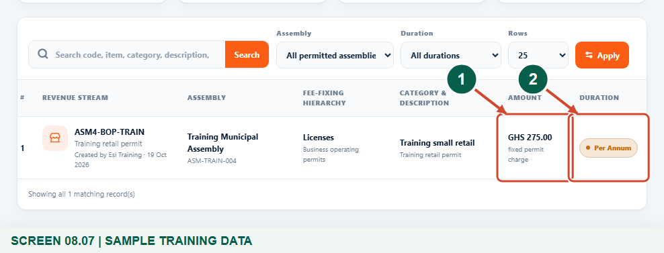
Verified saved annual GHS 275 training business rate.
1 Updated amount in GHS
2 Saved duration
What should happen
The approved charge is saved and its separate billing follow-up is understood.

Check your result
- The intended stream and charging basis were reviewed before editing.
- The update passed validation and the directory shows the approved value.
- The finance team understands the effective period and any separate billing action required.

If you need help
The edit action is unavailable.
Confirm the correct assembly and ask the authorized administrator to review your update permission. Do not use another person's account.
A field is invalid or the change does not save.
Read the validation message, correct the approved numeric value or missing classification, then submit Update again.
The wrong charge appears on an issued bill.
Review the actual bill and generation history with finance. A stream update does not automatically rewrite existing bills; use the authorized correction or rebilling process.
The fee schedule uses an area-based or other calculation.
Confirm the supported calculation with finance and support before configuring it. Do not infer multiplication rules from the duration label or Basic Rate field.

Useful things to know
- All figures are synthetic training examples, not statutory rates.
- For assessed property, gross is the larger of rateable value times impost and Min Amount. For unassessed property, gross is the larger of Flat Rate and Min Amount. Business billing also uses the larger of its flat amount and any stored minimum. Approved discounts are applied after that floor. Basic Rate is not automatically added by the current property/business generation calculations.
- Editing a stream does not itself issue, settle or automatically replace an existing bill.

Continue learning
- Guide 07: Create revenue streams
- Guide 11: Generate a BOP bill
- Guide 12: Generate business bills in bulk
- Guide 13: Print bills
Download all 13 guides in this collection
For account or bill-record corrections, contact the relevant assembly using its verified contact details. Keep your account or bill reference available when requesting assistance.

