
GYE NTOBOA
MANUAL 4 - ASSEMBLY USER
PROCESS GUIDE 07 / 13

Create revenue streams
Create the correct assembly revenue stream from approved catalogue entries, choosing an assessed or flat property charge, or a business operating permit charge.
WHO THIS IS FOR  Assembly administrators | ALLOW ABOUT  20-30 minutes | DOCUMENT VERSION  1.0 | 19 October 2026

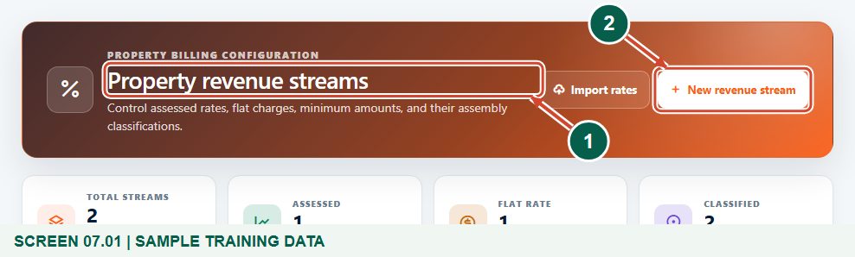
Illustrated steps with numbered arrows and clear expected results.
About the examples
Screens show the actual application in a training environment with sample data. Use your own verified account, assigned records and contact details when following the guide.

Website: assembly.gyentoboa.com

Process flow
Follow the arrows from start to finish. Optional routes are explained in the numbered steps.

Before you start
- Confirm the signed-in assembly and that your account is authorized to create revenue streams.
- Obtain the approved fee-fixing schedule and classification from your finance team. Every amount in this guide is fictional training data, not a recommended statutory charge.
- Have the required reference catalogue entries available. Property streams use a zone, optional property class and, for flat charges, a property type. Business streams use an item description and category, with main/sub items where applicable.
- Confirm the required revenue stream types are available: Property Rate for property charges and BOP (Licenses) for business operating permits. Reference categories and descriptions identify a charge; they do not themselves create a billable stream.
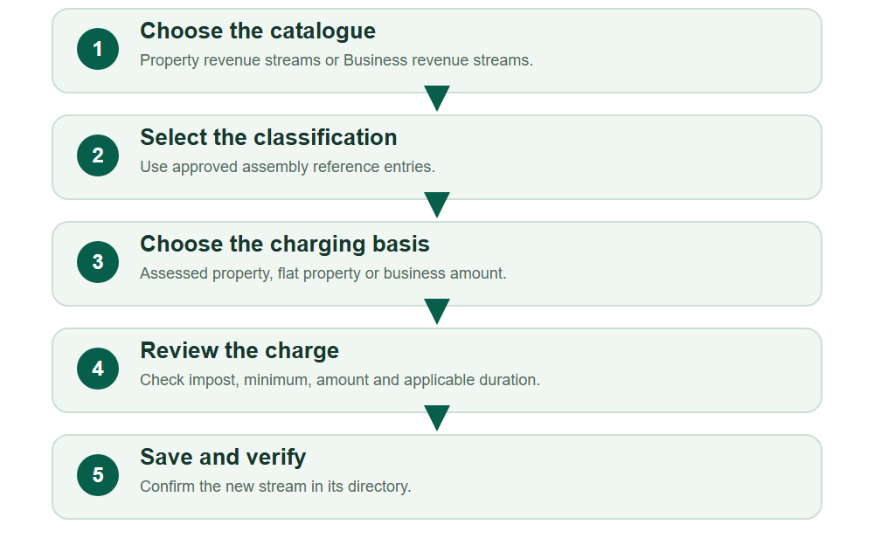
Numbered markers on screenshots identify the controls described beneath each image.

STEP 01

Choose Property revenue streams
1. Expand Revenue catalogue and select Property revenue streams. Review the existing directory before adding another stream.
2. Use the search and Assessment filter to check whether the required zone and classification already have a suitable stream. Select New revenue stream only for a genuinely new configuration.
Synthetic training property catalogue.
1 Property revenue streams
2 New revenue stream
What should happen
The property revenue stream form opens for your assembly.

STEP 02

Property option A: create an assessed stream
1. Confirm the Assembly and choose Yes for Assessed Property?. Select the approved Zone Type and Property Classes where applicable.
2. Enter the approved Rate Impost and Min Amount. The example uses a multiplier of 0.005 and a GHS 100 minimum. Do not type a percentage value unless it has been converted and approved for this multiplier field.
3. Review the configuration, then select Save. Continue with the flat option only if the assembly also needs a separate flat-charge stream.
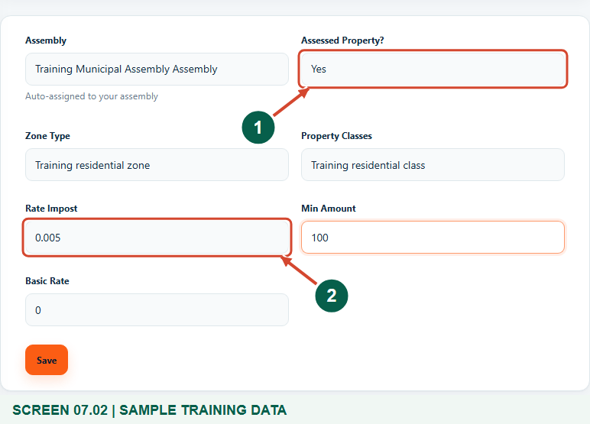
Fictional assessed-property training rate; no bill is issued by this form.
1 Assessed property
2 Approved rate impost
What should happen
An assessed-property configuration is saved after successful validation.

Helpful note: The property calculation uses rate impost multiplied by rateable value, subject to the minimum before approved discounts. These sample figures are not policy advice.

STEP 03

Property option B: create a flat-charge stream
1. For a separate unassessed-property configuration, select New revenue stream again and choose No for Assessed Property?.
2. Select the approved Zone Type, applicable Property Classes and required Property Type. Enter the approved Flat Rate and an optional clear Description. The training example uses GHS 120 for Training dwelling.
3. Review any minimum and Basic Rate fields with the finance team. A flat property charge is still subject to a higher Min Amount before approved discounts. Select Save when the classification and amount are correct. Do not create both options for one case without a reason.
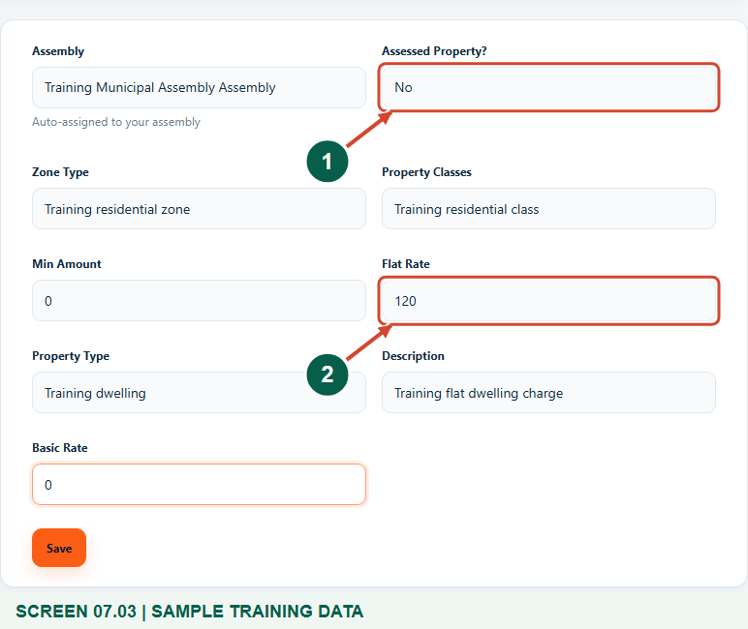
Alternative flat-charge property workflow with synthetic classification and amount.
1 Unassessed property option
2 Approved flat charge
What should happen
The flat-charge property configuration is saved separately from the assessed stream.

STEP 04

Verify the property stream
1. Wait for the successful creation message and return to Property revenue streams.
2. Find the saved configuration and check its assessment type, zone/classification, Applied charge and Minimum. The directory distinguishes a multiplier from a fixed GHS charge.
3. If validation reports an existing combination, inspect that stream instead of inventing another zone or class to bypass the duplicate check.
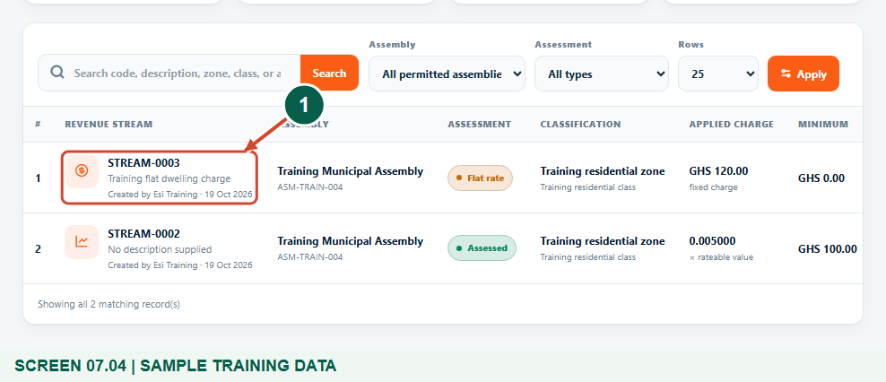
The training catalogue contains two separate example property streams.
1 Saved property stream identity
What should happen
The property directory contains the intended classification and charging basis.

STEP 05

Business option: open BOP revenue streams
1. For a business operating permit charge, choose Revenue catalogue > Business revenue streams. The page heading is BOP revenue streams.
2. Search the existing business catalogue by its code, description or category. Select New BOP stream to add the approved new combination.
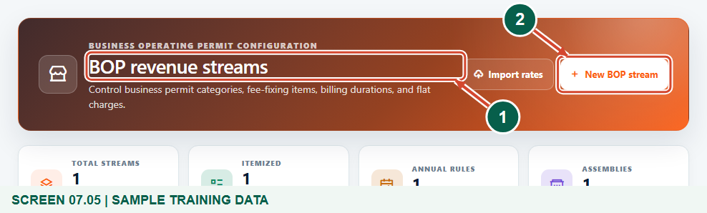
Synthetic business operating permit catalogue.
1 Business operating permit streams
2 New BOP stream
What should happen
The business revenue stream form opens.

STEP 06

Select the business classification
1. Confirm the auto-assigned Assembly and enter a useful Code if required by your assembly.
2. Select the approved Main Item and Sub Item where applicable. Choose the required Item Description and Category. The example uses Licenses, Business operating permits, Training retail permit and Training small retail.
3. If the correct entry is missing, have an authorized officer create or correct the corresponding reference catalogue first. A new category alone does not set the charge.
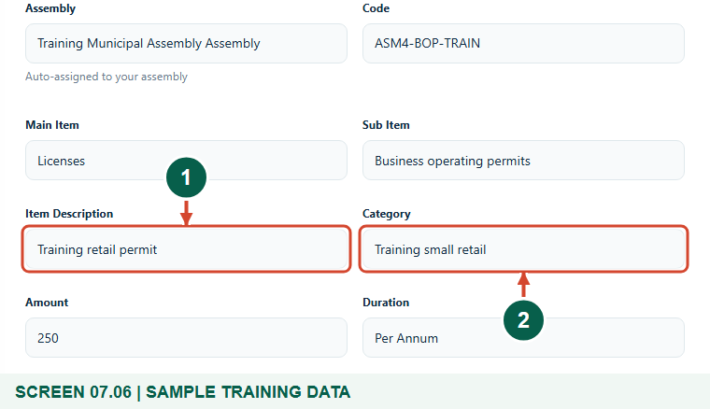
Fictional business reference entries; select approved entries in normal work.
1 Required fee item description
2 Required business category
What should happen
The stream is tied to the intended business fee item and category.

STEP 07

Enter the approved business amount
1. Enter the approved Amount and choose its applicable Duration. The training creation example uses GHS 250 and Per Annum.
2. Check the amount against the fee-fixing schedule and review any Basic Rate field according to approved setup. Current business billing uses the larger of the flat amount and any stored minimum before approved discounts. Do not assume Basic Rate is automatically added by current bill generation.
3. Select Save when the identity, category, description, amount and duration are correct. A later rate-change example revises this training amount to GHS 275.
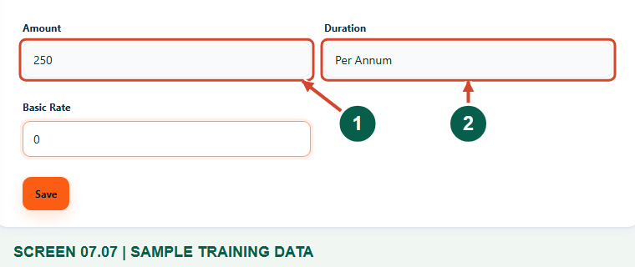
Fictional GHS 250 annual charge entered at initial stream creation.
1 Approved amount in GHS
2 Approved duration
What should happen
The business configuration passes validation and can be saved.

Helpful note: Per Square Meter is another displayed duration choice. Do not assume that this label makes the current business bill calculation multiply the amount by floor area; obtain confirmation before using it.

STEP 08

Confirm the saved business stream
1. Wait for Revenue stream created successfully. Locate the saved code in BOP revenue streams.
2. Check the fee item, category, amount and duration. Scroll the table horizontally when necessary to inspect all columns and row actions.
3. Record the approved setup and proceed to the separate business assignment and billing workflow only when required. Saving this stream does not assign it to every business or issue a bill.
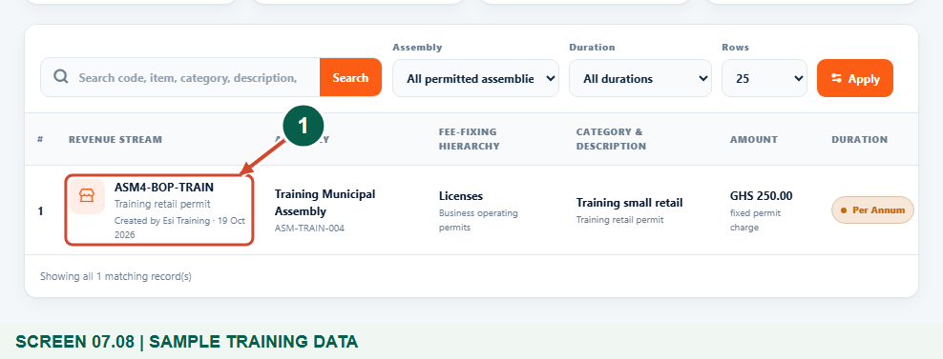
Saved synthetic stream ASM4-BOP-TRAIN; the rate-setting guide later updates its amount.
1 Saved business stream
What should happen
The new business revenue stream exists in your own assembly catalogue.

Check your result
- The approved classification and charge are saved in the correct catalogue.
- The directory displays the correct assessed multiplier or fixed amount.
- No bills or collections have been assumed merely because the stream was created.

If you need help
The required category, zone or description is missing.
Check the assembly and the relevant Revenue catalogue reference page. Have an authorized officer create the approved entry before completing the stream.
The form reports a duplicate configuration.
Search the existing streams for the same classification. Review or update the appropriate record instead of creating artificial reference entries.
An amount is rejected.
Use a valid non-negative numeric value and the required fields for the selected charging basis. Confirm approved amounts with finance; a zero-value stream may not be eligible for billing.
A stream exists but no bill appears.
Creating a catalogue stream is separate from assigning it to an asset or business and generating bills. Follow the relevant billing guide.

Useful things to know
- All names and amounts are synthetic examples. Use the approved assembly fee-fixing schedule.
- The stream form has no billing-year or currency selector. The catalogue displays applicable monetary amounts in GHS; the billing year is handled during bill generation.
- Category and stream creation do not automatically update assets, generate bills or collect payment.

Continue learning
- Guide 08: Set rates
- Guide 09: Create properties and assign a rate payer
- Guide 10: Create businesses
- Guide 11: Generate a BOP bill
- Guide 12: Generate business bills in bulk
Download all 13 guides in this collection
For account or bill-record corrections, contact the relevant assembly using its verified contact details. Keep your account or bill reference available when requesting assistance.

