
GYE NTOBOA
MANUAL 4 - ASSEMBLY USER
PROCESS GUIDE 06 / 13

Create blocks within a division
Create a uniquely identified block under the correct mapped division and save a boundary wholly contained by that division.
WHO THIS IS FOR  Assembly administrators | ALLOW ABOUT  12-18 minutes | DOCUMENT VERSION  1.0 | 19 October 2026

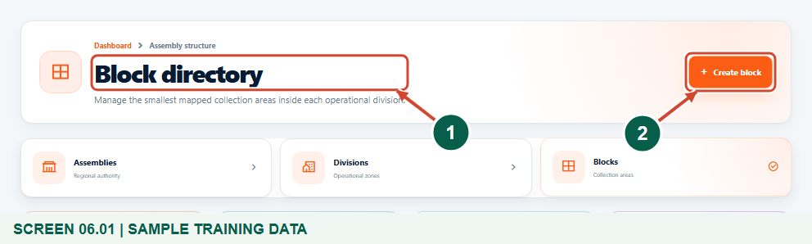
Illustrated steps with numbered arrows and clear expected results.
About the examples
Screens show the actual application in a training environment with sample data. Use your own verified account, assigned records and contact details when following the guide.

Website: assembly.gyentoboa.com

Process flow
Follow the arrows from start to finish. Optional routes are explained in the numbered steps.

Before you start
- Sign in with your own authorized Assembly Administrator account and confirm your assembly.
- Create or identify the approved parent division first. Its boundary must be mapped before a block can be drawn inside it.
- Have the approved block name, unique code and boundary available. Review existing blocks so you do not add an unintended duplicate.
- Use the fictional Training Riverside Division and Training Riverside North Block only as training examples.
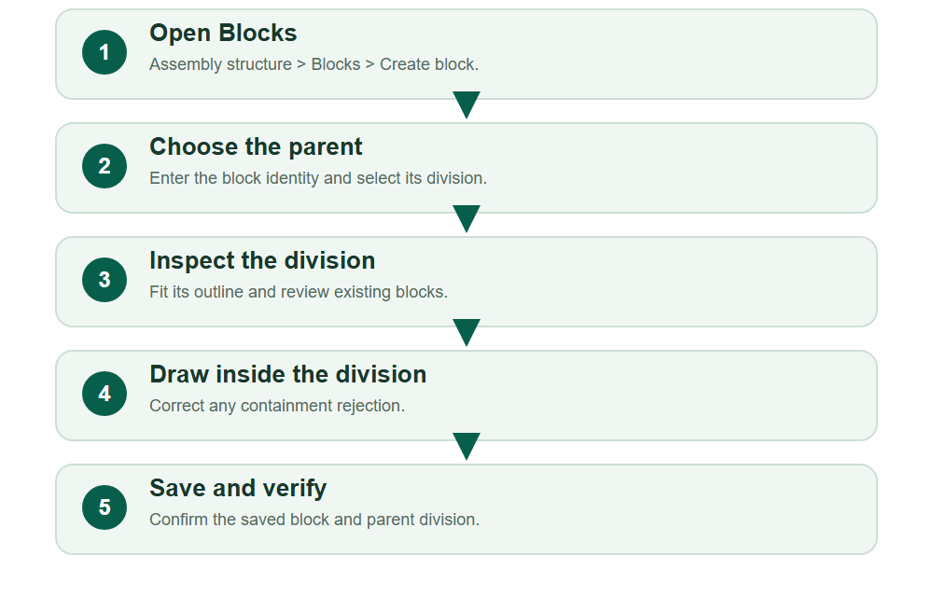
Numbered markers on screenshots identify the controls described beneath each image.

STEP 01

Open the block directory
1. Expand Assembly structure and choose Blocks.
2. Review the Block directory, then select Create block. Use the search to check any existing name or code before adding another record.
Synthetic training data in Training Municipal Assembly. Boundaries are fictional examples, not official survey data.
1 Block directory
2 Create block
What should happen
The Create Block form opens.

STEP 02

Identify the block and its division
1. Enter the approved Block Name and Block Code. The example uses Training Riverside North Block and ASM4-B02.
2. Confirm the auto-assigned Assembly Code, then select the intended Division Name. The example belongs to Training Riverside Division.
3. Wait for the division to load. Selecting another division changes the parent boundary used for validation; check this choice before drawing.
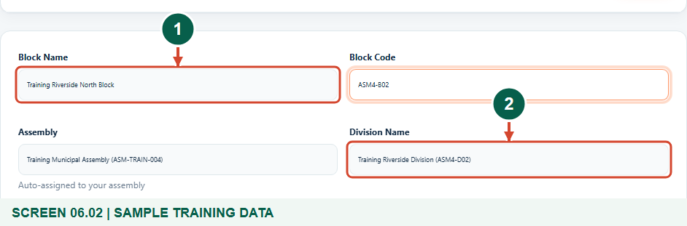
Synthetic training data in Training Municipal Assembly. Boundaries are fictional examples, not official survey data.
1 Block name
2 Selected parent division
What should happen
The block has an identity and a selected parent division.

Helpful note: Do not choose a convenient neighbouring division simply because the correct parent is missing. Resolve the structure first.

STEP 03

Fit and inspect the parent boundary
1. Review Division boundary and block areas and read its status.
2. Use Fit division if you have panned away. Compare the selected division outline with existing blocks and the map legend.
3. Choose the polygon or rectangle drawing tool that matches the approved block outline. The map background supplies context; the selected division is the authoritative parent shape.
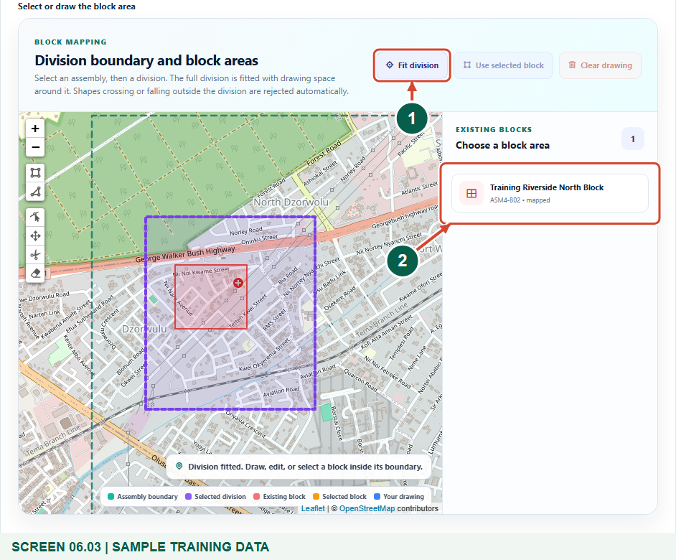
Synthetic training data in Training Municipal Assembly. Boundaries are fictional examples, not official survey data.
1 Fit the parent division
2 Existing blocks in this division
What should happen
The correct division is fitted and ready for an in-boundary block drawing.

STEP 04

Correct an out-of-division drawing
1. Read the rejection message when a drawing extends outside the selected division.
2. Clear and redraw as needed. Keep every edge within the division, including long edges that might cut across a concave boundary.
3. If the approved real boundary cannot fit, stop and request a review of the parent division rather than forcing the block into the wrong place.
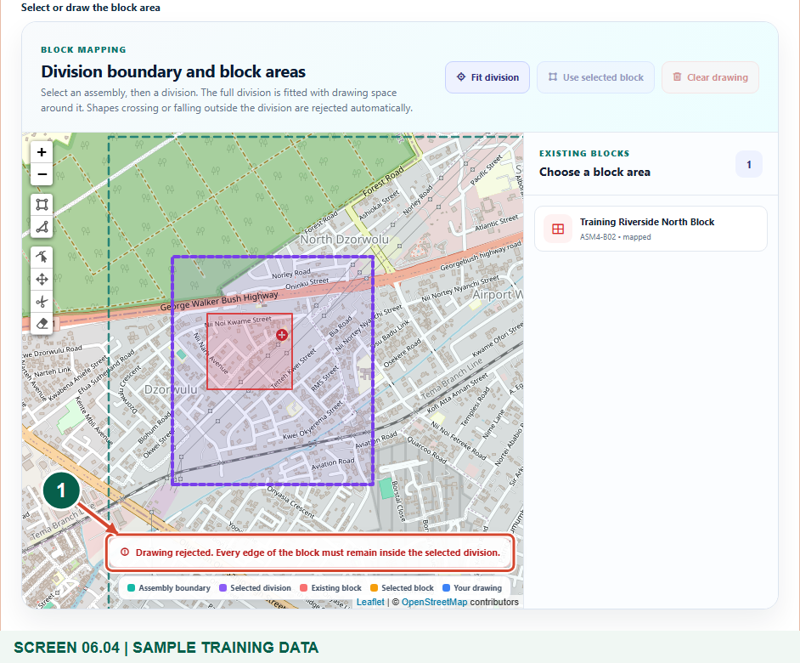
Synthetic training data in Training Municipal Assembly. Boundaries are fictional examples, not official survey data.
1 Block containment validation
What should happen
The out-of-boundary training example is rejected and is not a valid saved block.

STEP 05

Review the accepted block
1. Draw the approved block wholly within its division and wait for the acceptance message.
2. Use the editing controls for approved adjustments, checking the status after each change. Use Clear drawing if you need to restart.
3. Confirm the division name, block name, code and complete outline before submitting.
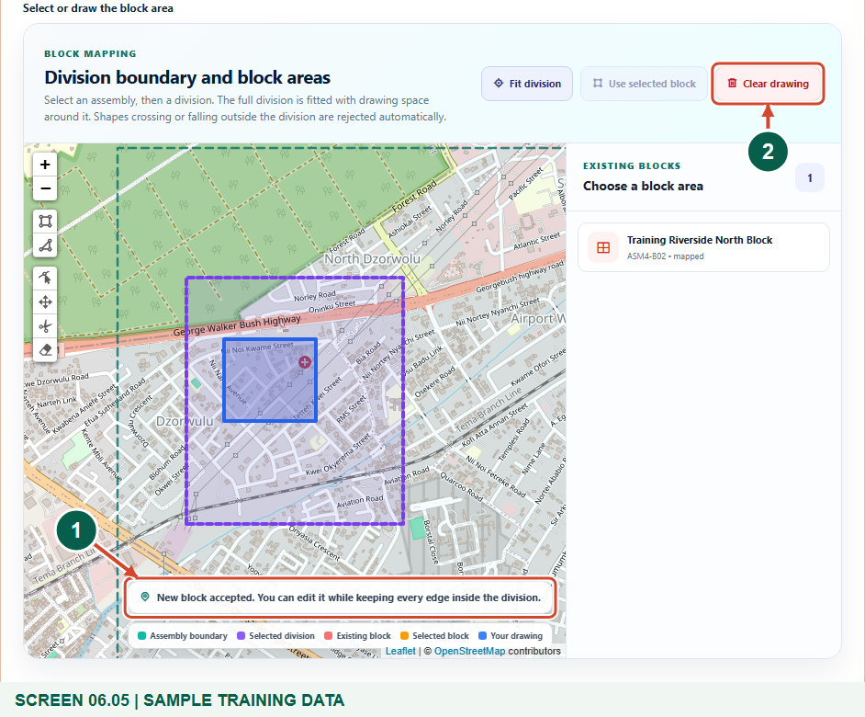
Synthetic training data in Training Municipal Assembly. Boundaries are fictional examples, not official survey data.
1 Accepted block boundary
2 Clear and redraw if needed
What should happen
The form contains an accepted block boundary ready to save.

STEP 06

Save and confirm the parent
1. Select Save and wait for the Block directory and creation confirmation.
2. Find the new block by name or code. Check that the Parent column shows the intended division and that the coverage is mapped.
3. Use the row actions for View profile or Edit record when further review is required. Keep property assignment, field staff allocation and billing as separate authorized tasks.
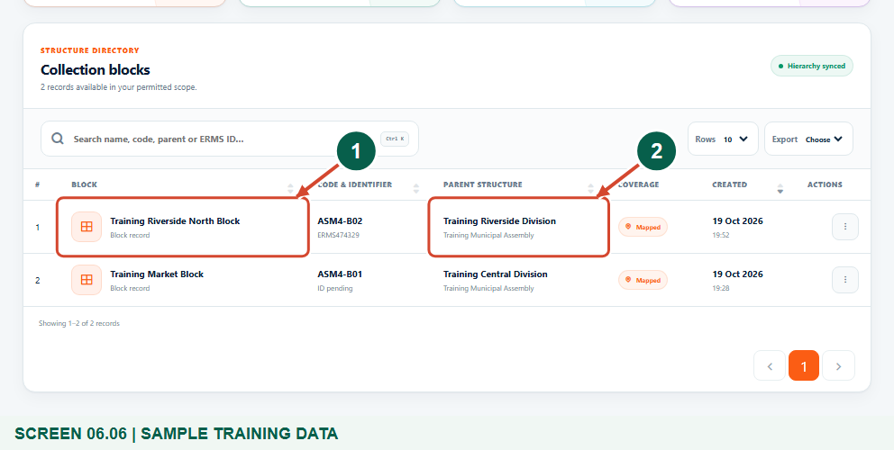
Synthetic training data in Training Municipal Assembly. Boundaries are fictional examples, not official survey data.
1 Saved block
2 Parent division
What should happen
The block is saved under the correct division.

Helpful note: A saved block does not automatically move existing properties or businesses into it, assign agents or generate bills.

Check your result
- The block identity is saved once.
- Its parent is the intended mapped division in your assembly.
- The directory confirms mapped coverage and any further asset or staff work is assigned separately.

If you need help
The required division is missing.
Check the assembly and available divisions. Create or correct the approved division first; another assembly division cannot be substituted.
The division has no mapped boundary.
Have an authorized officer map the parent division before creating blocks within it.
A drawing is rejected or a change disappears.
The whole shape must remain inside the parent. Review the status, refit the division and redraw or edit a valid shape.
A duplicate name or code is reported.
Search the directory and confirm whether the approved block already exists. Use a distinct approved identity for a genuinely separate block.

Useful things to know
- The screenshots demonstrate fictional boundaries in an isolated training database.
- Containment checks do not replace an approved survey or boundary decision.
- Do not assume automatic checks prohibit overlap between blocks; review the authorized layout.

Continue learning
- Guide 05: Create divisions in your assembly
- Guide 09: Create properties and assign a rate payer
- Guide 10: Create businesses
Download all 13 guides in this collection
For account or bill-record corrections, contact the relevant assembly using its verified contact details. Keep your account or bill reference available when requesting assistance.

