
GYE NTOBOA
MANUAL 4 - ASSEMBLY USER
PROCESS GUIDE 05 / 13

Create divisions in your assembly
Create a named, coded division with a complete mapped boundary inside your own assembly, then confirm that it is saved and mapped.
WHO THIS IS FOR  Assembly administrators | ALLOW ABOUT  12-18 minutes | DOCUMENT VERSION  1.0 | 19 October 2026

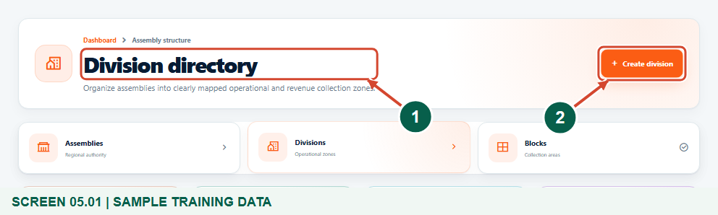
Illustrated steps with numbered arrows and clear expected results.
About the examples
Screens show the actual application in a training environment with sample data. Use your own verified account, assigned records and contact details when following the guide.

Website: assembly.gyentoboa.com

Process flow
Follow the arrows from start to finish. Optional routes are explained in the numbered steps.

Before you start
- Sign in with your own Assembly Administrator account and confirm the assembly name before entering data. Your account must be allowed to create divisions.
- Obtain the approved division name, unique code and boundary from the responsible assembly officer. The fictional rectangles in this guide demonstrate the controls only.
- The assembly must already have a mapped administrative boundary. If it is missing, ask the administrator responsible for mapping or synchronizing that boundary to correct it first.
- Use a reliable connection for the map background and saved assembly shapes. Review existing divisions before drawing another area.
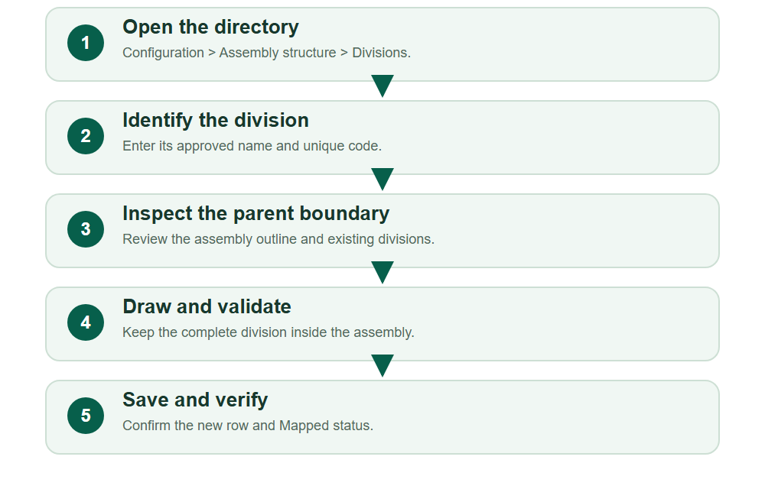
Numbered markers on screenshots identify the controls described beneath each image.

STEP 01

Open Divisions
1. Expand Assembly structure in the sidebar and select Divisions.
2. Check that the Division directory is the intended workspace. Review existing names and codes, then select Create division.
Synthetic training data in Training Municipal Assembly. Boundaries are fictional examples, not official survey data.
1 Division directory
2 Create division
What should happen
The Create Division form opens for your account and assembly.

STEP 02

Enter the division identity
1. Enter the approved Division Name and Division Code. The example uses Training Riverside Division and ASM4-D02.
2. Use a clear, stable code rather than a temporary note. Both name and code must be unique; do not reuse an existing record to get past validation.
3. Confirm the Assembly Code shown below the fields. For an assembly administrator it is assigned from the signed-in account.
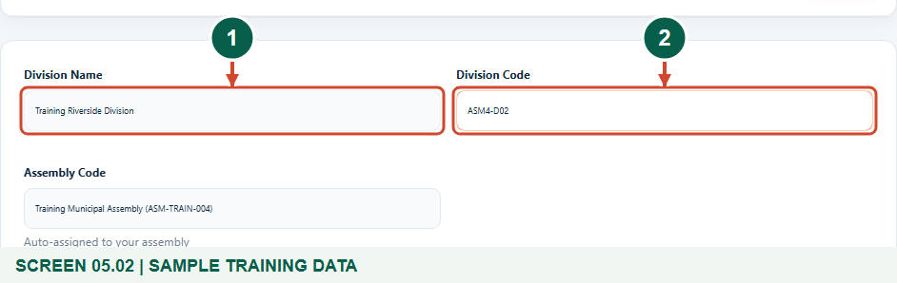
Synthetic training data in Training Municipal Assembly. Boundaries are fictional examples, not official survey data.
1 Division name
2 Division code
What should happen
The new division is identified, but it has not yet been saved.

STEP 03

Read the map before drawing
1. Move to Assembly boundary and division areas. Wait for the assembly shape and division list to load.
2. Use the map legend to distinguish the assembly boundary, existing divisions, a selected area and your drawing. Zoom and pan to inspect the proposed area.
3. Choose the polygon tool for an irregular approved boundary or the rectangle tool for an appropriate rectangular example. Finish a polygon by closing its outline; a rectangle is completed by setting its opposite corners.
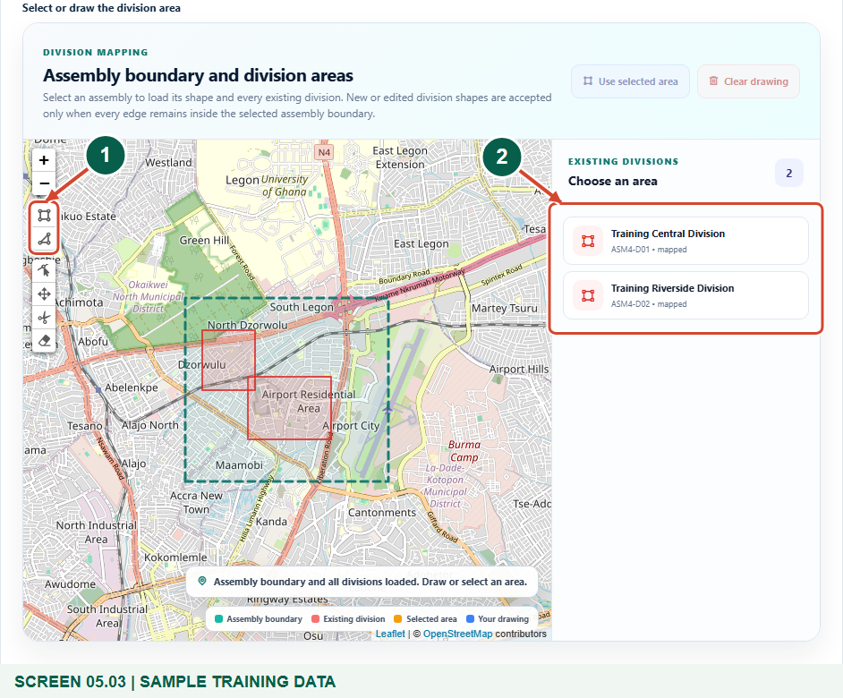
Synthetic training data in Training Municipal Assembly. Boundaries are fictional examples, not official survey data.
1 Draw a rectangle or polygon
2 Existing divisions
What should happen
The parent assembly and existing division areas are visible.

Helpful note: Use selected area copies an existing shape into an editable drawing. It does not save a new division or authorize duplicate coverage.

STEP 04

Respond to a rejected boundary
1. Read the map status after drawing. An area with an edge outside the assembly is rejected.
2. Do not repeatedly press Save. Clear the drawing if necessary, zoom in and redraw within the parent boundary.
3. Check the whole outline, including edges that cross a bend in the assembly boundary. Having only the corner points inside is not enough.
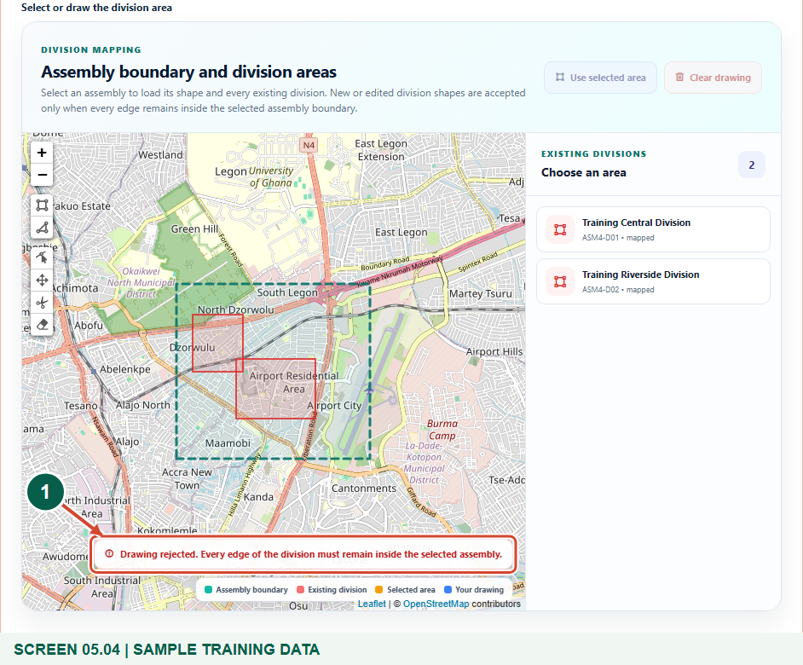
Synthetic training data in Training Municipal Assembly. Boundaries are fictional examples, not official survey data.
1 Boundary validation feedback
What should happen
The rejected example is not retained as a valid division boundary.

Helpful note: This screenshot deliberately demonstrates a failed training drawing. In normal work, start with the approved boundary rather than drawing outside the assembly.

STEP 05

Confirm a contained drawing
1. Draw the approved area wholly inside the assembly. Read the acceptance message before continuing.
2. If adjustments are needed, use the available map editing controls and check the status again. Invalid changes are rejected or restored to the last accepted shape.
3. Use Clear drawing to remove a mistaken draft and start again. Review the name, code and geometry together before saving.
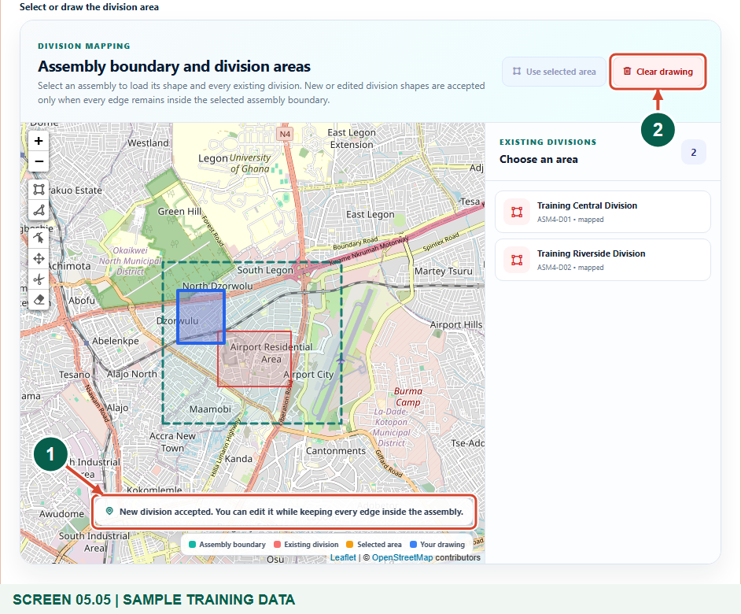
Synthetic training data in Training Municipal Assembly. Boundaries are fictional examples, not official survey data.
1 Accepted division boundary
2 Clear and redraw if needed
What should happen
The form holds an accepted division boundary ready to submit.

STEP 06

Save and check the directory
1. Select Save at the bottom of the form. Wait for the Division directory and the successful creation message.
2. Find the new division by name or code and confirm its parent assembly and Mapped coverage status.
3. If you need to inspect it further, open the row actions and choose View profile or Edit record as your permissions allow. Record any approved follow-up work separately.
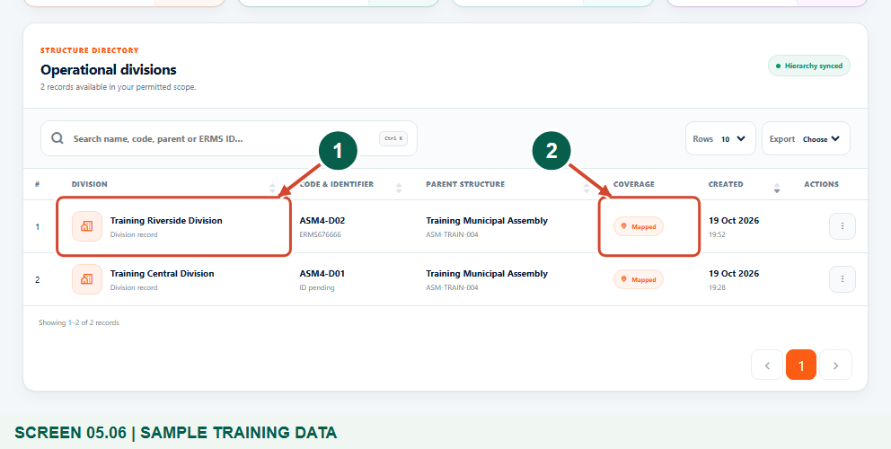
Synthetic training data in Training Municipal Assembly. Boundaries are fictional examples, not official survey data.
1 Saved division
2 Mapped boundary status
What should happen
The division exists as a mapped assembly structure record.

Helpful note: Creating a division does not allocate a supervisor or agent, move properties, create blocks or issue bills.

Check your result
- The approved division name and unique code are saved.
- The directory shows the correct assembly and Mapped coverage.
- Any separate block creation or staff allocation remains an explicit next task.

If you need help
The assembly boundary is unavailable.
Stop drawing and ask the mapping administrator to map or synchronize the assembly. A background street map alone is not the required assembly boundary.
The drawing is rejected.
Check every edge against the assembly outline, clear the draft if needed and redraw. Do not attempt to bypass the rejection.
The name or code already exists.
Search the directory first. Use the approved existing division or obtain a genuinely unique identity for a separate division.
The map or list does not load.
Check your connection and session, reload once and wait for the map status. Do not assume an empty list means there are no divisions.

Useful things to know
- All examples use fictional training boundaries and synthetic records.
- The application enforces containment within the assembly; it is not a survey or an approval of legal administrative boundaries.
- Do not assume the form prevents overlap with another division. Review the approved geography before saving.

Continue learning
- Guide 06: Create blocks within a division
- Guide 09: Create properties and assign a rate payer
- Guide 10: Create businesses
Download all 13 guides in this collection
For account or bill-record corrections, contact the relevant assembly using its verified contact details. Keep your account or bill reference available when requesting assistance.

