
GYE NTOBOA
MANUAL 4 - ASSEMBLY USER
PROCESS GUIDE 02 / 13

Create assembly users
Create an authorised Supervisor or Agent account in your own assembly, choose a compatible role and correct scope, verify the saved record and arrange a secure first sign-in.
WHO THIS IS FOR  Assembly administrators | ALLOW ABOUT  15-20 minutes | DOCUMENT VERSION  1.0 | 19 October 2026

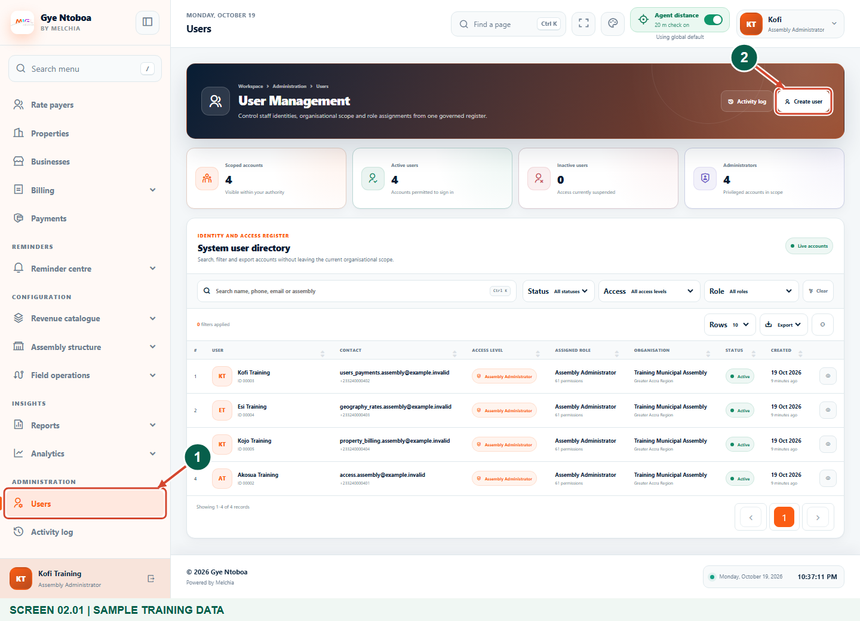
Illustrated steps with numbered arrows and clear expected results.
About the examples
Screens show the actual application in a training environment with sample data. Use your own verified account, assigned records and contact details when following the guide.

Website: assembly.gyentoboa.com

Process flow
Follow the arrows from start to finish. Optional routes are explained in the numbered steps.

Before you start
- Sign in as an active Assembly Administrator with permission to view and create users.
- Confirm the staff member's identity, unique official email, valid international phone number and intended operational role before creating an account.
- Have the correct division available when creating a supervisor. Agree a secure way to supply an individual initial password separately; never use a shared default password.
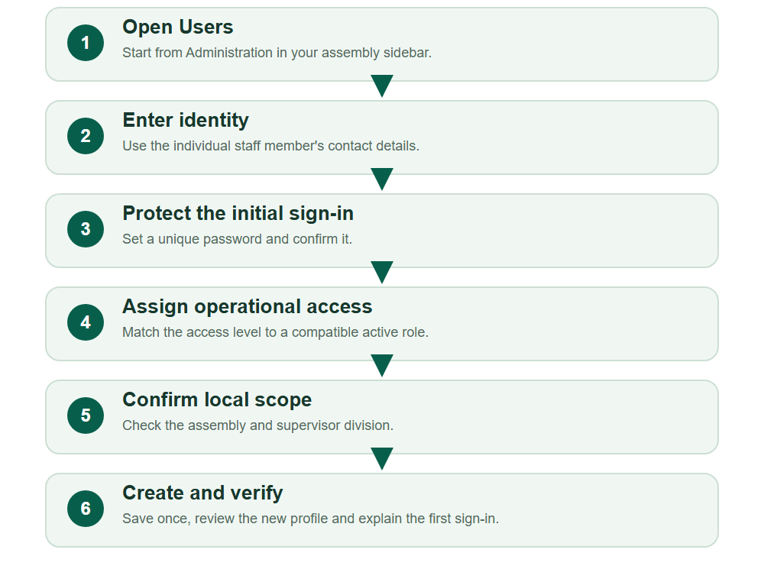
Numbered markers on screenshots identify the controls described beneath each image.

STEP 01

Open Users and start a new account
1. In the sidebar, open Administration, then Users.
2. Search for the person before creating another account. If no existing record is appropriate, choose Create user.
Synthetic training data. Open Users and start a new account.
1 Users
2 Create user
What should happen
The user creation form opens within your own assembly scope.

STEP 02

Enter the staff member's identity and contacts
1. Enter Full name, Email address, Phone number and Gender using the verified staff details.
2. Choose the correct phone country and enter a valid number. The email and phone must not already belong to another account.
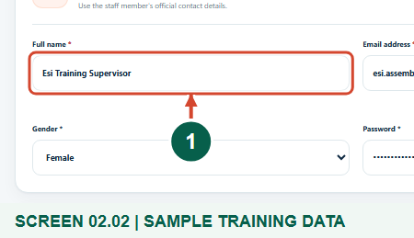
Synthetic training data. Enter the staff member's identity and contacts.
1 Full name
What should happen
The identity fields identify one staff member with usable registered contacts.

STEP 03

Check the country and registered phone number
1. Choose the correct country and check the international phone number for the staff member.
2. Confirm that the person can use this number for staff verification and account notifications. Complete the other required identity fields before continuing.
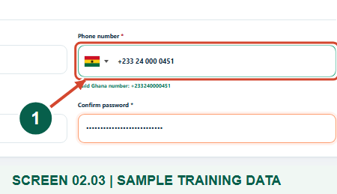
Synthetic training data. Check the country and registered phone number.
1 Phone number
What should happen
The form recognises a valid international phone number for the correct staff member.

STEP 04

Set an individual initial password
1. Enter a strong, unique initial Password and repeat it in Confirm password.
2. Keep both entries masked. Arrange to supply this initial password privately and separately from the welcome notification.
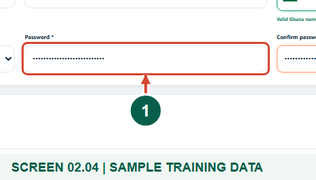
Synthetic training data. Set an individual initial password.
1 Password
What should happen
Both password entries match without exposing the password in the guide or notification.

Helpful note: New Supervisor and Agent accounts must replace the initial password on first sign-in. Do not use a common password for several people.

STEP 05

Select compatible access and role
1. Choose Assembly Supervisor or Assembly Agent as the Access level, then choose the matching Assigned role or an approved compatible role.
2. Set Account status deliberately. Active allows an eligible account to sign in; Inactive creates a record that cannot start a new sign-in.
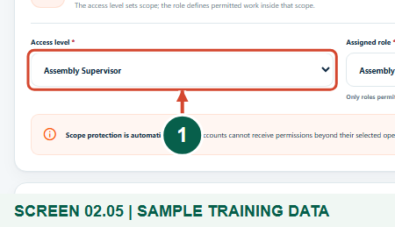
Synthetic training data. Select compatible access and role.
1 Access level
What should happen
The assigned role fits the selected operational access level.

Helpful note: An Assembly Administrator cannot create another Assembly Administrator or a global administrator here. Ask the authorised higher-level administrator when that access is needed.

STEP 06

Check the locked assembly and required division
1. Review Region and Assembly. Your assembly context is locked and cannot be changed to another assembly.
2. For an Assembly Supervisor, select the correct Division. The example uses Training Central Division; choose the real approved division in live work.
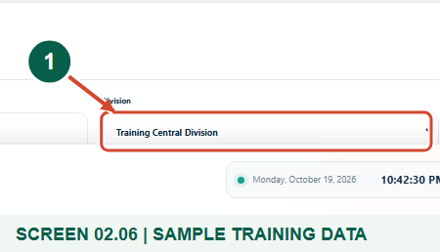
Synthetic training data. Check the locked assembly and required division.
1 Supervisor division
What should happen
The account is scoped to your assembly and a supervisor has an eligible division.

STEP 07

Review and create the account once
1. Review identity, initial password confirmation, role, status and organisational scope.
2. Choose Create user account once. If validation appears, correct the indicated fields and review the form again before resubmitting.
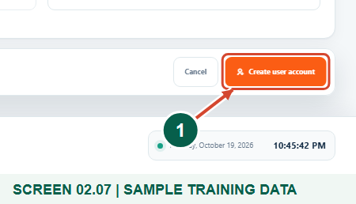
Synthetic training data. Review and create the account once.
1 Create user account
What should happen
A valid submission creates the account and returns to the directory.

STEP 08

Confirm the creation result in the directory
1. Read User created successfully, then search for the new staff member.
2. Check the account Access level, Assigned role, Organisation and Status. Open the row View action to inspect the saved profile.
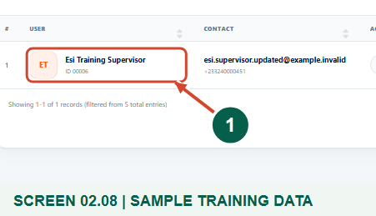
Synthetic training data. Confirm the creation result in the directory.
1 Created staff account
What should happen
One saved account appears with the intended assembly and operational role.

STEP 09

Verify scope and explain the first sign-in
1. Review the saved account details, including Division for a supervisor.
2. Tell the staff member to use https://operations.gyentoboa.com/ with their registered identity and privately supplied initial password, complete SMS verification when required and change that password immediately.
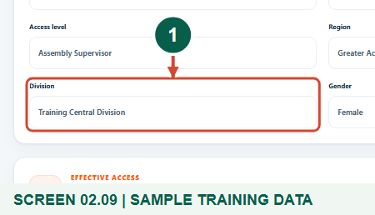
Synthetic training data. Verify scope and explain the first sign-in.
1 Division
What should happen
The saved profile is correct and the staff member understands the secure first sign-in.

Helpful note: Creation queues a welcome SMS for an active account; it does not prove delivery and does not include the password. A new active supervisor also receives a queued division-coverage notification.

Check your result
- The new account exists once, with the intended access level, compatible role, status and assembly.
- The staff member has a secure individual first-sign-in arrangement and knows that the initial password must be changed.

If you need help
Create user is missing
Ask an authorised administrator to review your permission to create users and Assembly Administrator access. Do not borrow another account.
Email or phone is already in use
Search the directory and confirm the existing identity. Update or reset an eligible existing account instead of making a duplicate.
No compatible role or division can be selected
Choose the intended Supervisor or Agent access level and an active compatible role. Create or confirm the correct assembly division through the authorised workflow.
The welcome message has not arrived
Verify the saved registered contact details and contact the administrator responsible for notification delivery. Use the secure reset-link workflow when appropriate; do not resend passwords in plain messages.

Useful things to know
- Assembly Administrators create and manage their own assembly Supervisor and Agent accounts; higher-level administrator provisioning is outside this guide.
- Account creation does not assign an agent to every supervisor, boundary or work item. Use the separate workforce assignment workflows for operational coverage.
- Messages shown in training were contained in a local delivery sink. Real delivery requires a configured service and functioning notification processing.

Continue learning
- Guide 01: Access your assembly administrator account
- Guide 03: Manage assembly users
- Guide 05: Create divisions in your assembly
Download all 13 guides in this collection
For account or bill-record corrections, contact the relevant assembly using its verified contact details. Keep your account or bill reference available when requesting assistance.

