
GYE NTOBOA
MANUAL 4 - ASSEMBLY USER
PROCESS GUIDE 01 / 13

Access your assembly administrator account
Access an authorised assembly administrator account, complete the configured SMS verification and initial password change, recognise the correct workspace, sign out safely and recover a forgotten password.
WHO THIS IS FOR  Assembly administrators | ALLOW ABOUT  10-15 minutes | DOCUMENT VERSION  1.0 | 19 October 2026

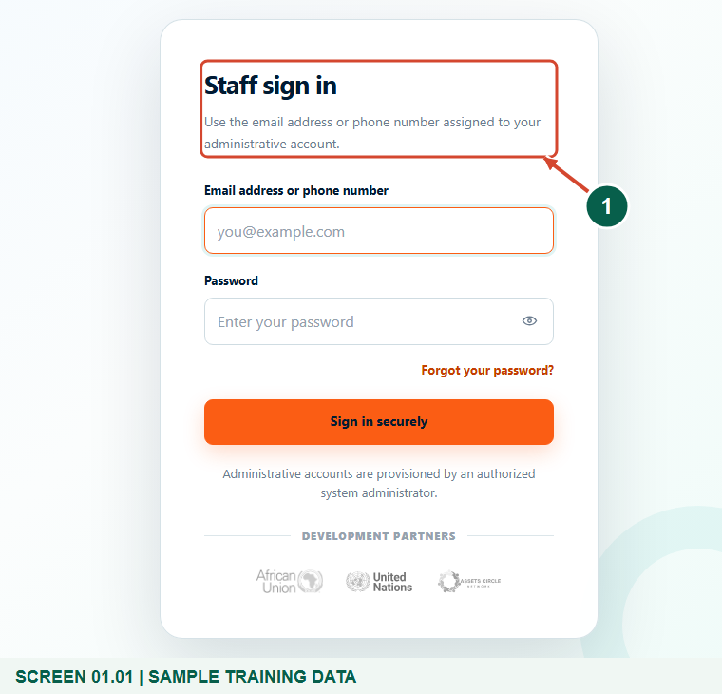
Illustrated steps with numbered arrows and clear expected results.
About the examples
Screens show the actual application in a training environment with sample data. Use your own verified account, assigned records and contact details when following the guide.

Website: assembly.gyentoboa.com

Process flow
Follow the arrows from start to finish. Optional routes are explained in the numbered steps.

Before you start
- Obtain an active Assembly Administrator account from an authorised system administrator. This staff sign-in page has no public self-registration.
- Use a modern browser and open https://assembly.gyentoboa.com/login. Check the address before entering credentials.
- Have access to your registered phone. Keep your password, verification codes and setup links private; the figures show synthetic training accounts.
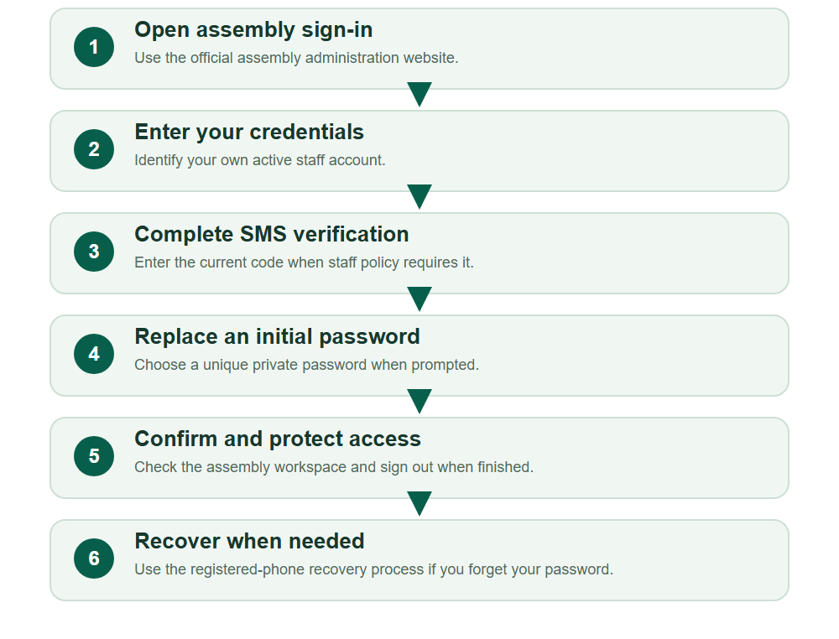
Numbered markers on screenshots identify the controls described beneath each image.

STEP 01

Open the assembly staff sign-in page
1. Open https://assembly.gyentoboa.com/login and confirm that Staff sign in is displayed.
2. Use the assembly administration website for these tasks. The rate payer website and field operations portal have different workspaces.
Synthetic training data. Open the assembly staff sign-in page.
1 Staff sign in
What should happen
The staff form offers Email address or phone number and Password.

STEP 02

Enter your own staff credentials
1. Enter the email address or international phone number registered to your administrator account, then your own password.
2. Choose Sign in securely. Keep the password masked; never reuse the training identity or another staff member's account.
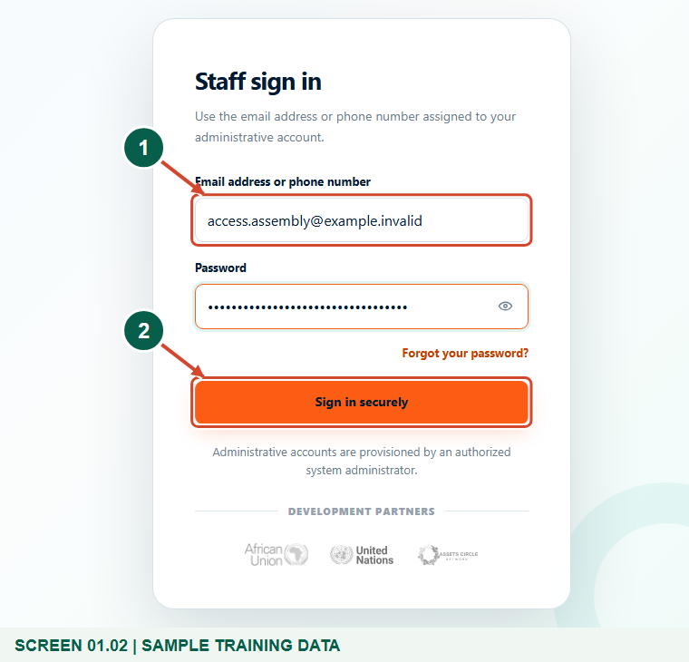
Synthetic training data. Enter your own staff credentials.
1 Email address or phone number
2 Sign in securely
What should happen
An active, authorised account proceeds to SMS verification when required, or to the next permitted screen.

STEP 03

Complete SMS verification when requested
1. Check the masked phone number and enter the current six-digit SMS code sent to your registered phone.
2. Choose Verify and sign in. If necessary, choose Send another code when permitted, or Return to staff sign in to correct the identity.
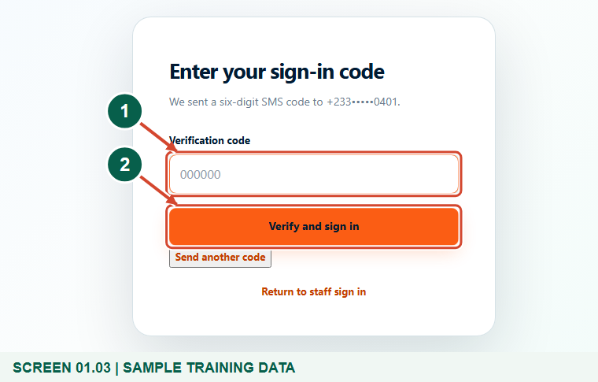
Synthetic training data. Complete SMS verification when requested.
1 Verification code
2 Verify and sign in
What should happen
A valid, unexpired code completes the sign-in check.

Helpful note: SMS verification depends on the effective staff sign-in policy. It is not a universal email-code step; the figure intentionally leaves the code blank.

STEP 04

Replace an initial password when prompted
1. If Change temporary password appears, enter and confirm a new password known only to you.
2. Choose Save and continue. Use a strong, unique password and keep it out of messages, screenshots and shared documents.
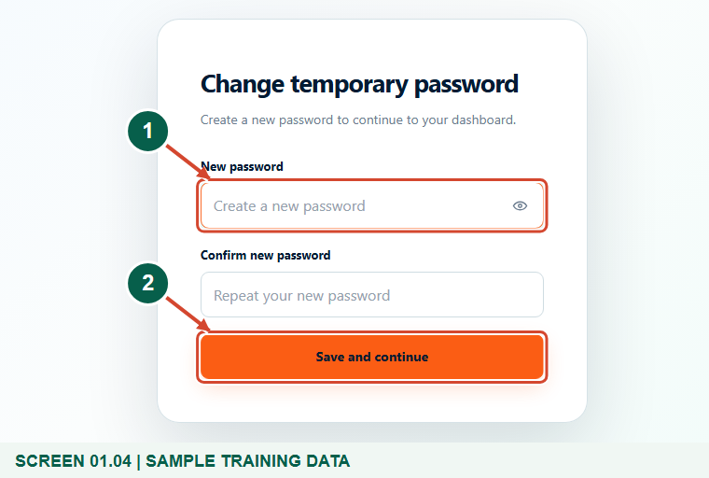
Synthetic training data. Replace an initial password when prompted.
1 New password
2 Save and continue
What should happen
The initial-password flag clears and the application continues to the authorised workspace.

STEP 05

Confirm your role and assembly workspace
1. Check the account role and the assembly context before opening or changing records.
2. Use the sidebar and Find a page to reach authorised work. Missing actions can reflect your assigned role; ask an authorised administrator to review access.
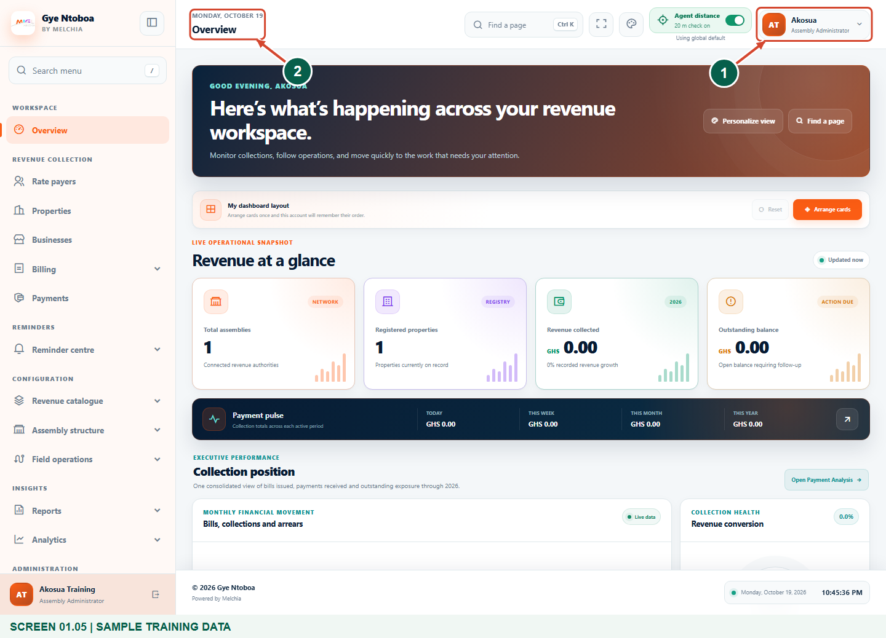
Synthetic training data. Confirm your role and assembly workspace.
1 Assembly administrator
2 Operational workspace
What should happen
You recognise your own assembly workspace and the available authorised navigation.

STEP 06

Sign out when you finish
1. Open your account menu in the top-right corner and choose Sign out.
2. On a shared computer, close the browser after the sign-in page returns. Do not leave an administrator session open.
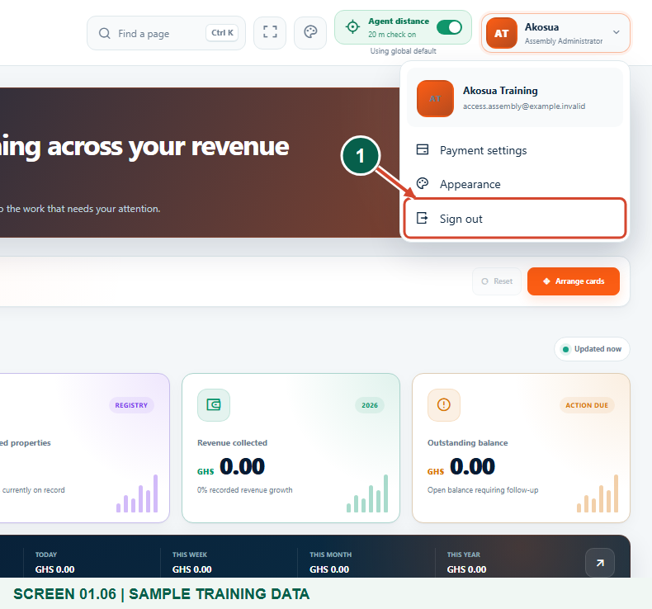
Synthetic training data. Sign out when you finish.
1 Sign out
What should happen
The authenticated session ends and Staff sign in is displayed.

STEP 07

Request recovery through your registered phone
1. If you have forgotten your password, choose Forgot your password? on Staff sign in.
2. Enter the registered phone number with the correct country selection, then choose Send verification code.
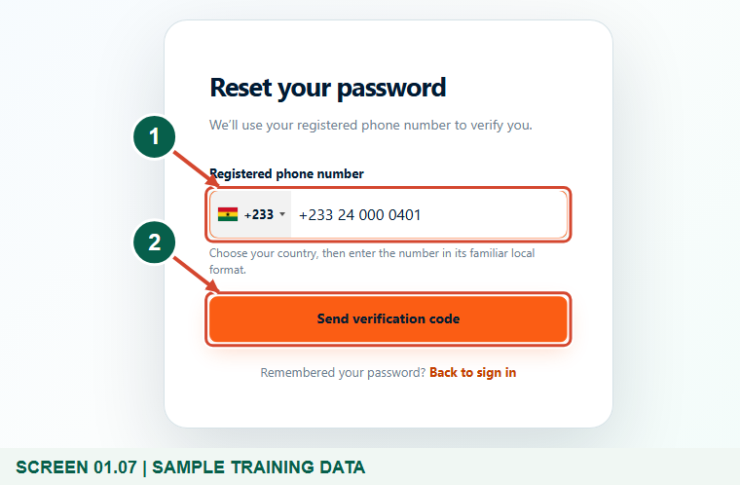
Synthetic training data. Request recovery through your registered phone.
1 Registered phone number
2 Send verification code
What should happen
A neutral acknowledgement appears and the application opens Set a new password; an eligible active account receives an SMS code.

Helpful note: The acknowledgement does not confirm that a matching account exists or that a message has already arrived.

STEP 08

Complete recovery with a new private password
1. Enter the current six-digit recovery SMS code, a new password and its confirmation.
2. For recovery, use at least 12 characters with upper and lower case letters, a number and a symbol. Choose Update password, then sign in with the new password.
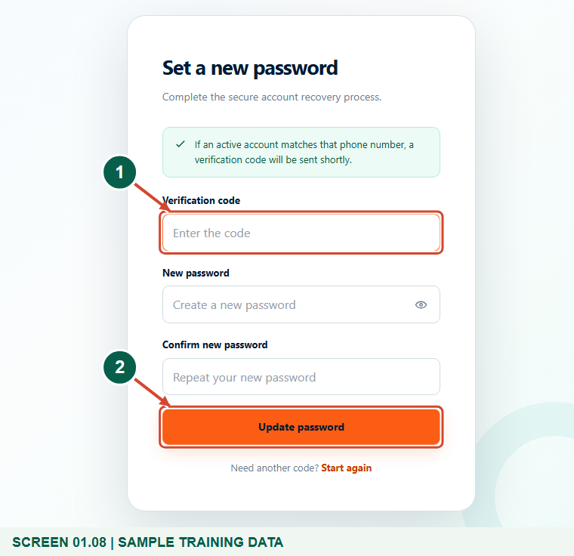
Synthetic training data. Complete recovery with a new private password.
1 Verification code
2 Update password
What should happen
Valid recovery details change the password and return to Staff sign in with a success message.

Helpful note: Recovery codes expire after 10 minutes. Use Start again for another code; never share a code or accept an unsolicited reset request.

Check your result
- You can enter your own assembly workspace through the required checks.
- You know how to sign out and use registered-phone recovery without sharing credentials.

If you need help
The account or password is rejected
Check the registered identity and password. Ask the authorised administrator to confirm that your Assembly Administrator account is active; do not create a duplicate identity.
No sign-in SMS arrives
Check the masked registered phone and use Send another code when allowed. Contact support if secure staff sign-in is unavailable; an administrator must resolve the configured SMS service.
A recovery code is invalid or expired
Use Start again, enter the correct registered phone and use the newest code promptly. Check both password entries against the displayed requirements.
The wrong assembly or missing functions appear
Stop before changing data and ask the authorised system administrator to review your assembly, access level and role.

Useful things to know
- These screens demonstrate synthetic accounts in an isolated training environment; use the official production address for real work.
- An Assembly Administrator account must already exist. Account provisioning and global staff authentication policy require the appropriate higher-level authority.
- SMS delivery and account recovery depend on correct registered contact details and configured delivery services.

Continue learning
- Guide 02: Create assembly users
- Guide 03: Manage assembly users
- Guide 04: Configure assembly payment options
Download all 13 guides in this collection
For account or bill-record corrections, contact the relevant assembly using its verified contact details. Keep your account or bill reference available when requesting assistance.

