
GYE NTOBOA
MANUAL 3 - AGENTS TRAINING
PROCESS GUIDE 06 / 06

Find your assigned boundary and territory
Read your assigned divisions and blocks, use the property and business map filters, and understand the difference between geographic scope, attendance and a visit's distance check.
WHO THIS IS FOR  Field agent | ALLOW ABOUT  10-15 minutes | DOCUMENT VERSION  1.0 | 19 October 2026

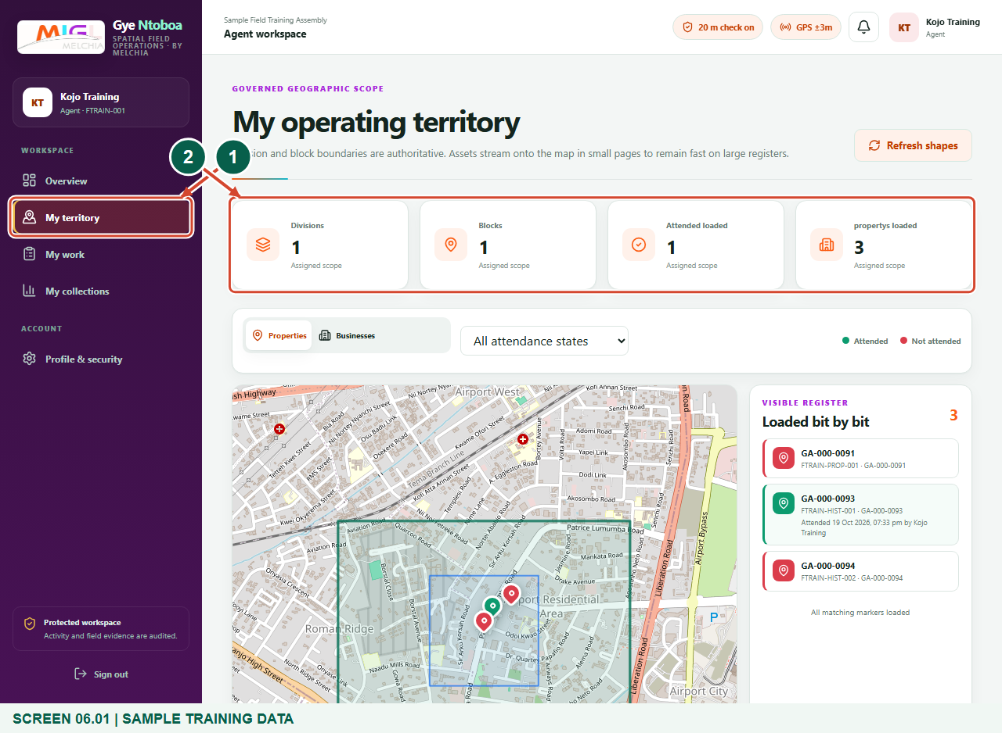
Illustrated steps with numbered arrows and clear expected results.
About the examples
Screens show the actual application in a training environment with sample data. Use your own verified account, assigned records and contact details when following the guide.

Website: operations.gyentoboa.com

Process flow
Follow the arrows from start to finish. Optional routes are explained in the numbered steps.

Before you start
- Sign in to your own agent workspace with an internet connection.
- Ask your supervisor to ensure your operating divisions or blocks have been assigned.
- The figures use synthetic training boundaries, markers and records. Your live assigned boundaries and records come from the assembly register.
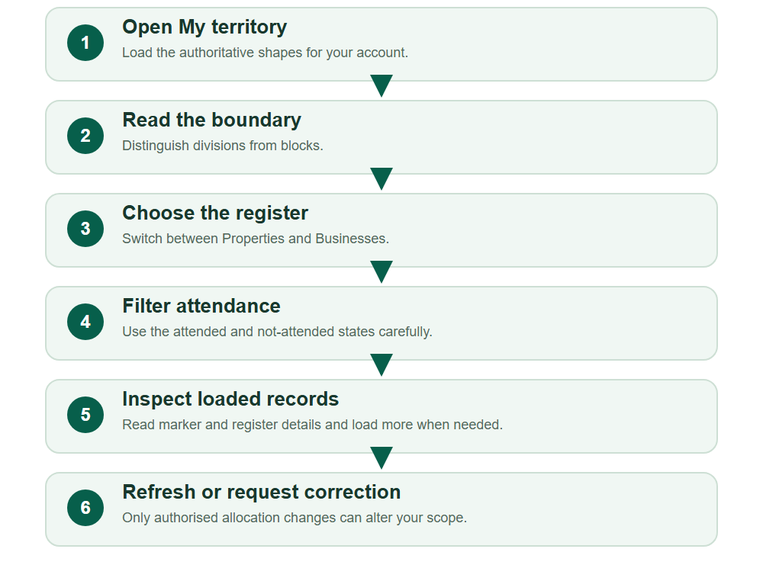
Numbered markers on screenshots identify the controls described beneath each image.

STEP 01

Open My territory and read the scope counts
1. Choose My territory from the agent navigation.
2. Read My operating territory and the assigned division and block counts. These describe your allocated geographic scope.
Synthetic training data in the actual agent portal. Open My territory and read the scope counts.
1 My territory
2 Assigned scope counts
What should happen
Your assigned shapes and register controls are shown.

STEP 02

Identify division and block boundaries
1. Use the map to inspect the green division outlines and blue block outlines. Hover a boundary to read its name and type.
2. Zoom and pan for orientation. The map is a viewer; it does not let an agent redraw boundaries or expand their allocation.
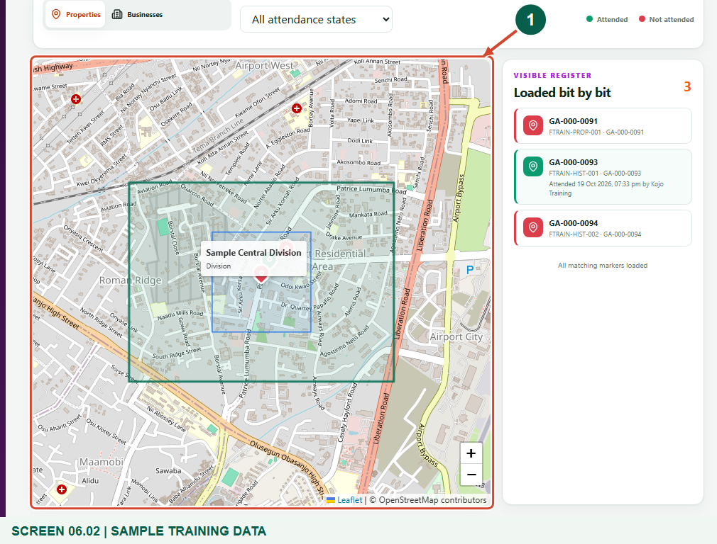
Synthetic training data in the actual agent portal. Identify division and block boundaries.
1 Assigned division and block shapes
What should happen
You can identify the named assigned division or block.

STEP 03

Choose Properties or Businesses
1. Select Properties to view the assigned property register, or Businesses for the business register.
2. Only records visible within your authorised area are returned. Changing the register tab does not grant access to another area.
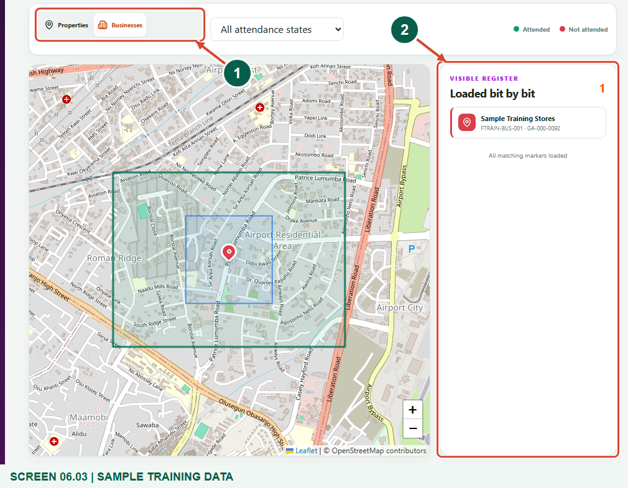
Synthetic training data in the actual agent portal. Choose Properties or Businesses.
1 Properties or Businesses
2 Visible business register
What should happen
The markers and Visible register list update for the selected record type.

STEP 04

Filter attended and not-attended records
1. Use All attendance states, Attended - green or Not attended - red to narrow the loaded markers.
2. Green and red refer to attendance evidence. They do not mean that a bill has been paid or remains unpaid.
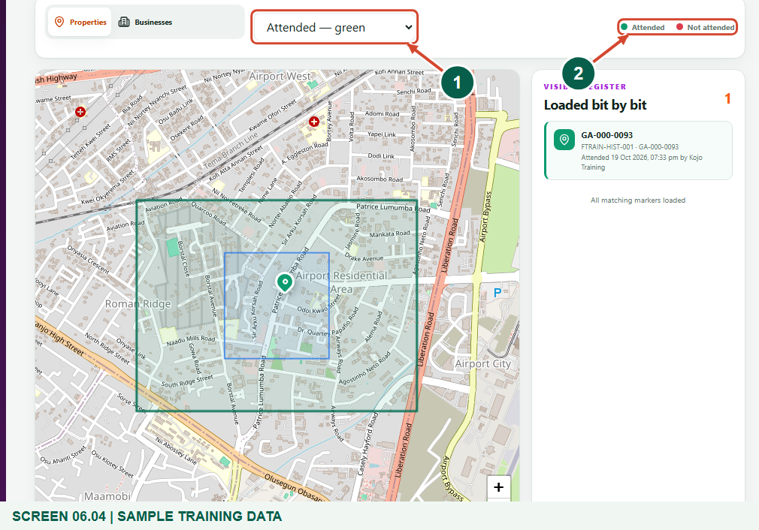
Synthetic training data in the actual agent portal. Filter attended and not-attended records.
1 Attendance filter
2 Attendance legend
What should happen
The visible markers match the selected attendance state.

STEP 05

Inspect a marker and the visible register
1. Select a marker to read the sample account reference and attendance state; compare it with the Visible register list.
2. Records load in pages. Use Load next 100 when shown, or continue down the list. Loaded counts are not totals for every record in the assembly.
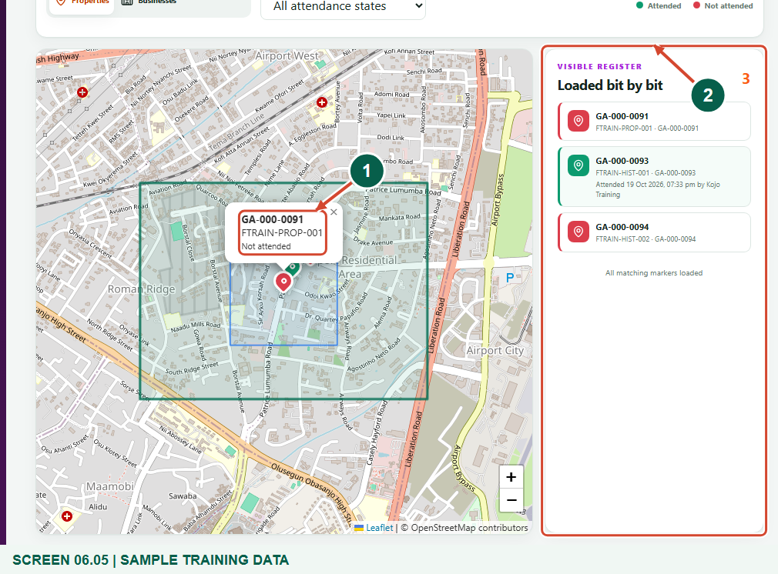
Synthetic training data in the actual agent portal. Inspect a marker and the visible register.
1 Record popup
2 Visible register
What should happen
You can identify a record without mistaking a loaded subset for the complete register.

STEP 06

Refresh shapes or request an allocation correction
1. Choose Refresh shapes after your supervisor confirms an allocation change.
2. If No operating area assigned appears, ask the supervisor or assembly administrator to review the division and block setup. A distance-check override does not enlarge your territory or service scope.
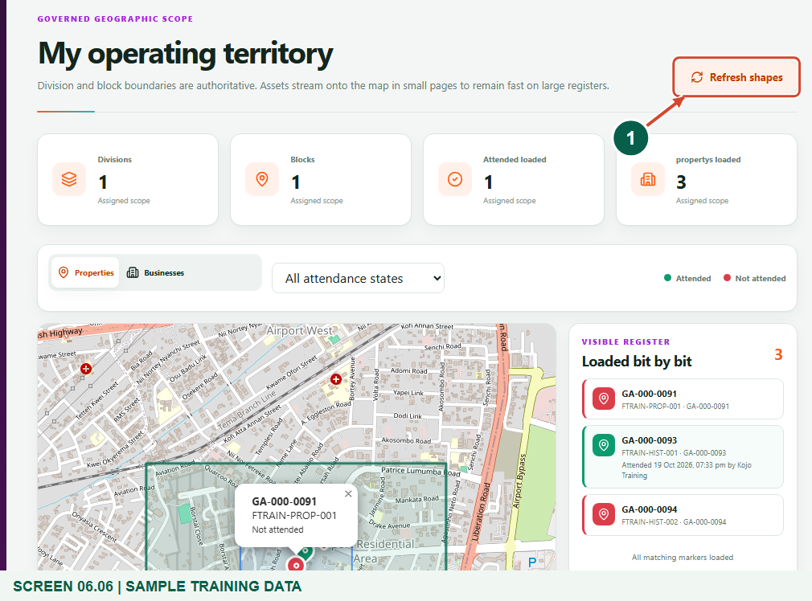
Synthetic training data in the actual agent portal. Refresh shapes or request an allocation correction.
1 Refresh shapes
What should happen
You know how to refresh authoritative shapes and request a proper correction.

Check your result
- You can name your assigned divisions and blocks.
- You can switch record types and attendance filters.
- You distinguish territory, loaded records, attendance and the separate visit-distance rule.

If you need help
No operating area assigned
The assembly administrator assigns supervisor divisions and the supervisor allocates agent divisions or blocks. Ask them to review your setup.
No markers match
Check the Properties or Businesses tab and attendance filter. Only assigned, mapped records are visible; ask the supervisor about missing coordinates or allocations.
Map background is slow or unavailable
Check connectivity and retry. Read the visible register and assigned shapes; do not infer a new boundary from a missing map tile.

Useful things to know
- Territory comes from authoritative supervisor and agent allocations. It is not a radius centred on your current GPS position.
- Attendance markers are operational evidence, not a payment-status display. Loaded counts describe the fetched subset.
- Turning off the visit distance check does not remove ownership or geographic access controls.

Continue learning
- Guide 01: Access your agent account
- Guide 02: Distribute bills
- Guide 05: Find your supervisor
Download all 6 guides in this collection
For account or bill-record corrections, contact the relevant assembly using its verified contact details. Keep your account or bill reference available when requesting assistance.

