
GYE NTOBOA
MANUAL 3 - AGENTS TRAINING
PROCESS GUIDE 05 / 06

Find your supervisor
Identify the supervisor named on your assigned work, read their instructions, and know when to ask the assembly for verified contact details or an allocation correction.
WHO THIS IS FOR  Field agent | ALLOW ABOUT  5-10 minutes | DOCUMENT VERSION  1.0 | 19 October 2026

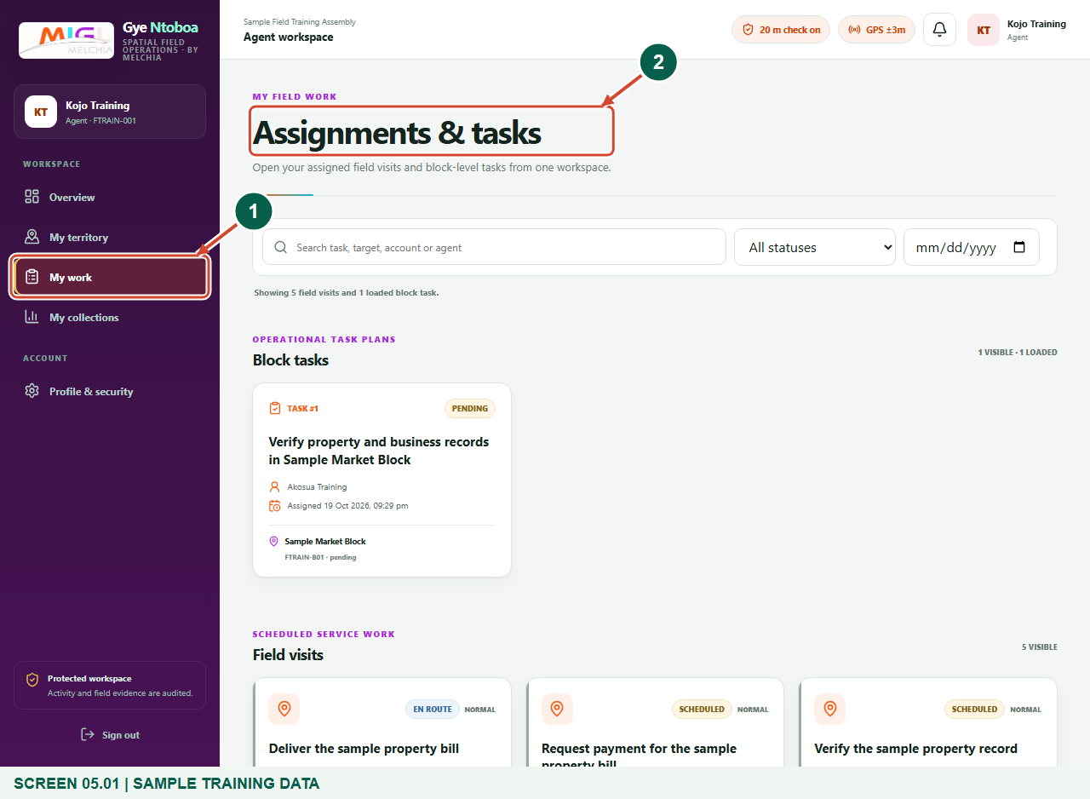
Illustrated steps with numbered arrows and clear expected results.
About the examples
Screens show the actual application in a training environment with sample data. Use your own verified account, assigned records and contact details when following the guide.

Website: operations.gyentoboa.com

Process flow
Follow the arrows from start to finish. Optional routes are explained in the numbered steps.

Before you start
- Sign in with your own active agent account.
- Have an assignment title, target reference or block task to identify the relevant work.
- Use verified assembly contact channels for sensitive information; this guide does not publish a staff directory.
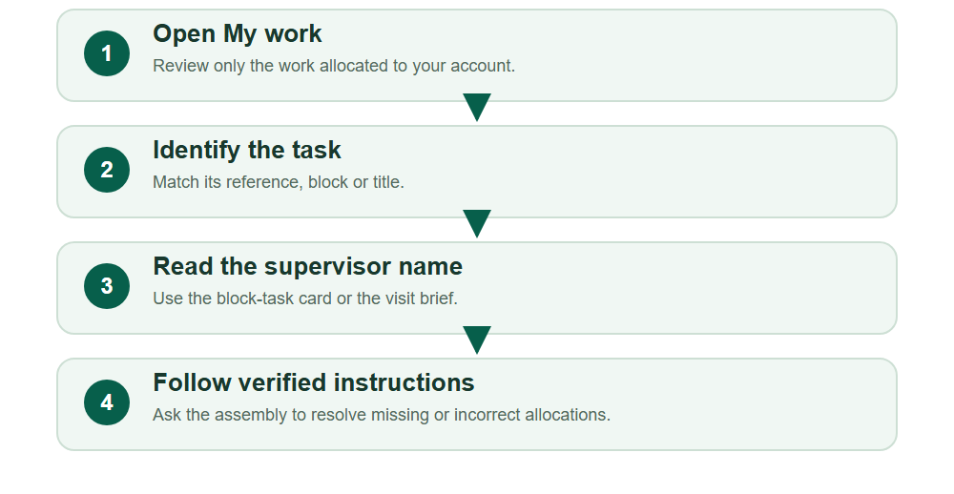
Numbered markers on screenshots identify the controls described beneath each image.

STEP 01

Open your allocated work
1. Choose My work in the agent navigation.
2. The page contains Field visits and, when allocated, Block tasks. It is not an assembly-wide staff directory.
Synthetic training data in the actual agent portal. Open your allocated work.
1 My work
2 Block tasks and field visits
What should happen
Assignments & tasks shows work within your agent scope.

STEP 02

Read the supervisor on a block task
1. Under Block tasks, match the task title and block name or code.
2. The person named alongside the task is the allocated supervisor. Do not confuse a block-task status with payment or visit completion.
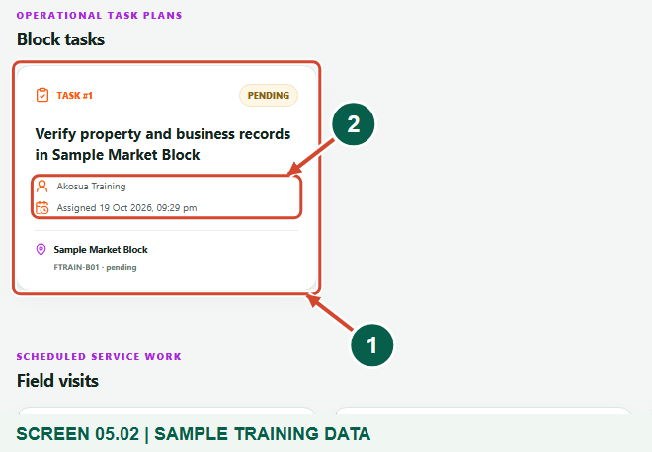
Synthetic training data in the actual agent portal. Read the supervisor on a block task.
1 Allocated block task
2 Supervisor on the task
What should happen
You can identify the supervisor attached to that block-level task.

STEP 03

Check the supervisor on a field visit
1. Open the relevant Field visit. In Target & schedule, read Supervisor alongside the service window and target account.
2. Match the visit and account before following instructions; another assignment can have a different allocated supervisor.
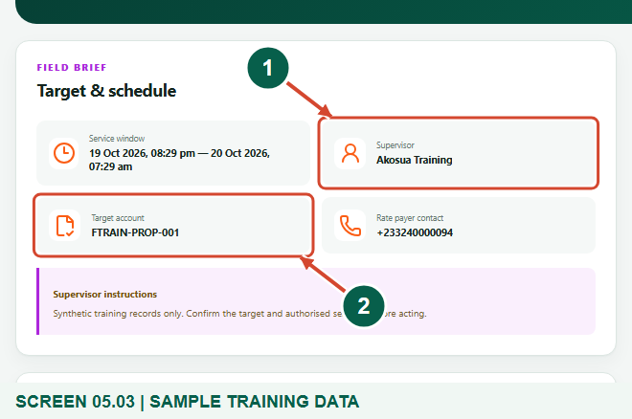
Synthetic training data in the actual agent portal. Check the supervisor on a field visit.
1 Supervisor for this visit
2 Target account
What should happen
The named supervisor for the selected visit is clear.

STEP 04

Read instructions and use verified contact channels
1. Read Supervisor instructions in the brief and keep the assignment or target reference available when asking for help.
2. This screen displays the supervisor name, not a direct call, chat or contact directory. Ask the assembly for verified contact details if needed. If no work or supervisor is shown, request an allocation check.
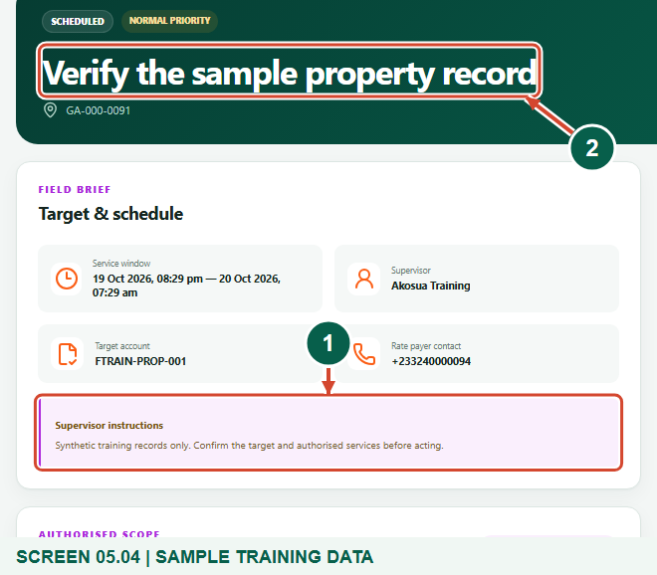
Synthetic training data in the actual agent portal. Read instructions and use verified contact channels.
1 Supervisor instructions
2 Selected assignment
What should happen
You know whose instructions apply and how to escalate a missing or incorrect allocation safely.

Check your result
- You identified the supervisor for the relevant task or visit.
- You read the instructions for the correct target.
- You know where to request verified contact or an allocation correction.

If you need help
No work appears
Clear date, status and search filters. If it remains empty, ask the assembly or supervisor to check your allocation.
Name is missing or says Former supervisor
Ask the assembly to review the current staff and task assignment; do not assume another officer is authorised.
You need a phone number or messaging
Use the assembly's verified staff-contact process. The agent portal does not provide a supervisor contact directory or chat control here.

Useful things to know
- The supervisor name shown belongs to the selected assignment or task; this is not a public staff lookup.
- An agent cannot assign or change their own supervisor from this workspace.

Continue learning
- Guide 01: Access your agent account
- Guide 02: Distribute bills
- Guide 04: Update property and business profiles or collect data
- Guide 06: Find your assigned boundary and territory
Download all 6 guides in this collection
For account or bill-record corrections, contact the relevant assembly using its verified contact details. Keep your account or bill reference available when requesting assistance.

