
GYE NTOBOA
MANUAL 3 - AGENTS TRAINING
PROCESS GUIDE 04 / 06

Update property and business profiles or collect data
Capture verified property, business or rate payer information under the assigned service scope and follow supervisor review before treating a proposed change as an approved live record.
WHO THIS IS FOR  Field agent | ALLOW ABOUT  15-25 minutes | DOCUMENT VERSION  1.0 | 19 October 2026

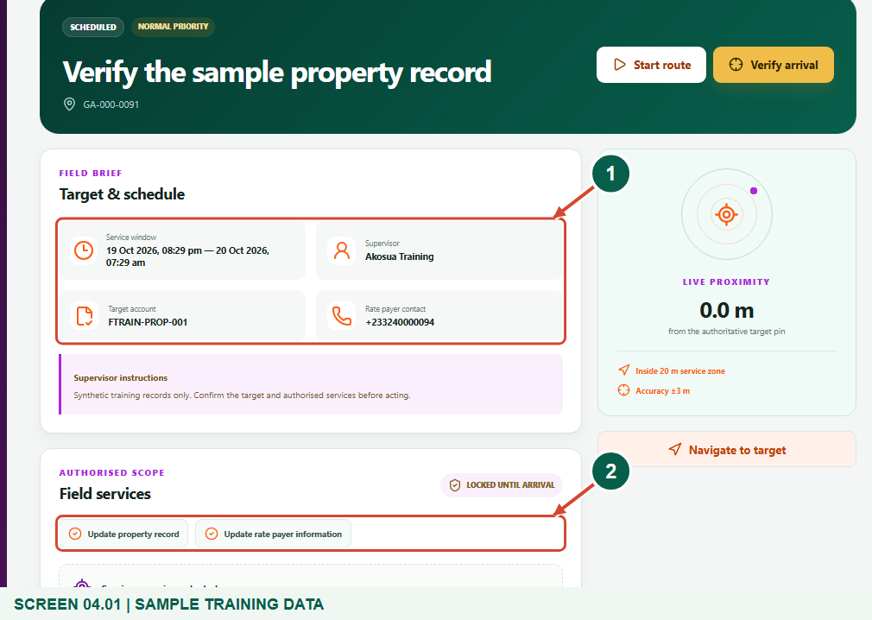
Illustrated steps with numbered arrows and clear expected results.
About the examples
Screens show the actual application in a training environment with sample data. Use your own verified account, assigned records and contact details when following the guide.

Website: operations.gyentoboa.com

Process flow
Follow the arrows from start to finish. Optional routes are explained in the numbered steps.

Before you start
- Obtain a visit with the relevant authorised service: Update property record, Update business record or Update rate payer information.
- Prepare verified source details and follow assembly procedures for valuation, classification and personal data. Collect only what is needed for the assignment.
- Keep location permission enabled. The default GPS requirement is accuracy of 15 metres or better and a reading captured within 60 seconds. When the distance check is on, distance to the target plus GPS uncertainty must fit within 20 metres.
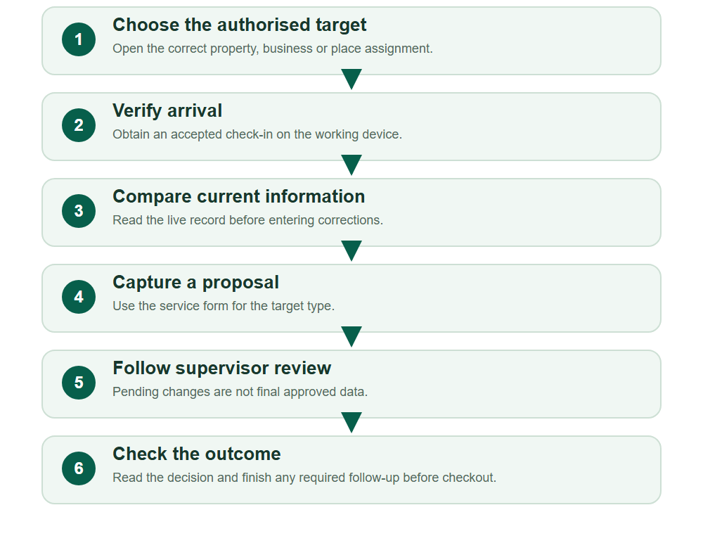
Numbered markers on screenshots identify the controls described beneath each image.

STEP 01

Choose the correct update assignment
1. Open My work and select the visit for the intended property or business.
2. Confirm its target reference and authorised service. Property, business and rate payer forms are alternatives determined by the allocated scope.
Synthetic training data in the actual agent portal. Choose the correct update assignment.
1 Correct target and assigned services
2 Permitted update services
What should happen
The brief identifies the target and permitted update type.

STEP 02

Verify arrival and compare the current record
1. Reach the target and choose Verify arrival using a fresh accurate fix.
2. Read Live account, billing & collection position and the Current property or Current business record before changing anything.
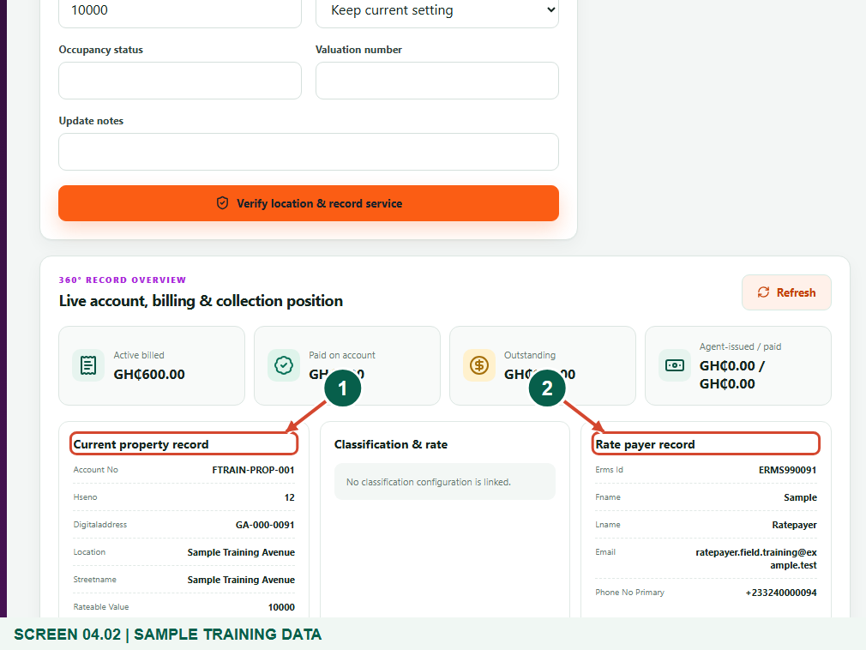
Synthetic training data in the actual agent portal. Verify arrival and compare the current record.
1 Current property record
2 Rate payer record
What should happen
The service is unlocked and you have checked the existing information.

STEP 03

Propose verified property corrections
1. For a property visit, choose Update property record. Correct supported details such as house number, digital address, street, locality or occupancy status.
2. Use classification, rateable value and valuation fields only with the required evidence and authority. Add useful Update notes and recheck the target before submitting.
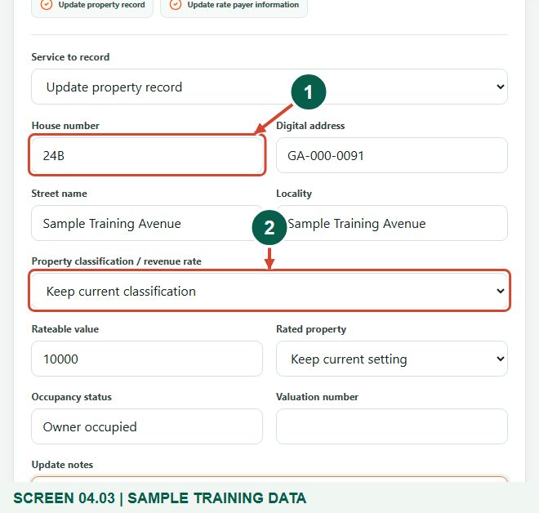
Synthetic training data in the actual agent portal. Propose verified property corrections.
1 Verified house number
2 Property classification
What should happen
The property form contains a justified proposal rather than an unverified guess.

STEP 04

Submit and inspect the pending comparison
1. Choose Verify location & record service.
2. Look for the notice that the proposal was sent to the supervisor. In Initial and proposed information, compare before and proposed values and note the pending status.
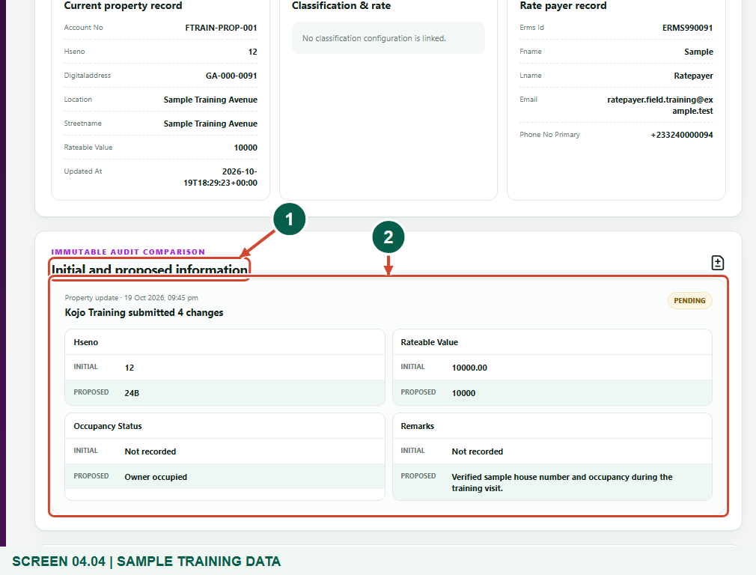
Synthetic training data in the actual agent portal. Submit and inspect the pending comparison.
1 Initial and proposed information
2 Pending review comparison
What should happen
The proposal is recorded for review; pending values have not silently replaced the live register.

STEP 05

Business alternative: capture the correct profile
1. For a business assignment, choose Update business record instead. Check business name, registration or permit, quantity, contact, address and the permitted classification fields.
2. Submit the verified proposal through the same location-checked service button. Do not copy property details into a business record.
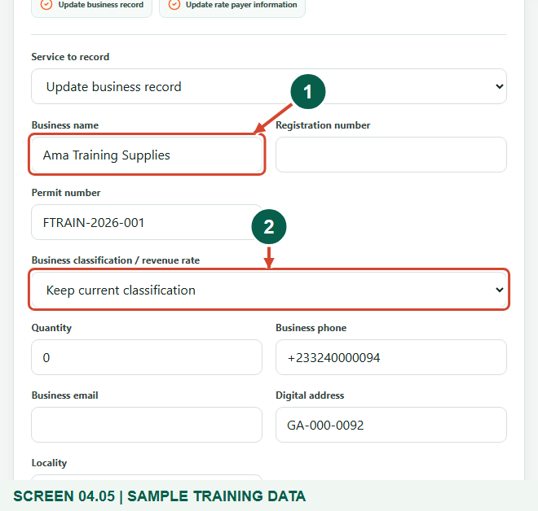
Synthetic training data in the actual agent portal. Business alternative: capture the correct profile.
1 Business name
2 Business classification
What should happen
The business proposal is saved for the same controlled review process.

STEP 06

Rate payer information alternative
1. Where authorised, choose Update rate payer information. Verify the linked person or organisation and correct only supported identity, phone, email or address fields.
2. For an Other place assignment without an existing linked record, this service captures field information in the audit trail; it does not automatically register a new property, business or customer account.
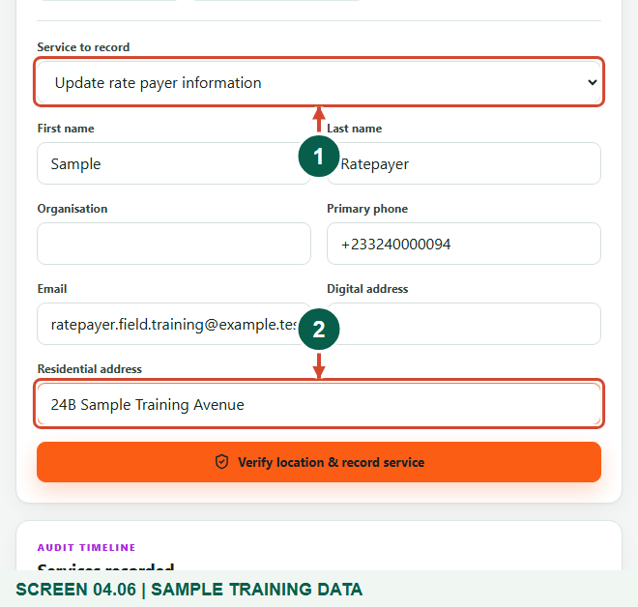
Synthetic training data in the actual agent portal. Rate payer information alternative.
1 Update rate payer information
2 Verified contact details
What should happen
The requested information is captured under the actual assignment context.

STEP 07

Read the supervisor decision before finishing
1. Reopen the assignment to refresh Initial and proposed information and read the approval status and any Supervisor note.
2. An approved proposal is applied by the controlled review process. If rejected, discuss the reason and submit an appropriate corrected proposal; the agent cannot approve their own change.
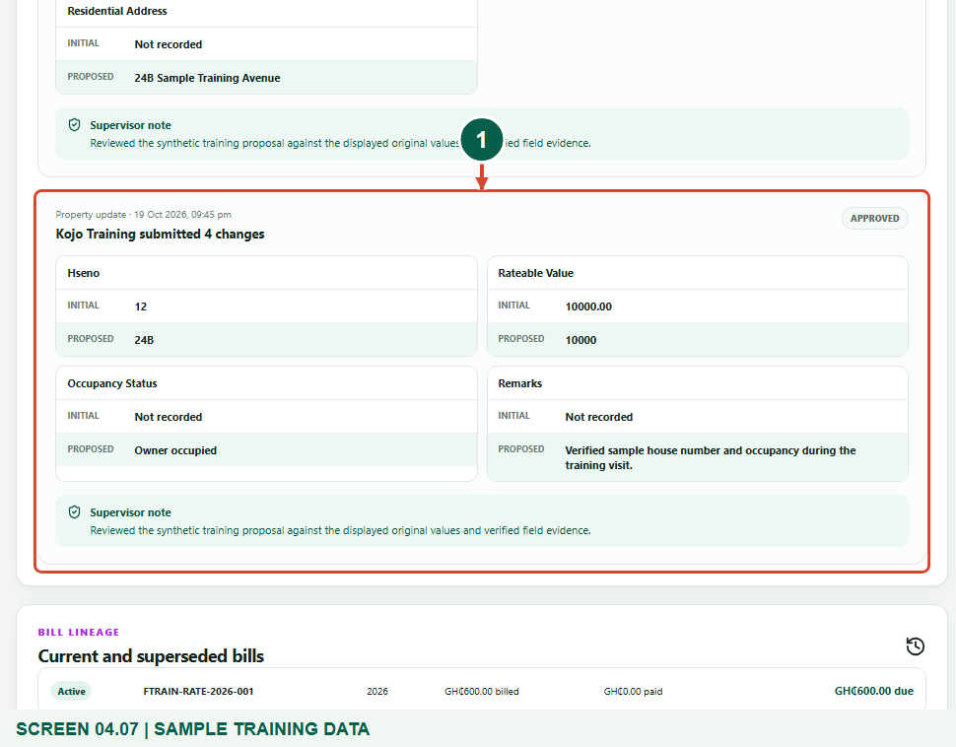
Synthetic training data in the actual agent portal. Read the supervisor decision before finishing.
1 Approved property comparison
What should happen
You know whether the update is pending, approved or rejected and which information is authoritative.

STEP 08

Complete the remaining workflow and check out
1. Wait for pending record decisions. If an instant replacement bill is authorised and required, follow its separate approval-to-generation workflow; approving a profile does not itself issue a replacement bill.
2. Choose Complete & check out only when the remaining approval or rebill workflow is resolved.
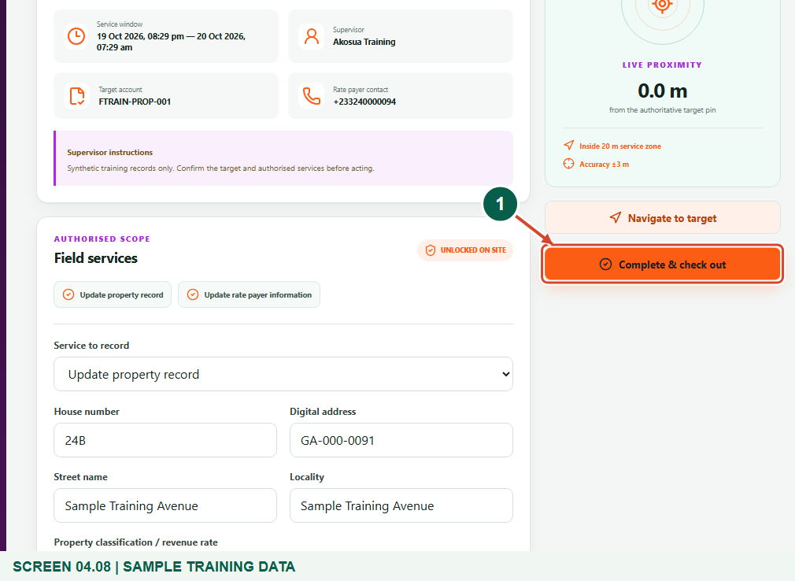
Synthetic training data in the actual agent portal. Complete the remaining workflow and check out.
1 Complete & check out
What should happen
The visit can close with completed evidence and no unresolved controlled workflow.

Check your result
- The correct target and current record were checked.
- Each proposed change has verified evidence and an audit comparison.
- Pending review, rejection and approved live changes are clearly distinguished.

If you need help
A needed field or service is unavailable
Confirm the target type and scope with the supervisor. The agent form supports selected fields and is not unrestricted register administration.
Proposal remains pending
Ask the assigned supervisor to review it. Do not claim that the live record has changed or repeatedly submit the same proposal.
Checkout is disabled
Resolve pending profile decisions and pending or approved-but-ungenerated rebills with the supervisor before completing the visit.

Useful things to know
- These are controlled update and information-capture workflows, not unrestricted property, business or rate payer registration.
- Profile approval and replacement billing are separate decisions. Historical payment or bill records are not overwritten by an agent editing a form.
- An administrator can turn off the distance boundary for the assembly. That does not remove GPS accuracy, freshness, verified arrival, assignment ownership, service scope or same-device checks.

Continue learning
- Guide 01: Access your agent account
- Guide 02: Distribute bills
- Guide 03: Initiate bill payments
- Guide 05: Find your supervisor
Download all 6 guides in this collection
For account or bill-record corrections, contact the relevant assembly using its verified contact details. Keep your account or bill reference available when requesting assistance.

