
GYE NTOBOA
MANUAL 3 - AGENTS TRAINING
PROCESS GUIDE 03 / 06

Initiate bill payments
Create a controlled payment request for an assigned bill and hand the secure QR or link to the rate payer without handling their credentials or claiming an unconfirmed payment.
WHO THIS IS FOR  Field agent | ALLOW ABOUT  10-15 minutes | DOCUMENT VERSION  1.0 | 19 October 2026

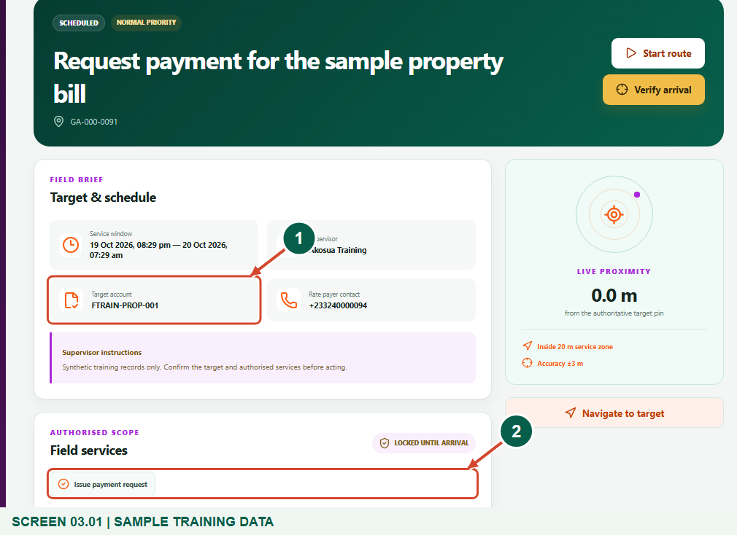
Illustrated steps with numbered arrows and clear expected results.
About the examples
Screens show the actual application in a training environment with sample data. Payment prompts and outcomes are simulated examples, not evidence of a real payment.

Website: operations.gyentoboa.com

Process flow
Follow the arrows from start to finish. Optional routes are explained in the numbered steps.

Before you start
- Use an assignment that authorises Issue payment request and targets the correct property or business.
- Confirm the issued active bill and its unreserved balance with the rate payer. Never request a mobile-money PIN, card secret, password or OTP.
- Keep location permission enabled. The default GPS requirement is accuracy of 15 metres or better and a reading captured within 60 seconds. When the distance check is on, distance to the target plus GPS uncertainty must fit within 20 metres.
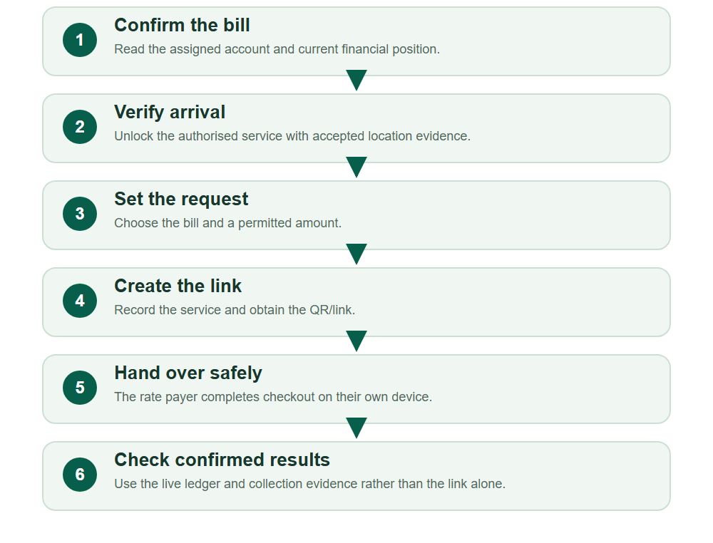
Numbered markers on screenshots identify the controls described beneath each image.

STEP 01

Open the assigned payment visit
1. In My work, open the visit that authorises Issue payment request.
2. Check the Target account and the live financial summary. Confirm that you are discussing the intended bill and receiving assembly.
Synthetic training data in the actual agent portal. Open the assigned payment visit.
1 Target account
2 Assigned payment service
What should happen
The brief and 360-degree record identify the correct target and bill.

STEP 02

Verify arrival before requesting payment
1. Start route if appropriate, reach the target and choose Verify arrival with location enabled.
2. Continue when the visit is On site and Field services is Unlocked on site. The same device must continue the visit.
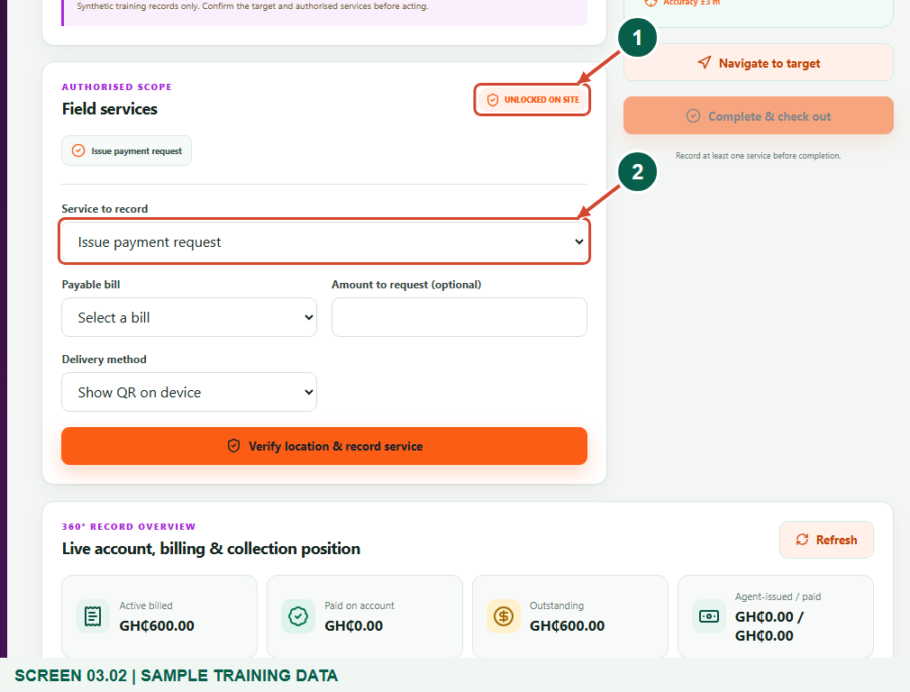
Synthetic training data in the actual agent portal. Verify arrival before requesting payment.
1 Unlocked on site
2 Service to record
What should happen
The payment request form is available within the authorised visit.

Helpful note: An administrator can turn off the distance boundary for the assembly. That does not remove GPS accuracy, freshness, verified arrival, assignment ownership, service scope or same-device checks.

STEP 03

Choose the bill, amount and safe sharing method
1. Select Issue payment request and the Payable bill. Enter Amount to request only when requesting a permitted partial amount; leaving it blank requests the available balance.
2. Choose Show QR on device or Copy secure link. The server rejects amounts above the available unreserved balance; do not create duplicates merely because a payer has not finished.
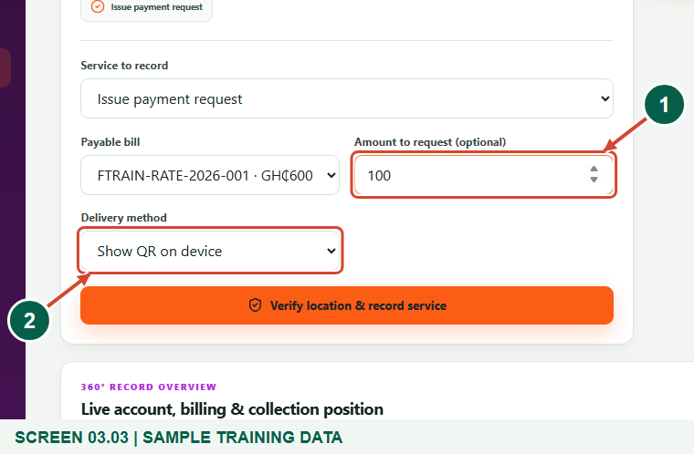
Synthetic training data in the actual agent portal. Choose the bill, amount and safe sharing method.
1 Bill and amount
2 QR or secure link
What should happen
The form contains the correct bill, intended amount and sharing method.

STEP 04

Record the payment request
1. Choose Verify location & record service and wait for the server response.
2. Confirm Payment request ready and the bill reference. This records a request; it does not charge the payer or prove that money has arrived.
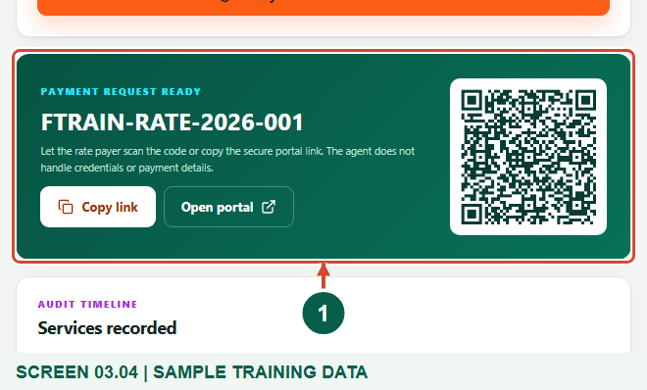
Synthetic training data in the actual agent portal. Record the payment request.
1 Payment request ready
What should happen
A secure rate payer link and QR code are displayed.

STEP 05

Let the payer scan or copy the secure link
1. Let the payer scan the QR on their own device, or choose Copy link and share it through an approved channel.
2. The payer should check https://gyentoboa.com/ and their bill and assembly before continuing. Open portal is available for the payer-facing page; the agent must not enter the payer's payment secrets.
3. Use the QR generated in your own live assignment; the training QR in this guide is not a payable link.
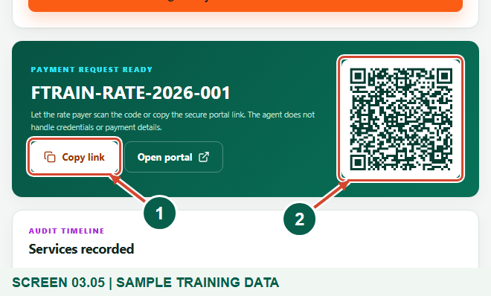
Synthetic training data in the actual agent portal. Let the payer scan or copy the secure link.
1 Copy link
2 Payer QR code
What should happen
The payer can open the bill-specific payment page without giving the agent their credentials.

Helpful note: The figures are synthetic training examples. No live payment or provider transfer was made.

STEP 06

Distinguish a request from a confirmed collection
1. The payer completes any required gateway approval themselves. A pending prompt, link, QR, browser return or screenshot is not a confirmed payment.
2. Reopen the assignment to refresh its live billing and collection position, or check My collections. Treat a payment as collected only when the server records successful payment and updates the balance.
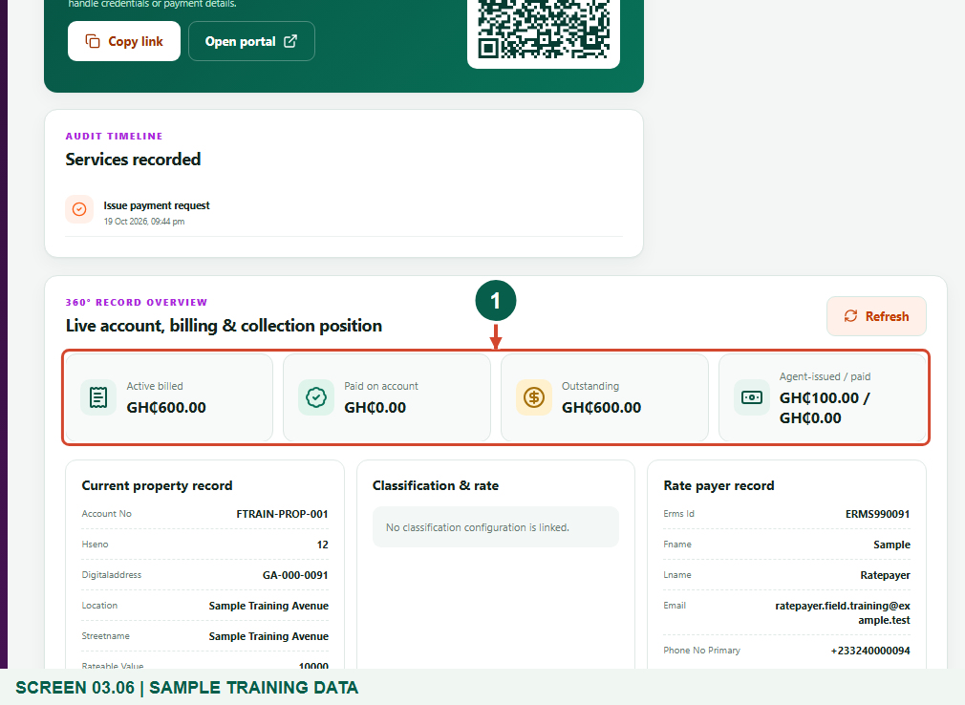
Synthetic training data in the actual agent portal. Distinguish a request from a confirmed collection.
1 Live billing and collection position
What should happen
You can explain the difference between a payment request, pending attempt and confirmed collection.

STEP 07

Close the field visit when its work is finished
1. Check Services recorded, then choose Complete & check out when the visit has no outstanding approval or rebill workflow.
2. A completed field visit is operational evidence and does not itself confirm that the payer settled the bill. Escalate an unresolved payment through the assembly with the bill reference.
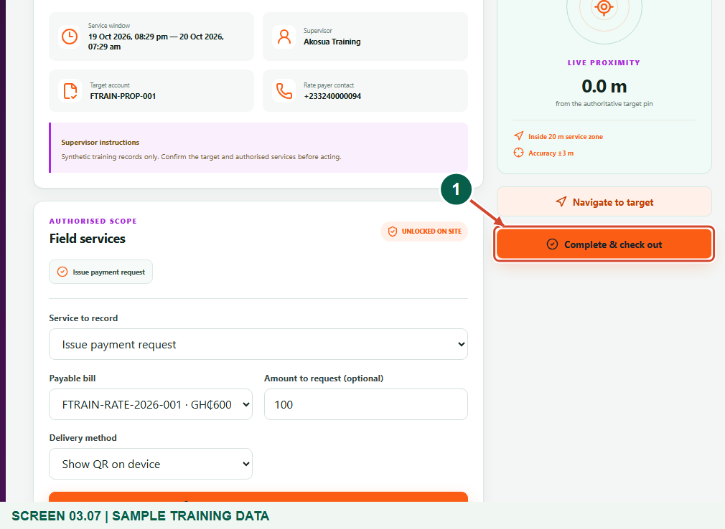
Synthetic training data in the actual agent portal. Close the field visit when its work is finished.
1 Complete & check out
What should happen
The visit is closed without misreporting an unconfirmed payment.

Check your result
- The correct bill has one intentional request.
- The payer received a QR or secure link without disclosing secrets.
- Requests and visits are not misreported as confirmed collections.

If you need help
No bill or no available balance
Ask the supervisor to verify that the active bill is issued and payable. Existing requests or unsettled payment attempts can reserve balance.
Requested amount is rejected
Use a positive amount no greater than the current available balance. Refresh the live record before creating another request.
Payer reports paying but balance is unchanged
Check the server-confirmed payment status with the assembly. Keep the reference; do not tell the payer to repeat the charge while an attempt may still settle.

Useful things to know
- The agent portal creates a payment request; the rate payer checkout uses the bill-issuing assembly's configured gateway. Agents do not choose the merchant account or charge provider here.
- Do not rely on the SMS link choice to send a message in the current portal. Use QR or Copy link; this guide does not claim an SMS was sent.
- A field payment link expires after one day. It is tied to the assigned bill and requested amount; do not publish it or treat it as a receipt.

Continue learning
- Guide 01: Access your agent account
- Guide 02: Distribute bills
- Guide 04: Update property and business profiles or collect data
- Guide 05: Find your supervisor
Download all 6 guides in this collection
For account or bill-record corrections, contact the relevant assembly using its verified contact details. Keep your account or bill reference available when requesting assistance.

