
GYE NTOBOA
MANUAL 3 - AGENTS TRAINING
PROCESS GUIDE 02 / 06

Distribute bills
Open an assigned delivery visit, verify arrival, record the actual bill recipient, and complete the visit with a clear audit trail.
WHO THIS IS FOR  Field agent | ALLOW ABOUT  10-20 minutes per visit | DOCUMENT VERSION  1.0 | 19 October 2026

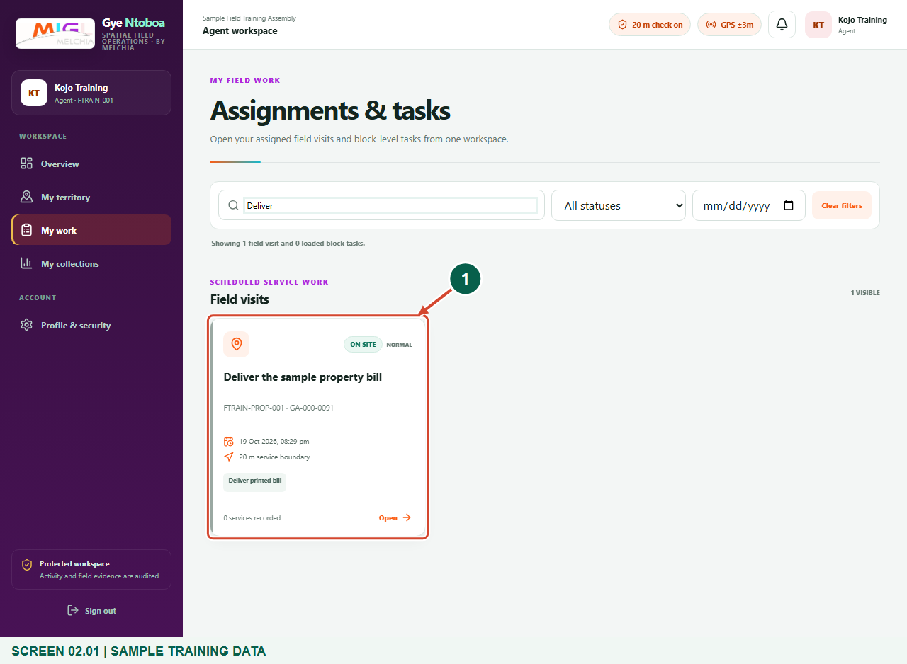
Illustrated steps with numbered arrows and clear expected results.
About the examples
Screens show the actual application in a training environment with sample data. Use your own verified account, assigned records and contact details when following the guide.

Website: operations.gyentoboa.com

Process flow
Follow the arrows from start to finish. Optional routes are explained in the numbered steps.

Before you start
- Sign in with your own agent account and obtain an assignment that authorises Deliver printed bill.
- Carry the correct printed bill and verify the recipient and target account before handing it over.
- Keep location permission enabled. The default GPS requirement is accuracy of 15 metres or better and a reading captured within 60 seconds. When the distance check is on, distance to the target plus GPS uncertainty must fit within 20 metres.
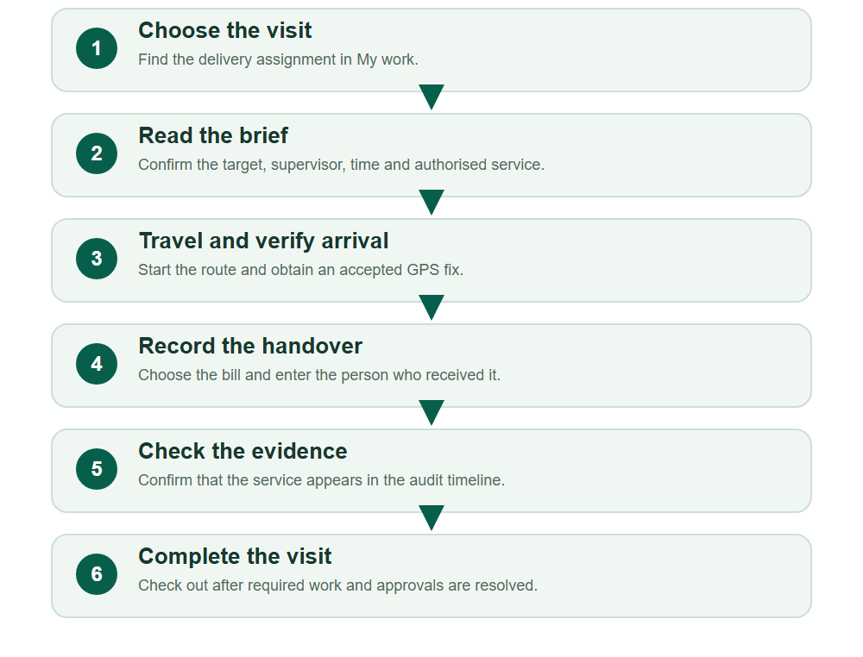
Numbered markers on screenshots identify the controls described beneath each image.

STEP 01

Find your delivery assignment
1. Choose My work and find the visit that includes Deliver printed bill.
2. Use the search, status or date filters if needed. Clear filters if an expected visit is hidden.
Synthetic training data in the actual agent portal. Find your delivery assignment.
1 Delivery assignment
What should happen
The delivery visit appears under Field visits with the correct target and schedule.

STEP 02

Read the field brief
1. Open the assignment and compare the Target account and address with the printed bill.
2. Read the service window and Supervisor instructions. Confirm that Deliver printed bill is in the authorised Field services.
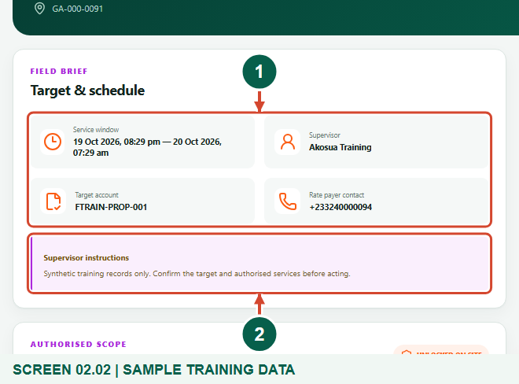
Synthetic training data in the actual agent portal. Read the field brief.
1 Target and schedule
2 Supervisor instructions
What should happen
You have identified the correct target, bill and permitted work.

STEP 03

Start the route and obtain reliable GPS
1. Choose Start route when the assignment is Scheduled. Navigate to target can open external map directions.
2. Keep location enabled and follow the current assembly distance rule. Start route alone does not unlock the service.
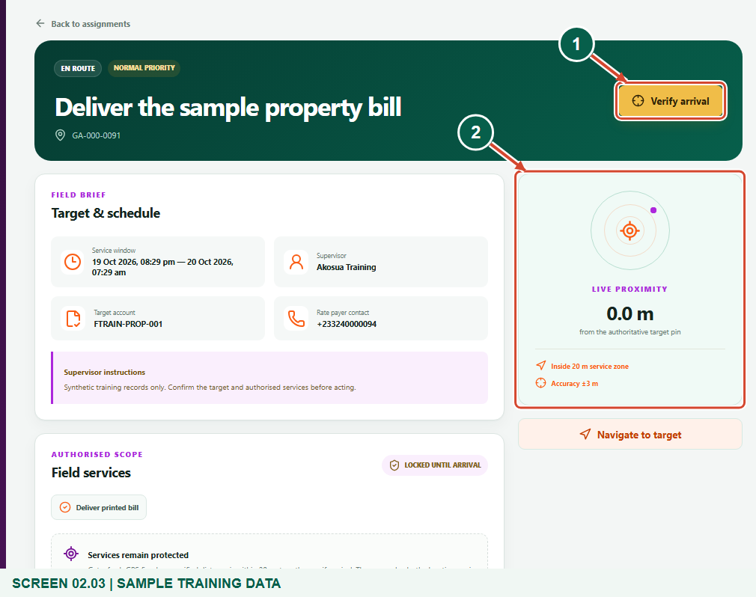
Synthetic training data in the actual agent portal. Start the route and obtain reliable GPS.
1 Verify arrival
2 Live proximity
What should happen
The visit becomes En route and the Live proximity panel shows the current fix.

Helpful note: An administrator can turn off the distance boundary for the assembly. That does not remove GPS accuracy, freshness, verified arrival, assignment ownership, service scope or same-device checks.

STEP 04

Verify arrival at the target
1. When you are at the assigned target with an accurate, fresh fix, choose Verify arrival.
2. Wait for the success message and On site state. Continue on the same browser device used for check-in.
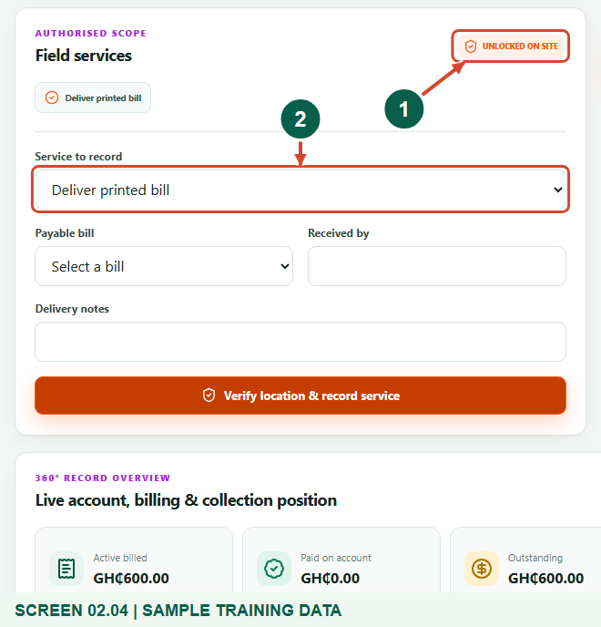
Synthetic training data in the actual agent portal. Verify arrival at the target.
1 Unlocked on site
2 Service to record
What should happen
Field services shows Unlocked on site and the service form becomes available.

STEP 05

Select the bill and record the real recipient
1. Choose Deliver printed bill under Service to record, then select the correct Payable bill.
2. After physically handing over the correct bill, enter Received by and any relevant Delivery notes. Record facts; do not mark a failed handover as delivered.
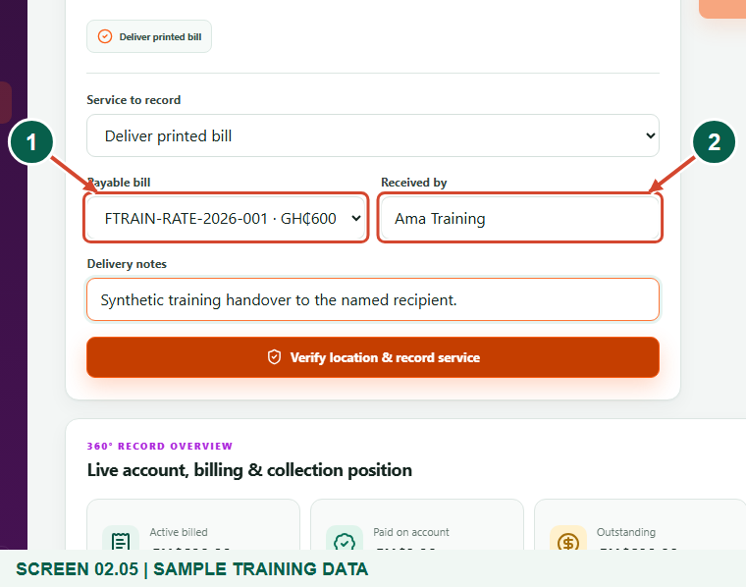
Synthetic training data in the actual agent portal. Select the bill and record the real recipient.
1 Payable bill
2 Received by
What should happen
The form identifies the bill and the person who actually received it.

STEP 06

Save and inspect the delivery evidence
1. Choose Verify location & record service. The server checks location and assignment scope again.
2. Confirm the success notice and Deliver printed bill entry in Services recorded. If an error appears, resolve it before claiming that delivery was recorded.
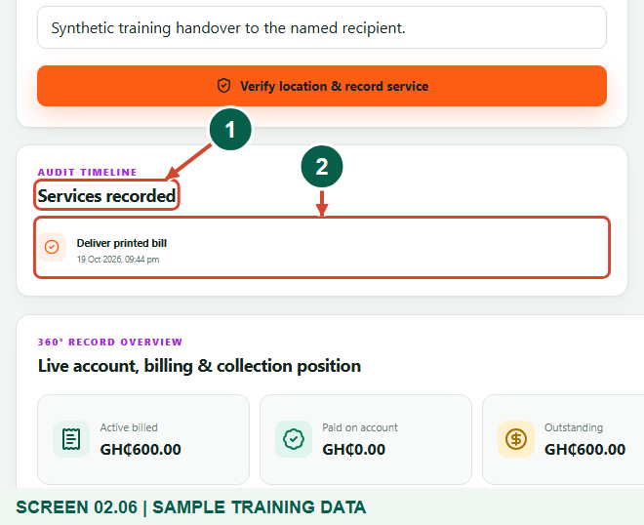
Synthetic training data in the actual agent portal. Save and inspect the delivery evidence.
1 Services recorded
2 Deliver printed bill evidence
What should happen
The bill handover is recorded with its agent, time and location evidence.

STEP 07

Complete and check out
1. When all work for the visit is finished, choose Complete & check out.
2. If a profile update or rebill is still awaiting review or generation, finish that workflow with your supervisor before trying to check out.
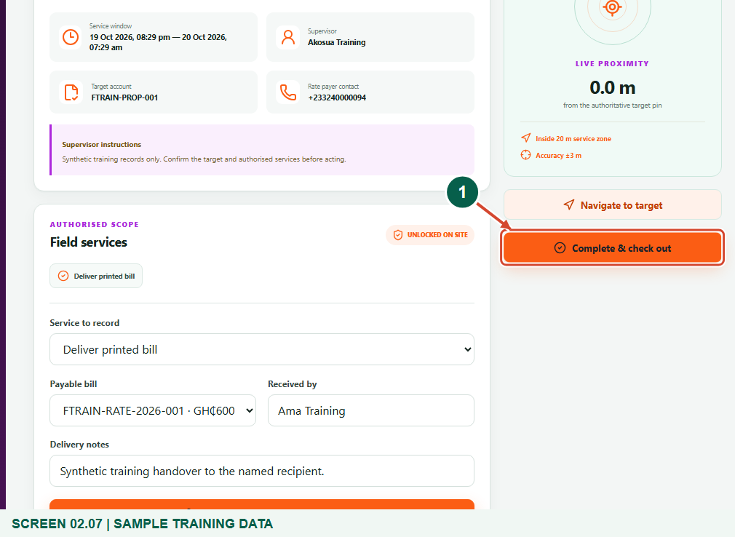
Synthetic training data in the actual agent portal. Complete and check out.
1 Complete & check out
What should happen
The visit becomes Completed after an accepted final location check.

Check your result
- The actual recipient and bill are recorded.
- The delivery service appears in the audit timeline.
- The visit is completed when its remaining workflow permits.

If you need help
Delivery service is missing or locked
Ask your supervisor to allocate the correct service. Verify arrival at the target; an agent cannot add service permissions.
No bill appears in Payable bill
Confirm the correct target and active bill with your supervisor. The current form lists only active payable bills with a positive balance.
GPS, schedule or same-device error
Obtain a fresh accurate fix, use the device that checked in, and ask the supervisor to review an out-of-window assignment.

Useful things to know
- This field portal does not ask for a bill-recipient OTP during printed delivery. Conditional SMS sign-in is a separate account-security step.
- An administrator can turn off the distance boundary for the assembly. That does not remove GPS accuracy, freshness, verified arrival, assignment ownership, service scope or same-device checks.
- Recording delivery is not payment confirmation. Paid or non-payable bills are not offered by this particular service form.

Continue learning
- Guide 01: Access your agent account
- Guide 03: Initiate bill payments
- Guide 05: Find your supervisor
- Guide 06: Find your assigned boundary and territory
Download all 6 guides in this collection
For account or bill-record corrections, contact the relevant assembly using its verified contact details. Keep your account or bill reference available when requesting assistance.

