
GYE NTOBOA
MANUAL 3 - AGENTS TRAINING
PROCESS GUIDE 01 / 06

Access your agent account
Sign in to the official field portal, complete the SMS challenge when required, replace an initial password when prompted, and enter the correct assembly workspace safely.
WHO THIS IS FOR  Field agent | ALLOW ABOUT  10-15 minutes | DOCUMENT VERSION  1.0 | 19 October 2026

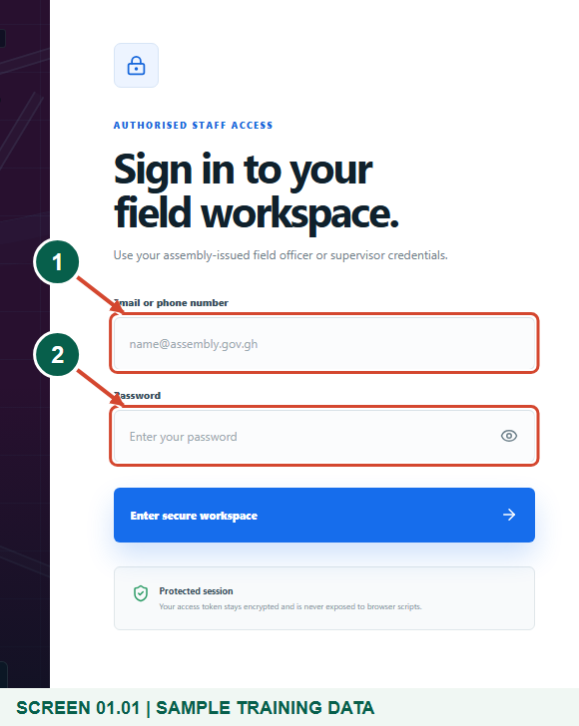
Illustrated steps with numbered arrows and clear expected results.
About the examples
Screens show the actual application in a training environment with sample data. Use your own verified account, assigned records and contact details when following the guide.

Website: operations.gyentoboa.com

Process flow
Follow the arrows from start to finish. Optional routes are explained in the numbered steps.

Before you start
- Obtain your own active agent account from the assembly. This portal does not provide public agent self-registration.
- Use https://operations.gyentoboa.com/ in a modern browser. Keep your own registered phone available when staff sign-in OTP is enabled.
- Use a device with location services for field work. Never share an account, password, verification code or payment PIN.
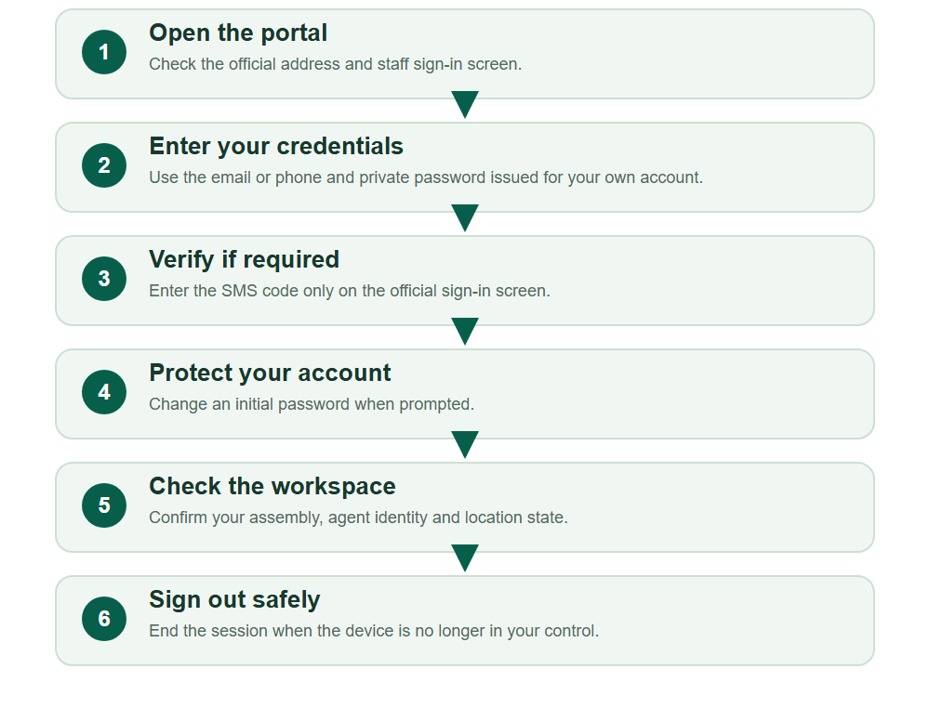
Numbered markers on screenshots identify the controls described beneath each image.

STEP 01

Open the official sign-in screen
1. Open https://operations.gyentoboa.com/ and choose the staff sign-in route if needed.
2. Confirm that the page is the field workspace and the address belongs to the official service before entering credentials.
Synthetic training data in the actual agent portal. Open the official sign-in screen.
1 Email or phone number
2 Password
What should happen
The form offers Email or phone number and Password.

STEP 02

Enter your own staff credentials
1. Enter your registered email address or phone number and your private password.
2. Choose Enter secure workspace. Do not use a rate payer account or another officer's credentials.
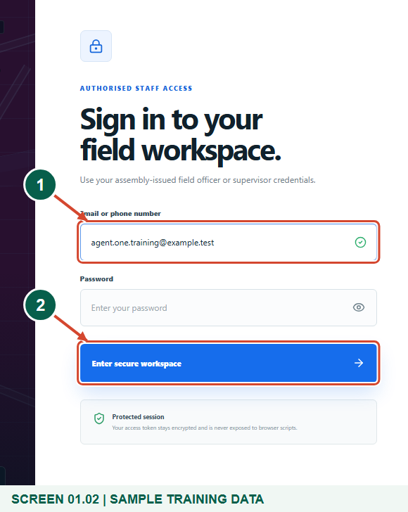
Synthetic training data in the actual agent portal. Enter your own staff credentials.
1 Your own staff identity
2 Enter secure workspace
What should happen
The portal opens a verification challenge when required, or continues to your authorised account.

STEP 03

Complete the SMS challenge when shown
1. If staff OTP is enabled, enter the six-digit code sent to your registered phone and choose Verify and sign in.
2. Use Resend code when its countdown permits. Use different credentials starts sign-in again if you used the wrong account.
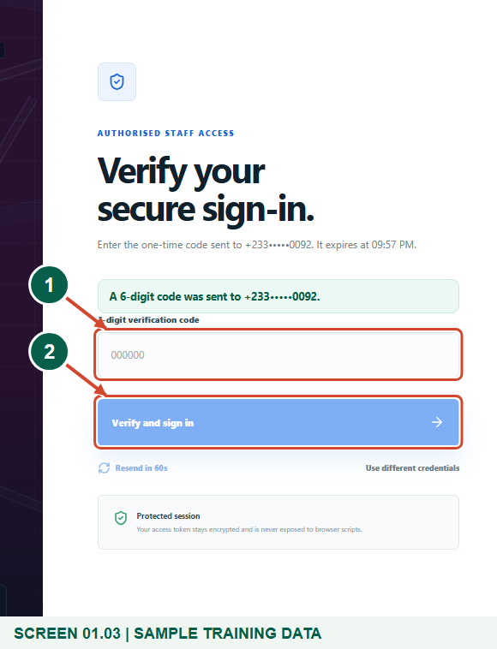
Synthetic training data in the actual agent portal. Complete the SMS challenge when shown.
1 6-digit verification code
2 Verify and sign in
What should happen
A valid, unexpired code completes the protected sign-in.

Helpful note: The sign-in code is sent by SMS, not email. This conditional screen may be skipped when staff OTP policy is off.

STEP 04

Replace an initial password if prompted
1. If the portal opens Profile & security with an initial-password warning, enter the current password and choose your own new password.
2. Use at least 12 characters including an uppercase letter, lowercase letter, number and symbol. Confirm it and choose Update password. No example password is provided in this guide.
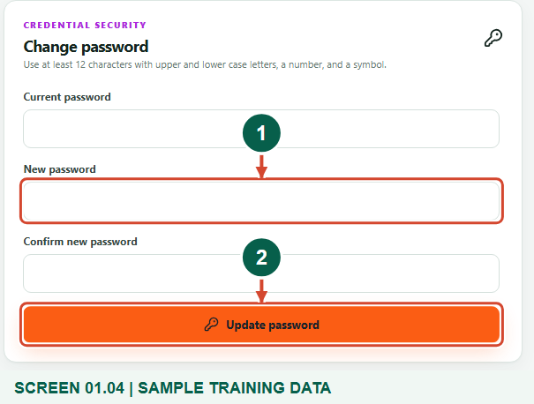
Synthetic training data in the actual agent portal. Replace an initial password if prompted.
1 New private password
2 Update password
What should happen
The password update succeeds and the initial-password restriction is removed.

STEP 05

Confirm your identity and location state
1. Check the assembly name and Agent role in the workspace. Contact the assembly if the identity is wrong.
2. Allow location in your browser for field work. The header shows GPS accuracy and whether the distance check is on. Opening the agent workspace makes your live position available to your assigned supervisor.
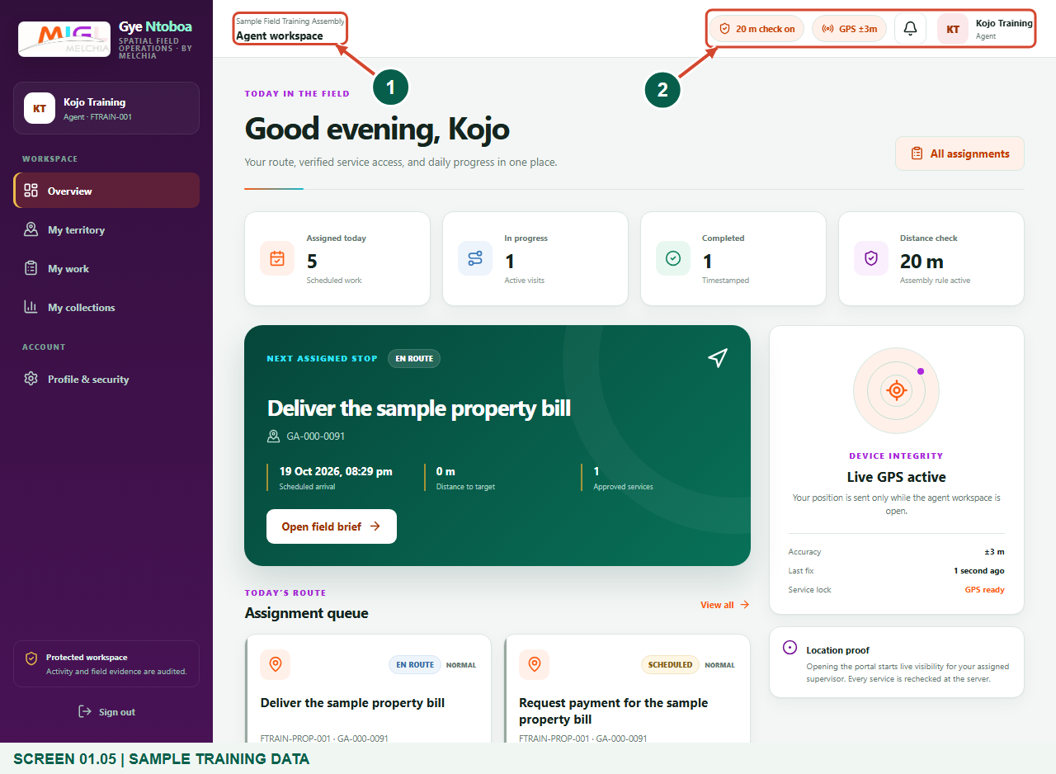
Synthetic training data in the actual agent portal. Confirm your identity and location state.
1 Your assembly and agent workspace
2 GPS and distance policy
What should happen
The Overview shows your own assigned work and the current location state.

STEP 06

Open your work and account controls
1. Choose My work for assigned visits and block tasks. Choose My territory for your geographic scope.
2. Use Profile & security to change your password or replay the guided tour. If the account has no work or areas, ask your supervisor to check the allocation.
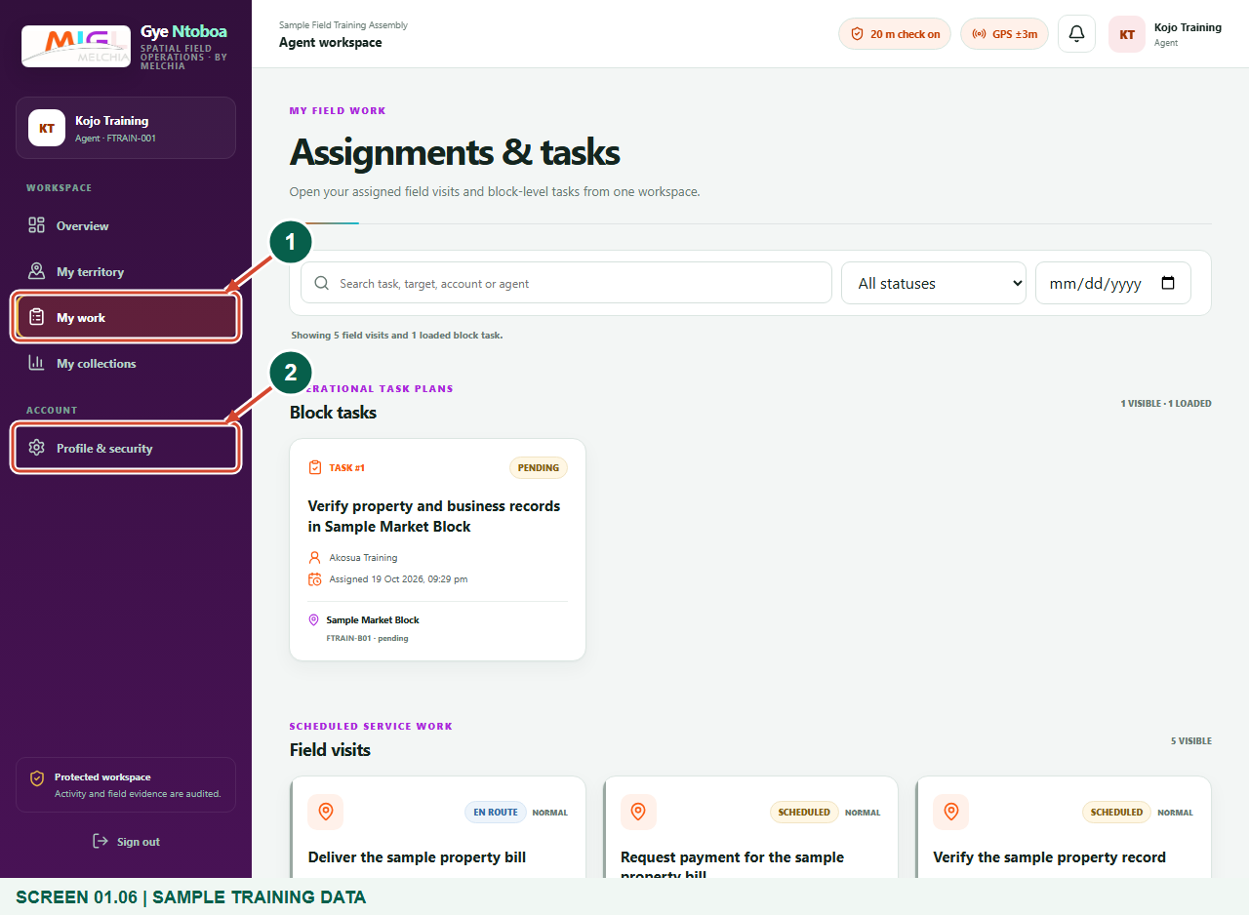
Synthetic training data in the actual agent portal. Open your work and account controls.
1 My work
2 Profile & security
What should happen
The correct agent navigation and assigned work are available.

STEP 07

Sign out when finished
1. Use Sign out in the navigation when you finish or hand the device to another person.
2. If a session expires, sign in again with your own account. For a forgotten password or unavailable registered phone, contact the authorised assembly support team; this login screen has no self-service reset button.
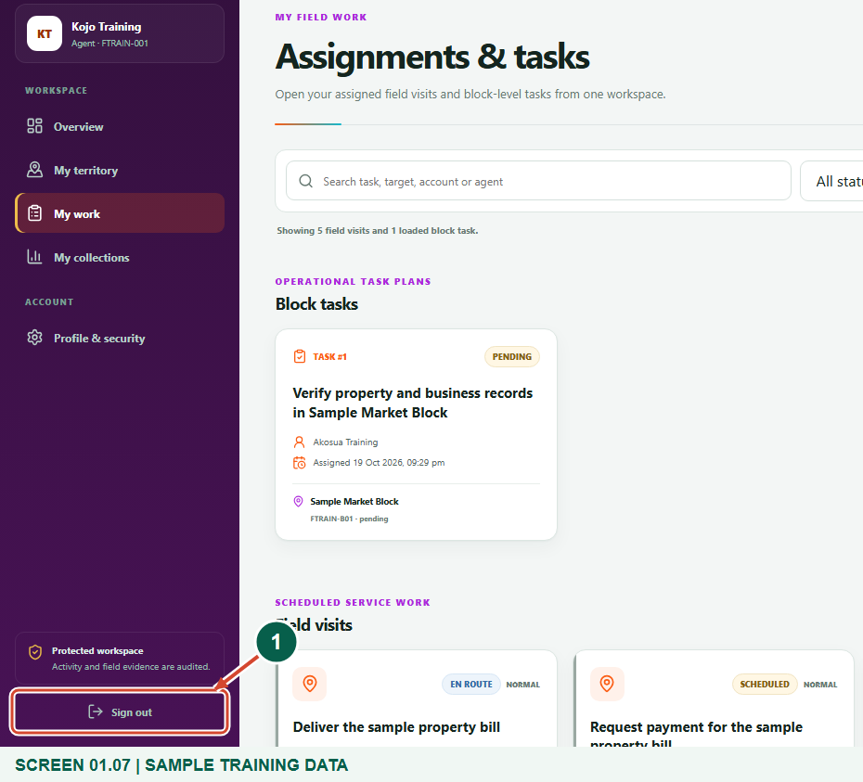
Synthetic training data in the actual agent portal. Sign out when finished.
1 Sign out
What should happen
The protected workspace closes and the sign-in screen is shown.

Check your result
- You reached your own assembly agent workspace.
- Any initial password was replaced privately.
- You know how to open My work and sign out.

If you need help
Credentials cannot be verified
Check the email or phone and password. Ask the assembly to confirm that your account is active, has the Agent role and belongs to the correct assembly.
No SMS or an expired code
Check the registered phone and signal. Wait for the resend countdown, then request a new code. If secure sign-in is unavailable, contact the system administrator.
Location is denied or inaccurate
Enable browser and device location, move into open sky and retry. A correct password does not replace field location checks.

Useful things to know
- The figures use synthetic people and locations. Passwords and codes are deliberately not shown.
- SMS OTP is conditional on the effective staff sign-in policy. The guide does not promise email OTP or public account registration.

Continue learning
- Guide 02: Distribute bills
- Guide 05: Find your supervisor
- Guide 06: Find your assigned boundary and territory
Download all 6 guides in this collection
For account or bill-record corrections, contact the relevant assembly using its verified contact details. Keep your account or bill reference available when requesting assistance.

